Results

Case 1:

Request Pushed to DB Via JMS

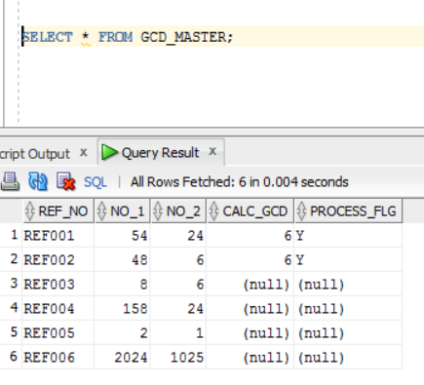

Case2:

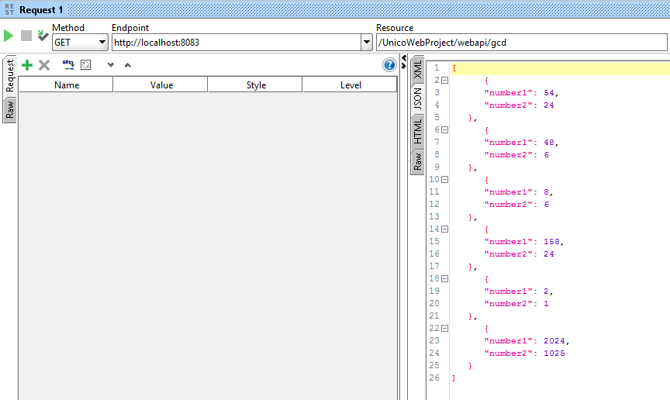

Case3: gcdList()

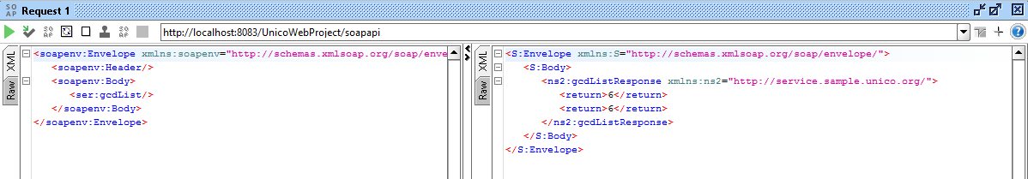

Case4: gcdSum()

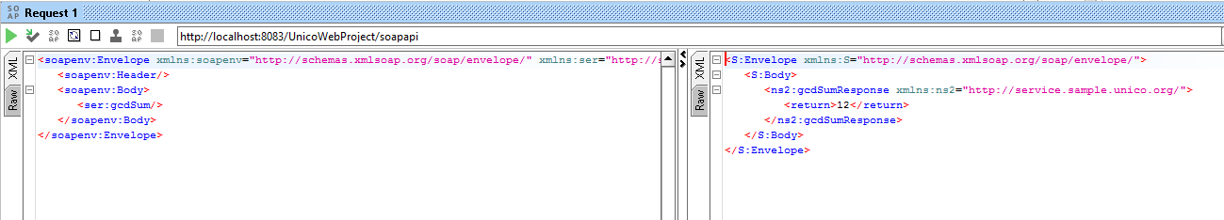

Case5: gcd()

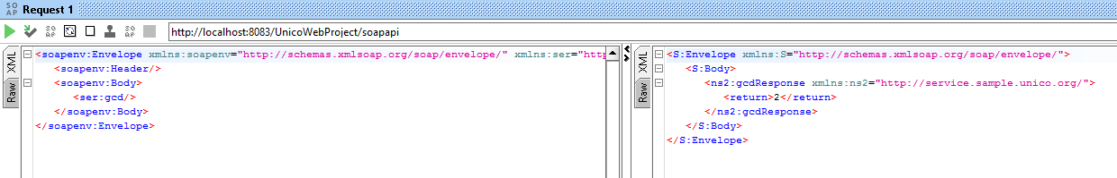

Case6: gcdList() after gcd()

