**COAL – Floating Point Unit in IA-32 Processors**

**Ali Muzahir (P18 - 0058)**

Numbers too large for standard integer representations or that have fractional components are usually represented in scientific notation, a form used commonly by scientists and engineers. Example : 4.25 ×10-3

We are most interested in normalized floating-point numbers, a format which includes:

* sign
* significand (1.0 ≤ Significand < Radix)
* integer power of the radix.

The Floating-Point Unit (FPU) provides high-performance floating-point processing capabilities for use in graphics processing, scientific, engineering, and business applications.

The FPU represents a separate execution environment within the IA-32 architecture. This execution environment consists of 8 data registers and following special purpose registers.

* The status register
* The counter register
* The tag word register

### Structure:

The FPU data register consists of eight 80-bits registers. Values are stored in these register in the double extended-precision floating point format. When floating-point, integer, or packed BCD (Binary Coded Decimal) integer values are loaded from memory into any of the FPU data registers, the values are automatically converted into the double extended-precision floating-point format (if they are not already in that format). When computation results are subsequently transferred back into memory from any of the FPU registers, the results can be left in the double extended-precision floating-point format or converted back into a shorter floating-point format, an integer format, or the packed BCD integer format.

The FPU instructions treat the eight FPU data register as a register stack. All addressing of the data registers is relative to the register on the top of the stack.

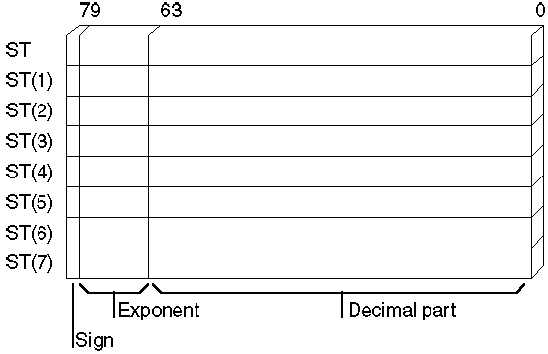

The register number of the current top-of-stack register is stored in the TOP (stack TOP) field in the FPU status word. Load operations decrement TOP by one and load a value into the new top-of-stack register, and store operations store the value from the current TOP register in memory and then increment TOP by one. (For the FPU, a load operation is equivalent to a push and a store operation is equivalent to a pop.) Note that load and store operations are also available that do not push and pop the stack.

if you use constants as operands, you cannot load them directly into FPU registers. You must allocate memory and initialize a variable to a constant value. That variable can then be loaded by using one of the load instructions.

The math FPU offers a few special instructions for loading certain constants. You can load 0, 1, pi, and several common logarithmic values directly. Using these instructions is faster and often more precise than loading the values from initialized variables.

### **Status word**

The Status Word 16-bit register indicates the general condition of the FPU. Its content may change after each instruction is completed. Part of it cannot be changed directly by the programmer. It can, however, be accessed indirectly at any time to inspect its content.

The Status Word is divided into several bit fields as depicted in the following Fig.

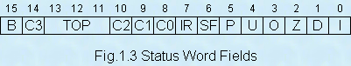

When the FPU is initialized, all the bits are reset to 0.

**Control Word**

The Control Word 16-bit register is used by the programmer to select between the various modes of computation available from the FPU and to define which exceptions should be handled by the FPU or by an exception handler written by the programmer.

The Control Word is divided into several bit fields as depicted in the following Fig.

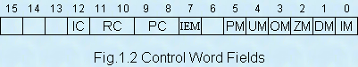

**Tag Word**

The Tag Word 16-bit register is managed by the FPU to maintain some information on the content of each of its 80-bit registers.

The Tag Word is divided into 8 fields of 2 bits each as depicted in the following Fig.

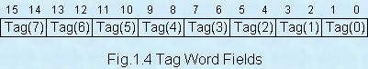

The above Tag numbers correspond to the FPU’s internal numbering system for the 80-bit registers (the BC numbers). The meaning of each pair of bits is as follows:

00 = The register contains a valid non-zero value

01 = The register contains a value equal to 0

10 = The register contains a special value (NAN, infinity, or denormal)

11 = The register is empty

## **Instruction Set**

### **Move**

FLD x ; push real4, real8, tbyte, convert to tbyte

FILD x ; push word, dword, qword, convert to tbyte

FST x ; convert ST and copy to real4, real8, tbyte

FIST x ; convert ST and copy to word, dword, qword

FSTP x ; convert to real and pop

FISTP x ; convert to integer and pop

FXCH st(n) ; swap with st(0)

### **Arithmetic**

FADD ; Adds the source and destination

FSUB ; Subtracts the source from the destination

FSUBR ; Subtracts the destination from the source

FMUL ; Multiplies the source and the destination

FDIV ; Divides the destination by the source

FDIVR ; Divides the source by the destination

FABS ; Sets the sign of ST to positive

FCHS ; Reverses the sign of ST

FRNDINT ; Rounds ST to an integer

FSQRT ; Replaces the contents of ST with its square root

FSCALE ; Multiplies the stack-top value by 2 to the power contained in ST(1)

FPREM ; Calculates the remainder of ST divided by ST(1)

## **Data type of floating point**

|  |  |  |  |  |  |  |
| --- | --- | --- | --- | --- | --- | --- |
| **Masm** | **C++** | **Sign Bits** | **Exponent** | **Mantissa** | **Range** | **Significant digits** |
| real4 | float | 1 | 8 | 23 | +- 1.7e38 | 6 |
| real8 | double | 1 | 11 | 52 | +- 1e308 | 14 |
| real10 | long double | 1 | 15 | 64 | +- 1e4932 | 18 |

***Here are three code examples that will compile and run on your system containing variables of real4, real8 and real10 types.***

### **Code - 1:**

.DATA

a REAL4 3.0

b REAL8 7.10217

cc REAL4 2.0

posx REAL4 0.0

negx REAL4 0.0

.CODE

Main proc

; Solve quadratic equation - no error checking

; The formula is: -b +/- square root(b2 - 4ac) / (2a)

fld1 ; Get constants 2 and 4

fadd st,st ; 2 at bottom

fld st ; Copy it

fmul a ; = 2a

fmul st(1),st ; = 4a

fxch ; Exchange

fmul cc ; = 4ac

fld b ; Load b

fmul st,st ; = b2

fsubr ; = b2 - 4ac

; Negative value here produces error

fsqrt ; = square root(b2 - 4ac)

fld b ; Load b

fchs ; Make it negative

fxch ; Exchange

fld st ; Copy square root

fadd st,st(2) ; Plus version = -b + root(b2 - 4ac)

fxch ; Exchange

fsubp st(2),st ; Minus version = -b - root(b2 - 4ac)

fdiv st,st(2) ; Divide plus version

fstp posx ; Store it

fdivr ; Divide minus version

fstp negx ; Store i

exit

Main endp

End Main

### **Code - 2:**

.DATA

diamtr REAL10 12.934921 ; Diameter of a circle

status WORD ?

.CODE

Main proc

; Get area of circle: Area = PI * (D/2)2

fld1 ; Load one and

fadd st, st ; double it to get constant 2

fdivr diamtr ; Divide diameter to get radius

fmul st, st ; Square radius

fldpi ; Load pi

fmul ; Multiply i

fstp status ; store it

exit

Main endp

End Main

### **Code - 3:**

.DATA

down REAL4 10.35 ; Sides of a rectangle

across REAL4 13.07

status WORD ?

.CODE

Main Proc

; Get area of rectangle

fld across ; Load one side

fmul down ; Multiply by the other

fstp status ; store it

exit

Main endp

End Main