Improving Data Quality through Deep Learning and Statistical Models
Wei Dai^{*1}, Kenji Yoshigoe^{#2}, William Parsley^{*3},
{Information Science*, Computer Science#}, University of Arkansas at Little Rock,
Little Rock, AR, USA
{wxdai¹, kxyoshigoe², wmparsley³}@ualr.edu

Abstract
Traditional data quality control methods are based on users’ experience or previously established business rules, and this limits performance in addition to being a very time consuming process with lower than desirable accuracy. Utilizing deep learning, we can leverage computing resources and advanced techniques to overcome these challenges and provide greater value to users.
In this paper, we, the authors, first review relevant works and discuss machine learning techniques, tools, and statistical quality models. Second, we offer a creative data quality framework based on deep learning and statistical model algorithm for identifying data quality. Third, we use data involving salary levels from an open dataset published by the state of Arkansas to demonstrate how to identify outlier data and how to improve data quality via deep learning. Finally, we discuss future work.

Keywords: data quality, data clean, deep learning, statistical quality control, Weka

- Introduction
In the era of Big Data, engineers are often challenged to innovate software platforms to store, analyze, and manage vast amounts of data in often diverse datasets. However, without improved data quality at data warehouses or data centers, engineers are not able to properly analyze this data due to garbage in, garbage out (GIGO) computing behavior. Hence, improving and controlling data quality has become one of the most critical business strategies for companies, organizations, governments, and financial service providers. One of the essential tasks for data quality is to detect data quality problems, especially outlier detection.
Dr. Richard Wang, a professor at MIT and leader in the field of data quality, speaks to a theoretical data quality framework as possessing qualities that are intrinsic, contextual, easily, and representational, accessible [1]. In software industry, popular data quality software tools contain many data profiling modules, but these functions usually are based on simple statistical algorithms [2]. In addition, these tools often do not offer insight into how to improve data quality problems through machine learning algorithms.
Machine learning is a promising subfield of computer science that approaches human-level artificial intelligence (AI), and is already utilized in self-driving cars, data mining, and natural speech recognition software [3-6]. These AI algorithms can either be unsupervised or supervised. In particular, deep learning is a type of machine learning that is one of the supervised methods [7-9]. It is clear that improving data quality is essential to data mining, data analysis, and Big Data processes. [16] mentions data quality assessment architecture via AI, but does not discuss how to improve and how to identify data quality with unique details based on AI and statistical modes. To the best of our knowledge, no literature published speaks to improving data quality through both machine learning and statistical quality control models.
Our first contribution is a data quality architecture based on deep learning and statistics model that enables identify data quality problems, and it also offers improve data quality.
The rest of this paper is organized as follows. Section 2 is related work; Section 3 discusses software architecture and data flow; Section 4 describes the data source and data structure used in this work; Section 5 describes data preparation; and Section 6 discusses machine learning modes, including deep learning and statistical quality controls. Section 7 is a summary of our work, and Section 8 is future discussion.

- Related Work
  - Outlier Detection Technologies
Outlier data is data that is so different from the rest of our dataset that is can skew models and statistical measures. Hawkins officially defined it as “…an observation which deviates so much from the other observations as to arouse suspicions that it was generated by a different mechanism” [10]. However, outlier data does not necessarily mean the data is erroneous or problematic, but this data is at greater risk for being erroneous or skewing models. Outlier detection can be used in different industries. For example, [11] mentions that intrusion detection systems, credit card fraud monitoring systems, medical diagnosis, law enforcement, and earth science all utilize this technology.
According to [11], there are many outlier detection processes helping people to identify outlier data, including probabilistic and statistical models, linear correlation analysis, proximity-based detection, and supervised outlier detection.

  - Statistical Quality Control
Probabilistic and statistical models can be used for outlier detection, including normal distribution and Zipf distribution. Moreover, these models work well in one-dimensional and multidimensional data.
Statistical process control (SPC) [12-14] is a procedure of quality control based on statistical methods. A normal distribution is a symmetric, continuous, bell-shaped distribution of a variable. Fig. 1 displays a normal probability distribution as a model for quality characteristics within the limits at three standard deviations (σ) on either side of the mean (μ).
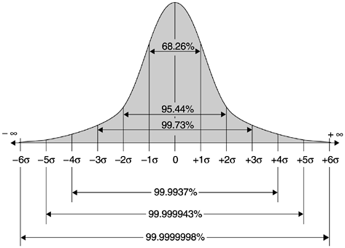
Figure 1. Normal Distribution Curve

The base of SPC is the central limit theorem [14]. In addition, a control chart is one of the key techniques of SPC, and this chart contains a center line (CL) and lower and upper control limits (LCL and UCL in formula 1 and 2).

UCL=μ+3σ (Formula 1)
LCL= μ-3σ (Formula 2)

where μ is population mean, and σ is population standard deviation.
A control chart is a graph or chart with limit lines, or control lines. There are basically three kinds of control lines: UCL, CL, and LCL (see Fig. 2).
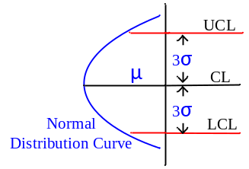
Figure 2. Quality Control Chart of SPC

  - Deep Learning

Deep learning is a computational model made up of multiple hidden layers of analysis used to understand representations of data so that analysts are able to better understand complex data problems (see Fig. 3). Deep learning network includes Convolutional neural networks and Backpropagation networks.
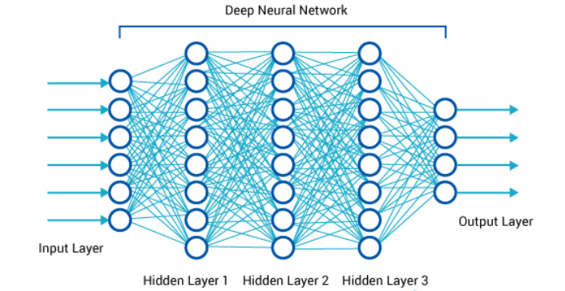
Figure 3. Deep Learning Network

In this paper, we develop algorithms based on KNIME and WEKA [16-20] because these applications are visually interactive tools, and the software supports JAVA programs.

- Overview Architecture

In this paper, we utilized a data quality architecture (see Fig. 6) with three parts: data preparation, machine learning, and data visualization. Data preparation focuses on identifying basic problems and cleaning the data; Machine learning contains neutral network and statistical quality control model for discovering complex outlier data; Data visualization then displays risk data, error data, and correct data.
The architecture also shows the process of data manipulation. At the data preparation stage, the data profiling program reads the data file (CSV file type); particularly for the purpose of transforming string type and date type data values into numeric values; data quality problems should be discovered at this stage as well, such as incorrect sex code or date. At the deep learning network stage, the data is then split into training data and testing data for use by the neural network algorithms. Our deep learning network will offer predictive salaries at this point as well. At the statistical quality control module stage, the program calculates the errors between predictive salary (P) and real salary (T). If the difference rate is out of UCL or LCL, this data will be marked as outlier data. Finally, at the data visualization stage, the program will produce reports through visualization models, which is not the focus of this work and is omitted from this paper.

- Data Source

For our data source, we accessed the state of Arkansas’ open data library and selected their public information sheets containing employee salaries. We downloaded it as a csv-format file from the website (transparency.arkansas.gov). The dataset is free use and open data and contains fiscal year, agency, pay class category, pay scale type, position number, position title, employee name, percent of time, annual salary, etc.
In this paper, we assume that most of officers’ salaries are accurate and correct because this data comes from Arkansas state human resource department. However, we also believe that this data may contain some errors.

- Data Preparation

The data preparation stage of our project contains Data Transform and Data Clean programs so that basic data quality problems can filtered as shown in Fig. 4. The Data Transform program is the process of transferring data from String, Boolean, and Character types into numeric types via a hash code function.
Data Transform program is completed by a program written in JAVA. There are three major benefits after transferring numeric data.
- Standardization data: The string value i long and takes up excess storage space, but an integer value is simple and short. For instance, a hash code of “DEPT OF PARKS AND TOURISM” is 1971843741, resulting in highly efficient compression.
- Identify problems: a tiny change of string leads to a big difference in hash code. For example, a hash code of “DEPT OF PARKS AND TOURISM” is 1971843741, but “DEPT OF PARK AND TOURISM” is 1553109818.
- Machine learning has been shown to run more efficiently with numeric values.

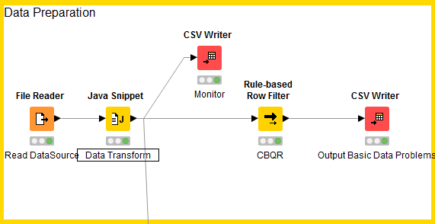
Figure 4 Data Preparation Program

  - Transferring String Type
If the data was null or empty, the data was marked with a special integrate value for future procedure function. The pseudo-code is here:

Read data
IF object is null THEN
iHashCode = -1;
ELSEIF object is empty THEN
iHashCode =0;
ELSE
iHashCode = hashcode(object)
EndIF

  - Transferring Date Type
Another kind of data being translated is date type, such as date of birth or career service dates. For example, the program transfers date of birth into days using the following pseudo-code:

Read data
iFlag = -1
IF date value is incorrect THEN
Mark error data, return error
ELSE
Calculate days, return iDays
ENDIF

  - Data Cleaning
Check Basic Quality Rule (CBQR) means that the program checked the element data quality problems via logical rules. For example, instances where the data is empty but it should not be an empty value. The pseudo-code is here:

Read data
iFlag = -1
IF iHashCode == -1 THEN
IF the data cannot be NULL value THEN
iFlag =0
END IF
ENDIF
IF iHashCode == 0 THEN
IF the data cannot be EMPTY value THEN
iFlag =0
END IF
ENDIF

IF iFlag=0 THEN
Push the data into element quality problem data
EndIF
Close Fetch

- Deep Learning
The Machine Learning program is able to learn patterns from data sets. The data was separated into two parts: training data and testing data. The Machine Learning program trains itself through training data, and it tests the accuracy of the Machine Learning algorithm via testing data. Weka has a test option for choosing different training data sets or test sets.
There are many algorithms for prediction. After comparing Back- propagation(BP) network, Convolutional Neural Network (CNN), Support Vector Machine (SVM), and Regression models, testing results show that BP network is the best choice.
As shown in Figure 5, there are six Layers BP networks, including 10 input nodes, four hidden layers (each hidden layer has 12, 18, 12, and 10 nodes, respectively), and one output node. Furthermore, input nodes contain agency hashcode, pay-class-category hashcode, pay-scale-type hashcode, etc. Output node is annual salary.

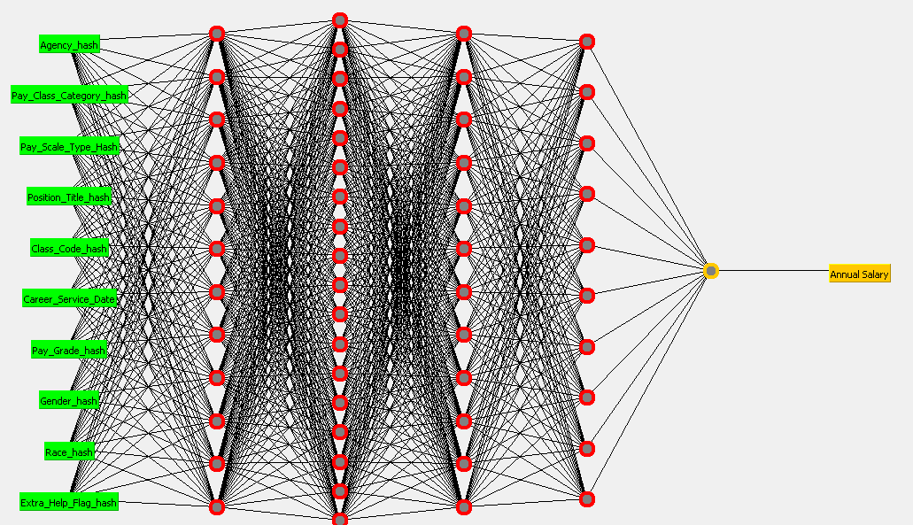
Figure 5. Backpropagation Network

After testing different hidden layers of BP algorithms, we compared test results, including correlation coefficient, mean absolute error, and root mean squared error as shown in Table 1.
According to the table, when hidden layers are 12, 18, 12, and 10, the correlation coefficient has the maximum value. Additionally, mean absolute error and root mean squared error are at their minimum values.
TABLE 1. Different hidden layers for BP
# | Hidden  Layers | Correlation Coefficient | Mean Absolute Error | Root Mean Squared Error
1 | 12,18,12 | 0.7756 | 8381.9728 | 12342.309
2 | 12,18,12,10 | 0.7846 | 8149.966 | 12133.4712
3 | 12,18,12,10,10 | 0.0225 | 12602.9016 | 19612.9531
4 | 12,18,12,10,8 | 0 | 12602.9034 | 19612.9514
5 | 12,18,24,10 | 0.7768 | 8701.5927 | 12315.6109
6 | 12,18,24 | 0.7712 | 8445.6757 | 12405.1537
7 | 12,36,24 | 0.75 | 8605.0589 | 13045.9201
8 | 12,36,24,10 | 0.7707 | 8424.1713 | 12472.9748
9 | 24,18,12,10 | 0.7765 | 8362.1652 | 12303.3004
10 | 12,18,10,10 | 0.7801 | 8300.8978 | 12352.81
11 | 12,18,16,10 | 0.7774 | 8543.8297 | 12277.3229
12 | 10,18,12,10 | 0.7787 | 8437.5677 | 12289.3999

- Statistical Quality Control Model
Outlier detection is based on a statistical quality control model. Our deep learning model outputs a predicated value when it reads input data. However, the predicated value usually is not equal to actual value because of error.
The error for the dataset equates to the difference between predicted salary and actual salary (Formula 3), and the difference ratio is error divided by actual salary (Formula 4).

Moreover, quality control charts need to take into account mean and standard deviation. However, we can incorporate the population mean and standard deviation of the population through the central limit theorem. This theorem has four important properties [15]:
- The mean of the sample () means will be the same as the population mean (μ).
- The standard deviation of the sample () means will be less than the standard deviation of the population (σ), and it will equal to the population standard deviation divided by the square root of the sample size.
- If the original variable is normally distributed, the distribution of the sample means will be normally distributed, for any sample size n.
- If the distribution of the original variable might not be normal, a sample size of 30 or more is needed to use a normal distribution to approximate the distribution of the sample means. The larger the sample, the better the approximation will be.
Before calculating our quality control chart, we randomly selected 100 rows to calculate the standard deviation of the sample () and mean of the sample () for use in the Difference-Ratio column as partial sample data. (Show in Table 2).
Table 2. Part of Sample Data
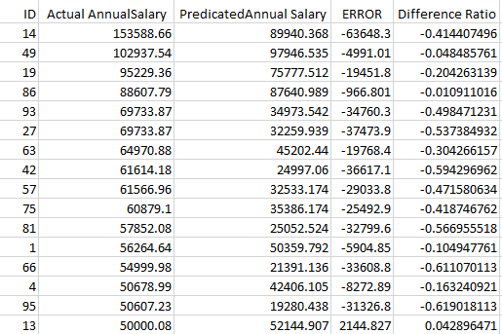

After choosing 100 samples, we produced the following:
According to formulas 5, 6, and 7, the population mean (μ) and standard deviation of the population (σ) are:

According to formula 8, the upper and lower control limits (UCL and LCL) are:

UCL=μ+3σ = -0.23 + 3×2.2= 5.37
LCL=μ-3σ = -0.23 - 3×2.2 = -6.83
If difference ratio is out of UCL or LCL, this data is out of three sigma (3σ), and will be marked as outlier data, or risk data. In Table 3, some data is marked as outlier data because the difference ratio is more than 25. For example, salaries for some full-time employees for the Arkansas state government were only 21 cents per year.

- Conclusion
We have built a unique framework for outlier detection in data profiling, including data preparation, machine learning, and statistical quality control models. After cleaning data in data preparation, machine learning model outputs have been able to predict salaries. Then, outlier data was detected by our statistical quality control model.

Table 3. Outlier Data of Annual Salary
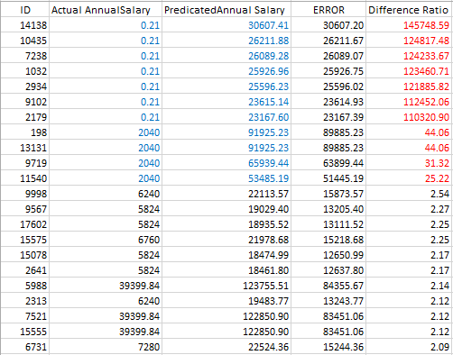

Our work integrates deep learning networks and statistical quality control models for improving data quality. This idea has a great potential to reduce workload and improve performance as system developers and business users do not need to create excessive data rules to identify data quality problems, as deep learning algorithms automatically learn data patterns through training datasets.

- Future Work

Data profiling of information quality is very important for the advancement of Big Data. Deep learning is a very promising approach for potentially solving many Big Data challenges. We will continue to explore other neural network models with various datasets, and k-folds validation. We will also conduct these experiments on GPU-based server to expedite the deep learning performance and to seek effective data visualization solutions.

- References

- Strong, Diane M., Yang W. Lee, and Richard Y. Wang. "Data quality in context." Communications of the ACM 40, no. 5 (1997): 103-110.

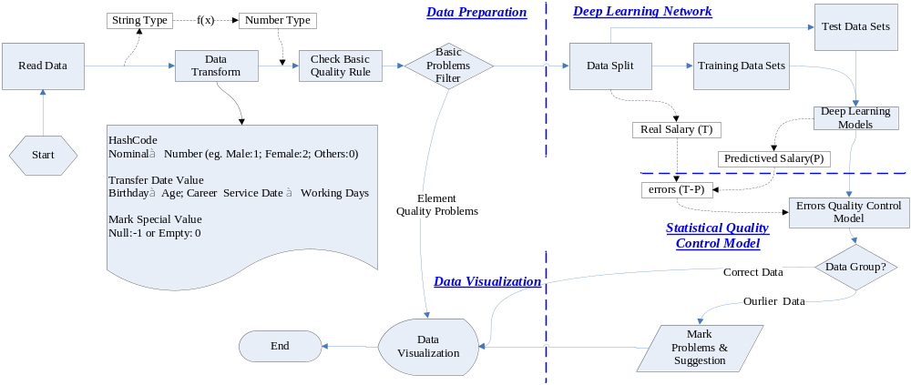

Figure 6 Logical Architecture

- Michalski, Ryszard S., Jaime G. Carbonell, and Tom M. Mitchell, eds. Machine learning: An artificial intelligence approach. Springer Science & Business Media, 2013.
- Alpaydin, Ethem. Introduction to machine learning. MIT press, 2014.
- Murphy, Kevin P. Machine learning: a probabilistic perspective. MIT press, 2012.
- Natarajan, Balas K. Machine learning: a theoretical approach. Morgan Kaufmann, 2014.
- Schmidhuber, Jürgen. "Deep learning in neural networks: An overview." Neural Networks 61 (2015): 85-117.
- LeCun, Yann, Yoshua Bengio, and Geoffrey Hinton. "Deep learning." Nature 521, no. 7553 (2015): 436-444.
- Deng, Li, Geoffrey Hinton, and Brian Kingsbury. "New types of deep neural network learning for speech recognition and related applications: An overview." In Acoustics, Speech and Signal Processing (ICASSP), 2013 IEEE International Conference on, pp. 8599-8603. IEEE, 2013.
- Hawkins, Simon, Hongxing He, Graham Williams, and Rohan Baxter. "Outlier detection using replicator neural networks." In Data warehousing and knowledge discovery, pp. 170-180. Springer Berlin Heidelberg, 2002.
- Aggarwal, Charu C. "Outlier analysis." In Data Mining, pp. 237-263. Springer International Publishing, 2015.
- Montgomery, Douglas C. Statistical quality control. Vol. 7. New York: Wiley, 2009.
- Leavenworth, Richard S., and Eugene Lodewick Grant. Statistical quality control. Tata McGraw-Hill Education, 2000.
- DeVor, Richard E., Tsong-how Chang, and John William Sutherland. Statistical quality design and control: contemporary concepts and methods. Prentice Hall, 2007.
- Bluman, Allan G. Elementary statistics: A step by step approach, A brief version. No. 519.5 B585E. New York: McGraw Hill, 2008: 331Sessions, Valerie, and Marco Valtorta. "The Effects of Data Quality on Machine Learning Algorithms." ICIQ 6 (2006): 485-498.
- Berthold, Michael R., Nicolas Cebron, Fabian Dill, Thomas R. Gabriel, Tobias Kötter, Thorsten Meinl, Peter Ohl, Christoph Sieb, Kilian Thiel, and Bernd Wiswedel. KNIME: The Konstanz information miner. Springer Berlin Heidelberg, 2008.
- O'hagan, Steve, and Douglas B. Kell. "Software review: the KNIME workflow environment and its applications in genetic programming and machine learning." Genetic Programming and Evolvable Machines 16, no. 3 (2015): 387-391.
- Hall, Mark, Eibe Frank, Geoffrey Holmes, Bernhard Pfahringer, Peter Reutemann, and Ian H. Witten. "The WEKA data mining software: an update." ACM SIGKDD explorations newsletter 11, no. 1 (2009): 10-18.
- Hall, Mark, Eibe Frank, Geoffrey Holmes, Bernhard Pfahringer, Peter Reutemann, and Ian H. Witten. "Weka 3: Data mining and open source machine learning software in java." (2013).
- Fournier-Viger, Philippe, Antonio Gomariz, Ted Gueniche, Azadeh Soltani, Cheng-Wei Wu, and Vincent S. Tseng. "SPMF: a java open-source pattern mining library." The Journal of Machine Learning Research 15, no. 1 (2014): 3389-3393.

