A
MINI PROJECT REPORT

on

SOUND SEGMENTATION

Submitted in partial fulfilment for the completion of BE-III Semester
in
INFORMATION TECHNOLOGY
By
MURARI (160118737116)
PRASHANTH(160118737105)

Under the guidance of

Mr.RajeshKannan,
Asst.ProfessorDept. of IT, CBIT.


DEPARTMENT OF INFORMATION TECHNOLOGY CHAITANYA BHARATHI INSTITUTE OF TECHNOLOGY (A)
(Affiliated to Osmania University; Accredited by NBA(AICTE) and NAAC(UGC), ISO Certified 9001:2015)
GANDIPET, HYDERABAD – 500 075
Website: www.cbit.ac.in

2019-2020

CHAITANYA BHARATHI INSTITUTE OF TECHNOLOGY (A)
DEPARTMENT OF INFORMATION TECHNOLOGY

CERTIFICATE

This is to certify that the project work entitled “Sound Segmentation” submitted to CHAITANYA BHARATHIINSTITUTE OF TECHNOLOGY, in partial fulfilment of the requirements for the award of the completion of3rd semester of B.E in Information Technology, during the academic year 2019-2020, is a record of original work done by Murari (160118737116), Prashanth (160118737105) during the period of study in Department of IT, CBIT, HYDERABAD, under our supervision and guidance.

Project Guide Head of the Department
Mr.Rajesh Kannan, Dr.SureshPabboju,
Asst. Professor, Dept.ofIT,CBIT, Professor, Dept. of IT, CBIT,Hyderabad. Hyderabad.

ACKNOWLEDGEMENT

We would like to express our heartfelt gratitude to Mr.RajeshKhannan, our project guide, for his invaluable guidance and constant support, along with her capable instruction and persistent encouragement.

We are grateful to our Head of Department, Dr.SureshPabboju, for his steady support and for the provision of every resource required for the completion of this project.

We would like to take this opportunity to thank our Principal, Dr.P.Ravinder Reddy, as well as the management of the institute, for having designed an excellent learning atmosphere.

Our thanks are due to all member of the staff and our lab assistants for providing me with the help required to carry out the groundwork of this project.

We are also thankful to Ms.T.Prathima, one of our faculty who gave us the inspiration to choose this topic and also for her invaluable guidance and support, along with her constant encouragement.

ABSTRACT
The analysis of audio signals of popular and rock songs of the verse chorus form to reconstruct its original musical structures is investigated in this work. We first compute the similarity degree between any two measures in a song based on selected features and represent these numbers in a measure-based similarity matrix. Then, we study the similarity across a sequence of consecutive measures, which is revealed by straight segments in parallel with the diagonal line of the similarity matrix. Generally, chorus parts have higher similarity values while verse parts have lower similarity values. As a result, the verse parts are difficult to detect in the presence of the chorus parts. To tackle this problem systematically, the Viterbi Algorithm is adopted to find optimal paths in the lower-triangular similarity matrix, which represent repetitive segments of both choruses and verses. Finally, several post-processing steps are developed to decode the music structure into the verse, the chorus and other non-repetitive parts. Experimental results obtained from several musical audio data are shown to demonstrate the performance of the proposed method.
The signal structure, in this context, refers to a parametric model describing the signal evolution; this can be a tonal model, for instance, where one is interested in detecting changes on the fundamental frequency or other features of the spectrum.
The goals of the system are:
- To provide anytime any place service for the customer
- To represent every segment of sound wave so that every user will easily understand the calculated data.

CONTENTS

Chapter | Chapter Description |  | Page
 | Certificate |  | ii
 | Acknowledgement |  | iii
 | List Of Figures |  | vi
 | List Of Tables |  | vii
1 | Introduction |  | 1
 | 1.1  1.2  1.3 | Motivation  Objectives of the project  Model and Algorithm | 2  3
2 | Existing System |  | 4
 | 2.1 | An automatic segmentation method for heart sounds | 4
3 | Proposed System |  | 5
 | 3.1  3.2  3.3  3.4 | Problem Statement  Methodology  Analysis-Plots  Flow Chart | 5  5  7  8
4 | Software And Hardware Requirements |  | 9
5 | Result And Screenshots |  | 10
6 | Conclusion |  | 13
7 | Future Scope |  | 14
8 | Bibliography |  | 15

List of Figures
Figure number | Figure Description | Page
2.1 | Information about automatic segmentation method for heart sounds. | 4
3.1 | Use of sound segmentation related software by different companies and organisations. | 5
3.2 | Flow chart of the project is shown below | 5
5.1 | Testing the sequential algorithm with stimulated data | 8
5.2 | Fig :Computing time for various time resolutions | 8
5.3 | Fig:Testing alpha and beta with many segments | 9
5.4 | Characteristics of all segments for sound wave | 9

List Of Tables

Table Number | Table Description | Page
2.1 | Information about sound segmentation | 3
4.1 | Software and hardware requirements | 7

Introduction
Automatic audio segmentation aims to divide a digital audio signal into segments, each of which contains audio information from a specific acoustic type, such as speech, music, non-verbal human activity sounds, animal vocalizations, environmental sounds, noises, etc. The degree of detail in audio class analysis depends on the application. For example in radio broadcast signals segmentation the interest falls in the detection of the audio parts that contain speech, music, silence and noises. In information processing frameworks dealing with audio data the role of the automatic segmentation subsystem is to divide the audio signal to the acoustic categories of interest in order to be further processed by the corresponding systems. Such post-processing systems can be speech recognizers, speaker recognizers, language recognizers, singer recognizers, song recognizers, sound event recognizers etc. The overall concept of such a framework and the role of audio segmentation within it are illustrated in Fig. 1. As can be seen, the initial audio stream is driven into an audio segmentation architecture, which is an open type of architecture in terms of its type .
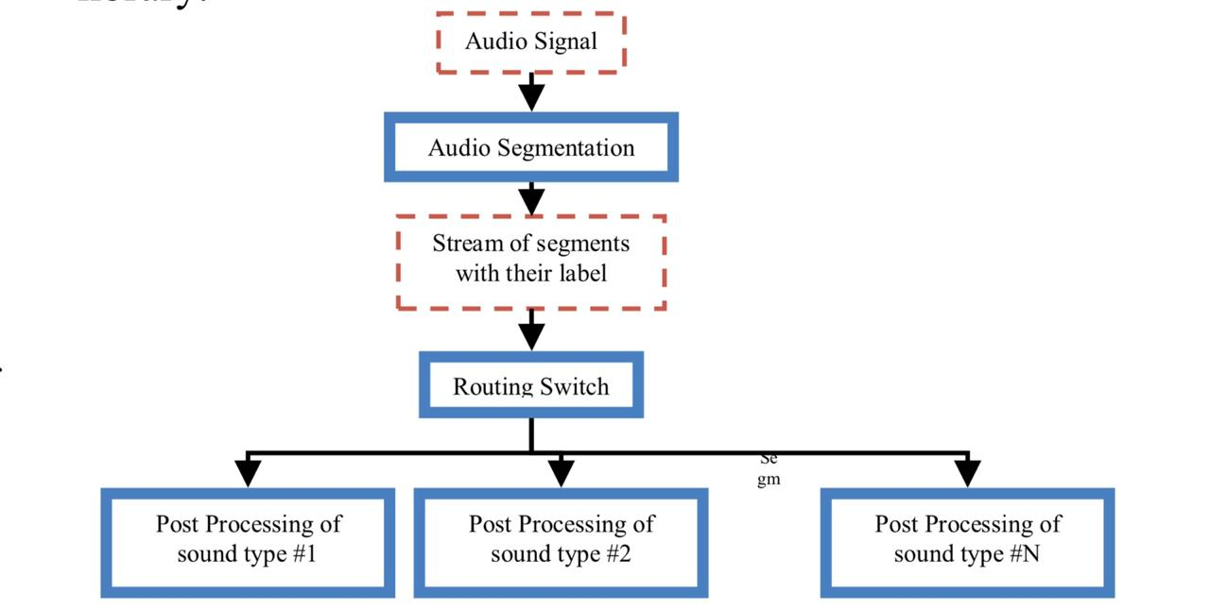 That holds an adjunct data series of segment level labels, is forward into a routing switch in which each audio type is driven into a suitable type of post-processing. For instance, in broadcast transmissions, speech parts can be driven into automatic speech recognizer for linguistic or speaker role processing while music parts can be driven into a sound effect collection library.

1.1 Motivation
Our main goal when developing this algorithm was to analyse signals coming from the OceanPod. The prime motivation for installing the hydrophone in this location was to study the patterns of behavior of ﬁshing vessels that navigate through the park. Since ﬁshing in the park is prohibited, understanding of these patterns can be a valuable asset in the design of ﬁscalization policies.
As a secondary objective, the data coming from the hydrophone also allows the study of other noise irradiating events, either caused by man or nature. Obtaining samples of different kinds of acoustic events from a region with high diversity of marine life can be potentially very useful for the investigation of animal behaviour off the Brazilian coast, in the least by providing annotated samples to be fed to classiﬁcation algorithms that can later be developed to search for speciﬁc events.
Automatic music structure analysis from audio signals is an interesting topic that receives a lot of attention these days. The technique can be used for music data analysis, indexing, retrieval and management. The music structure of many songs, including modern popular and rock songs, is of the verse-chorus form. Under this form, chorus and verse parts are two different repetitive patterns. The chorus parts contain the same melody, chords and lyrics while the verse parts have the same melody and chord but different lyrics. Usually, the verse parts are for the story-telling purpose, and the chorus parts are for people to sing along. The analysis of audio signals of songs of the verse-chorus form to reconstruct its original musical structure is the main objective of this research. Both verses and choruses appear as repetitive parts in a song. Accurate detection of both verse and chorus parts is a key component to the success of automatic music structure analysis. Foote used the similarity matrix of a music piece along with its novelty measure for audio summarization and segmentation.
The OceanPod installed at a depth of 20 m , and delivers 15 minutes long audio files sampled at 11,250 Hz, With this data, we are interested in indicating times and duration of boats passing by boats passing by, but also in detecting other possibly by, but also in detecting other possibly interesting events.

1.2 Objective of theProject
The general architecture of the automatic audio segmentation scheme consists of four basic steps :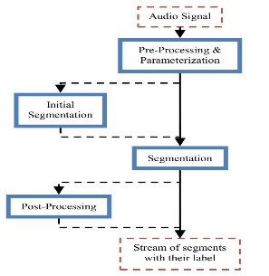
1.3 Model and algorithm
To deﬁne the sequential segmentation algorithm (SeqSeg), we start by assuming that the (discretely sampled) signal y∈ℜ^{N} has 0 mean amplitude, and ﬁnite power σ²₀. We can adopt -a Gaussian probabilistic model for the signal, y_{t} ~ N (0 , σ²₀ ) .
Now suppose that from sample t = t` on, the signal’s power shifts from σ²₀ to σ²₁ =δ· σ²₀, with δ > 0. This leads to the following probabilistic model:
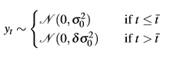
The likelihood function associated with this model is thus :
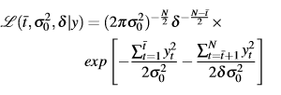
2. Existing System

2.1 An automatic segmentation method for heart sounds
This software is widely used by many hospitals. There are two major challenges in automated heart sound analysis: segmentation and classification. An efficient segmentation is capable of providing valuable diagnostic information of patients. In addition, it is crucial for some feature-extraction based classification methods. Therefore, the segmentation of heart sound is of significant value.
Table 2.1: Information about automatic segmentation method for heart sounds.
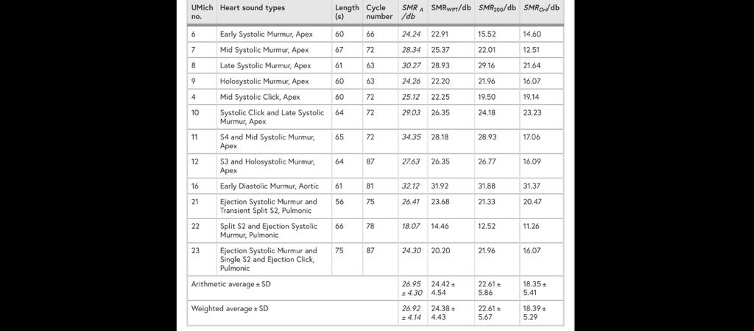

3. Proposed System

3.1 Problem statement
Audio segmentation aims to find changing points in the audio content of an audio stream. Initially, we present the basic steps in an automatic audio segmentation procedure. Afterwards, the basic categories of segmentation algorithms, and more specific the unsupervised, the data-driven and the mixed algorithms, are presented. So we would like to use this not only to calculate heart beat rates but also for other sounds like ocean waves etc.

3.2 Methodology
The following methodology applied for the developing the programme for the automatic audio segmentation scheme
- Programming language Python is used.
- The Bayesian information criterion, Likelihood Function are used to get the average range and to identify the heterogeneous segments, divide them and calculate the segment characteristics of that specific identified spot.
- The average ranges are calculated using the average powers.
- Each wave is checked if it has a heterogenous point. If a point is found then the segment is subdivided into 2 other segments and again repeats the same process until the segments are simplified with no further heterogeneous points in it.
- The process of checking heterogeneous points is done by comparing the average power of each segment with initial average power of whole equation.
- To implement the SeqSeg algorithm we choose the python language, for a few reasons. First, because python is now widely used in the scientiﬁc community (specially after the release of NumPy and SciPy), and is thus a convenient programming language to use for open source scientiﬁc software.
- Second, because it is a simple to read language, that will make it easier for users to understand and modify the code.
- And third, because of the Cython package.
- Cython supports the OpenMP (http://www.openmp.org) library for multiprocessing programming, with allows the programmer to boost even further the numerical performance of parallelizable methods.
- Besides using Cython and parallelizing our algorithm, we also chose to adopt the GSL library (http: //www.gnu.org/software/gsl) for random number generation, and the standard C implementations of math.h for the mathematical functions (such as the gamma and log-gamma functions).
- All of these components together allowed us to improve our average computing time from 120s to less than 1 second.
- Algorithm is as follows :

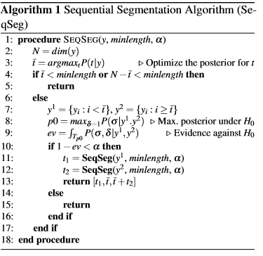

3.3 Analysis-plots:

Fig 3.1: Use of sound segmentation related software by different companies and organisations.

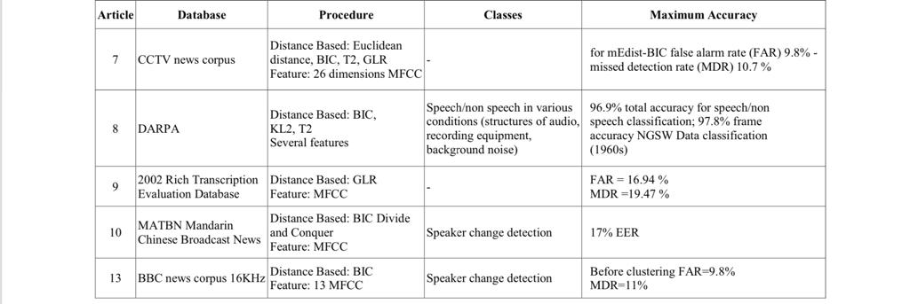
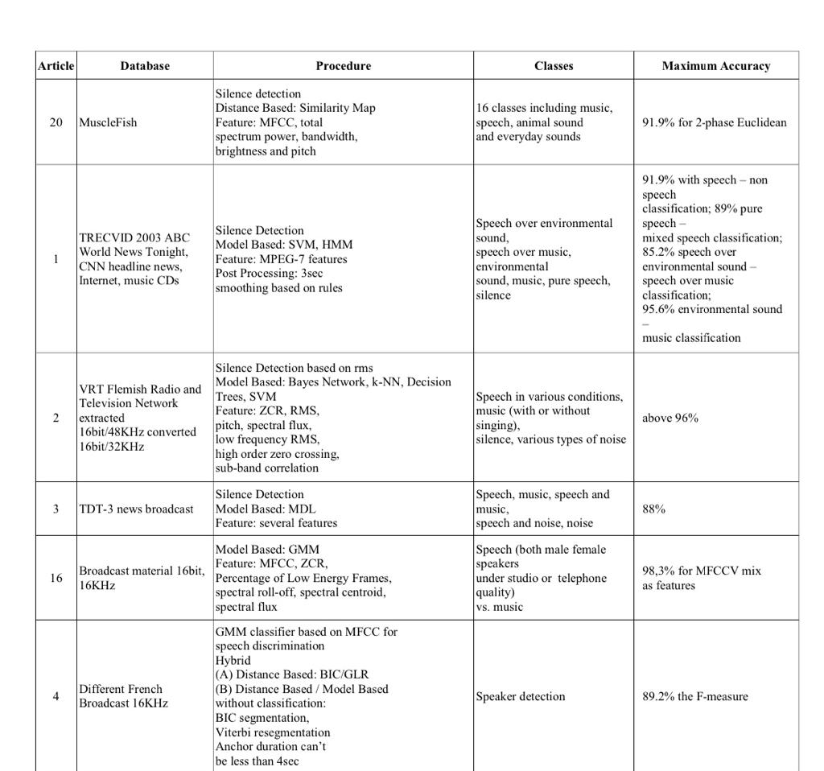
Fig 3.5: Flow chart of the project is shown below

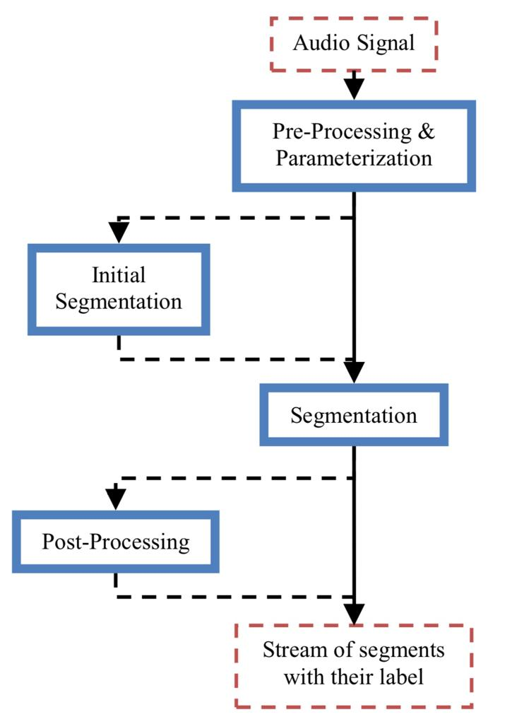

4. Software and Hardware Requirements

A software requirements specification (SRS) is a description of a software system to be developed. Used appropriately, software requirements specifications can help prevent software project failure. The software requirements specification document lists sufficient and necessary requirements for the project development.

Computer hardware is a collective term used to describe any of the physical components of an analog or digital computer .the term hardware distinguishes the tangible aspects of a computing device from software, which consists of written instructions that tell physical components what to do.

Table 4.1: software and hardware requirements

S.No | Description | Requirement
 | Operating system | Ubuntu
 | Programming language | Python
 | Software | Anaconda
 | Processor | Intel Core™ i7-8700 CPU @3.20GHz
 | Ram | 2 GB or more
 | Disc space | 20 GB or more

5. Results and Screenshots

Once programme is executed, thee User is presented with the a block of code as shown page as shown in the Fig5.1 .
As step 1: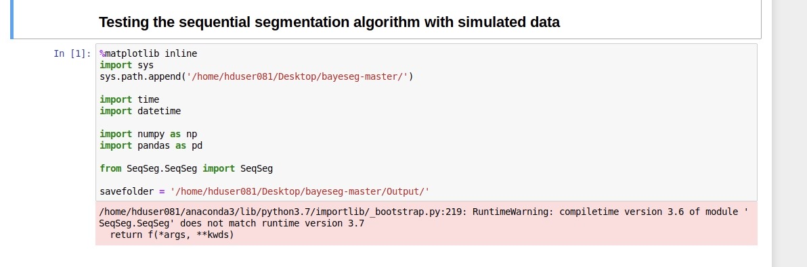Fig5.1:Testing the sequential algorithm with stimulated data
Step 2:This is how the segments are divided.
Fig 5.2:Computing time for various time resolutions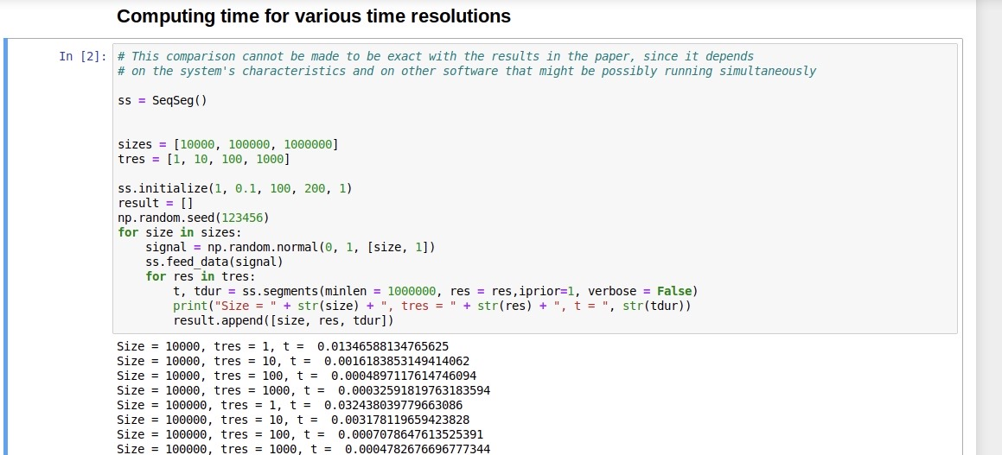
Step 3: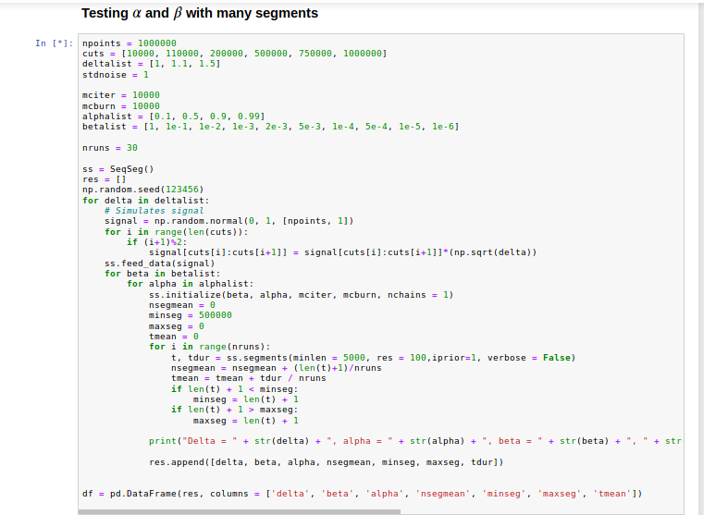
Fig5.3:Testing alpha and beta with many segments

When we run this block of code then we get :
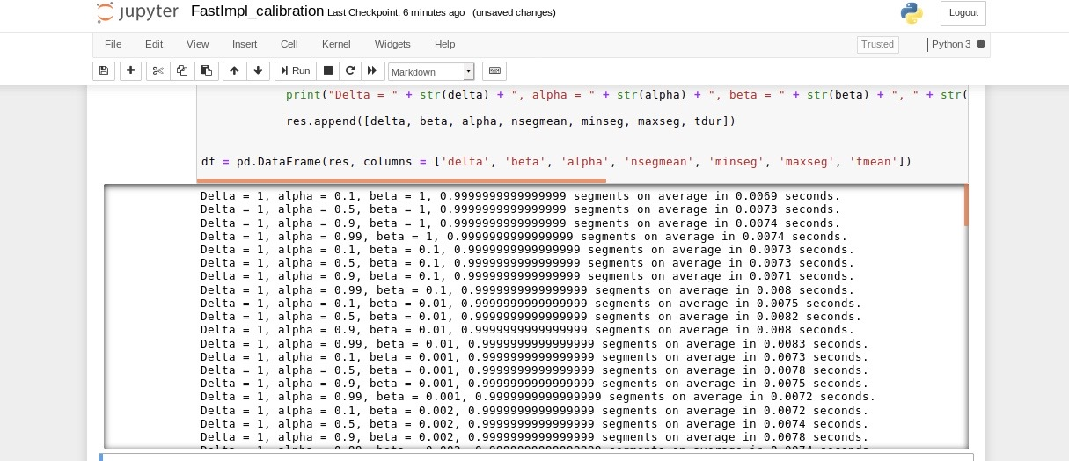

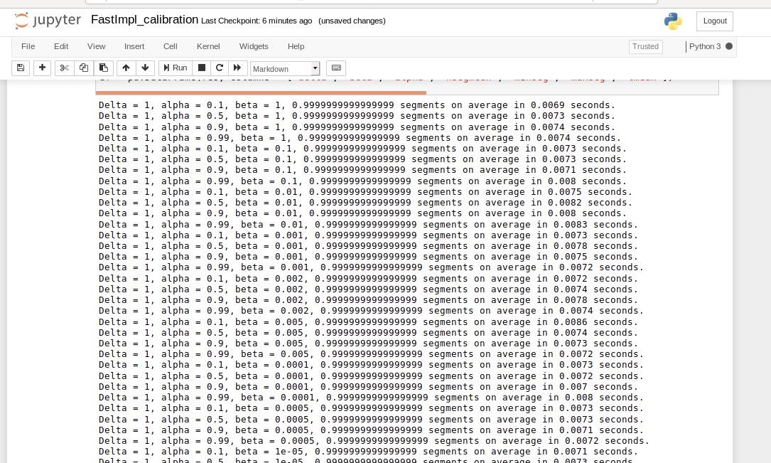

Fig 5.4: Characteristics of all segments for sound wave

6. Conclusion
The sequential segmentation algorithm is a Bayesian unsupervised methodology aimed at segmenting audio signals. It is based on the basic assumption that the occurrence of events in an audio signal induces a change in the signal’s total power. In this paper we presented a Python module that implements the sequential segmentation algorithm using Cython. The computing time is about 120s.
We have also provided details on the MCMC step involved in the calculation of evidence values for the hypothesis of equality of variances, which is part of the algorithm’s stopping criteria, and ﬁnally we analysed the algorithm’s sensibility to its parameters using both simulated and real signals. What we found is that the algorithm is robust to the acceptance threshold,α in most situations; we recommend settingα = 0.1 as a default value. Once ﬁxed the value ofα, there remains only the need for calibrating for β.
The calibration procedure for this parameter, however, depends on the characteristics of the data and the goals of the analysis.A framework of automatic music structure analysis from audio signals was proposed in this work. The similarity matrix that records the similarity degree between measures was introduced.
Then, the Viterbi algorithm was used to detect long similarity segments along the sub-diagonals of the matrix. Several post-processing techniques were proposed to fine-tune the decomposition procedure so that we are able to decompose a song into repetitive parts (i.e., verses and choruses) and non-repetitive parts (i.e., intro, bridge and outro). Performance of the proposed scheme was demonstrated.

Future Scope

- The system generates various types of information that can be used for various purposes.

- Makes people aware of technology

- Let developers use this technique for many other sound wave related data

- It is not complicated so any one can use this sound segmentation software

- To utilize resources in efficient manner by increasing the productivity through automation

- Event detection on subaquatic signals.

Bibliography
- Paulo haubert article based on audio segmentation (https://github.com/paulohubert/bayeseg)
- Geeksforgeeks

