INTERNSHIP

EXCHAUSTIVE ANALYSIS OF INDIAN AGRICULTURE USING POWER BI (WEEK 1)

* TASK 1

1.STEPS TO DOWNLOAD POWER BI ON WINDOWS:

* **Visit Microsoft’s Official Download Page**: Go to Power BI Desktop page.
* **Download Button**: Click on the **Download** button.
* **Choose the Correct Version**: Select the version that matches your system's architecture (32-bit or 64-bit).
* **Download the File**: Click on **Next** to start the download.
* **Install Power BI Desktop**: After downloading, open the file and follow the installation steps.

2. **Business Intelligence (BI)** is a technology-driven process that involves the collection, integration, analysis, and presentation of business information.

**Power BI** is a powerful business analytics tool developed by Microsoft.

It involves 3 phases of transforming data simply ETL:

1.Extract : Pull data from sources like excel,csv,text,database,etc.

2.Transform: cleaning and processing of data.

3.Load: Used for analysis of data

Step 1: Extracting the data from file “Exhaustive Analysis of Indian Agriculture.csv.csv”

Step 2:Load data (Usually data to be loaded if is cleaned)

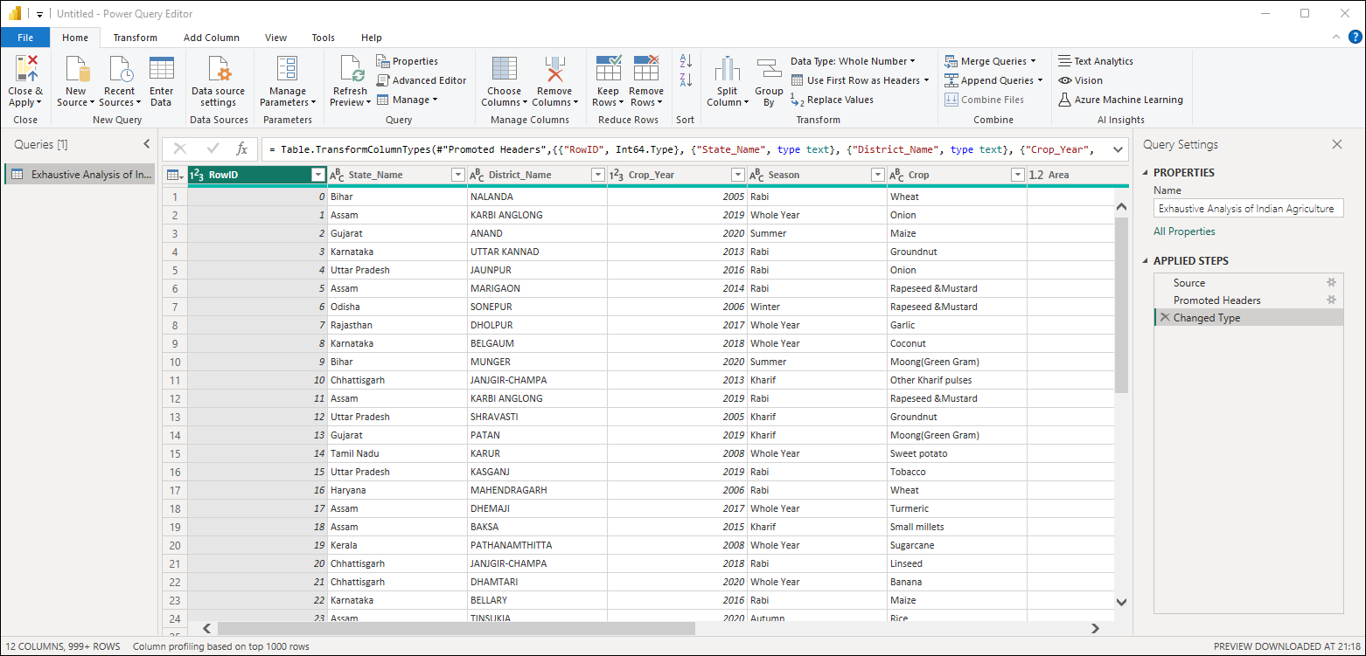

Step 3:Transforming of data

.Click on Tranform Data

* Remove a column :

. select the column to be deleted (RowId)

.click on remove rows on top

(column with RowId is removed)

OR

Right click on selected row and click remove row

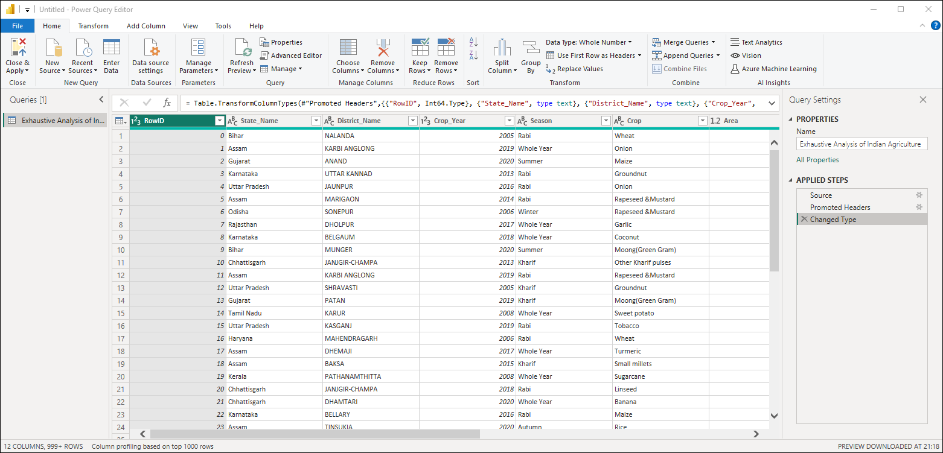

* View the Quality of data:

Click on view on top

Select column quality check box to view the Valid,error,empty data

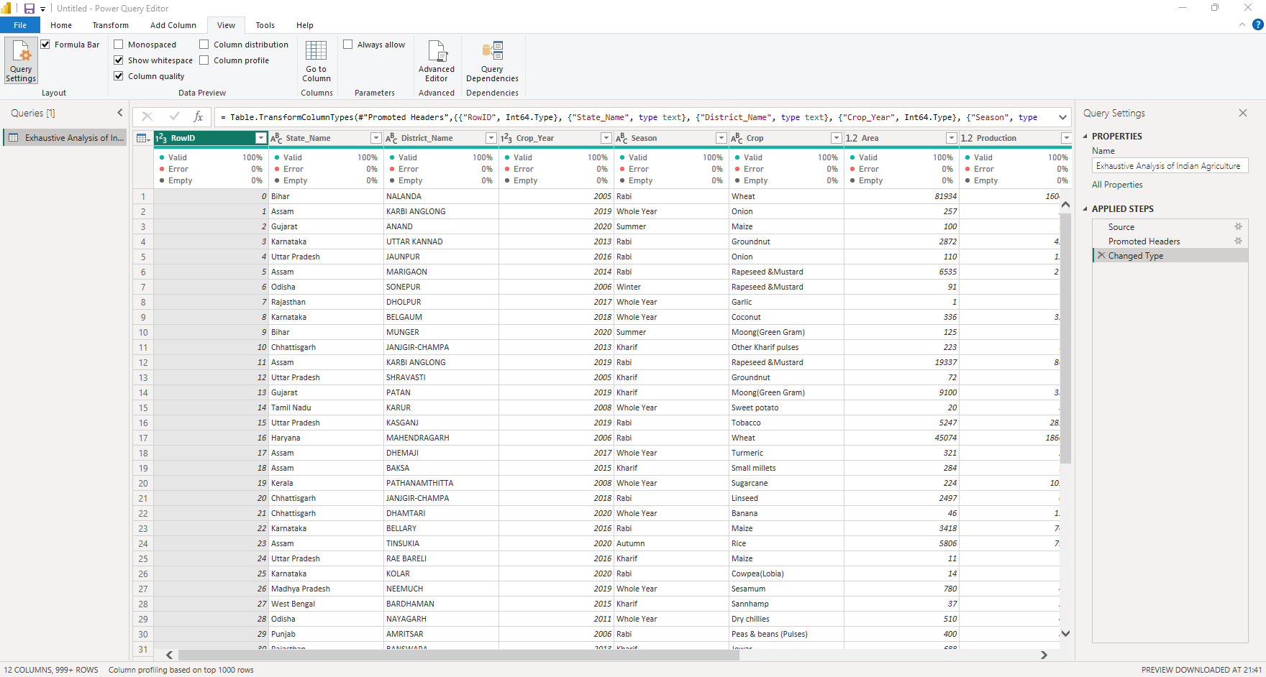

* Removing duplicates:

Click on Remove rows on top

Select remove dupicates to remove the duplicate rows

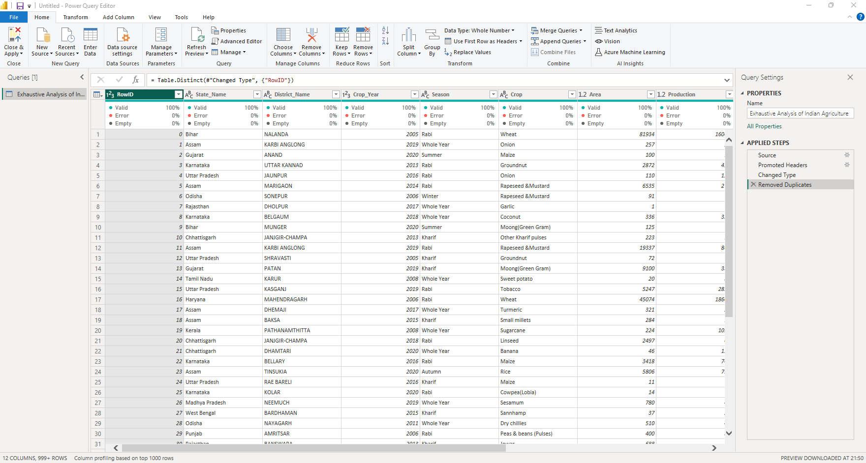

* Datatypes:

Click on column heading prefix to view datatypes

And if needed can change them

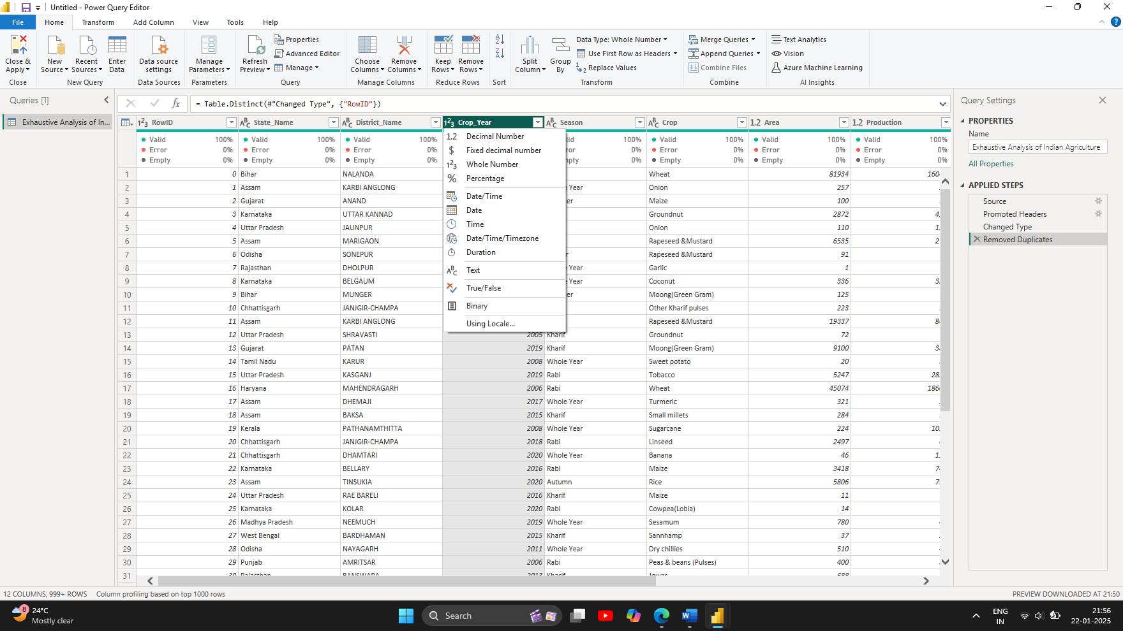

* Saving of data changes :

Select on close and apply on top left to reflect the changes in power bi

* Data Viewing :

3 types:

1.Report View : for Visualization

2.Table View : data representation in table format

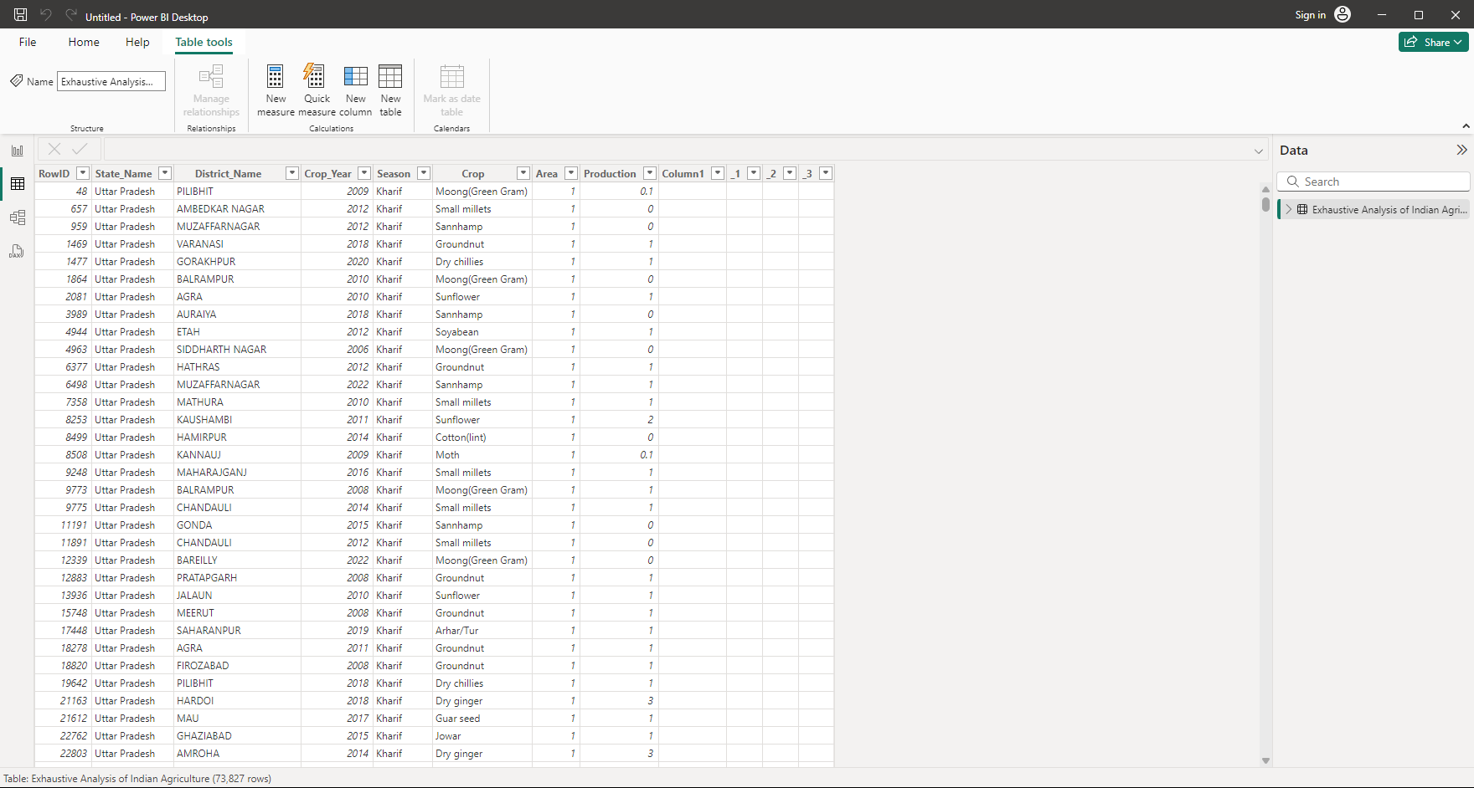

3. Model View:

Relationship viewing and managing between different databases