ASE Lab 7

Register Page:

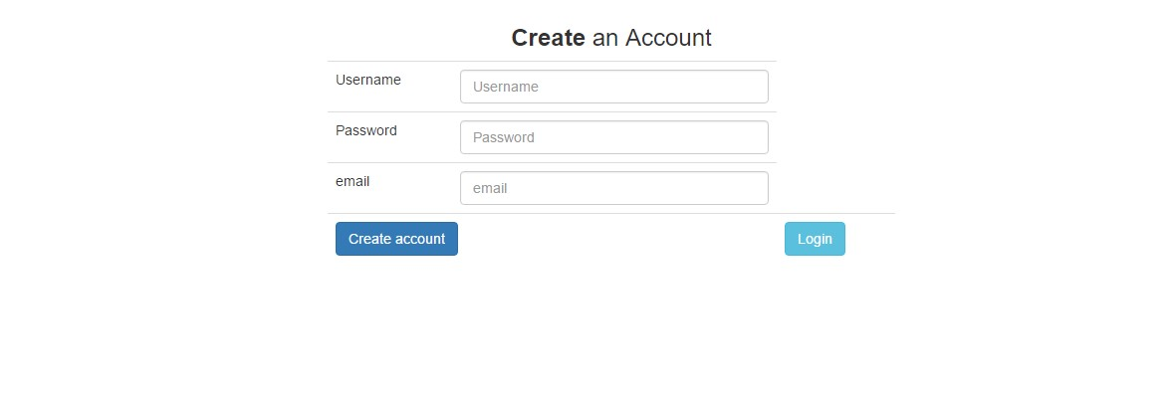

Here I had used 2 buttons. One for creating account and one for going to login page. If the user doesn’t have account he should click create account button. By clicking login button he will be redirected to login page.

Login Page:

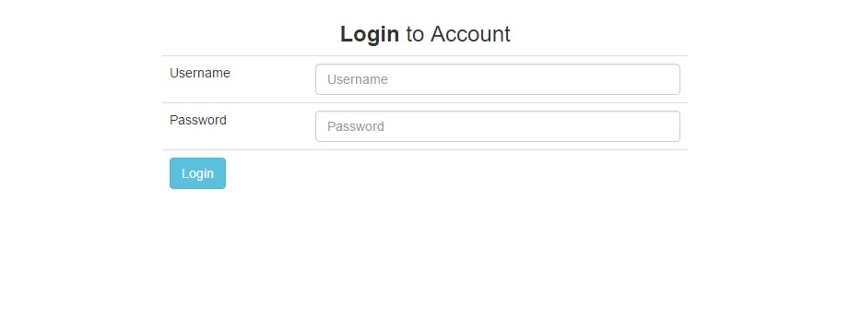

Here the user will enter username and password. If details are wrong, it will not be logged in. It will throw error on top of table.

Update:

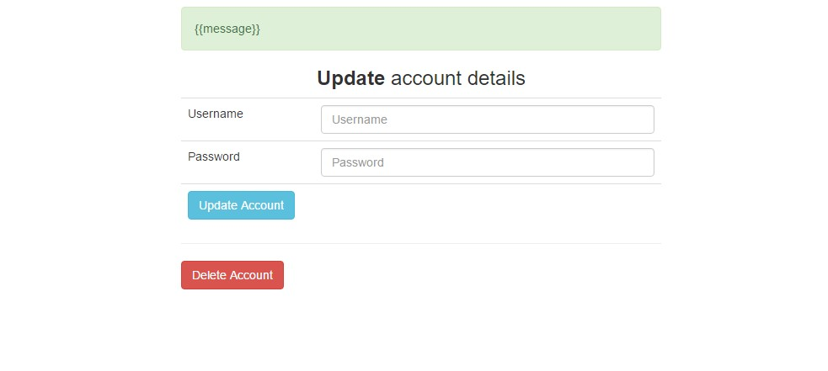

Here user can update password by typing username and password. If the username is wrong, error will be thrown.

User can redirect to delete account page by clicking delete account button.

**Delete Page:**



After clicking deleting button, in update page the account of the username mentioned in the update page will be deleted.