WordStatix - User manual
Version 1.5.0

Copyright © Massimo Nardello, Modena (Italy) 2016.
Permission is granted to copy, distribute and/or modify this document under the terms of the GNU Free Documentation License, Version 1.3 or any later version published by the Free Software Foundation; with no Invariant Sections, no Front-Cover Texts, and no Back-Cover Texts. A copy of the license is included in the section entitled "GNU Free Documentation License".

WordStatix is a free and multiplatform software useful to create concordances, that are lists of the words used within a document along with their recurrence and context. The document may be structured in chapters, numbers or in any another way. The software allows to track specific words by prefix or suffix, to skip those which are meaningless (like articles or prepositions) or numbers, to create a simple statistic of the recurrence of all words or of some of them, possibly within the different sections of the document, and to create three kind of diagrams to visualize the statistical data in different ways.

WordStatix is free software and is released under the GPL license version 3 or following. It has been created with Free Pascal and Lazarus (http://www.lazarus.freepascal.org).

The interface of WordStatix is divided in four sections, called “File”, “Concordance”, “Statistic” and “Diagram” which correspond to the main menu items with the same names. The sections can be selected with “Ctrl” + “1”, “Ctrl” + “2”, “Ctrl” + “3” and “Ctrl” + “4”. In the first section it’s possible to manage the document to be analyzed, in the second to create the concordance. in the third to create a statistic of the recurrence of some selected words, possibly in the various sections of the document, and in the fourth to create three kinds of diagrams to visualize the statistical data. Let’s take a look at each one of them.

File section
The File section, with some sample data, looks like this:

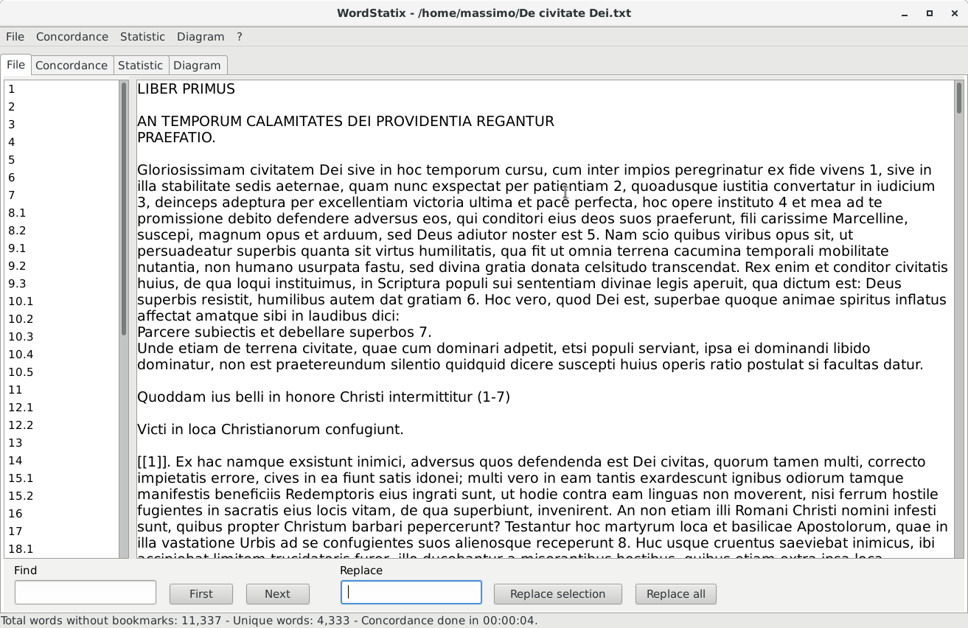
The bigger field on the right contains the document to be analyzed. This can be inserted in many ways:

- it can be open or imported with the menu item “File – Open” or with the shortcut “Ctrl” + “O”;
- it can be pasted after having copied from other sources, like a word processor, a browser or a pdf file, with “Ctrl” + “V” or with the popup menu “Paste” available with a right click of the mouse on this field;
- it can be typed directly by the user.

The file formats that WordStatix can actually open or import are the following:

- it can open directly text files, usually with “.txt” extension or with no extension at all, that can be created also with a word processor saving the document in text format;
- it can import Open Document (“.odt”) files, created with LibreOffice Writer or OpenOffice Writer; in this case the footnotes and the endnotes are shown within the text among single square brackets;
- it can import Word files (“.docx”, not “.doc”) files, created with Microsoft Word: in this case the footnotes and the endnotes are shown at the end of the text among single square brackets.

Note that if the user imports a file with “.odt” or “.docx” extension, the name of the file that can be saved within WordStatix will have the “.txt” extension, since the software cannot save in other formats.
The menu item “File – New” is useful to clear everything and start a new document and the related concordance. The menu item “File – Save” or the shortcut “Ctrl” + “S” is useful to save the current document in text format, necessary only to keep it but not to create the concordance. The menu item “File – Save as...” is useful to change the name of the file to be saved. The menu item “File – Exit” or the shortcut “Ctrl” + “Q” quits the software.
It’s also possible to clean a text pasted from another source if this contains unwanted carriage returns and double spaces. To use this feature, just separate each paragraph with an empty line and press “Ctrl” + “Shift” + “P”. Note that carriage returns, like punctuation marks, are not relevant for the concordance, so they can be added freely by the user.
The font size of the text may be enlarged and reduced with “Ctrl” + “Shift” + “+” and “Ctrl” + “Shift” + “-”, or using the mouse wheel while holding the “Ctrl” key.
The list on the left gathers all the bookmarks contained within the document. A bookmark is used to denote the beginning of a new section of the text, like a chapter, a number or the like. It has the following characteristics:

- it’s a single word, separated by the other words by spaces or punctuation marks, or placed at the beginning of a paragraph;
- it doesn’t contain commas, spaces or carriage returns inside it;
- it’s not an asterisk, since this is a special virtual bookmark used to identity the part of a text which precedes the first real bookmark;
- it’s contained between double square brackets without spaces inside (like “[[chapter1]]”);
- it’s unique in the text to be processed, so a bookmark can be used only once.

Anyway, the user doesn’t need to remember all these rules, since the software checks the bookmarks and possibly changes them, removing commas and changing spaces with “_” and asterisks with dots, to make them match these requirements. If a bookmark is used more than once, the user will be warned about it and the bookmark list will be cleared. It will be still possible to create a concordance, but the reference to the bookmarks might be incorrect. To fix this, find the repeated bookmark, possibly using the “Find” function described below, modify all its recurrences to make them unique and update the list of bookmarks with the menu item “File – Update bookmark list” or with the shortcut “Ctrl” + “U”. Likewise, if in the text there are double open square brackets (“[[”) not followed by double closed square brackets (“]]”) in the same paragraph and within 50 characters, the software will warn the user about that and will not create the bookmark list. It will be still possible to create a concordance, but the reference to the bookmarks might be incorrect. To fix the problem, just look in the text for isolated open double square brackets and remove them.
A bookmarks must be typed by the user within the document before the beginning of a new section, but possibly also in any other place if it’s necessary to create a structure of the document that is different from the original one. Obviously the bookmarks will not be considered words to include in the concordance by the software. It’s better to use bookmarks not longer than 10 or 15 characters, just to make them look clearly in the diagrams. Anyway, the maximum length of a bookmark is of 50 characters.
To insert an existing word as bookmark, select it and use the menu item “File – Set Bookmark” or the shortcut “Ctrl” + “R”. In this case the list of the bookmarks on the left will be updated automatically. On the contrary, when no word is selected, this menu item will simply insert the open and closed double square brackets (“[[]]”), and the user will have to type the bookmark inside them. In this case the bookmark list will not be updated automatically. This should be done manually with the menu item “File – Update bookmark list” or with the shortcut “Ctrl” + “U”. Anyway, the bookmark list will be update automatically also just before creating a concordance.
A click on a bookmark in the bookmark list selects the corresponding bookmark in the text. With this option it’s possible to check very easily that all the bookmarks are in the right place before creating the concordance.
At the bottom of the section there are fields and buttons to find a text within the document in use and to replace the text found with another text. To use this feature, fill the field “Find” with the text to look for, then click on the button “First” to select its first recurrence and on the button “Next” to select its next recurrences. Fill the field “Replace” with a text to replace the searched one, and then click on “Replace selection” to replace the word actually selected with the previous feature, or “Replace all” to replace all the recurrences of the searched text. In the first case, after having replaced the selection, the software will find the next word to be found and will selected it automatically. The search and the replacements are case sensitive, so the software will consider lowercase and uppercase characters as different. Note that the software will search and replace a text also if it’s within another word and not only if it match a whole word. So use the “Replace all” function with care, to avoid to replace unwanted part of the text.

Concordance section
The Concordance section, with some sample data, looks like this:

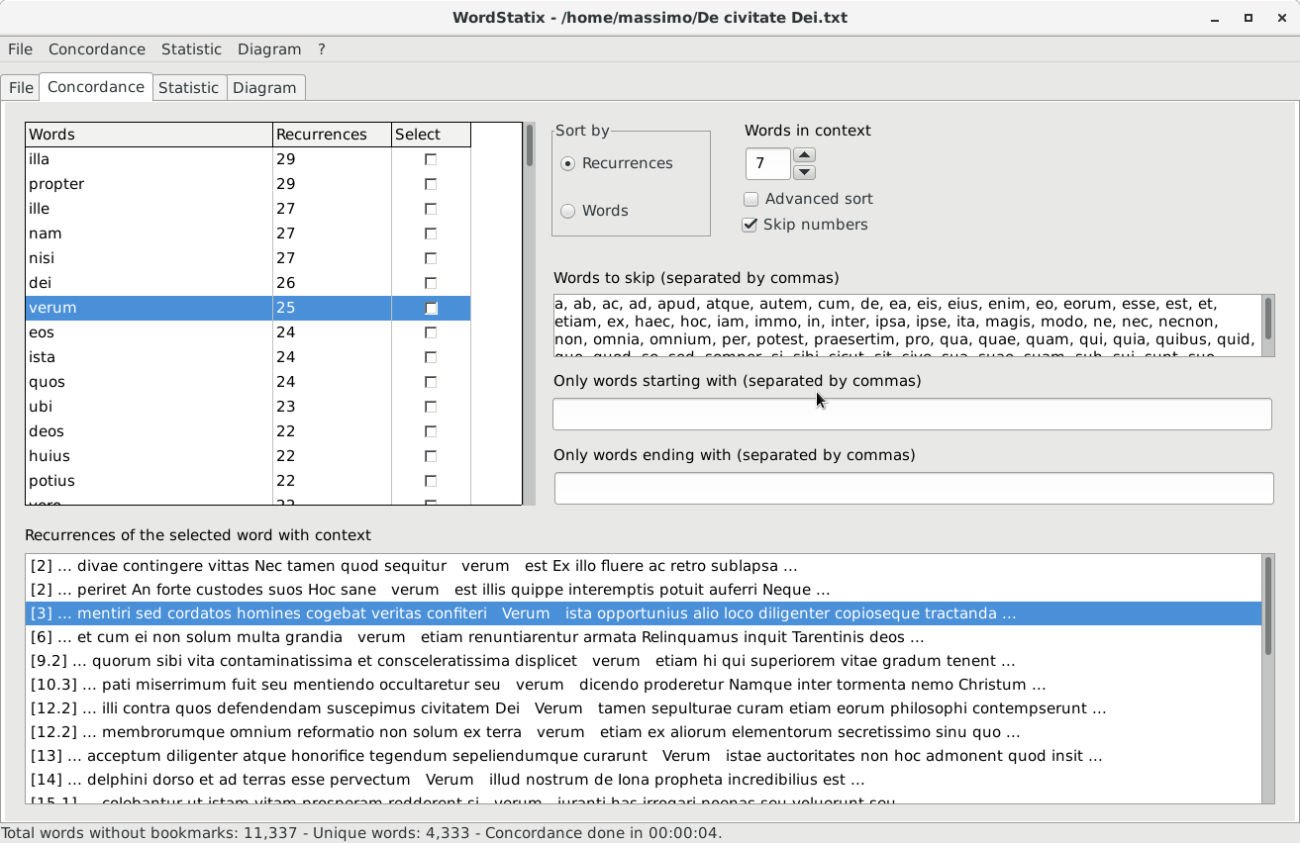
The top left grid shows the list of the words and their recurrence in the document in use. To create the concordance and fill it, use the menu item “Concordance – Create concordance” or the shortcut “Ctrl” + “N”. To interrupt the creation of the concordance already started, use the shortcut “Ctrl”+ “Shift” + “H”, as indicated also in the status bar at the bottom of the form when the concordance process is activated. While creating the concordance, which may take some time, no other section of the software may be selected, and many menu items are not enabled, but the user may use other application while leaving WordStatix complete its work. While the process goes on, the status bar reports the words analyzed, and at the end of the procedure also the time spent to complete it. The user will be informed by a message when the concordance will be ready.
The concordance list is sorted by words of by number of recurrences, according to the value of the field “Sort by”, which is remembered by the software. If a concordance is sorted by number of recurrences, the words that have the same recurrence will be sorted also by their name. Changing the vlue of the field “Sort by” the sorting will not be updated correspondingly. To have the concordance properly resorted, it’s necessary to recreate the concordance or to update only the list of words in the concordance grid using the menu item “Concordance – Refresh concordance grid” or shortcut “Ctrl”+ “Shift” + “U”. This feature will not recreate the concordance, but will just fill again the concordance grid with its proper values, a procedure much faster that the first one. Note that in this way all the words and recurrences that have been possibly deleted with the menu items “Concordance – Add current word to skip list”, “Concordance – Remove current word” and “Concordance – Delete selected recurrences”, which are described below, will be restored. Anyway, when the concordance grid is refreshed, if some words or recurrences have been deleted, the user is request to confirm the update and the consequent loss of the changes made.
The option “Advanced sort” makes the software sort properly special characters, like accented ones. Without this options, the sort is much faster, but these special characters are sorted after the more common ones. If this doesn’t matter, leave this option unchecked.
The option “Skip numbers” makes the software skip the words that contain only numbers and punctuation marks. Without this options, the concordance will be processed faster, so if it doesn’t matter, leave this option unchecked.
In the field “Words to skip (separated by commas)” the user may type some words, separated by commas, that should not enter in the concordance since they are meaningless, like articles and propositions. The filter is not case sensitive, so the software will not distinguish among lowercase and uppercase characters. It’s possible to type the words to skip directely in this list , or to add to it a word already present in the concordance grid with the menu item “Concordance – Add current word to skip list” or with the shortcut “Ctrl” + “Shift” + “K”. In this way, that word will be also removed from the concordance. To remove just the word from the grid without inserting it in the skip list, use the menu item “Concordance – Remove current word” or the shortcut “Ctrl” + “K”. To restore the deleted words and recurrences, use the menu item “Concordance – Refresh concordance grid” or shortcut “Ctrl”+ “Shift” + “U”. Note that to change the sort order of the words it’s necessary to update the concordance grid and loose all the deletions that have been made.
The skip list will be remembered by the software. Furthermore, it’s possible to save it in a text file with the menu item “Concordance – Save skip list…”, and open an existing skip list file with the menu item “Concordance – Open skip list…”. In this way the user may keep different skip lists corresponding to different languages or various kinds of documents to analyze.
In the field “Only words starting with (separated by commas)” it’s possible to type one or more prefix of words separated by commas. When creating the concordance, only the words beginning with one of those prefix will be shown. The filter is not case sensitive, so the software will not distinguish among lowercase and uppercase characters.
In the field “Only words ending with (separated by commas)” it’s possible to type one or more suffix of words separated by commas. When creating the concordance, only the words ending with one of those suffix will be shown. The filter is not case sensitive, so the software will not distinguish among lowercase and uppercase characters.
When the user adds new words to the fields “Words to skip (separated by commas)”, “Only words starting with (separated by commas)” and “Only words ending with (separated by commas)”, the software sorts them automatically, so that they can be seen more easily.
When a word is selected in the concordance grid, in the bottom list “Recurrence of the selected word with context” is shown each single recurrence of that word in the document analyzed. Each recurrence will be reported in a single row of the list along with its context, that are the words before and after it in the document analyzed. The number of words before and after the selected one are determined by the field “Words in context”, whose value can be changed by the user and that will be remembered by the software. At the beginning of each recurrence, among single square brackets, is shown the last bookmark before that recurrence, to indicate the section of the document in which it’s located. If no bookmark is present, it will be shown an asterisk, that is a the mentioned virtual bookmark.
A single recurrence of a word in the bottom grid “Recurrence of the selected word with context” can be removed, if for some reason it’s not to be included in the concordance nor computed in the statistic and in the diagrams. To delete a recurrence, use the menu item “Concordance – Delete selected recurrences” or the shortcut “Ctrl” + “Shift” + “D”. To restore the removed recurrences and words, just refresh the concordance grid with the menu item “Concordance – Refresh concordance grid” or with the shortcut “Ctrl”+ “Shift” + “U”.
The words in the concordance grid may also be individually selected with a click on the check box in the column “Selected” or with the space bar when the grid is focused (click with the mouse on it to focus it). Then it’s possible to show only the words that are selected in this way with the menu item “Concordance – Show only selected words” or with the shortcut “Ctrl” + “L”. When this filter is enabled, using the same menu item removes the filter and shows all the words. This selection is necessary to create the statistic and the diagrams, described below.
It’s possible to save the concordance in a text file or in a HTML file with the menu item “Concordance – Save concordance…” or with the shortcut “Ctrl” + “Shift” + “S”. To save the concordance in HTML format, add the extension “.html” (not just “.htm”) to the file to be saved. If the extension is different, the concordance will be saved in text format. The HTML file may be open in a browser or with a word processor. The single words will be formatted as Heading 2 paragraphs, to be tracked and managed more easily. Before saving the file of the concordance, the software will ask for a possible title to be inserted at the beginning of the concordance.
Note that the only the words that are actually visible in the concordance grid will be saved in the file. So, if the menu item “Concordance – Show only selected words” is checked, only the selected visible words will be saved. Also the possible deleted words and recurrences will be excluded from the file.
The concordance is not case sensitive, so lowercase and uppercase characters will be considered as the same and printed always in lower case. On the contrary, the list of the recurrences is case sensitive, so each word is printed as it is in the original text. If only lowercase or uppercase recurrences of a word must be considered, just delete the recurrences that contain the wrong version of the word.

Statistic section
The Statistic section, with some sample data, looks like this:

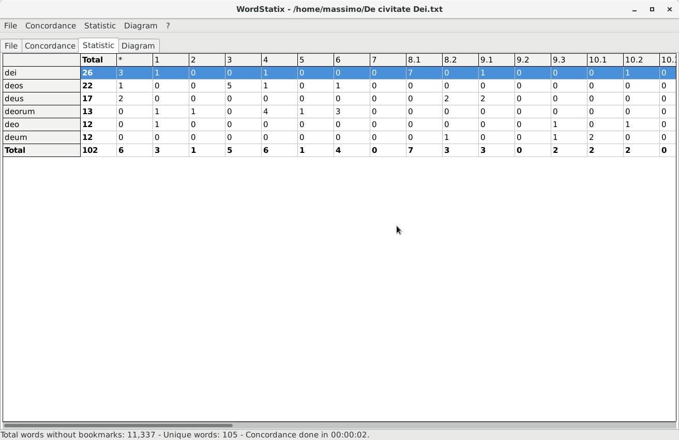
In this section it’s possible to show a grid with the recurrence of the words selected in the concordance grid. The software will shows both their total number in the second column of the statistic grid (under the label “Total”) and their recurrence within each section of the document, identified by the various bookmarks, in the other columns of the grid. The words are shown in the first left column, while the bookmarks are shown in the top row. The words that precedes the first possible bookmark will be gathered under the “*” virtual bookmark.
To create or update the statistic, use the menu item “Statistic – Create statistic” or the shortcut “Ctrl” + “T”. This series of values can be exported in a CSV file, which can be easily open by a spreadsheet like Calc. To export the current statistic in a file of this kind, use the menu item “Statistic – Save statistics…”.

Diagram section
The Diagram section, with some sample data, looks like this:

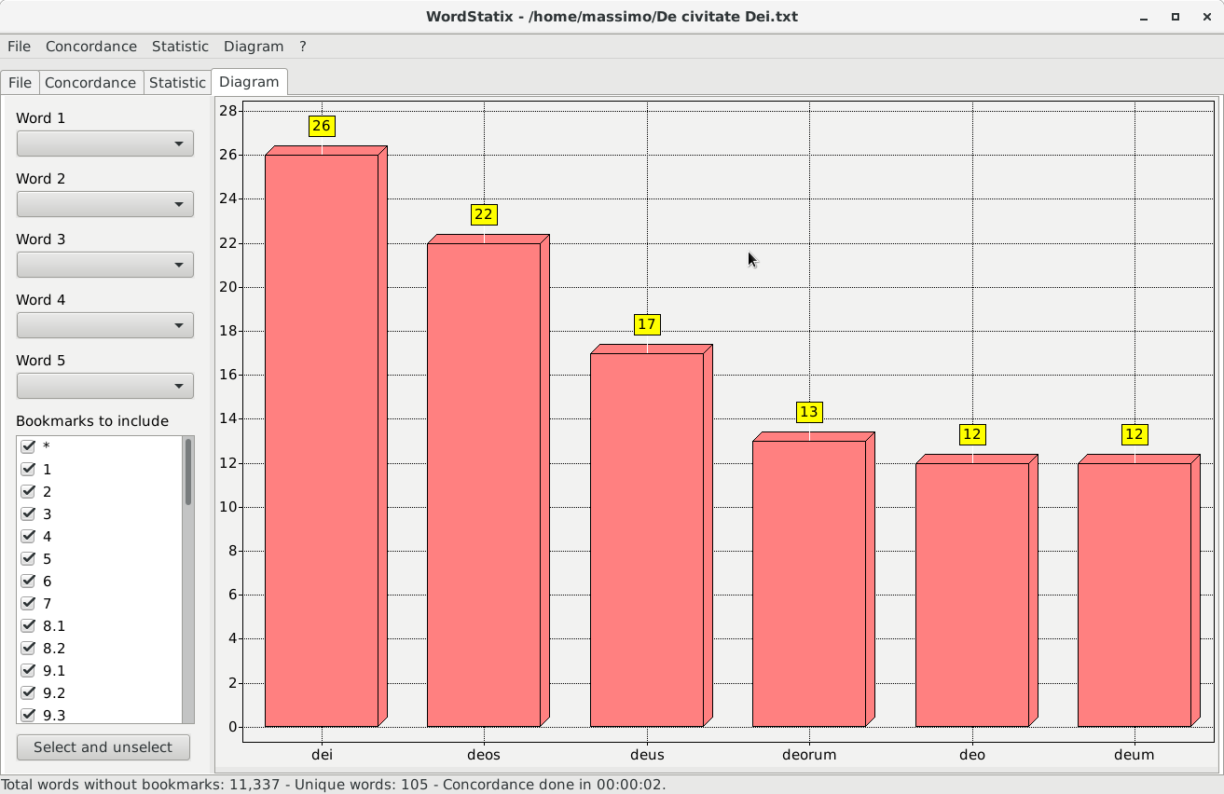
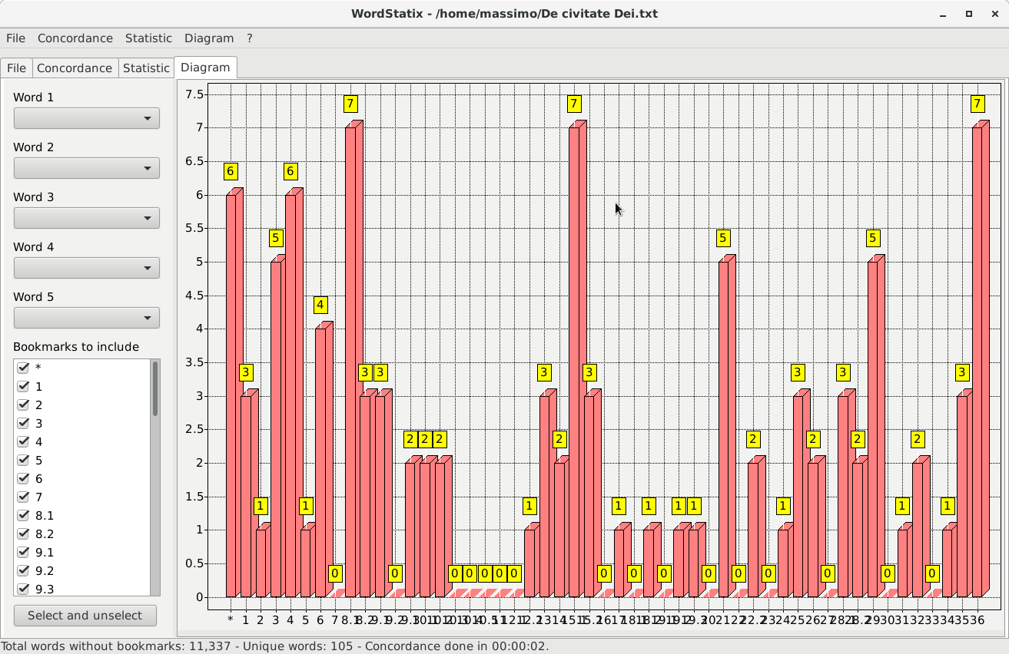
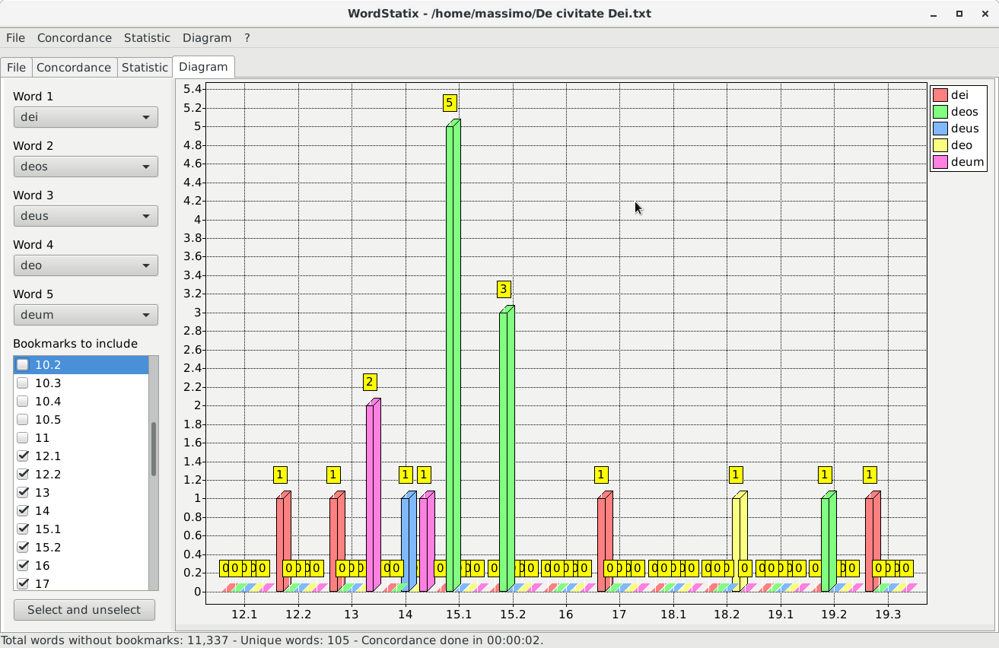
In the Diagram section it’s possible to visualize in a diagram the numeric data of the statistic, with three different kinds of diagrams.

1. A diagram of the total recurrences of the selected words of the statistic apart from the bookmarks (first picture above). The values are taken from the second column of the statistic grid, under the label “Total”. To create this kind of diagram, obviously after having created a statistic, use the menu item “Diagram – Total words without bookmarks” or the shortcut “Ctrl” + “I”. At the bottom of the diagram are shown the names of the different selected words, and the height of the various bars indicates the total of their recurrences in the statistic. For this kind of diagram, the fields and the list at the left of the section are useless.

2. A diagram of the total recurrences of the selected words of the statistic gathered within their bookmarks (second picture above). The values are taken from the last row of the statistic grid, at the right of the label “Total”. To create this kind of diagram, use the menu item “Diagram – Total words with bookmarks” or the shortcut “Ctrl” + “Shift” + “I”. At the bottom of the diagram are shown the names of the various bookmarks (so chapters, numbers, etc.), and the height of the various bars indicates the total recurrences of all the words used in the statistic for each bookmark. The words that precedes the first possible bookmark will be gathered under the “*” virtual bookmark. Only the words contained in the bookmarks selected in the list “Bookmarks to include” will be taken into consideration to create the diagrams. So, in order to exclude the words contained in one or more bookmarks deselect their names in this list with the mouse or the space bar. The button “Select and unselect” allows to select and unselect alternately all the bookmarks in this list. For this kind of diagram, the fields above the list of bookmarks are useless.

3. A diagram of the total recurrences of up to five words among those selected in the statistic gathered within their bookmarks (third picture above). To create the third kind of diagram, select at maximum five words in the fields called “Word 1”, “Word 2”, “Word 3”, “Word 4” and “Word 5” at the left of the section. Then use the menu item “Diagram – Single words with bookmarks” or the shortcut “Ctrl” + “Shift” + “Alt” + “I”. At the bottom of the diagram are shown the names of the various bookmarks (so chapters, numbers, etc.), while the height of the various bars indicates the recurrences of each one of the selected words for each bookmark. The words that precedes the first possible bookmark will be gathered under the “*” virtual bookmark. The different colors of the bars are related to the selected words, as indicated in the labels at the right top of the diagram. Note that to create this kind of diagram the field “Word 1” must contain a word, and the following fields must be compiled contiguously, so that no field above a compiled field is empty. To remove any word from one of these fields, except from the first one, select it and press the “Del” or the “Backspace” key. All the fields will be cleared when a new statistic is created. Only the words contained in the bookmarks selected in the list “Bookmarks to include” will be taken into consideration to create the diagrams. So, in order to exclude the words contained in one or more bookmarks, deselect their names in this list with the mouse or the space bar. The button “Select and unselect” allows to select and unselect alternately all the bookmarks of this list.

Each diagram may be zoomed in with the menu item “Diagram – Zoom in” or with the shortcut “Ctrl” + “+” to see more clearly the various items and values. It can be zoomed out with the menu item “Diagram – Zoom out” or with the shortcut “Ctrl” + “-”. The normal view of the diagram can be restored with the menu item “Diagram – Normal width” or with the shortcut “Ctrl” + “0”. Note that when the windows of the software is resized, the diagram will be resized as well to the normal width. When the diagram is zoomed, it can be scrolled toward left or right dragging the bar at the bottom with the mouse or with the left and right arrow keys.
The menu item “Diagram – Show values” allows to show or to hide the values of the bars of the diagram, which are shown in yellow boxes. The menu item “Diagram – Show grid” allows to show or to hide the grid of the diagram and the left labels with the scale of values of the bars. These two options are mutually exclusive, because if there were neither left labels nor values marks, it would be impossible to understand the values indicated by the bars.
The menu item “Diagram – Save diagram” allows to save the actual diagram in “.jpeg” or “.png” format. Note that the diagram will be saved with the width corresponding to the actual zoom level, and with or without the grid and the yellow boxes, according to the state of the menu item “Diagram – Show values” and “Diagram – Show grid”. On the contrary, the height of the diagram will be the same of the one shown in the section. So, in order to increase the height of the saved diagram, increase the height of the form of the software.

GNU Free Documentation License
Version 1.3, 3 November 2008
Copyright © 2000, 2001, 2002, 2007, 2008 Free Software Foundation, Inc. <http://fsf.org/>
Everyone is permitted to copy and distribute verbatim copies of this license document, but changing it is not allowed.

0. PREAMBLE

The purpose of this License is to make a manual, textbook, or other functional and useful document "free" in the sense of freedom: to assure everyone the effective freedom to copy and redistribute it, with or without modifying it, either commercially or noncommercially. Secondarily, this License preserves for the author and publisher a way to get credit for their work, while not being considered responsible for modifications made by others.
This License is a kind of "copyleft", which means that derivative works of the document must themselves be free in the same sense. It complements the GNU General Public License, which is a copyleft license designed for free software.
We have designed this License in order to use it for manuals for free software, because free software needs free documentation: a free program should come with manuals providing the same freedoms that the software does. But this License is not limited to software manuals; it can be used for any textual work, regardless of subject matter or whether it is published as a printed book. We recommend this License principally for works whose purpose is instruction or reference.

1. APPLICABILITY AND DEFINITIONS

This License applies to any manual or other work, in any medium, that contains a notice placed by the copyright holder saying it can be distributed under the terms of this License. Such a notice grants a world-wide, royalty-free license, unlimited in duration, to use that work under the conditions stated herein. The "Document", below, refers to any such manual or work. Any member of the public is a licensee, and is addressed as "you". You accept the license if you copy, modify or distribute the work in a way requiring permission under copyright law.
A "Modified Version" of the Document means any work containing the Document or a portion of it, either copied verbatim, or with modifications and/or translated into another language.
A "Secondary Section" is a named appendix or a front-matter section of the Document that deals exclusively with the relationship of the publishers or authors of the Document to the Document's overall subject (or to related matters) and contains nothing that could fall directly within that overall subject. (Thus, if the Document is in part a textbook of mathematics, a Secondary Section may not explain any mathematics.) The relationship could be a matter of historical connection with the subject or with related matters, or of legal, commercial, philosophical, ethical or political position regarding them.
The "Invariant Sections" are certain Secondary Sections whose titles are designated, as being those of Invariant Sections, in the notice that says that the Document is released under this License. If a section does not fit the above definition of Secondary then it is not allowed to be designated as Invariant. The Document may contain zero Invariant Sections. If the Document does not identify any Invariant Sections then there are none.
The "Cover Texts" are certain short passages of text that are listed, as Front-Cover Texts or Back-Cover Texts, in the notice that says that the Document is released under this License. A Front-Cover Text may be at most 5 words, and a Back-Cover Text may be at most 25 words.
A "Transparent" copy of the Document means a machine-readable copy, represented in a format whose specification is available to the general public, that is suitable for revising the document straightforwardly with generic text editors or (for images composed of pixels) generic paint programs or (for drawings) some widely available drawing editor, and that is suitable for input to text formatters or for automatic translation to a variety of formats suitable for input to text formatters. A copy made in an otherwise Transparent file format whose markup, or absence of markup, has been arranged to thwart or discourage subsequent modification by readers is not Transparent. An image format is not Transparent if used for any substantial amount of text. A copy that is not "Transparent" is called "Opaque".
Examples of suitable formats for Transparent copies include plain ASCII without markup, Texinfo input format, LaTeX input format, SGML or XML using a publicly available DTD, and standard-conforming simple HTML, PostScript or PDF designed for human modification. Examples of transparent image formats include PNG, XCF and JPG. Opaque formats include proprietary formats that can be read and edited only by proprietary word processors, SGML or XML for which the DTD and/or processing tools are not generally available, and the machine-generated HTML, PostScript or PDF produced by some word processors for output purposes only.
The "Title Page" means, for a printed book, the title page itself, plus such following pages as are needed to hold, legibly, the material this License requires to appear in the title page. For works in formats which do not have any title page as such, "Title Page" means the text near the most prominent appearance of the work's title, preceding the beginning of the body of the text.
The "publisher" means any person or entity that distributes copies of the Document to the public.
A section "Entitled XYZ" means a named subunit of the Document whose title either is precisely XYZ or contains XYZ in parentheses following text that translates XYZ in another language. (Here XYZ stands for a specific section name mentioned below, such as "Acknowledgements", "Dedications", "Endorsements", or "History".) To "Preserve the Title" of such a section when you modify the Document means that it remains a section "Entitled XYZ" according to this definition.
The Document may include Warranty Disclaimers next to the notice which states that this License applies to the Document. These Warranty Disclaimers are considered to be included by reference in this License, but only as regards disclaiming warranties: any other implication that these Warranty Disclaimers may have is void and has no effect on the meaning of this License.

2. VERBATIM COPYING

You may copy and distribute the Document in any medium, either commercially or noncommercially, provided that this License, the copyright notices, and the license notice saying this License applies to the Document are reproduced in all copies, and that you add no other conditions whatsoever to those of this License. You may not use technical measures to obstruct or control the reading or further copying of the copies you make or distribute. However, you may accept compensation in exchange for copies. If you distribute a large enough number of copies you must also follow the conditions in section 3.
You may also lend copies, under the same conditions stated above, and you may publicly display copies.

3. COPYING IN QUANTITY

If you publish printed copies (or copies in media that commonly have printed covers) of the Document, numbering more than 100, and the Document's license notice requires Cover Texts, you must enclose the copies in covers that carry, clearly and legibly, all these Cover Texts: Front-Cover Texts on the front cover, and Back-Cover Texts on the back cover. Both covers must also clearly and legibly identify you as the publisher of these copies. The front cover must present the full title with all words of the title equally prominent and visible. You may add other material on the covers in addition. Copying with changes limited to the covers, as long as they preserve the title of the Document and satisfy these conditions, can be treated as verbatim copying in other respects.
If the required texts for either cover are too voluminous to fit legibly, you should put the first ones listed (as many as fit reasonably) on the actual cover, and continue the rest onto adjacent pages.
If you publish or distribute Opaque copies of the Document numbering more than 100, you must either include a machine-readable Transparent copy along with each Opaque copy, or state in or with each Opaque copy a computer-network location from which the general network-using public has access to download using public-standard network protocols a complete Transparent copy of the Document, free of added material. If you use the latter option, you must take reasonably prudent steps, when you begin distribution of Opaque copies in quantity, to ensure that this Transparent copy will remain thus accessible at the stated location until at least one year after the last time you distribute an Opaque copy (directly or through your agents or retailers) of that edition to the public.
It is requested, but not required, that you contact the authors of the Document well before redistributing any large number of copies, to give them a chance to provide you with an updated version of the Document.

4. MODIFICATIONS

You may copy and distribute a Modified Version of the Document under the conditions of sections 2 and 3 above, provided that you release the Modified Version under precisely this License, with the Modified Version filling the role of the Document, thus licensing distribution and modification of the Modified Version to whoever possesses a copy of it. In addition, you must do these things in the Modified Version:
- A. Use in the Title Page (and on the covers, if any) a title distinct from that of the Document, and from those of previous versions (which should, if there were any, be listed in the History section of the Document). You may use the same title as a previous version if the original publisher of that version gives permission.
- B. List on the Title Page, as authors, one or more persons or entities responsible for authorship of the modifications in the Modified Version, together with at least five of the principal authors of the Document (all of its principal authors, if it has fewer than five), unless they release you from this requirement.
- C. State on the Title page the name of the publisher of the Modified Version, as the publisher.
- D. Preserve all the copyright notices of the Document.
- E. Add an appropriate copyright notice for your modifications adjacent to the other copyright notices.
- F. Include, immediately after the copyright notices, a license notice giving the public permission to use the Modified Version under the terms of this License, in the form shown in the Addendum below.
- G. Preserve in that license notice the full lists of Invariant Sections and required Cover Texts given in the Document's license notice.
- H. Include an unaltered copy of this License.
- I. Preserve the section Entitled "History", Preserve its Title, and add to it an item stating at least the title, year, new authors, and publisher of the Modified Version as given on the Title Page. If there is no section Entitled "History" in the Document, create one stating the title, year, authors, and publisher of the Document as given on its Title Page, then add an item describing the Modified Version as stated in the previous sentence.
- J. Preserve the network location, if any, given in the Document for public access to a Transparent copy of the Document, and likewise the network locations given in the Document for previous versions it was based on. These may be placed in the "History" section. You may omit a network location for a work that was published at least four years before the Document itself, or if the original publisher of the version it refers to gives permission.
- K. For any section Entitled "Acknowledgements" or "Dedications", Preserve the Title of the section, and preserve in the section all the substance and tone of each of the contributor acknowledgements and/or dedications given therein.
- L. Preserve all the Invariant Sections of the Document, unaltered in their text and in their titles. Section numbers or the equivalent are not considered part of the section titles.
- M. Delete any section Entitled "Endorsements". Such a section may not be included in the Modified Version.
- N. Do not retitle any existing section to be Entitled "Endorsements" or to conflict in title with any Invariant Section.
- O. Preserve any Warranty Disclaimers.
If the Modified Version includes new front-matter sections or appendices that qualify as Secondary Sections and contain no material copied from the Document, you may at your option designate some or all of these sections as invariant. To do this, add their titles to the list of Invariant Sections in the Modified Version's license notice. These titles must be distinct from any other section titles.
You may add a section Entitled "Endorsements", provided it contains nothing but endorsements of your Modified Version by various parties—for example, statements of peer review or that the text has been approved by an organization as the authoritative definition of a standard.
You may add a passage of up to five words as a Front-Cover Text, and a passage of up to 25 words as a Back-Cover Text, to the end of the list of Cover Texts in the Modified Version. Only one passage of Front-Cover Text and one of Back-Cover Text may be added by (or through arrangements made by) any one entity. If the Document already includes a cover text for the same cover, previously added by you or by arrangement made by the same entity you are acting on behalf of, you may not add another; but you may replace the old one, on explicit permission from the previous publisher that added the old one.
The author(s) and publisher(s) of the Document do not by this License give permission to use their names for publicity for or to assert or imply endorsement of any Modified Version.

5. COMBINING DOCUMENTS

You may combine the Document with other documents released under this License, under the terms defined in section 4 above for modified versions, provided that you include in the combination all of the Invariant Sections of all of the original documents, unmodified, and list them all as Invariant Sections of your combined work in its license notice, and that you preserve all their Warranty Disclaimers.
The combined work need only contain one copy of this License, and multiple identical Invariant Sections may be replaced with a single copy. If there are multiple Invariant Sections with the same name but different contents, make the title of each such section unique by adding at the end of it, in parentheses, the name of the original author or publisher of that section if known, or else a unique number. Make the same adjustment to the section titles in the list of Invariant Sections in the license notice of the combined work.
In the combination, you must combine any sections Entitled "History" in the various original documents, forming one section Entitled "History"; likewise combine any sections Entitled "Acknowledgements", and any sections Entitled "Dedications". You must delete all sections Entitled "Endorsements".

6. COLLECTIONS OF DOCUMENTS

You may make a collection consisting of the Document and other documents released under this License, and replace the individual copies of this License in the various documents with a single copy that is included in the collection, provided that you follow the rules of this License for verbatim copying of each of the documents in all other respects.
You may extract a single document from such a collection, and distribute it individually under this License, provided you insert a copy of this License into the extracted document, and follow this License in all other respects regarding verbatim copying of that document.

7. AGGREGATION WITH INDEPENDENT WORKS

A compilation of the Document or its derivatives with other separate and independent documents or works, in or on a volume of a storage or distribution medium, is called an "aggregate" if the copyright resulting from the compilation is not used to limit the legal rights of the compilation's users beyond what the individual works permit. When the Document is included in an aggregate, this License does not apply to the other works in the aggregate which are not themselves derivative works of the Document.
If the Cover Text requirement of section 3 is applicable to these copies of the Document, then if the Document is less than one half of the entire aggregate, the Document's Cover Texts may be placed on covers that bracket the Document within the aggregate, or the electronic equivalent of covers if the Document is in electronic form. Otherwise they must appear on printed covers that bracket the whole aggregate.

8. TRANSLATION

Translation is considered a kind of modification, so you may distribute translations of the Document under the terms of section 4. Replacing Invariant Sections with translations requires special permission from their copyright holders, but you may include translations of some or all Invariant Sections in addition to the original versions of these Invariant Sections. You may include a translation of this License, and all the license notices in the Document, and any Warranty Disclaimers, provided that you also include the original English version of this License and the original versions of those notices and disclaimers. In case of a disagreement between the translation and the original version of this License or a notice or disclaimer, the original version will prevail.
If a section in the Document is Entitled "Acknowledgements", "Dedications", or "History", the requirement (section 4) to Preserve its Title (section 1) will typically require changing the actual title.

9. TERMINATION

You may not copy, modify, sublicense, or distribute the Document except as expressly provided under this License. Any attempt otherwise to copy, modify, sublicense, or distribute it is void, and will automatically terminate your rights under this License.
However, if you cease all violation of this License, then your license from a particular copyright holder is reinstated (a) provisionally, unless and until the copyright holder explicitly and finally terminates your license, and (b) permanently, if the copyright holder fails to notify you of the violation by some reasonable means prior to 60 days after the cessation.
Moreover, your license from a particular copyright holder is reinstated permanently if the copyright holder notifies you of the violation by some reasonable means, this is the first time you have received notice of violation of this License (for any work) from that copyright holder, and you cure the violation prior to 30 days after your receipt of the notice.
Termination of your rights under this section does not terminate the licenses of parties who have received copies or rights from you under this License. If your rights have been terminated and not permanently reinstated, receipt of a copy of some or all of the same material does not give you any rights to use it.

10. FUTURE REVISIONS OF THIS LICENSE

The Free Software Foundation may publish new, revised versions of the GNU Free Documentation License from time to time. Such new versions will be similar in spirit to the present version, but may differ in detail to address new problems or concerns. See http://www.gnu.org/copyleft/.
Each version of the License is given a distinguishing version number. If the Document specifies that a particular numbered version of this License "or any later version" applies to it, you have the option of following the terms and conditions either of that specified version or of any later version that has been published (not as a draft) by the Free Software Foundation. If the Document does not specify a version number of this License, you may choose any version ever published (not as a draft) by the Free Software Foundation. If the Document specifies that a proxy can decide which future versions of this License can be used, that proxy's public statement of acceptance of a version permanently authorizes you to choose that version for the Document.

11. RELICENSING

"Massive Multiauthor Collaboration Site" (or "MMC Site") means any World Wide Web server that publishes copyrightable works and also provides prominent facilities for anybody to edit those works. A public wiki that anybody can edit is an example of such a server. A "Massive Multiauthor Collaboration" (or "MMC") contained in the site means any set of copyrightable works thus published on the MMC site.
"CC-BY-SA" means the Creative Commons Attribution-Share Alike 3.0 license published by Creative Commons Corporation, a not-for-profit corporation with a principal place of business in San Francisco, California, as well as future copyleft versions of that license published by that same organization.
"Incorporate" means to publish or republish a Document, in whole or in part, as part of another Document.
An MMC is "eligible for relicensing" if it is licensed under this License, and if all works that were first published under this License somewhere other than this MMC, and subsequently incorporated in whole or in part into the MMC, (1) had no cover texts or invariant sections, and (2) were thus incorporated prior to November 1, 2008.
The operator of an MMC Site may republish an MMC contained in the site under CC-BY-SA on the same site at any time before August 1, 2009, provided the MMC is eligible for relicensing.

