User Manual For Sim World 01 Game

İndex of Game Controls

Player controls **1**

F16 controls 2

3-Su27 controls

4-Ah64D controls

1. PLAYER CONTROL

Fig.1

Sound Button (Mute / Unmute) Menü Button Look zoom slider Head Turn factor

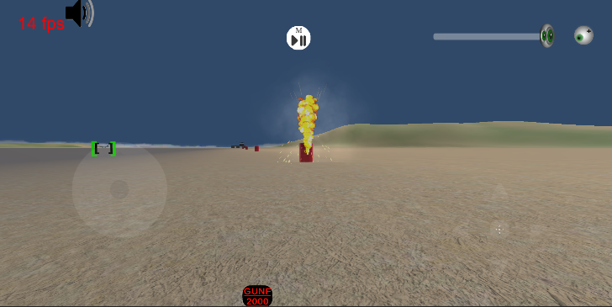

Look Joystick Gun Fire Button Player Move Joystick

2- F16 CONTROLS

Fig. 2

a)Displays & Controls Head Lock/Unlock

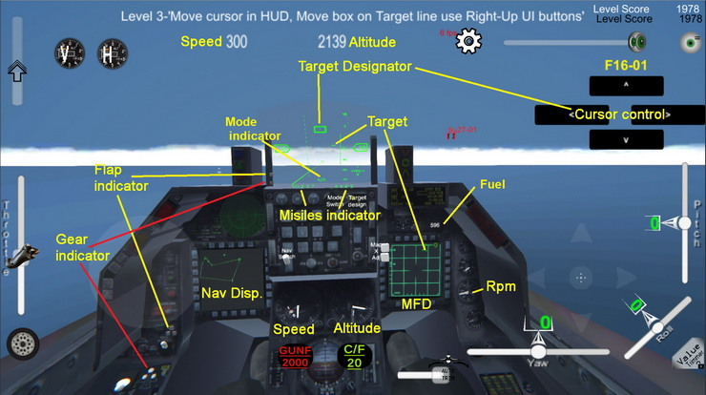

Throttle

Player cam up/Dn

Fig.3

Mouse İndicator (user interface for switches control)

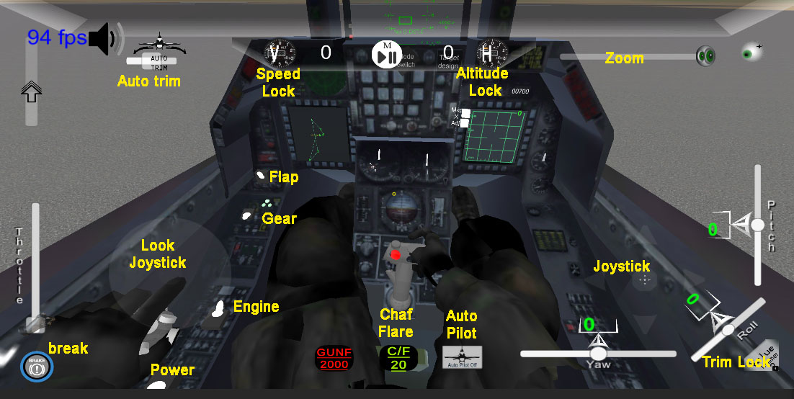

F16 – Startup Sequences

Use Look joystick Fig.1 , İf mouse indicator speed is fast then change slow. Use Look zoom slider. (Zoom +/Zoom-)

Fig.1

1. Look at F16’s power switch in Game……. > Tap The [Power On] Button (Showing Right Side of screen

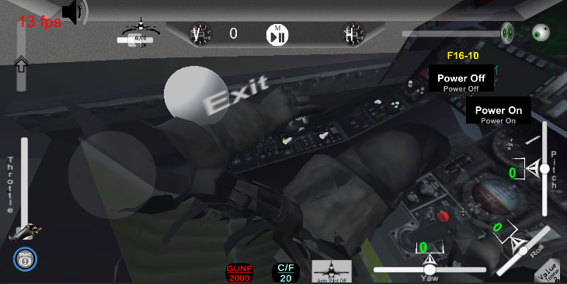

2. Look at F16 engine switch and Engine On

3. Wait Engine RPM going zero to idle RPM.

4. Check Flap, MFD modes (Nav,A2A,A2G).

5. Nav mode: Nav point change (np+ np-), A2A mode: target design cursor,(< ^ v >)