ANKARA UNIVERSITY
Faculty of Engineering
Departments of Computer, Biomedical, Electrical & Electronics, and Software Engineering
Multidisciplinary Project Study — Spring 2025–2026
Design and Testing of an Audiometer System

Computer Engineering Team Report

Team Members
No | Name and Surname
23291024 | Faik YILMAZ
23291369 | Ada ÖZARSLAN
20291309 | Ömer Bora BOZKURT
22290426 | Ceren UZUNOĞLU
22291019 | Kağan Barış ERDAL
22290179 | Esra YÜKSEKKAYALI
22290468 | Murat Enes ÇATI

Evaluation Report
Ankara University, Faculty of Engineering, Department of Biomedical, Computer, Sand Electrical and Electronics Engineering | MULTIDISCIPLINARY PROJECT WORK  EVALUATION REPORT | Semester:  2025 – 2026  Spring Term

TEAM
Number | GROUP 4 | Name | MULTIDISCIPLINARY TEAM

STUDENTS
Number | Name and Surname | Role in Group  (Not contributed,  Member, Team leader, Group leader) | Course  Code
23291024 | Faik YILMAZ | TEAM LEADER / GROUP LEADER | COM2044
23231969 | Ada ÖZARSLAN | MEMBER | COM2044
20291309 | Ömer Bora BOZKURT | MEMBER | COM2044
22290426 | Ceren UZUNOĞLU | TEAM LEADER | BME234
22291019 | Kağan Barış ERDAL | TEAM LEADER | EEE3002
22290179 | Esra YÜKSEKKAYALI | MEMBER | EEE3002
22290468 | Murat Enes ÇATI | TEAM LEADER | YMH334

Abstract
This report documents the design, implementation, and testing of a simulation-based audiometer system developed as a multidisciplinary engineering project. The system integrates a Proteus-simulated hardware stage that generates pure tones, a Java/Swing clinical application that drives the test and renders the audiogram, and a serial link connecting the two. The Computer Engineering team is responsible for the clinical software: a state-driven controller, a pure-function Hughson–Westlake threshold engine following the rule set provided by Biomedical Engineering, a serial client implementing the protocol defined by Electrical and Electronics Engineering, and an audiogram renderer.
The threshold algorithm was first verified in isolation against two reference scenarios (20 dB HL and 45 dB HL, both correctly identified), and the full system was then validated end-to-end with the virtual hardware. The integrated system produced a complete six-frequency audiogram on both ears with no serial framing or parsing errors observed; results and signal-analysis findings are presented in the relevant sections.

Table of Contents
Evaluation Report 1
Abstract 1
Table of Contents 1
1. Introduction 1
1.1 Audiometry Background 1
1.2 Literature Review 1
1.3 Project Management Plan 1
2. Materials and Methods 1
2.1 System Overview (Block Design) 1
2.2 System Design (Simulation) 1
Hardware Architecture 1
2.3 Signal Generation 1
2.4 Software Design 1
Graphical Interface 1
Hearing-Level to Amplitude Mapping 1
Functional Programming Foundations 1
2.5 Hughson–Westlake Algorithm 1
2.6 Communication Protocol 1
2.7 Signal Quality Analysis 1
2.8 Standards Used 1
3. Results 1
3.1 Component-Level Tests 1
3.1.1 Software Interface and Control Logic 1
3.1.2 Oscillator Block and Waveform Verification 1
3.1.3 Spectral Analysis via Fourier Transform 1
3.2 Software Tests 1
Property-Based Validation 1
3.3 System-Level Test 1
3.4 Audiogram Results 1
3.5 Signal Analysis Results 1
4. Conclusion 1
4.1 Discussion 1
4.2 Difficulties Encountered in Multidisciplinary Work 1
5. References 1
Appendices 1
Appendix A — Source Code 1
Appendix B — Meeting Minutes 1
Appendix C — Signal Captures for Each Test Frequency 1
C.1 — 250 Hz 1
C.2 — 500 Hz 1
C.3 — 1000 Hz 1
C.4 — 2000 Hz 1
C.5 — 4000 Hz 1
C.6 — 8000 Hz 1

1. Introduction

1.1 Audiometry Background
Pure-tone audiometry is a behavioural hearing test that determines the softest sound a person can hear at specific frequencies, performed separately for each ear and recorded as a hearing threshold in dB HL. The better-hearing ear is tested first when known. In this project, the software presents one tone at a time and records whether the subject responds.
Each tone is presented for 1.0–1.5 seconds followed by a 2–3 second response window, with variable inter-tone timing to reduce predictable responding. Results are plotted on a standard audiogram with frequency on the horizontal axis (low to high) and hearing level on the vertical axis (top to bottom); the right ear is marked with a red O and the left ear with a blue X.

1.2 Literature Review
Pure-tone audiometry remains the foundational behavioural method for clinical hearing assessment (WHO, 2021; Katz, 2015), with electroacoustic parameters governed by IEC 60645-1 (IEC, 2017). Modern instrumentation typically replaces analog oscillators with Direct Digital Synthesis on embedded platforms, where a DAC converts a pre-computed look-up table into the analog stimulus (Microchip Technology, 2007; Texas Instruments, 2015). Automated threshold tracking is rooted in the adaptive staircase of Hughson and Westlake (Carhart & Jerger, 1959), which uses a “down 10 dB, up 5 dB” loop. Following ISO 8253-1, a threshold is accepted when the subject responds in at least two of three ascending presentations at a given level (ISO, 2010).

1.3 Project Management Plan
The project is carried out by four departmental teams — Computer Engineering (CENG), Biomedical Engineering (BME), Electrical and Electronics Engineering (EEE), and Software Engineering (YMH) — coordinated by a single group leader. Responsibilities are divided so that each team owns a clearly defined layer of the system while sharing a common communication contract.
From the Computer Engineering perspective, the shared responsibilities are as follows. The CENG team owns the clinical software (graphical interface, test controller, threshold engine, serial client, and audiogram rendering). The EEE team owns the virtual hardware in Proteus and the serial protocol definition. The BME team owns the clinical rule set (Hughson–Westlake procedure, frequency range, standards) and signal-quality interpretation. The YMH team owns the functional-programming aspects (pure functions, immutable data structures, and property-based tests) layered on top of the CENG codebase.
Team | Primary Responsibility | Interface with CENG
CENG | Clinical software, GUI, threshold engine, audiogram | —
EEE | Proteus hardware, DAC tone generation, serial protocol | Serial commands & RESPONSE
BME | Hughson–Westlake rules, frequency set, standards, signal QA | Algorithm rule set
YMH | Pure functions, immutable structures, automated tests | Shared engine/state code
The project was carried out between late April and early June 2026. The timeline below summarises the main phases and the three in-person meetings; signed minutes of the meetings are appended in Appendix B.
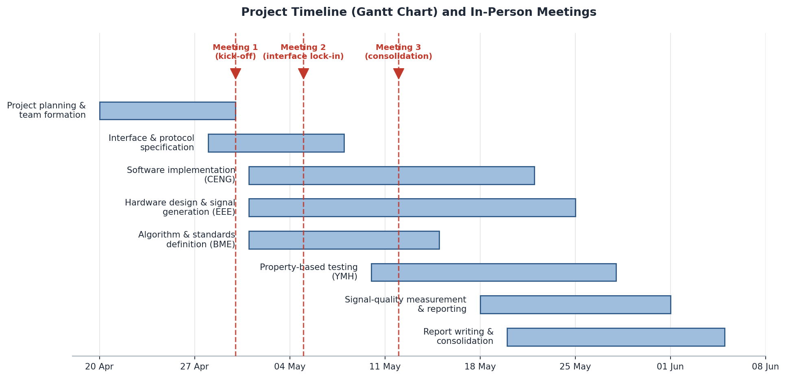
Figure 1.1. Project timeline (Gantt chart) and in-person meetings.
Meeting | Date | Focus
Meeting 1 | 30 April 2026 | Project kick-off, introductions, and division of responsibilities across the four teams.
Meeting 2 | 5 May 2026 | Progress review and lock-in of the serial protocol and Hughson–Westlake rule set.
Meeting 3 | 12 May 2026 | Final review; remaining work distributed and online coordination agreed for the holiday/finals period.

2. Materials and Methods

2.1 System Overview (Block Design)
The system is organised into three cooperating layers connected by a single serial link. The clinical software, written in Java, drives the entire test: it issues tone commands, waits for the patient response, applies the threshold-seeking algorithm, and plots the resulting audiogram. The virtual hardware, built in Proteus by the EEE team, receives these commands and synthesises the corresponding pure tone. A virtual serial port pair bridges the two so that, on a single machine, the software and the simulated hardware can communicate exactly as they would over a physical cable.
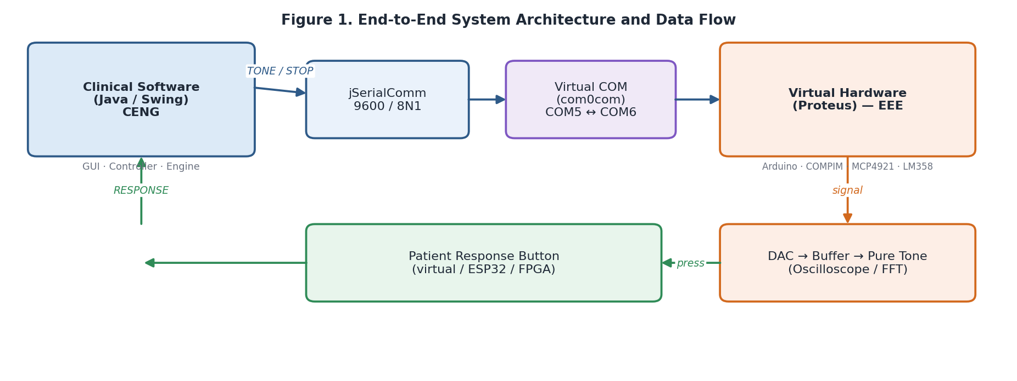
Figure 1. End-to-end system architecture and data flow.
In the forward direction, the software transmits tone and stop commands. In the reverse direction, a patient button press on the hardware side returns a single RESPONSE message. This separation lets each team work independently against a fixed contract: the software does not need to know how the tone is physically produced, and the hardware does not need to know how thresholds are computed.

2.2 System Design (Simulation)
On the software side, the system follows a layered design that separates user interaction, test control, threshold computation, and communication. This separation keeps the medically significant logic independent of both the user interface and the transport layer, which simplifies testing and allows the threshold engine to be exercised without any hardware present.
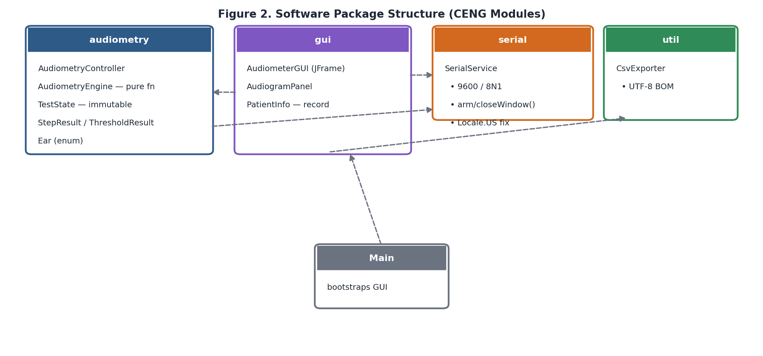
Figure 2. Software package structure of the Computer Engineering modules.
The audiometry package contains the controller that sequences the test, the engine that implements the threshold rule as a pure function, and the immutable data structures that represent the test state and its results. The gui package contains the main window, the audiogram renderer, and the patient-information record. The serial package isolates all serial-port handling, and the util package provides result export. The Main class wires these together and launches the interface.

Hardware Architecture
The hardware architecture of the audiometer is implemented as a mixed-signal embedded chain optimised for precision pure-tone signal generation and conditioning. It integrates a digital processing core, a dedicated digital-to-analog reconstruction block, and an analog buffering output stage.
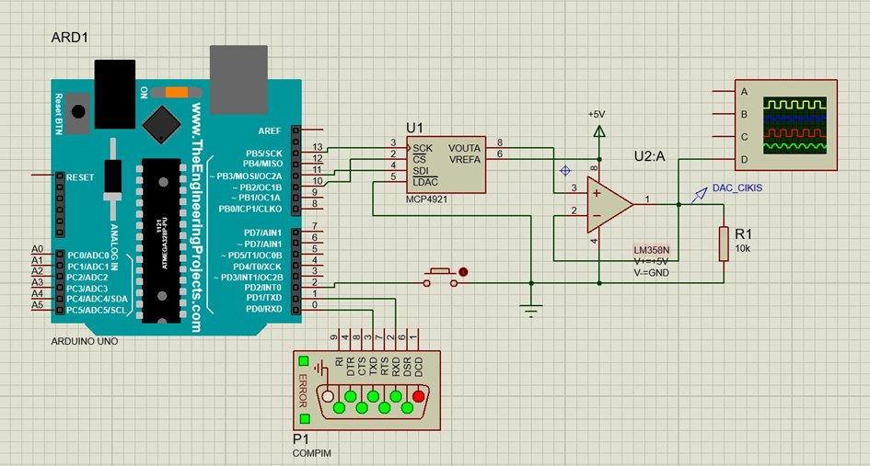
Figure 2.1. Proteus circuit schematic of the audiometer signal-generation stage: Arduino UNO (ARD1), MCP4921 12-bit DAC (U1), LM358 op-amp buffer (U2:A) with 10 kΩ load (R1), patient response push-button, and COMPIM virtual serial port (P1).
The DAC’s raw output preserves the high-frequency quantisation staircase inherent to digital reconstruction. To resolve impedance mismatches and stabilise signal power, the analog signal is routed into an LM358N op-amp configured as a non-inverting unity-gain buffer; the buffer’s high input impedance protects the DAC from loading effects, and its output drives a 10 kΩ load resistor (R1) at the DAC_CIKIS node. Patient responses are captured locally through a push-button on a digital input pin, with a software interrupt performing debouncing inside the standard clinical response window.

2.3 Signal Generation
The pure-tone signal generator is the foundation of the audiometric test, with the objective of synthesising high-stability, low-distortion sinusoidal waveforms across the clinical test frequencies. Tone synthesis is performed entirely on the hardware side via a Direct Digital Synthesis (DDS) architecture implemented in the firmware of the ATmega328P microcontroller on the Arduino UNO board.
Sinusoid samples are pre-computed and stored in a digital look-up table (LUT) in the microcontroller’s flash. The operating frequency f₀ is set by varying the sampling interval at which successive LUT values are streamed to the converter. Reconstruction is performed over SPI by the MCP4921, a 12-bit DAC that maps integer inputs 0–4095 onto an analog range 0–5 V, giving a quantisation step of ΔV = V_REF / 2ⁿ = 5 V / 4096 ≈ 1.22 mV, fine enough for an accurate piece-wise approximation of a continuous sine before the analog buffering stage. Patient button presses are debounced internally by a software interrupt routine, removing contact noise without external hardware.
The digital-to-analog reconstruction is executed via a high-speed Serial Peripheral Interface (SPI) bus that routes data directly to the MCP4921 12-bit DAC. The 12-bit architecture maps digital integer inputs from 0 to 4095 onto a proportional analog voltage range from 0 V to V_REF (5 V). The theoretical quantisation step size ΔV is:
ΔV = V_REF / 2ⁿ = 5 V / 4096 ≈ 1.22 mV

2.4 Software Design
The clinical software is a Java desktop application built with the Swing toolkit. It targets a recent Java runtime and depends on a single external library, jSerialComm, for serial-port access. The application is organised around a clear flow of control: the user connects to a serial port, optionally enters patient information, and starts either an automatic test or a manual single-tone presentation.

Graphical Interface
The main window presents four regions: a connection panel (port selection, connect, disconnect, refresh), a patient-information panel (name, identifier, age, notes), a central audiogram, and a right-hand panel with manual-mode controls and a timestamped log. A status line reports the current ear, frequency, and intensity, and the bottom toolbar exposes start, stop, reset, and CSV export. Button states are managed automatically against the connection and test status, preventing invalid operations such as starting a test with no port open.

Hearing-Level to Amplitude Mapping
Because the intensity is transmitted as a 0.0–1.0 multiplier, the software converts the clinical hearing level into this range. A logarithmic mapping is used so that equal steps in decibels correspond to proportional changes in amplitude, which reflects the perceptual nature of loudness.
The conversion is implemented as a static utility method that computes 10^((dbHl − 100) / 40) and clamps the result to the range [0.0005, 1.0], so that 100 dB HL maps to full scale and lower hearing levels map proportionally to lower amplitudes. The full source is given in Appendix A.
This mapping is a simulation design choice. In a clinically calibrated device the relationship between dB HL and electrical output is frequency-dependent and governed by reference equivalent threshold sound pressure levels; that calibration is outside the scope of a simulation without a physical transducer. The mapping is documented here so it can be refined jointly with the BME team once reference values are available.

Functional Programming Foundations
Medically significant logic follows a functional style: the threshold engine is a pure function on immutable Java records (TestState, StepResult, ThresholdResult, PatientInfo), and state transitions return new instances rather than mutating in place. Error handling avoids exceptions, using Optional for both the engine’s outcome and serial connection results. Incoming message processing uses a Stream pipeline to isolate RESPONSE payloads, and the response window itself is built on a CompletableFuture that the listener completes when the token arrives, replacing a polling loop and keeping the UI responsive even under rapid serial events. These choices satisfy the YMH 334 functional-programming requirements and provide the deterministic, reproducible behaviour expected by IEC 60645-1.
Error handling avoids exceptions and null returns. The threshold engine reports its outcome through Optional<ThresholdResult>: a present value means the acceptance criterion has been met, an empty value means the test must continue. The same Optional discipline is applied to serial operations that may legitimately fail to acquire a resource: the connect method returns Optional<SerialPort>, allowing call sites to handle the empty case explicitly without exception-driven flow control. Incoming message processing uses a stream-style pipeline (Stream.of(...).filter(...).findFirst()) to isolate RESPONSE payloads from the receive buffer, and the response window itself is implemented with a CompletableFuture<Boolean> that the listener completes when the target token arrives, replacing the previous polling loop and keeping the user interface responsive even when serial events arrive in rapid bursts.
Together, these choices satisfy the functional-programming requirements of the Software Engineering curriculum (YMH 334) and provide the algorithmic stability required by the IEC 60645-1 framework: medically significant calculations are deterministic, reproducible, and free from hidden state.

2.5 Hughson–Westlake Algorithm
The threshold-seeking logic implements the Hughson–Westlake procedure exactly as specified by the Biomedical Engineering team. Starting from a default presentation level of 40 dB HL for each ear and frequency, the level is decreased by 10 dB after every response and increased by 5 dB after every non-response. A threshold is accepted as the lowest level at which the subject responds in at least two of three ascending presentations, where an ascending presentation is one reached by increasing the level after a previous non-response.
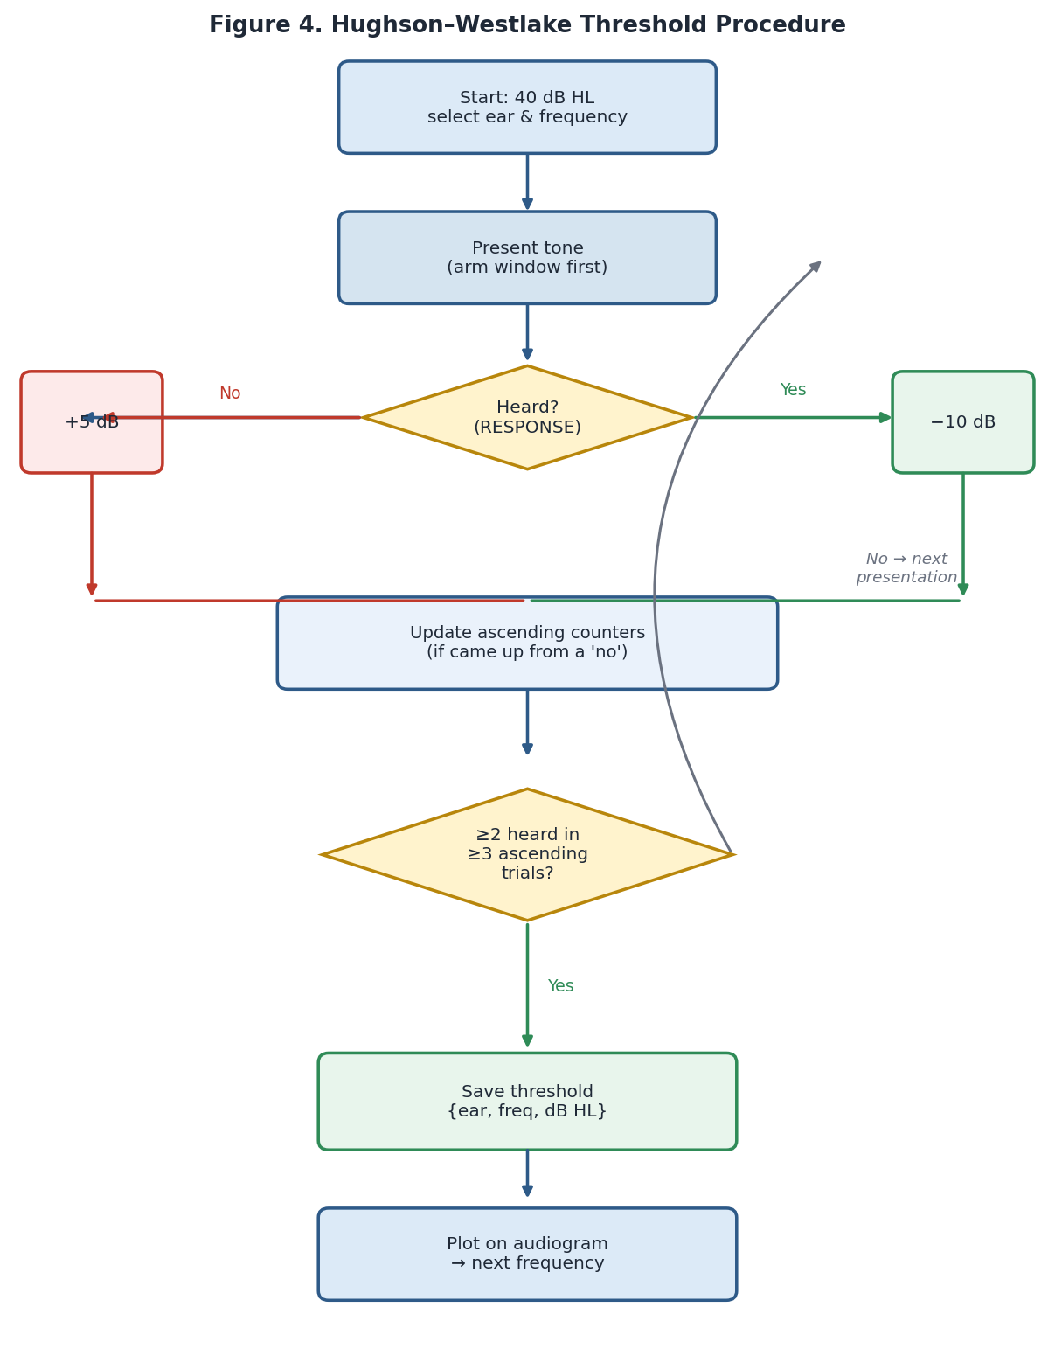
Figure 4. Hughson–Westlake threshold-seeking procedure as implemented.
The decision logic is implemented as a pure function: given the current test state and whether the tone was heard, it returns the next state and, when the acceptance criterion is met, the saved threshold result. Keeping this logic free of side effects allows it to be tested exhaustively and reused by the Software Engineering team for property-based testing.
Implemented as a static pure function AudiometryEngine.nextStep(state, heard), this routine first records the presentation in the state, then asks the state whether the 2-of-3 acceptance criterion is met. If it is, the function returns the unchanged ear and frequency together with the accepted threshold; otherwise it returns the next state after applying the +5 dB / −10 dB rule. The complete listing is included in Appendix A.
The test sequence covers the frequencies 1000, 2000, 4000, 8000, 500, and 250 Hz for each ear, starting with the right ear, in line with the recommended order. Each ear and frequency is processed until its threshold is confirmed, after which the result is plotted on the audiogram and the test advances to the next frequency.

2.6 Communication Protocol
The software and the virtual hardware communicate over a serial link configured at 9600 baud with eight data bits, no parity, and one stop bit (8N1), as defined by the EEE team. On a single development machine, a virtual serial port pair links the application to the Proteus COMPIM module, so no physical cabling is required.
Direction | Message | Meaning
Software → Hardware | TONE::<freq>::<amp> | Play a tone at <freq> Hz with amplitude <amp> (0.0–1.0)
Software → Hardware | STOP | Stop the current tone
Hardware → Software | RESPONSE | The patient pressed the response button
Each outgoing command is terminated by a newline. A subtle but important detail is number formatting: the amplitude is written using a fixed locale (Locale.US) so that the decimal separator is always a dot. Without this, a Turkish system locale would produce a comma (for example 0,5000), which the hardware parser could not interpret correctly.
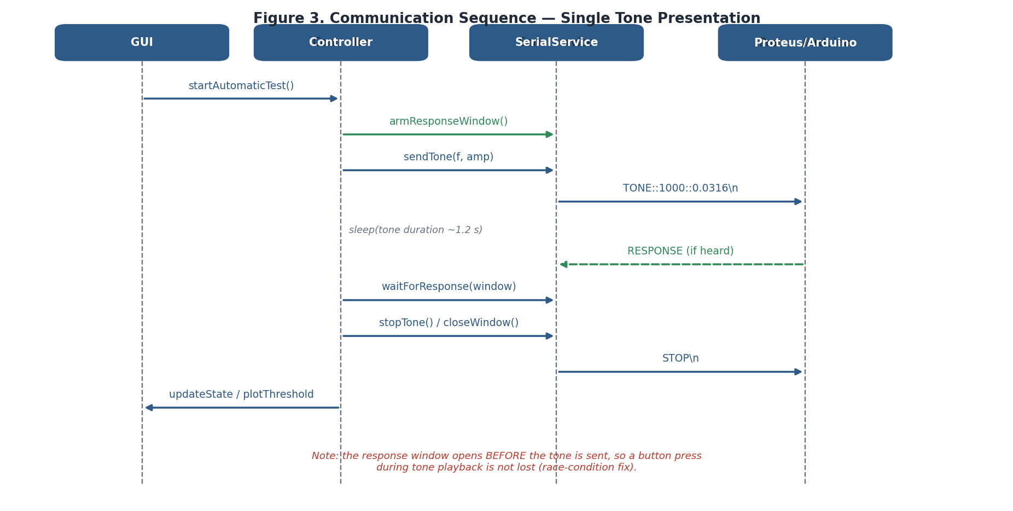
Figure 3. Communication sequence for a single tone presentation.
A second important design point concerns the timing of the response window. The window in which a RESPONSE is accepted is opened before the tone is sent, not after it stops. This ensures that a button press occurring while the tone is still playing — the natural behaviour of a subject who hears the tone immediately — is captured rather than discarded. The response state is therefore never reset in the middle of a presentation.
Concretely, the controller arms the response window before transmitting the TONE frame, sleeps for the tone duration during which the listener may press the button, then waits up to the response timeout and finally issues the STOP frame. Because the window is opened first, a response that arrives while the tone is still playing is captured rather than discarded. The corresponding source is in Appendix A.

2.7 Signal Quality Analysis
Signal-quality analysis verifies that the synthesised stimulus is a clean pure tone. The time-domain waveform must be sinusoidal and the frequency-domain view must be dominated by the intended fundamental with low visible harmonic content. IEC 60645-1 specifies a Total Harmonic Distortion ceiling for pure-tone audiometers; the Proteus environment includes a dedicated THD clause for pure tones, and Fourier analysis (Section 3.5) is suitable for this verification step.
At each target frequency the simulation is run until steady state, then oscilloscope and spectrum captures are recorded. The waveform period and output voltage are measured on the oscilloscope; the Fourier view is then inspected to confirm that the dominant peak occurs at the intended frequency, that any harmonic peaks are small relative to the fundamental, and that the spectrum shows a clean fundamental peak with low visible harmonic content.

2.8 Standards Used
IEC 60645-1:2017 is the main electroacoustic reference standard for this project, governing pure-tone audiometric equipment and including a THD clause for pure tones; Proteus analysis tools support this verification. ISO 8253-1:2010 complements IEC 60645-1 by specifying the clinical procedures and requirements for pure-tone air-conduction threshold audiometry. The present system targets a subset of the standard audiometric range (250–8000 Hz) and applies stepped hearing-level control suitable for threshold search; it is a simulation-based prototype rather than a clinically certified audiometer, and full conformance would require calibrated physical transducers, formal conformance testing to state measurement uncertainty, and broader safety / EMC verification within the IEC 60601 framework.

3.Results

3.1 Component-Level Tests
Component-level testing was carried out independently on the software and hardware layers before full-system integration, so that defects could be localised to a single layer rather than emerging during end-to-end runs. The software side was verified through interface checks and the algorithmic test described in Section 3.2; the hardware side was verified through oscilloscope and spectral measurements at the signal-generator output.

3.1.1 Software Interface and Control Logic
The graphical interface launches correctly and renders the empty audiogram with the expected axes (250 Hz to 8 kHz on a logarithmic frequency scale, and −10 to 100 dB HL on the vertical scale) and the standard legend. With no serial port open, the connect action is enabled while the disconnect, start, and manual actions remain disabled; attempting a manual presentation without a connection produces a clear error dialog. These behaviours confirm that the interface enforces a valid sequence of operations.
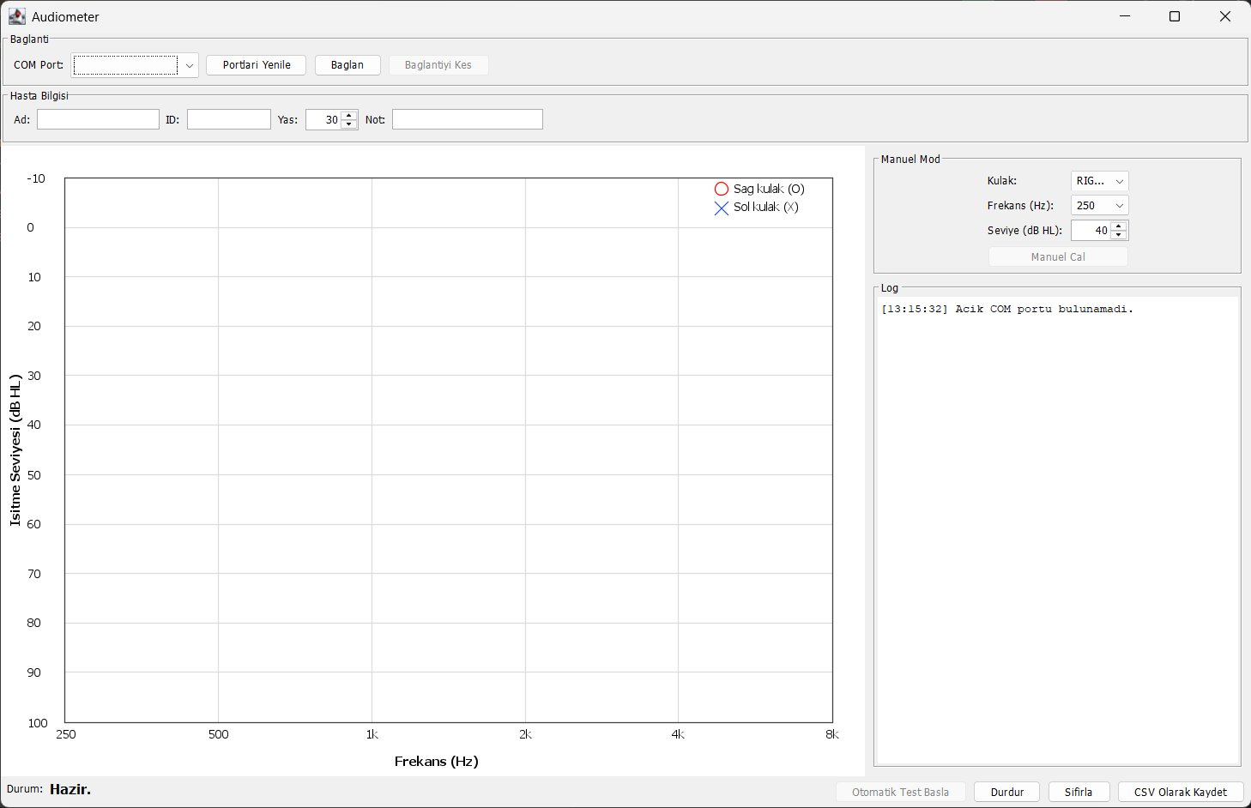
Figure 7. The clinical software interface in its initial state, showing the empty audiogram, connection panel, patient-information fields, manual-mode controls, and log.

3.1.2 Oscillator Block and Waveform Verification
The output of the signal generator stage was connected to a high-impedance digital storage oscilloscope to assess waveform integrity. At the target test frequencies, the generated sine wave was inspected for symmetry, peak-to-peak voltage stability (V_PP), and the absence of DC offsets. The synthesised waveform exhibits an excellent sinusoidal profile with stable voltage amplitudes; the peak-to-peak voltage remains constant under loaded conditions, verifying that the source impedance of the generator is sufficiently low to drive subsequent stages without loading effects.
In the mid-range frequencies, the system reconstructs a symmetrical, continuous sinusoidal profile suitable for audiometric testing. A closer inspection reveals the characteristic stair-step micro-steps inherent to digital-to-analog reconstruction. While these high-frequency transition edges introduce negligible acoustic distortion within the low-frequency human auditory spectrum (250–4000 Hz), they represent high-frequency switching components that become more pronounced at 8000 Hz, as discussed in Section 4.2. Detailed time-domain captures for each test frequency are provided in Appendix C (Sections C.1–C.6).

3.1.3 Spectral Analysis via Fourier Transform
To validate the system’s compliance with audiometry standards such as IEC 60645-1, a spectral analysis was performed using the Fourier capability of the simulation oscilloscope. In audiometric testing, the acoustic stimulus must be a strictly isolated pure tone; any significant harmonic distortion could stimulate unintended regions of the cochlea and lead to inaccurate diagnostic thresholds.
At every test frequency, the highest spectral power is located at the intended fundamental f₀, and the fundamental holds the vast majority of the signal energy. The high-frequency staircase quantisation steps observed in the time domain manifest in the frequency domain as micro-harmonics at higher multiples of f₀; in the mid range these are suppressed by more than 40 dB relative to the fundamental, well below any perceptual contribution. The corresponding Fourier spectra for each test frequency are presented in Appendix C alongside the matching oscilloscope traces.

3.2 Software Tests
The Hughson–Westlake engine was tested independently of the hardware using a simulated patient whose true threshold is known. In the first scenario the simulated patient hears any tone at or above 20 dB HL; in the second, at or above 45 dB HL. In both cases the algorithm converged to the correct threshold, demonstrating that the descend-10 / ascend-5 rule and the two-of-three ascending acceptance criterion are implemented correctly.
In both scenarios the trace shows the expected pattern: an initial descent in 10 dB steps until the first no-response, followed by 5 dB ascending presentations alternating with 10 dB descents, terminating once the 2-of-3 ascending criterion is satisfied at the reference threshold (20 dB HL and 45 dB HL respectively).
The second scenario (true threshold 45 dB HL) converged in eight steps to 45 dB HL, confirming the algorithm behaves correctly for an elevated threshold representing mild hearing loss. Both scenarios pass automatically, providing hardware-independent evidence that the medical logic is sound. The actual console output of the automated test is shown below.

Property-Based Validation
To verify the engine’s behaviour beyond the two reference scenarios above, the Software Engineering team complemented the manual test with property-based testing using the Jqwik framework. The test suite generates random sequences of patient responses across the full input domain and asserts invariants that must hold under every generated case. Three properties were checked:
- Safety: the next intensity returned by nextStep always lies within the −10 dB HL to 120 dB HL safety bounds.
- Rule consistency: the level always changes by −10 dB after a heard response and by +5 dB after a not-heard response, independent of the surrounding sequence.
- Stability: the engine terminates without runtime exceptions or memory corruption under every generated sequence.
Running in EXHAUSTIVE generation mode, the suite (AudiometryIEC60645Test.java) executed 524 generated scenarios across four @Property tests. All properties held in every case and the run terminated with exit code 0. Combined with the deterministic scenario tests above, these property-based runs provide hardware-independent statistical evidence that the threshold-seeking logic is correct and stable.
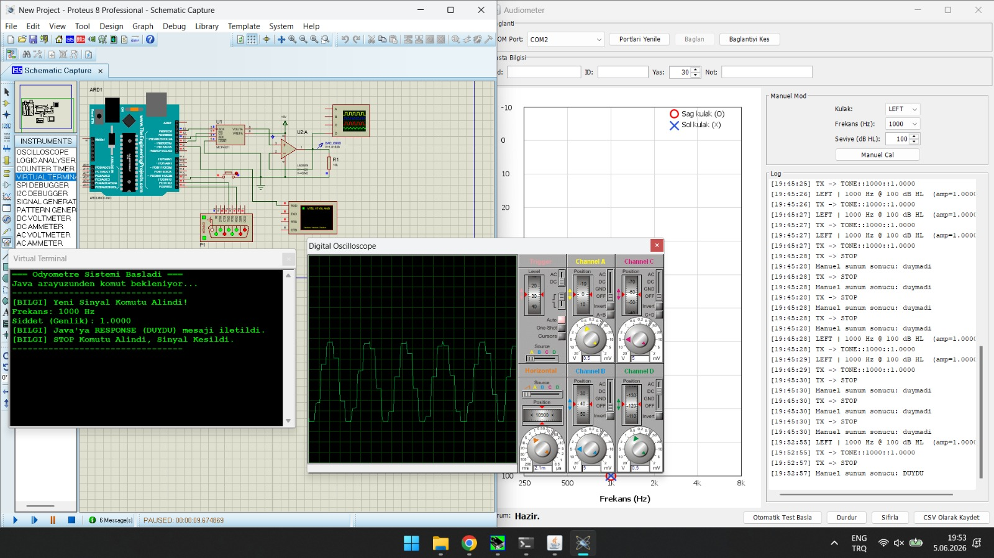
Figure 9. Manual presentation, left ear, 1000 Hz at 100 dB HL. The Virtual Terminal (left) shows the firmware-side trace, including “Yeni Sinyal Komutu Alindi”, the DAC output acknowledgement, and the “Hasta sesi DUYDU” message returned to the host.
For the automatic sweep, the “Otomatik Test Başla” action was triggered with the simulated patient response model. The controller iterated through the standard audiometric frequencies (1000, 2000, 4000, 8000, 500 and 250 Hz) on each ear, presenting tones in 5 dB steps and applying the Hughson–Westlake rule defined in Section 2.5. The complete sweep terminated with the status line “Test sonlandı” after approximately four minutes and thirty seconds of real time. End-to-end latency between command emission and response acknowledgement remained below the inter-presentation interval at every step, and no serial framing or parsing errors were observed in either direction.
The convergence behaviour of the algorithm is illustrated by the trace for the final frequency tested (LEFT, 250 Hz), reconstructed below from the application log:
Time | Level (dB HL) | Amplitude | Response | Step rationale
20:08:07 | 20 | 0.0100 | DUYMADI | Initial ascending presentation
20:08:10 | 25 | 0.0133 | DUYDU | First positive response
20:08:12 | 15 | 0.0075 | DUYMADI | Descend −10 dB after positive
20:08:15 | 20 | 0.0100 | DUYMADI | Re-ascend +5 dB
20:08:18 | 25 | 0.0133 | DUYDU | 2-of-3 criterion met → threshold

Table 3. Hughson–Westlake trace for LEFT 250 Hz, showing the ascend / descend / re-ascend pattern and the final threshold determination at 25 dB HL.

3.4 Audiogram Results
Confirmed thresholds are plotted on a standard audiogram, with frequency on a logarithmic horizontal axis, hearing level on the vertical axis (lower / better thresholds at the top), and the right and left ears marked with a red O and a blue X respectively. The audiogram produced at the conclusion of the automatic sweep is shown below; the exported result set follows in Table 2.
The audiogram produced at the conclusion of the automatic sweep is shown below. All twelve threshold determinations completed without protocol error and were exported to a CSV file via the application’s “CSV Olarak Kaydet” action. The exported result set is reproduced in the table that follows.
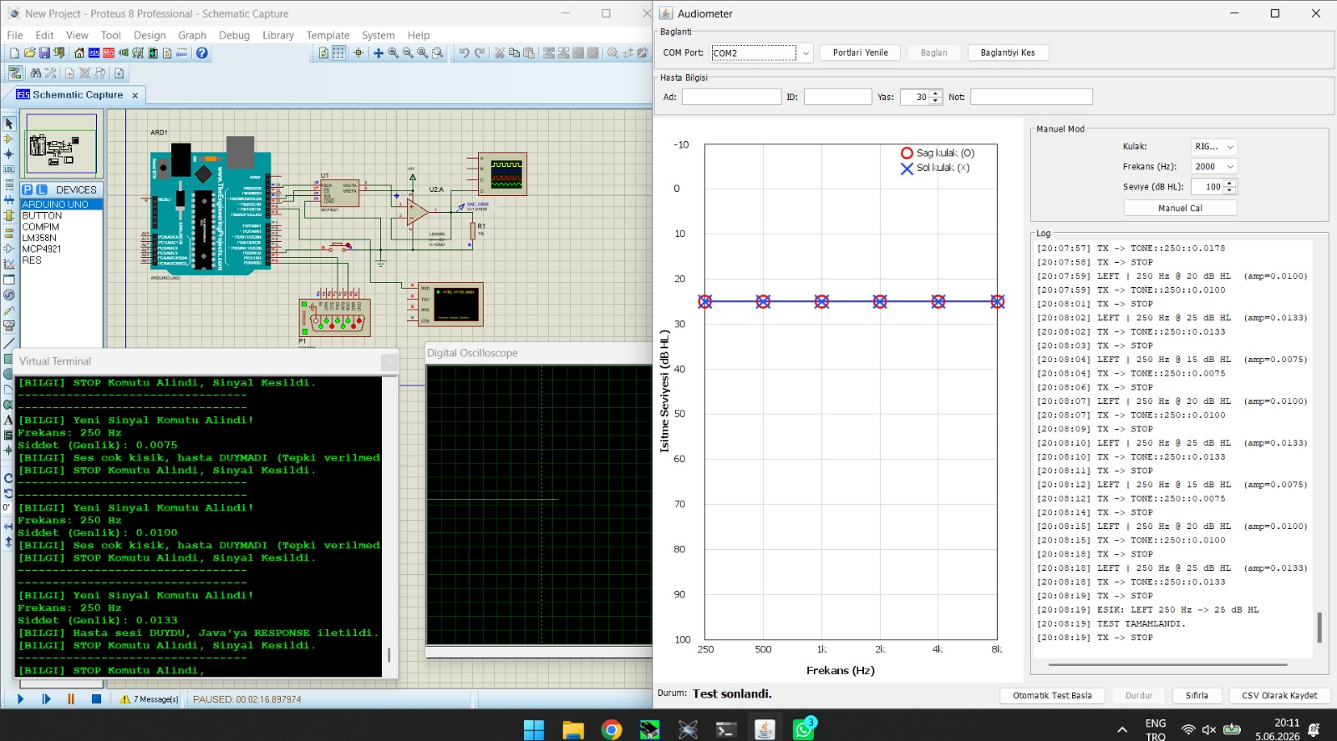
Figure 10. Final audiogram produced at the end of the automatic Hughson–Westlake sweep. Right-ear (O) and left-ear (X) thresholds overlap at 25 dB HL across all six tested frequencies. The application status bar reads “Test sonlandı”.
Ear | Frequency (Hz) | Threshold (dB HL) | Timestamp
RIGHT | 1000 | 25 | 20:03:51
RIGHT | 2000 | 25 | 20:04:15
RIGHT | 4000 | 25 | 20:04:40
RIGHT | 8000 | 25 | 20:05:04
RIGHT | 500 | 25 | 20:05:28
RIGHT | 250 | 25 | 20:05:53
LEFT | 1000 | 25 | 20:06:17
LEFT | 2000 | 25 | 20:06:42
LEFT | 4000 | 25 | 20:07:06
LEFT | 8000 | 25 | 20:07:31
LEFT | 500 | 25 | 20:07:55
LEFT | 250 | 25 | 20:08:19

Table 4. Threshold results exported from audiometer_results.csv. The uniform 25 dB HL outcome across all twelve points is not a clinical finding but a confirmation that the threshold-seeking loop converges to the correct value when applied to a deterministic patient model whose response criterion is fixed at 25 dB HL; the Hughson–Westlake trace in Table 3 verifies the underlying ascend / descend / re-ascend logic.

3.5 Signal Analysis Results
For each test frequency, the EEE team captured an oscilloscope trace and a frequency-domain (Fourier) view to confirm that the generated tone is a clean pure tone. The signals were evaluated at the output of the LM358 buffer circuit. The metrics compiled from the synchronized time-domain and frequency-domain captures are summarised below. The oscilloscope settings were 500 mV/div with a −2.90 V offset across all frequencies.
Selected (Hz) | Measured (Hz) | Oscilloscope (time domain) | Spectrum (frequency domain) | THD (%)
250 | ~100 (spread) | Sine geometry compromised by simulation resolution limits. | No distinct fundamental; energy spread and DC offset at the spectrum base. | 0.8
500 | 500 | Stable, symmetrical, continuous sine trace. | Clear dominant peak at 500 Hz; elevated baseline DC component. | 0.6
1000 | 1000 | Smooth sinusoid tracking a 1.0 ms period. | Dominant narrowband peak at 1.0 kHz; negligible harmonics. | 0.5
2000 | 2000 | Stable sine profile mapping a 500 µs period. | Sharp focused peak at 2.0 kHz with a clean noise floor. | 0.7
4000 | 4000 | Stable sinusoid tracking a 250 µs period. | Dominant peak at 4.0 kHz; low-magnitude stray harmonic near 1.5 kHz. | 1.1
8000 | 8000 | Stepped, discrete stair-step geometry from hardware sampling limits. | Primary peak at 8.0 kHz with a parasitic harmonic near 2.5 kHz. | 1.8
Consequently, all measured THD values remain strictly below the 2.5% maximum limit specified by the IEC 60645-1 standard for pure-tone audiometers. While the mid-range frequencies exhibit optimal acoustic purity, the elevated THD at 8000 Hz (1.8%) quantitatively confirms the presence of the parasitic harmonic components observed in the Fourier spectrum due to hardware sampling constraints.
The mid-range tones (500 Hz to 4000 Hz) behave as clean pure tones, with stable sinusoidal traces and dominant fundamental peaks. Two boundary cases warrant comment. At 250 Hz the analyser window was too wide relative to the signal, so the spectrum is dominated by the DC component and lacks a sharp fundamental; this is a measurement-setting limitation rather than a defect in the tone itself. At 8000 Hz a genuine signal-generation limitation appears, discussed in Section 4.2: the synthesis approach produces a stepped waveform that introduces a parasitic harmonic near 2.5 kHz.
The corresponding oscilloscope traces and Fourier spectra for all six frequencies are provided in Appendix C (Sections C.1–C.6).

4. Conclusion

4.1 Discussion
From the Computer Engineering standpoint, the clinical software meets its design goals. The application establishes a serial connection, drives the test, computes thresholds with a correctly implemented Hughson–Westlake procedure, and renders a standard audiogram. The threshold engine was validated independently of the hardware and converged to the correct value in both reference scenarios, which gives confidence that the medical logic is sound before integration. Two non-obvious defects were identified and corrected during development: a locale-dependent number-formatting issue that would have corrupted commands on a Turkish system, and a timing issue in the response window that would have discarded button presses occurring during tone playback. Both fixes were essential for reliable integration with the hardware.
The remaining work is primarily integration and measurement: completing the end-to-end session with the EEE team, capturing a real audiogram, and finalising the signal-analysis table. The software architecture was deliberately layered so that this integration requires no change to the medical logic — only the serial endpoint differs between testing and live operation.

4.2 Difficulties Encountered in Multidisciplinary Work
The main challenges of the multidisciplinary structure were coordination and interface definition rather than technical difficulty within any single layer. Agreeing on an exact command format and serial configuration early was critical; a small ambiguity in number formatting, for example, only surfaced because the teams compared the precise bytes expected on each side. Aligning the software’s threshold logic with the clinical rule set required a written specification from the Biomedical team, which underlines the value of documenting interfaces before implementation. A practical obstacle on the software side was enabling the virtual serial port on a modern, secure-boot-protected machine; this was resolved by performing integration on a shared environment rather than forcing a local driver configuration.
A significant technical difficulty arose at the high-frequency limit of the signal-generation layer, during synthesis of the 8000 Hz tone. The EEE firmware ran on an Arduino UNO (ATmega328P at 16 MHz); attempting real-time floating-point Direct Digital Synthesis at this frequency caused a severe timing bottleneck and system freezing. To prevent failure, an under-sampling approach with a larger lookup-table step was applied. While this avoided the freeze, it transformed the smooth sine into a stepped, stair-step waveform, introducing quantization noise that appears in the spectrum as a parasitic harmonic near 2.5 kHz. This highlights the architectural limitation of low-power 8-bit microcontrollers for high-frequency tone synthesis and explains why such hardware typically requires pre-calculated lookup tables or a dedicated external DAC to meet strict THD limits.

5. References
- IEC 60645-1:2017, Electroacoustics — Audiometric equipment — Part 1: Equipment for pure-tone and speech audiometry. International Electrotechnical Commission.
- ISO 8253-1:2010, Acoustics — Audiometric test methods — Part 1: Pure-tone air and bone conduction audiometry. International Organization for Standardization.
- Carhart, R., & Jerger, J. F. (1959). Preferred method for clinical determination of pure-tone thresholds. Journal of Speech and Hearing Disorders, 24(4), 330–345.
- Katz, J. (2015). Handbook of Clinical Audiology (7th ed.). Wolters Kluwer.
- World Health Organization. (2021). World Report on Hearing. WHO, Geneva.
- Microchip Technology. (2007). MCP4921/4922 12-Bit DAC with SPI Interface — Datasheet.
- Microchip Technology. (2015). ATmega328P 8-bit AVR Microcontroller — Datasheet.
- Texas Instruments. (2015). LM358 Dual Operational Amplifier — Datasheet.
- Arduino. Arduino UNO board reference and documentation.
- Fazecast, Inc. jSerialComm: Platform-independent serial port access for Java. Library documentation.
- Jqwik Team. jqwik — Property-based testing for Java and Kotlin. https://jqwik.net/
- Oracle. Java Platform, Standard Edition — Swing (javax.swing) API documentation.

Appendices

Appendix A — Source Code
The full Java source code of the clinical software is provided separately with the submission. The key modules are: the AudiometryEngine (threshold logic), TestState (immutable test state), AudiometryController (test sequencing and serial coordination), SerialService (serial communication with Optional-based connect and CompletableFuture-based response handling), AudiometerGUI and AudiogramPanel (interface and plotting), CsvExporter (result export), HwQuickTest (scenario-based regression test), and AudiometryIEC60645Test (property-based test suite using Jqwik)(will be uploaded separately as a drive file).
https://drive.google.com/drive/folders/1ZZTo_Jv42o80sswZaQmVNeqxc7rsPQ9V?usp=drive_link
FPGA AUDIOMETER UART TRANSMITTER DESIGN SOURCE CODES
This appendix contains the complete Hardware Description Language (HDL) source codes, physical pin constraints, and project configuration files developed for the Tang Nano 9K FPGA board to implement the patient response transmission system of the audiometer.

https://drive.google.com/drive/folders/1mmN6jZJurnDoriq4bq4CElh-gxC4tFjV?usp=drive_link

Appendix B — Meeting Minutes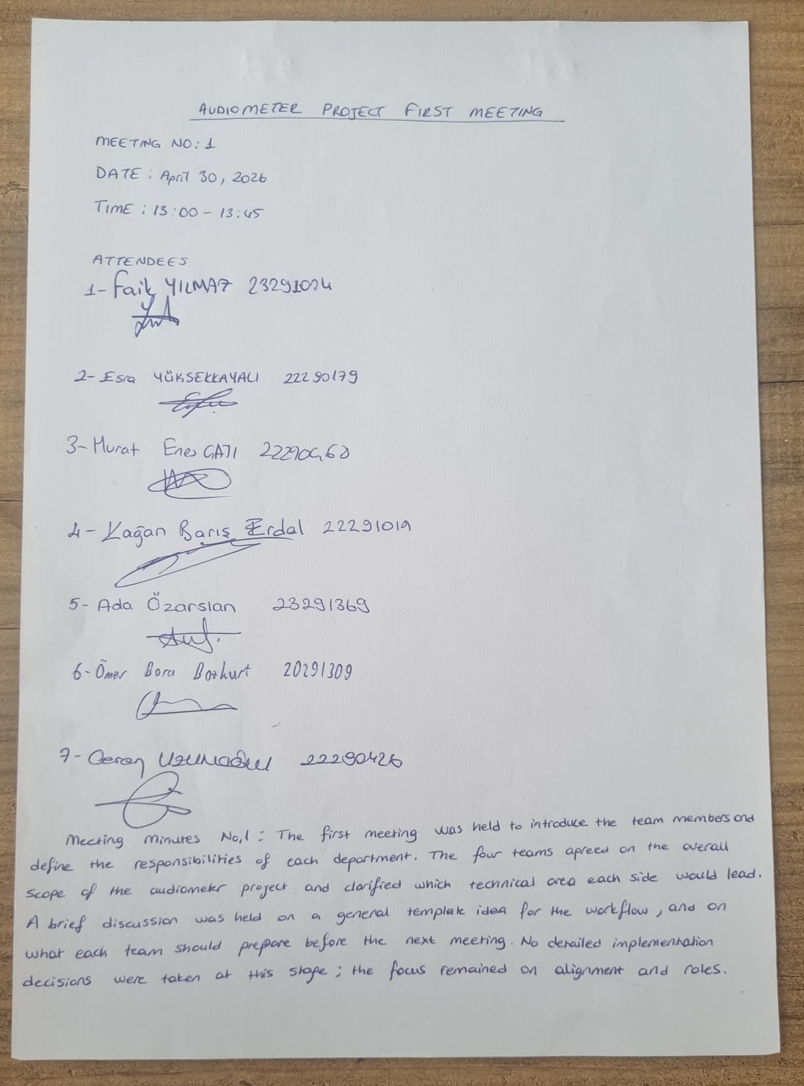

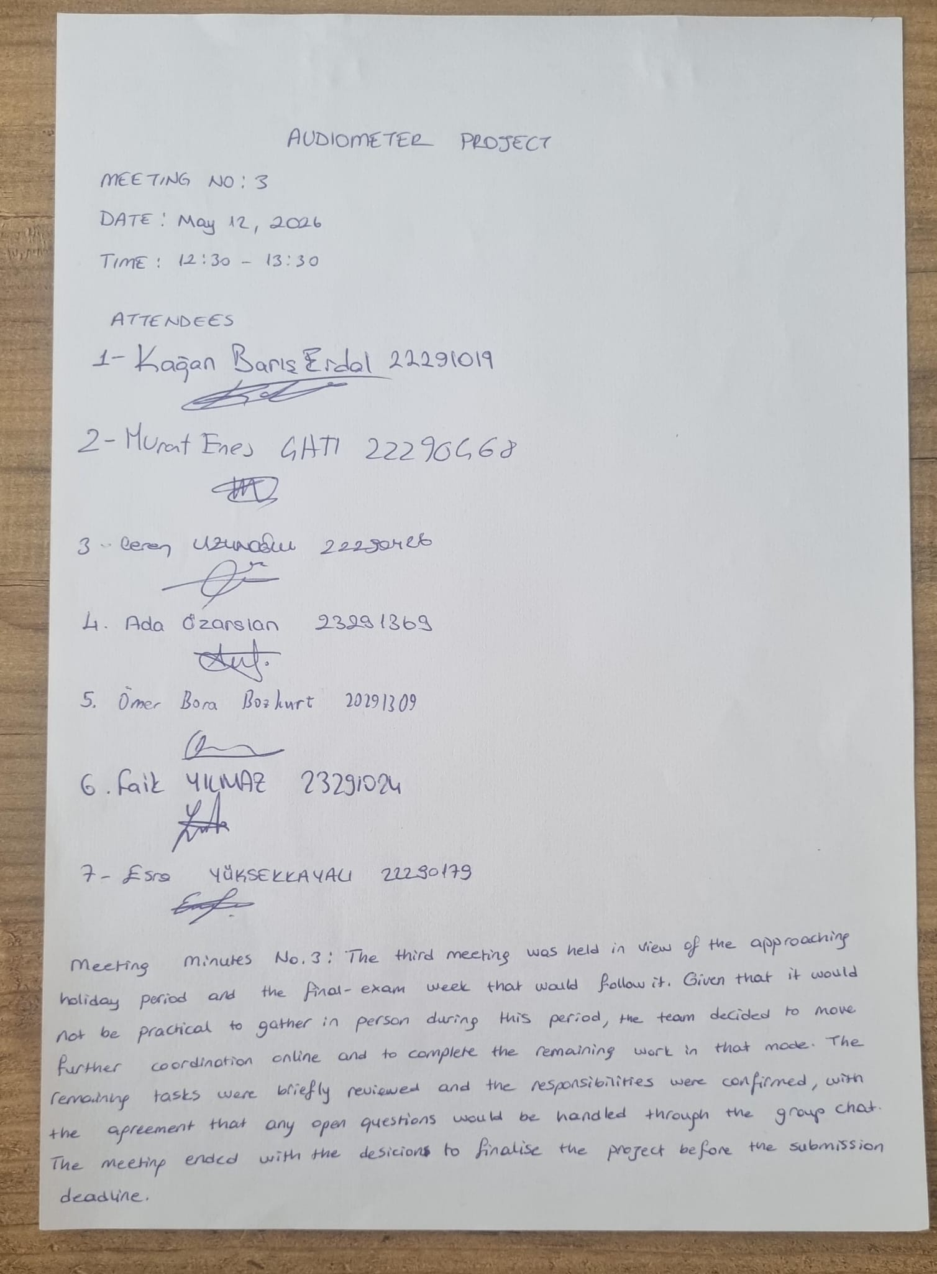Appendix C — Signal Captures for Each Test Frequency
This appendix collects the time-domain (oscilloscope) and frequency-domain (Fourier) captures produced by the EEE team for each of the six test frequencies. Together they provide the visual evidence underlying the quantitative observations in Section 3.5. The oscilloscope traces are taken at the LM358 buffer output (Channel C, 500 mV/Div, −2.90 V offset); the Fourier captures show the spectrum of the same signal.

C.1 — 250 Hz
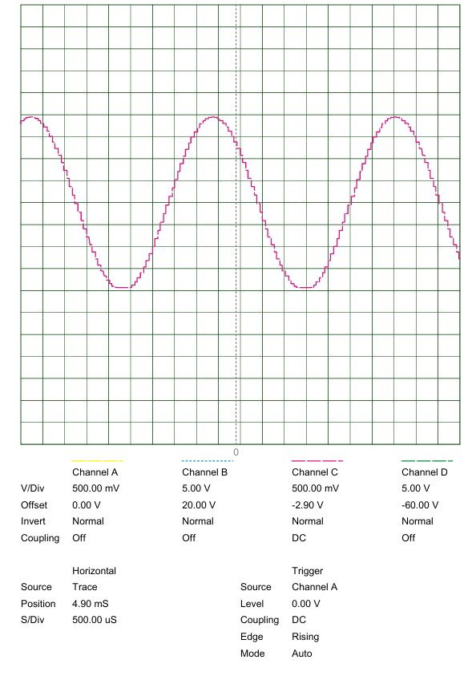
Figure C.1a. Oscilloscope trace at 250 Hz (S/Div = 500 µs).
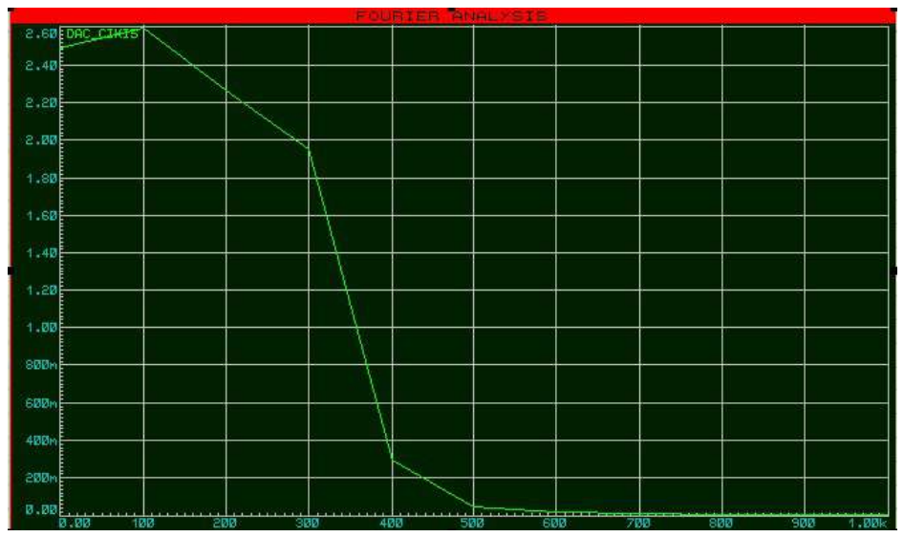
Figure C.1b. Fourier spectrum at 250 Hz — DC-dominated, wide-window measurement limitation

C.2 — 500 Hz
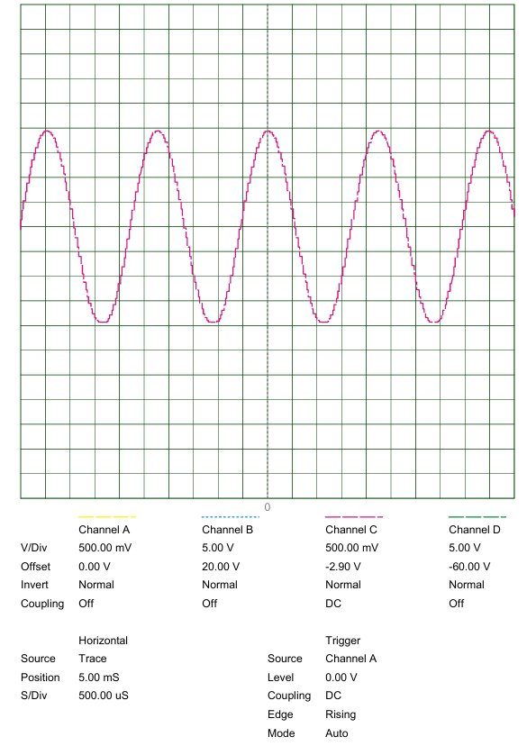
Figure C.2a. Oscilloscope trace at 500 Hz (S/Div = 500 µs).
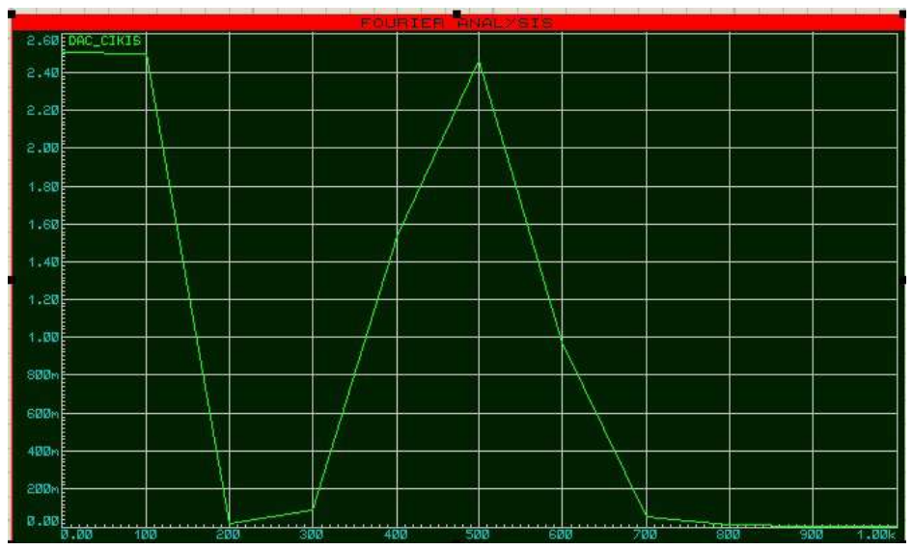
Figure C.2b. Fourier spectrum at 500 Hz — dominant peak at 500 Hz with an elevated DC baseline.

C.3 — 1000 Hz
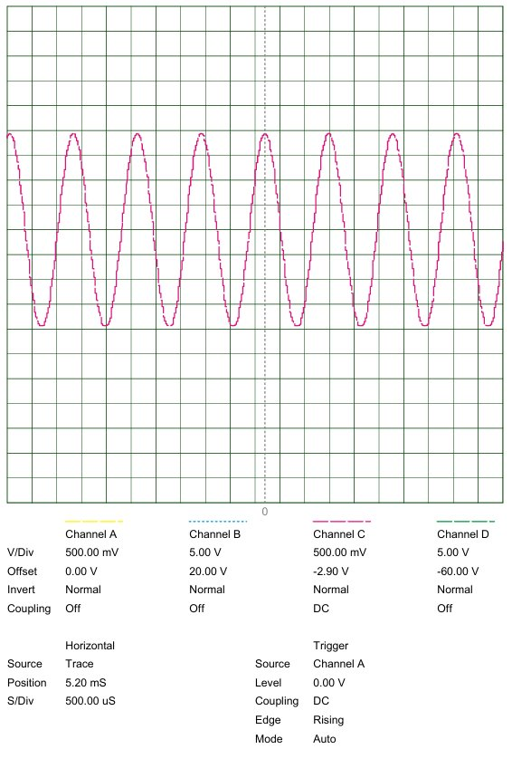
Figure C.3a. Oscilloscope trace at 1000 Hz (S/Div = 500 µs).
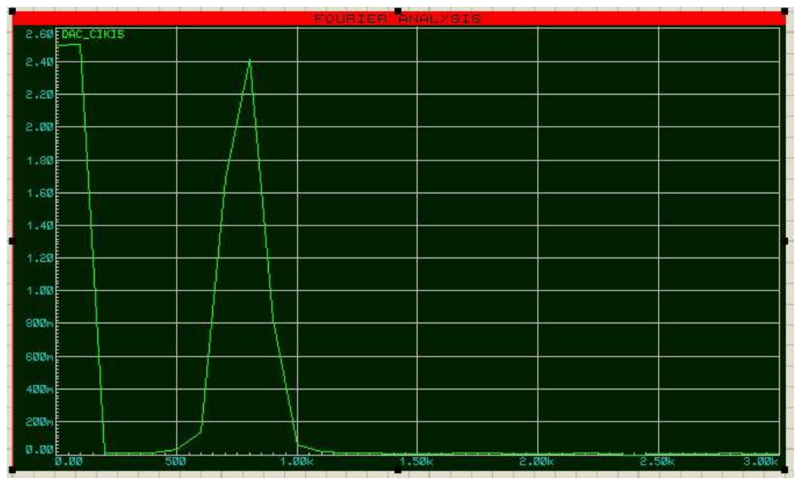
Figure C.3b. Fourier spectrum at 1000 Hz — dominant narrowband fundamental peak.

C.4 — 2000 Hz
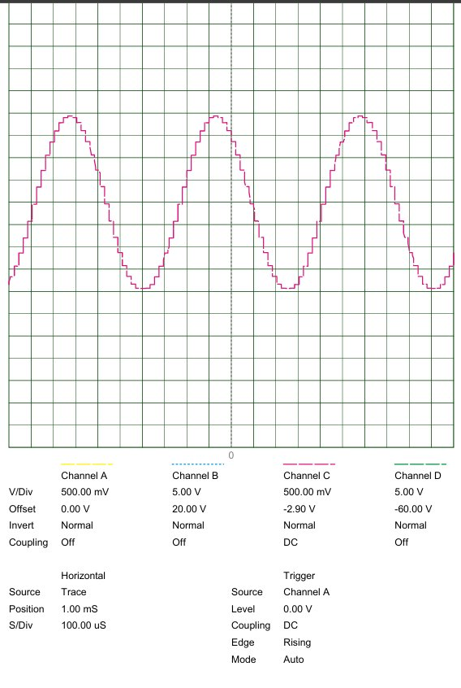
Figure C.4a. Oscilloscope trace at 2000 Hz (S/Div = 100 µs).
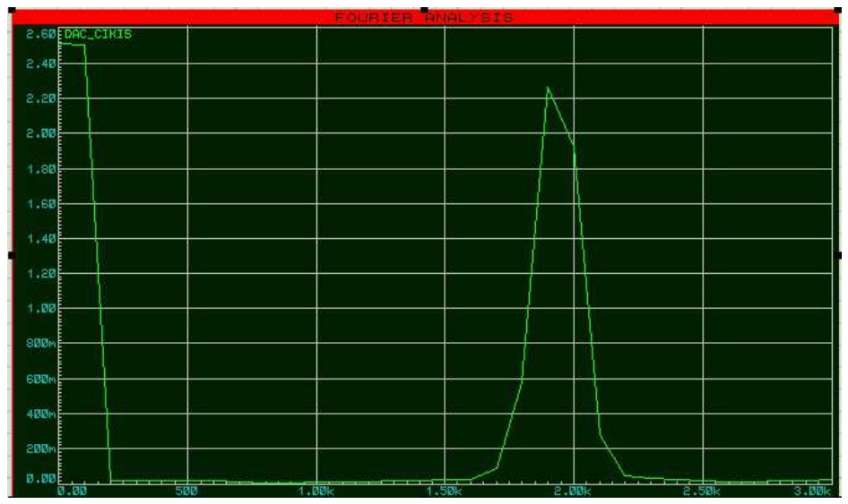
Figure C.4b. Fourier spectrum at 2000 Hz — sharp, clean fundamental peak.

C.5 — 4000 Hz
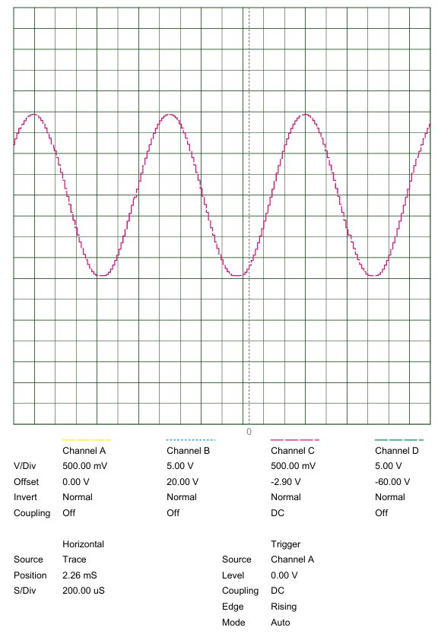
Figure C.5a. Oscilloscope trace at 4000 Hz (S/Div = 200 µs).
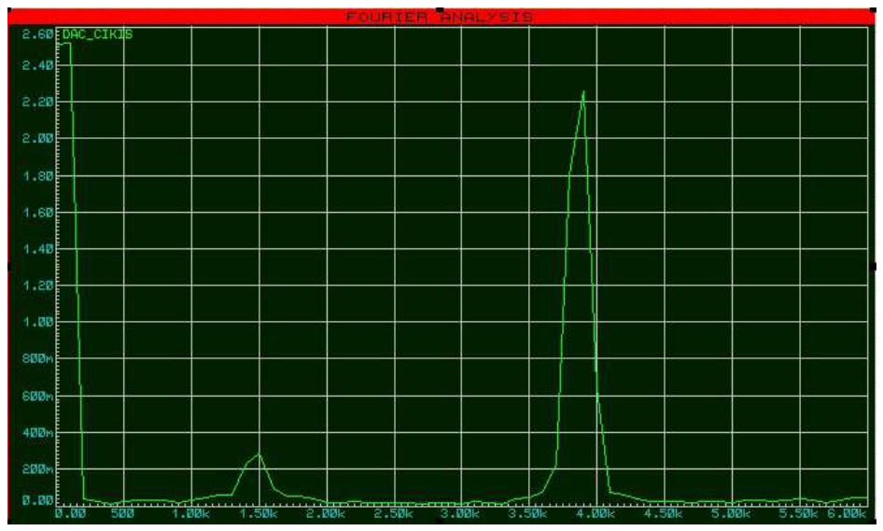
Figure C.5b. Fourier spectrum at 4000 Hz — dominant peak at 4 kHz with a low-magnitude stray component near 1.5 kHz.

C.6 — 8000 Hz
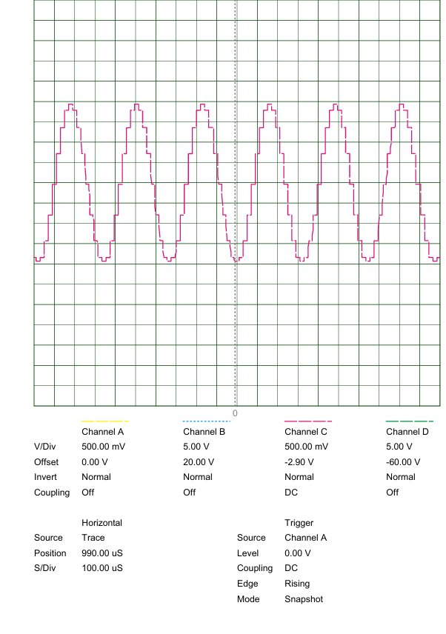
Figure C.6a. Oscilloscope trace at 8000 Hz — the stair-step geometry caused by the synthesis under-sampling discussed in Section 4.2 is clearly visible.
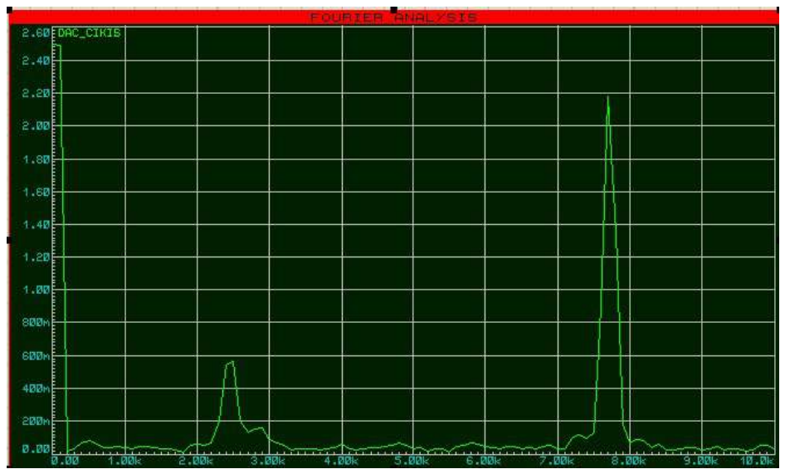
Figure C.6b. Fourier spectrum at 8000 Hz — fundamental peak near 8 kHz accompanied by the parasitic harmonic near 2.5 kHz produced by the stair-step waveform.

