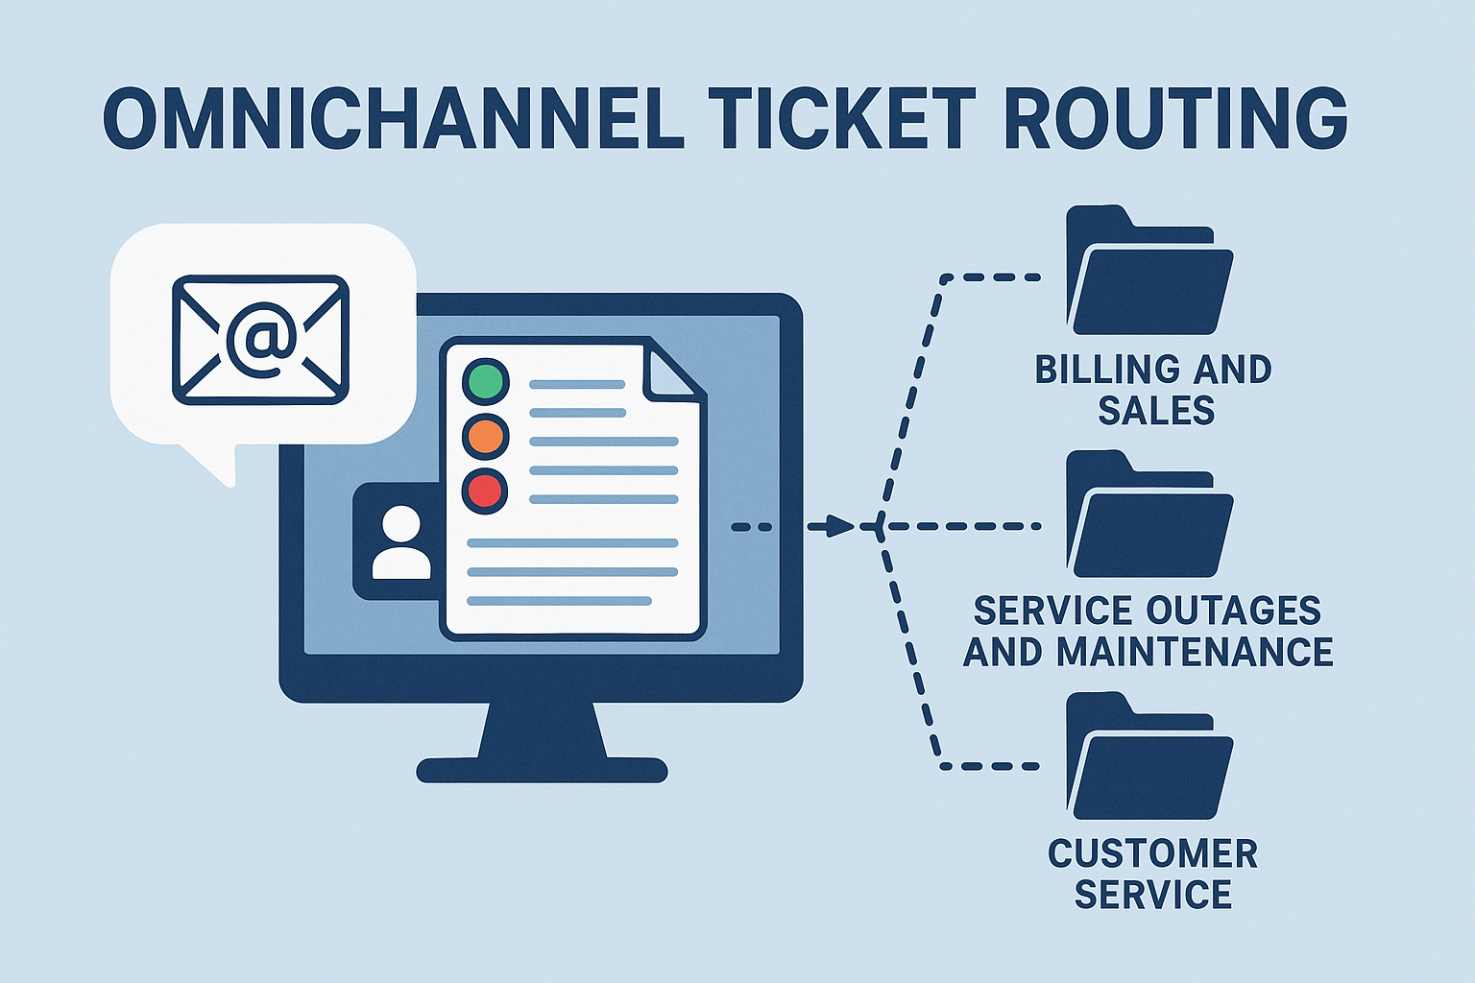
DATASET
OMNICHANNEL TICKET ROUTING

SCENARIO
A technology company has recently deployed an omnichannel communication platform that unifies all customer interactions such as email, chat, forms, and app requests into one central system. At the heart of this platform lies a data-driven ticket routing engine that must automatically direct incoming support tickets to the correct business department.
As a result of a comprehensive business process audit, the company has discovered a costly inefficiency:
- Whenever a ticket is routed to the wrong department, the case bounces around the organization before reaching the correct team. This adds delays and costs an estimated €10 per misrouted ticket.
- Exception:
Customer Service department often receives misrouted tickets because they act as the “catch-all” triage department. If a ticket is incorrectly sent to Customer Service, there is no cost penalty, because they already handle the triage process internally.
The company’s leadership is eager: a well-performing omnichannel ticket routing system will dramatically reduce cross-team back-and-forth, improve customer satisfaction, and streamline internal workflows.
This is where you come in. You are hired as a freelancer/consultant. Fresh from successfully completing IM0503 Data Analytics, you now have the skills and tools to solve this costly problem.

DATASET DESCRIPTION
The company has compiled a dataset of historical support tickets, annotated by the agents who previously handled them. The dataset contains both everyday service questions and highly specific domain issues (e.g., invoice mismatches, network outages, employee leave requests).

Attribute | Description
DEPARTMENT | The department to which the ticket was routed. Possible values: Billing and Sales, Service Outages and Maintenance, Customer Service, Human Resources.
Priority | Urgency level assigned to the ticket: Low, Medium, Critical.
Subject | The subject line of the customer’s email.
Body | The full text of the customer’s message.
Type | Ticket type selected by an agent (e.g., Incident, Request, Problem, Change).

Reference:
Derived from: https://www.kaggle.com/datasets/tobiasbueck/multilingual-customer-support-tickets/data

