

Hacettepe University
Department of Electrical and Electronics Engineering

ELE432 - Advanced Digital Design
Preliminary Work 1

Murathan Yılmaz
2210357037

Lab Date: 25.03.2025
Q1) Lab Duration
- Total Time Spent: 6 hours.

Q2) State Transition Diagrams
The system is designed using two communicating Finite State Machines (FSMs):
A. Room FSM
This FSM tracks the player's location across seven distinct rooms.
- States: CAVE, TUNNEL, RIVER, STASH, DRAGON, VAULT, GRAVEYARD .
- Transitions: Movements are triggered by directional inputs (N, S, E, W).
- Logic: Access to the VAULT from the DRAGON's Den is only possible if the has_sword signal is high; otherwise, the state transitions to GRAVEYARD.
B. Sword FSM
This FSM monitors the possession of the Vorpal Sword.
- States: NO_SWORD (Initial), HAS_SWORD.
- Logic: Transitions to HAS_SWORD when the Room FSM signals sw_found (upon entering the STASH).

Q3) Behavioral SystemVerilog Code
The implementation consists of a top-level module connecting the two sub-modules.
- adventure_game.sv: Connects the Room and Sword FSMs using internal signals sw_found and has_sword.
module adventure_game (
input logic clk,
input logic reset,
input logic n, s, e, w,
output logic win, die
);
logic sw_found;
logic has_sword;

// Room FSM
room_fsm rooms (
.clk(clk),
.reset(reset),
.n(n), .s(s), .e(e), .w(w),
.has_sword(has_sword),
.sw_found(sw_found),
.win(win),
.die(die)
);

// Sword FSM
sword_fsm sword (
.clk(clk),
.reset(reset),
.sw_found(sw_found),
.has_sword(has_sword)
);

endmodule

- room_fsm.sv: Implements the room navigation logic using a 3-bit enumerated type and a synchronous always_ff block for state updates.
module room_fsm (
input logic clk, reset,
input logic n, s, e, w,
input logic has_sword,
output logic sw_found,
output logic win, die
);
typedef enum logic [2:0] {
CAVE, TUNNEL, RIVER, STASH, DRAGON, VAULT, GRAVEYARD
} state_t;

state_t current_state, next_state;

// State Register
always_ff @(posedge clk or posedge reset) begin
if (reset) current_state <= CAVE;
else current_state <= next_state;
end

// Next State Logic
always_comb begin
case (current_state)
CAVE: next_state = (e) ? TUNNEL : CAVE;
TUNNEL:next_state = (w) ? CAVE : (s) ? RIVER : TUNNEL;
RIVER: next_state = (n) ? TUNNEL : (w) ? STASH : (e) ? DRAGON : RIVER;
STASH: next_state = (e) ? RIVER : STASH;
DRAGON:begin
if (has_sword) next_state = VAULT;
else next_state = GRAVEYARD;
end
VAULT: next_state = VAULT; // game is finished
GRAVEYARD:next_state = GRAVEYARD; // game is finished
default: next_state = CAVE;
endcase
end

// Output Logic
assign sw_found = (current_state == STASH);
assign win = (current_state == VAULT);
assign die = (current_state == GRAVEYARD);

endmodule

- sword_fsm.sv: Manages the sword status, ensuring the sword remains possessed once found until a system reset occurs.
module sword_fsm (
input logic clk,
input logic reset,
input logic sw_found,
output logic has_sword
);
typedef enum logic { NO_SWORD, HAS_SWORD } state_t;
state_t current_state, next_state;

// State Register
always_ff @(posedge clk or posedge reset) begin
if (reset) current_state <= NO_SWORD;
else current_state <= next_state;
end

// Next State Logic
always_comb begin
case (current_state)
NO_SWORD: next_state = (sw_found) ? HAS_SWORD : NO_SWORD;
HAS_SWORD: next_state = HAS_SWORD;
default: next_state = NO_SWORD;
endcase
end

// Output Logic
assign has_sword = (current_state == HAS_SWORD);

endmodule

Q4) Testbench and Test Vectors
A self-checking testbench was developed to verify the design.
- Scenario 1 (Die): The player moves directly from CAVE -> TUNNEL -> RIVER -> DRAGON without the sword, resulting in the die output being asserted.
- Scenario 2 (Win): After a reset, the player moves CAVE -> TUNNEL -> RIVER -> STASH (obtaining the sword) -> RIVER -> DRAGON -> VAULT, asserting the win output.
`timescale 1ns/1ps

module tb_adventure_game();
logic clk, reset, n, s, e, w;
logic win, die;
adventure_game dut (.*);

// Generate clock signal
initial clk = 0;
always #5 clk = ~clk;

// Helper for clearing signal
task clear_inputs();
{n, s, e, w} = 4'b0000;
endtask

initial begin
// --- scenario 1
reset = 1; clear_inputs(); #20 reset = 0;

@(posedge clk); e = 1; #10; clear_inputs(); // Twisty Tunnel
@(posedge clk); s = 1; #10; clear_inputs(); // Rapid River
@(posedge clk); e = 1; #10; clear_inputs(); // Dragon's Den

#10;

// --- scenario 2
#20 reset = 1; #20 reset = 0; // restart

@(posedge clk); e = 1; #10; clear_inputs(); // Tunnel
@(posedge clk); s = 1; #10; clear_inputs(); // River
@(posedge clk); w = 1; #10; clear_inputs(); // Stash (sword is taken)
@(posedge clk); e = 1; #10; clear_inputs(); // Back to River
@(posedge clk); e = 1; #10; clear_inputs(); // Dragon's Den
@(posedge clk); e = 1; #10; clear_inputs(); // Victory Vault

#10;

#50 $stop;
end
endmodule

Q5) Simulation Waveforms
The simulation was performed using QuestaSim.
- Verification: The waveforms display the clk, reset, directional inputs, and the current_state signal.
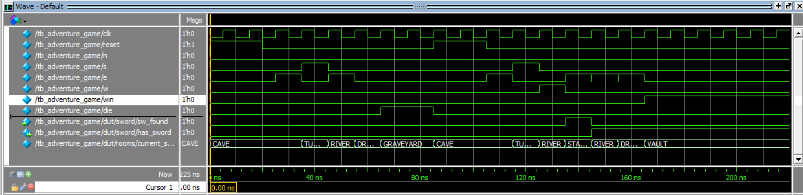
- Result: All test vectors passed the self-checking mechanism, confirming that the FSM transitions correctly match the game logic and map requirements.

Q6) RTL Viewer Schematics
The synthesized schematic confirms the structural integrity of the design.
- Analysis: The RTL Viewer displays the two FSM blocks and their bidirectional communication.
- Expectation: The registers (flip-flops) and combinational logic (multiplexers) correctly represent the intended behavioral idiom.
