**Task 2.** A common typing mistake is to place your hands on the keyboard one row to the right of the correct position.

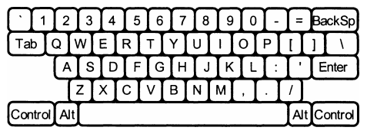

Then "Q" is printed as "W", "J" is printed as "K", etc. Your task is to decipher the message typed in this way.

**Input data:** The input consists of several lines of text. Each line can contain numbers, spaces, capital letters (except "Q", "A", "Z") and the punctuation marks shown above [except backquote (*)]. Keys labeled [Tab, BackSp, Control, etc.] are not represented in the input.

**Output data:** You must replace each letter and punctuation mark with the one immediately to the left of it on the QWERTY keyboard pictured above. Gaps (space) in the input must be copied in the output.

**Program execution time:** no more than 1 second.

**Note:** all characters in text files must be 1 byte in size.

**Examples:**

|  |  |
| --- | --- |
| **Sample input** | **Sample output** |
| О S, GOMR YPSFU/ | I AM FINE TODAY. |