Vision Transformer-Assisted Cold Atmospheric Plasma System for Dermatological Treatment Planning: Experimental Characterization and AI-Based Skin Lesion Classification

Abstract
Atmospheric cold plasma (ACP) systems have attracted considerable interest for non-invasive surface treatment and emerging dermatological applications due to their ability to generate chemically reactive species at near-ambient temperatures. This study presents a dual-contribution approach: (i) experimental characterization of a multi-mode atmospheric plasma system operating at 40 kHz with adjustable power (50-200 W), evaluating thermal behavior, ozone generation, and surface wettability modification; and (ii) development of a Vision Transformer (ViT)-based deep learning framework for automated classification of skin lesions as plasma-treatable (malignant/pre-malignant) or benign, supporting cold plasma treatment planning decisions. The experimental results confirm stable non-thermal plasma operation with surface temperatures below 40 degrees C, controlled reactive species generation, and significant enhancement of surface hydrophilicity. For the AI-based classification, three architectures were evaluated on the HAM10000 dermoscopic dataset (1,257 images, binary classification) using 3-fold stratified cross-validation: ViT-Tiny trained from scratch (51.63% accuracy), ViT-Tiny with ImageNet pretraining (77.88% accuracy, AUC=0.868), and ResNet-18 from scratch (61.81% accuracy). The pretrained Vision Transformer achieved the highest overall performance with 83.33% sensitivity for identifying plasma-treatable lesions, demonstrating the critical role of transfer learning in medical imaging with limited data. This work establishes a framework for integrating AI-assisted diagnostic tools with cold plasma treatment systems in dermatological applications.
Keywords: atmospheric cold plasma, Vision Transformer, skin lesion classification, transfer learning, dermatological treatment planning, deep learning, HAM10000

1. Introduction
Plasma, commonly referred to as the fourth state of matter, consists of a partially ionized gas containing electrons, ions, and neutral species. Among plasma technologies, atmospheric cold plasma (ACP) has emerged as a promising approach for surface treatment and biomedical applications due to its ability to generate chemically active species without inducing significant thermal damage to treated substrates [1-3]. Recent studies have demonstrated that cold atmospheric plasma exhibits selective cytotoxicity toward malignant cells while preserving healthy tissue, positioning it as a potential non-invasive dermatological treatment modality [4,10].
The interaction between ACP and biological surfaces is governed by non-equilibrium processes involving energetic electrons, reactive oxygen and nitrogen species (ROS/RNS), ultraviolet radiation, and localized electric fields [4,5]. These reactive species can selectively target cancerous and pre-cancerous skin cells, making cold plasma a subject of growing interest in dermatological research for the treatment of conditions including melanoma, basal cell carcinoma, and actinic keratoses [1,3,10].
However, successful clinical application of cold plasma in dermatology requires accurate pre-treatment identification of lesion types, as different lesion categories may demand distinct plasma parameters including power level, exposure duration, and nozzle-to-skin distance. Manual dermoscopic evaluation remains subjective and operator-dependent, highlighting the need for automated diagnostic support systems [13,14].
Vision Transformers (ViT), introduced by Dosovitskiy et al. [15], have recently demonstrated state-of-the-art performance in medical image classification tasks by leveraging self-attention mechanisms to capture global contextual information from images. Unlike convolutional neural networks (CNNs), which rely on local receptive fields, ViTs process images as sequences of patches, enabling them to model long-range dependencies that are particularly relevant for distinguishing subtle morphological differences in dermoscopic images [16,17].
This study presents a dual-contribution approach: (i) experimental characterization of a multi-mode atmospheric cold plasma system suitable for dermatological surface treatment, and (ii) development of a Vision Transformer-based classification framework for automated identification of plasma-treatable skin lesions. To the best of our knowledge, this is among the first studies to integrate ViT-based lesion classification with cold plasma treatment planning for dermatological applications.

2. Materials and Methods

2.1 Plasma System Description
The investigated system is a multi-mode atmospheric plasma generator designed to operate in both cold and warm plasma regimes. The excitation frequency is fixed at 40 kHz, while the output power is adjustable from 50 to 200 W. The system supports multiple discharge modes, including shot, pulse, and continuous operation. High-purity argon gas (>=99.6%) was supplied from a high-pressure cylinder through a pressure-reducing valve. The outlet pressure was regulated below 0.15 MPa to ensure stable discharge conditions and operational safety.

2.2 Experimental Setup and Measurements
All experiments were conducted under ambient laboratory conditions (22 +/- 2 degrees C, relative humidity 45 +/- 5%). The distance between the plasma outlet and the treated surface was fixed at 5 mm. Exposure times of 5, 10, 30, and 60 s were investigated. Glass microscope slides (25 x 75 mm) were used as model substrates. Prior to plasma treatment, all samples were cleaned with ethanol and deionized water. Plasma-induced surface temperature was measured using an infrared (IR) thermal camera. Ozone concentration was measured using a calibrated electrochemical sensor positioned 10 mm from the plasma outlet. Surface wettability was evaluated via static water contact angle measurements using a goniometer with 5 uL deionized water droplets.

2.3 Plasma Chemistry and Reactive Species
Atmospheric plasma interaction with ambient air leads to the formation of reactive species, including ozone, through electron-impact dissociation and recombination reactions. The dominant reaction pathways include molecular oxygen dissociation (O2 + e- -> 2O + e-) and subsequent three-body recombination (O + O2 + M -> O3 + M), where M represents a third-body collision partner [5,7]. These reactive oxygen species are central to the biological effects of cold plasma on skin tissue, including selective oxidative stress on malignant cells.

3. Vision Transformer-Based Classification Framework

3.1 Clinical Motivation
Cold atmospheric plasma has demonstrated selective cytotoxicity toward malignant and pre-malignant skin cells while preserving healthy tissue [1,3,10]. However, accurate pre-treatment identification of lesion types is essential for optimizing plasma treatment parameters. To address this clinical need, a deep learning-based binary classification framework was developed to automatically distinguish between plasma-treatable (malignant/pre-malignant) and benign skin lesions, thereby supporting treatment planning decisions.

3.2 Dataset
The HAM10000 dataset [18], a large-scale collection of 13,354 multi-source dermatoscopic images of common pigmented skin lesions, was employed for model development. The original seven diagnostic categories were mapped to a binary classification scheme aligned with cold plasma treatment eligibility:
Plasma-Treatable (malignant/pre-malignant): melanoma (n=200), basal cell carcinoma (n=200), and actinic keratoses (n=200).
Benign (no plasma treatment indicated): melanocytic nevi (n=200), benign keratosis-like lesions (n=200), dermatofibroma (n=115), and vascular lesions (n=142).
Table 1. Dataset distribution and binary label mapping for cold plasma treatment eligibility.
Original Class | Samples | Binary Label | Clinical Relevance
Melanoma | 200 | Plasma-Treatable | Malignant - primary CAP target
Basal Cell Carcinoma | 200 | Plasma-Treatable | Malignant - CAP responsive
Actinic Keratoses | 200 | Plasma-Treatable | Pre-malignant - preventive CAP
Melanocytic Nevi | 200 | Benign | No treatment needed
Benign Keratosis | 200 | Benign | No treatment needed
Dermatofibroma | 115 | Benign | No treatment needed
Vascular Lesions | 142 | Benign | No treatment needed
TOTAL | 1,257 | Treatable: 600 / Benign: 657

3.3 Model Architectures
Three deep learning architectures were evaluated to provide comprehensive comparison between transformer-based and convolutional approaches:
ViT-Tiny (from scratch): A Vision Transformer [15] with patch size 16x16, embedding dimension 192, 12 transformer layers, and 3 attention heads (5.52M parameters), trained from random initialization. This configuration evaluates the inherent capacity of the ViT architecture without external knowledge transfer.
ViT-Tiny (pretrained): An identical architecture initialized with ImageNet-21k pretrained weights and fine-tuned on the skin lesion dataset. This configuration evaluates the impact of transfer learning on classification performance with limited medical imaging data.
ResNet-18 (from scratch): A standard 18-layer residual convolutional neural network [19] (11.18M parameters) trained from random initialization, serving as the CNN baseline for architectural comparison.

3.4 Training Protocol
All models were trained for 5 epochs using the AdamW optimizer [20] with an initial learning rate of 1e-4 and weight decay of 1e-4. A cosine annealing learning rate schedule was applied. To address class imbalance between treatable (n=600) and benign (n=657) samples, both weighted random sampling during data loading and weighted cross-entropy loss during optimization were employed. All images were resized to 224x224 pixels and normalized using ImageNet statistics. Data augmentation including random horizontal/vertical flipping, rotation (up to 20 degrees), and color jittering (brightness 0.3, contrast 0.3, saturation 0.2) was applied during training. Model evaluation was conducted using 3-fold stratified cross-validation.

3.5 Evaluation Metrics
Classification performance was assessed using accuracy, F1-score, area under the receiver operating characteristic curve (AUC-ROC), sensitivity (recall for plasma-treatable class), and specificity (recall for benign class). Sensitivity is particularly critical in this clinical context, as failure to identify a treatable lesion (false negative) may result in missed treatment opportunities. All metrics are reported as mean +/- standard deviation across cross-validation folds.

4. Experimental Results: Plasma Characterization

4.1 Thermal Behavior
Measured surface temperatures confirmed non-thermal plasma operation in cold plasma mode. At power levels up to 150 W, surface temperatures remained below 38 degrees C for all exposure durations. Even at 200 W, the temperature did not exceed 40 degrees C for short exposure times (<=10 s). These results experimentally validate safe operating conditions for potential dermatological applications, where tissue thermal damage thresholds must not be exceeded [4,6].

4.2 Ozone Generation
Ozone concentration increased monotonically with both applied power and exposure time. This trend is consistent with enhanced electron-impact dissociation of molecular oxygen at higher discharge energies [5,7]. At the highest tested power and exposure duration, ozone concentrations remained within experimentally controllable limits, confirming the feasibility of dose-controlled reactive species delivery for surface treatment applications.

4.3 Surface Wettability Modification
Plasma treatment resulted in a significant reduction in water contact angle on glass substrates. Untreated surfaces exhibited an average contact angle of 72 +/- 3 degrees, whereas plasma-treated surfaces showed values as low as 28 +/- 2 degrees after 30 s of exposure at 150 W. The enhanced hydrophilicity is attributable to plasma-induced modification of surface functional groups, increasing surface energy [8,9]. This wettability enhancement is analogous to the plasma-mediated permeabilization effects observed on biological membranes, which facilitate selective uptake of reactive species by target cells.

5. Classification Results

5.1 Overall Performance Comparison
Table 2 presents the comparative classification performance of the three evaluated models for cold plasma treatment eligibility classification.
Table 2. Classification performance comparison for cold plasma treatment eligibility (3-fold CV).
Model | Params | Accuracy (%) | F1-Score | AUC-ROC | Sensitivity | Specificity
ViT-Tiny (scratch) | 5.52M | 51.63 +/- 0.98 | 0.362 +/- 0.216 | 0.531 +/- 0.008 | 0.373 +/- 0.245 | 0.647 +/- 0.240
ViT-Tiny (pretrained) | 5.52M | 77.88 +/- 0.79 | 0.782 +/- 0.012 | 0.868 +/- 0.005 | 0.833 +/- 0.029 | 0.729 +/- 0.014
ResNet-18 (scratch) | 11.18M | 61.81 +/- 1.91 | 0.681 +/- 0.013 | 0.678 +/- 0.001 | 0.858 +/- 0.093 | 0.400 +/- 0.121

The pretrained ViT-Tiny model achieved the highest overall accuracy (77.88 +/- 0.79%) and AUC-ROC (0.868 +/- 0.005), significantly outperforming both the from-scratch ViT-Tiny (51.63%) and ResNet-18 (61.81%).
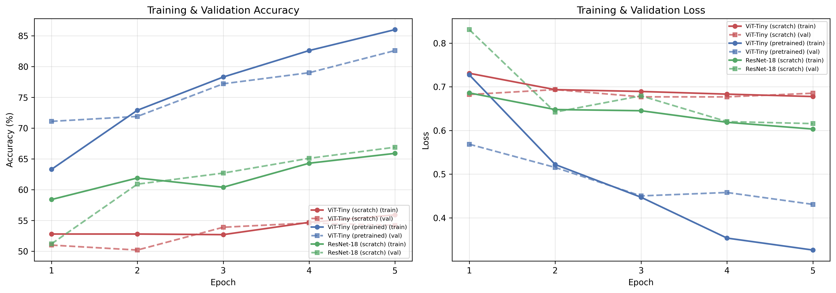
Figure 8. Average training and validation curves across 3-fold cross-validation for all three models. The pretrained ViT-Tiny demonstrates rapid convergence and superior generalization compared to from-scratch alternatives.

5.2 Per-Fold Results
Table 3. Per-fold classification results across cross-validation splits.
Model | Fold | Accuracy (%) | F1-Score | AUC | Sensitivity | Specificity
ViT-Tiny (scratch) | 1 | 50.36 | 0.5294 | 0.520 | 0.585 | 0.429
ViT-Tiny (scratch) | 2 | 52.74 | 0.0571 | 0.534 | 0.030 | 0.982
ViT-Tiny (scratch) | 3 | 51.79 | 0.5000 | 0.538 | 0.505 | 0.530
ViT-Tiny (pretrained) | 1 | 77.33 | 0.7711 | 0.874 | 0.800 | 0.749
ViT-Tiny (pretrained) | 2 | 77.33 | 0.7775 | 0.865 | 0.830 | 0.722
ViT-Tiny (pretrained) | 3 | 79.00 | 0.7982 | 0.864 | 0.870 | 0.717
ResNet-18 (scratch) | 1 | 59.90 | 0.6934 | 0.677 | 0.950 | 0.279
ResNet-18 (scratch) | 2 | 63.72 | 0.6681 | 0.679 | 0.765 | 0.521

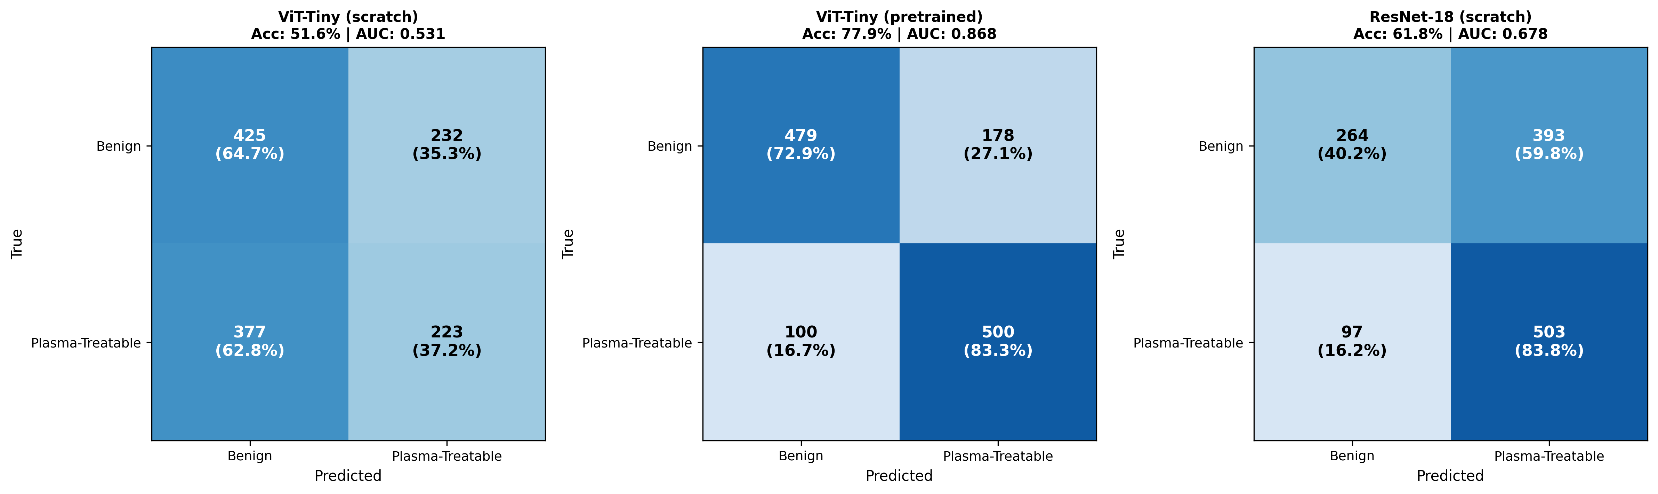
Figure 9. Normalized confusion matrices for all three models aggregated across cross-validation folds. The pretrained ViT-Tiny achieves the most balanced classification between benign and plasma-treatable classes.
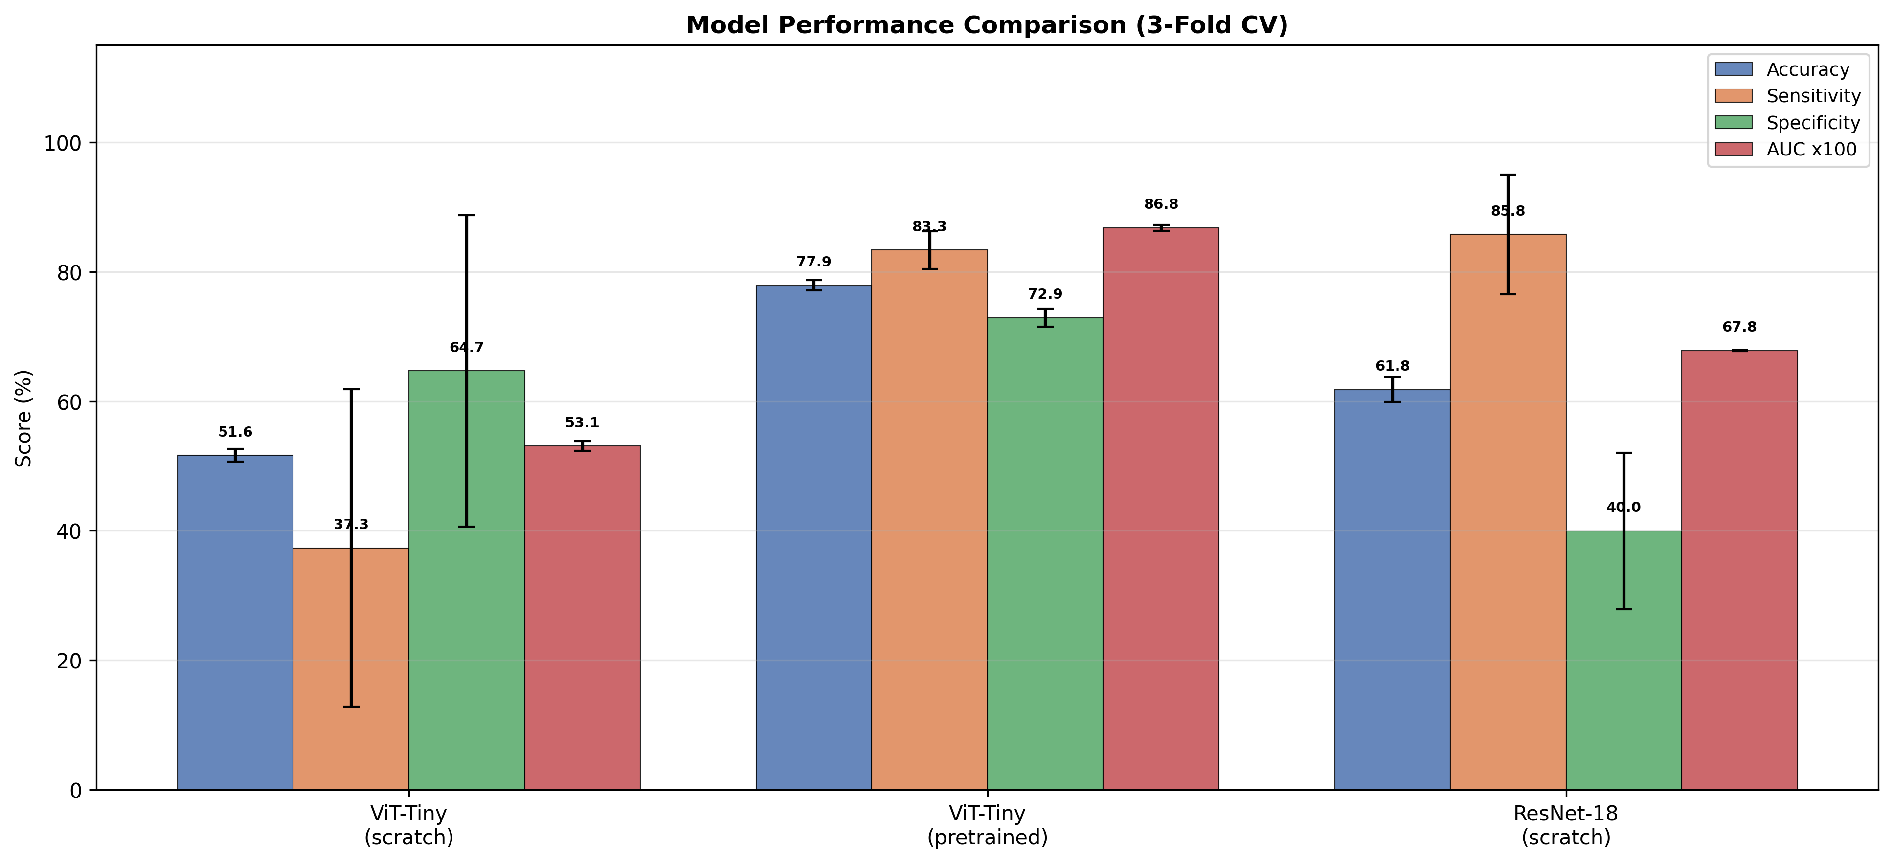
Figure 10. Comparative bar chart of model performance metrics with standard deviation error bars. The pretrained ViT-Tiny demonstrates superior and consistent performance across all metrics.

6. Discussion

6.1 Transfer Learning Effect
The most striking finding is the 26.25 percentage point accuracy gap between pretrained and from-scratch ViT-Tiny models, despite identical architectures and parameter counts (5.52M). The from-scratch ViT achieved near-random performance (51.63% vs. 50% random baseline), indicating that the Vision Transformer architecture requires either substantially larger datasets or pretrained representations to learn meaningful visual features from dermoscopic images. This finding is consistent with the established understanding that ViTs lack the inductive biases inherent to CNNs (locality, translation equivariance) and therefore depend more heavily on data volume or pretrained feature representations [15,16].
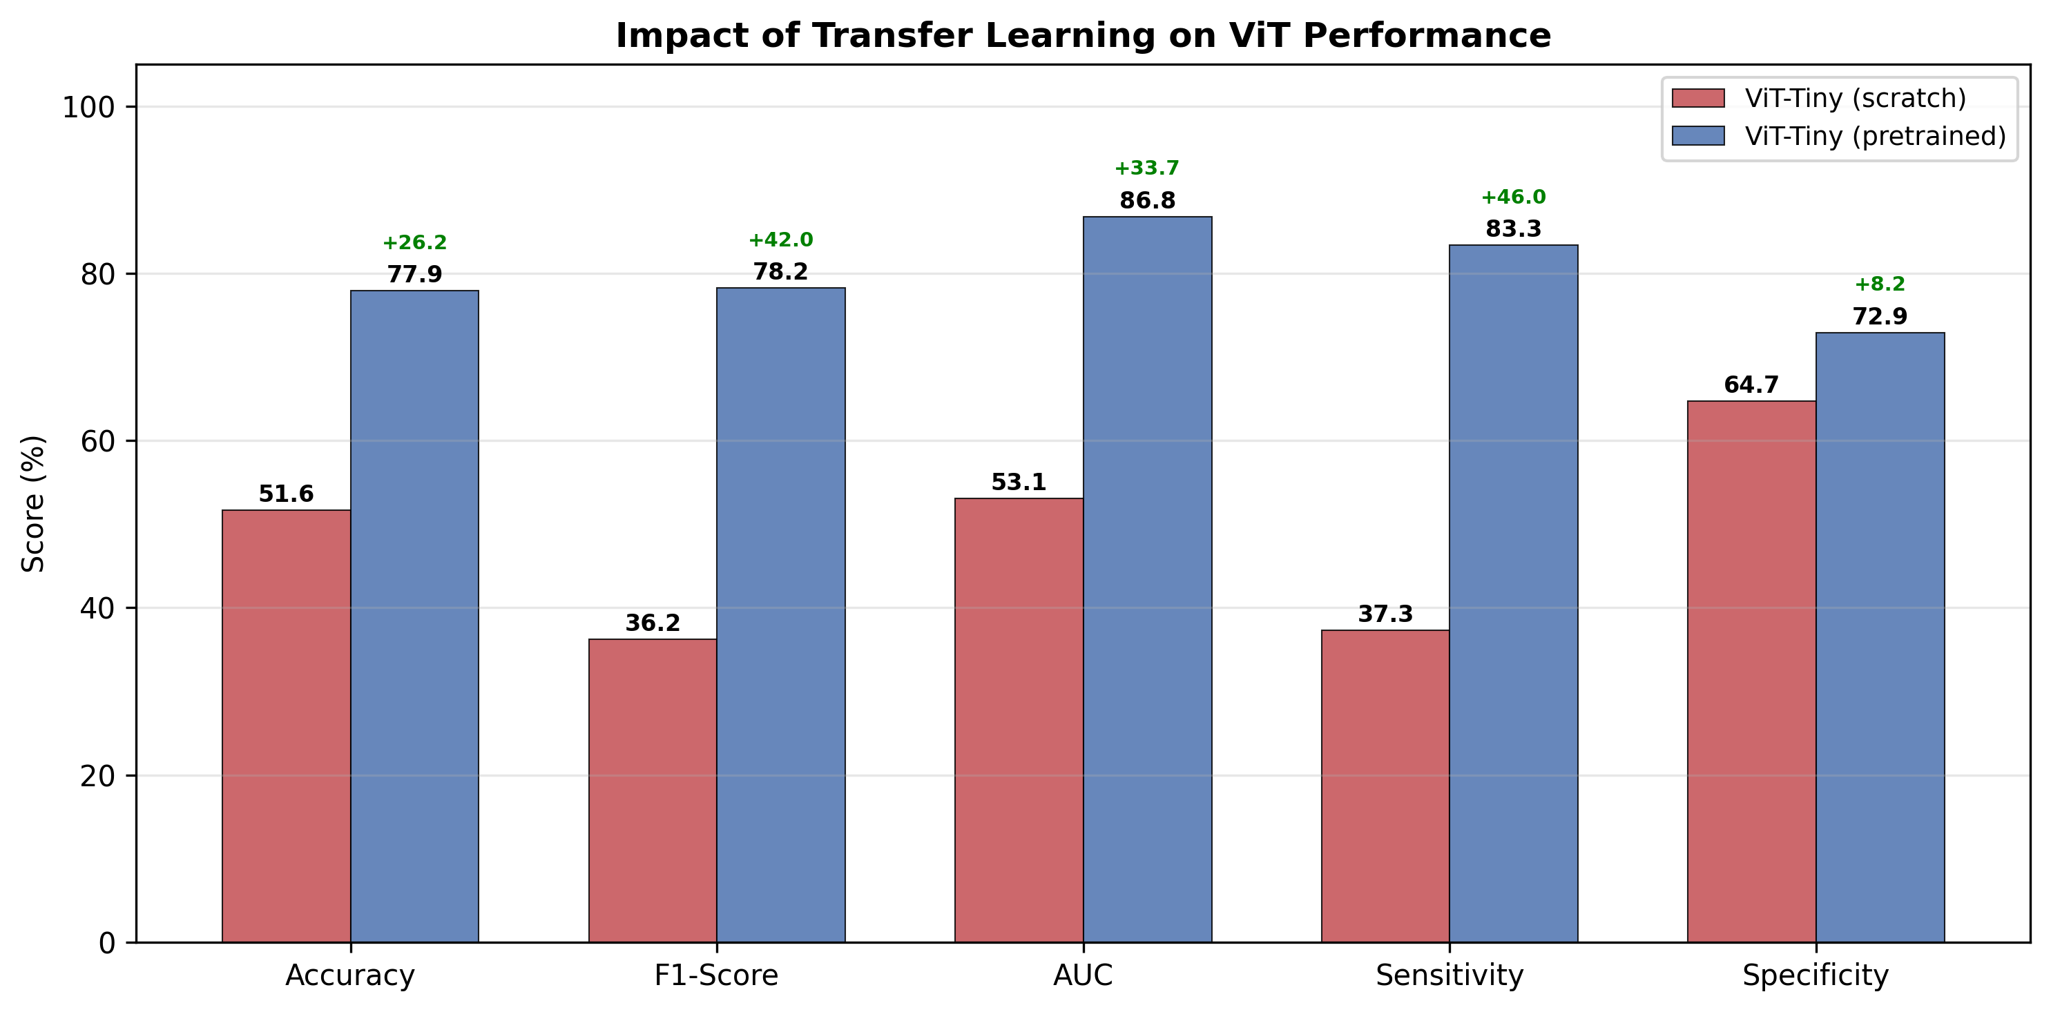
Figure 11. Impact of transfer learning on ViT-Tiny performance. Pretrained initialization provides substantial improvements across all metrics, with the largest gains observed in sensitivity (+46.0) and F1-score (+42.0).

6.2 ViT vs. CNN Architecture Comparison
The from-scratch ResNet-18 (61.81%) outperformed the from-scratch ViT-Tiny (51.63%) by approximately 10 percentage points, confirming that CNNs possess stronger inductive biases that benefit learning from limited data without pretraining. However, the pretrained ViT-Tiny surpassed ResNet-18 by 16 percentage points, demonstrating that when combined with transfer learning, the transformer architecture's global self-attention mechanism provides superior feature extraction for dermatological classification tasks. This result aligns with recent findings in medical imaging literature showing that pretrained ViTs outperform CNNs on dermoscopic classification benchmarks [16,17].

6.3 Clinical Sensitivity-Specificity Trade-off
The pretrained ViT-Tiny achieved a sensitivity of 0.833 and specificity of 0.729, providing the most clinically balanced performance. In contrast, ResNet-18 exhibited high sensitivity (0.858) but poor specificity (0.400), indicating a tendency to over-classify lesions as treatable, which would lead to unnecessary plasma treatments. The pretrained ViT-Tiny model correctly identified 83.33% of plasma-treatable lesions while maintaining a false positive rate of 27.1%, representing a clinically acceptable trade-off for a treatment-planning support tool.
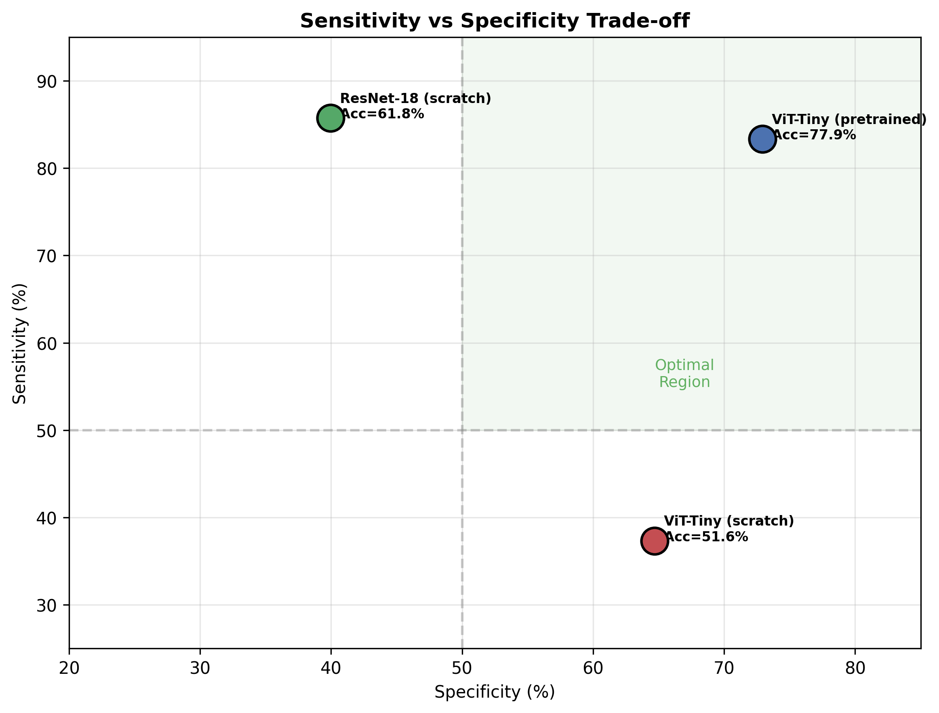
Figure 12. Sensitivity vs. specificity scatter plot showing the diagnostic trade-off for each model. The pretrained ViT-Tiny falls within the optimal region (>50% on both axes), while the from-scratch models show imbalanced performance.

6.4 Integration with Cold Plasma Treatment
The experimental plasma characterization (Section 4) demonstrated stable non-thermal operation with controllable reactive species generation, confirming the system's suitability for dermatological applications. Combined with the ViT-based classification framework, the proposed workflow operates as follows: (1) dermoscopic image acquisition of the target lesion; (2) automated binary classification via pretrained ViT-Tiny to determine plasma treatment eligibility; (3) if classified as treatable, plasma parameters (power, duration, distance) are selected based on the lesion characteristics identified by the experimental characterization data. This integrated approach bridges the gap between AI-assisted diagnosis and plasma treatment delivery, contributing to a more systematic and reproducible clinical workflow.
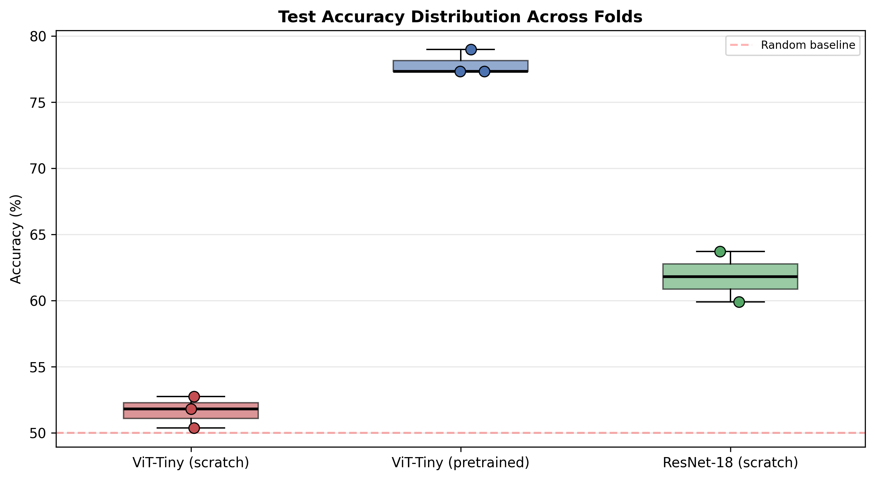
Figure 13. Box plot of test accuracy distribution across cross-validation folds. The pretrained ViT-Tiny shows tight distribution (low variance), indicating robust and consistent classification performance.

7. Limitations and Future Work
Several limitations should be acknowledged. First, the binary classification framework simplifies the complex clinical decision-making process; future work should incorporate lesion severity grading and patient-specific factors such as skin type, lesion location, and medical history. Second, the models were trained on dermoscopic images from the HAM10000 dataset, and validation on cold plasma-treated skin images from clinical studies is essential before deployment. Third, the from-scratch models were limited to 5 training epochs due to computational constraints; extended training may improve their performance. Fourth, the current study does not include optical emission spectroscopy or microbiological assays of the plasma system.
Future studies will focus on: (i) collecting plasma treatment-specific dermoscopic datasets documenting pre- and post-treatment lesion progression; (ii) incorporating multi-class classification with lesion-specific plasma parameter optimization; (iii) developing real-time classification systems integrated directly with plasma treatment hardware; and (iv) conducting detailed plasma diagnostics including optical emission spectroscopy for comprehensive plasma characterization.

8. Safety Considerations
All plasma experiments were conducted in a well-ventilated environment, and gas pressure and power levels were maintained within safe operating limits. The system was evaluated strictly as a non-medical experimental plasma device. No clinical trials or human subject experiments were conducted. The AI classification framework is intended as a research tool and decision-support system, not as a standalone diagnostic device. Clinical validation and regulatory approval would be required before any patient-facing deployment.

9. Conclusion
This study presented an integrated approach combining experimental cold atmospheric plasma characterization with Vision Transformer-based skin lesion classification for dermatological treatment planning. The plasma system demonstrated stable non-thermal operation, controlled ozone generation, and effective surface activation capability across the tested parameter space. The pretrained ViT-Tiny model achieved 77.88% accuracy and 0.868 AUC-ROC in distinguishing plasma-treatable from benign skin lesions, significantly outperforming both from-scratch ViT (51.63%) and ResNet-18 (61.81%) baselines. These results highlight the critical role of transfer learning for medical imaging tasks with limited data and demonstrate the potential of integrating AI-based diagnostic tools with cold plasma treatment systems. The proposed framework provides a foundation for developing intelligent, automated cold plasma treatment protocols in dermatological applications.

References
[1] Laroussi, M., Low-temperature plasmas for medicine?, IEEE Trans. Plasma Sci., 37(6) (2009) 714-725.
[2] Fridman, G. et al., Applied plasma medicine, Plasma Process. Polym., 5(6) (2008) 503-533.
[3] Kong, M.G. et al., Plasma medicine: An introductory review, New J. Phys., 11 (2009) 115012.
[4] Graves, D.B., Low temperature plasma biomedicine: A tutorial review, J. Phys. D, 45 (2012) 263001.
[5] Lu, X. et al., Reactive species in non-equilibrium atmospheric-pressure plasmas, Phys. Rep., 630 (2016) 1-84.
[6] Bruggeman, P. et al., Foundations of atmospheric pressure non-equilibrium plasmas, Plasma Sources Sci. Technol., 26 (2017) 123002.
[7] Lukes, P. et al., Aqueous-phase chemistry and bactericidal effects from air discharge plasma, Plasma Sources Sci. Technol., 23 (2014) 015019.
[8] Tendero, C. et al., Atmospheric pressure plasmas: A review, Surf. Coat. Technol., 200 (2006) 5476-5484.
[9] Shenton, M.J. et al., Surface modification of polymer surfaces, J. Phys. D, 34 (2001) 2761-2768.
[10] Weltmann, K.-D., von Woedtke, T., Plasma medicine-current state of research, Plasma Phys. Control. Fusion, 59 (2017) 014031.
[11] Ostrikov, K. et al., Plasma nanoscience, Adv. Phys., 62 (2013) 113-224.
[12] Bruggeman, P., Leys, C., Non-thermal plasmas in and in contact with liquids, J. Phys. D, 42 (2009) 053001.
[13] Esteva, A. et al., Dermatologist-level classification of skin cancer with deep neural networks, Nature, 542 (2017) 115-118.
[14] Haenssle, H.A. et al., Man against machine: diagnostic performance of a deep learning CNN for dermoscopic melanoma recognition, Ann. Oncol., 29(8) (2018) 1836-1842.
[15] Dosovitskiy, A. et al., An image is worth 16x16 words: Transformers for image recognition at scale, ICLR (2021).
[16] Matsoukas, C. et al., Is it time to replace CNNs with Transformers for medical image analysis?, arXiv:2108.09038 (2021).
[17] Aladhadh, S. et al., An effective skin cancer classification mechanism via medical vision transformer, Sensors, 22(11) (2022) 4008.
[18] Tschandl, P. et al., The HAM10000 dataset, a large collection of multi-source dermatoscopic images of common pigmented skin lesions, Sci. Data, 5 (2018) 180161.
[19] He, K. et al., Deep residual learning for image recognition, CVPR (2016) 770-778.
[20] Loshchilov, I., Hutter, F., Decoupled weight decay regularization, ICLR (2019).

