
FACULTY OF ELECTRICAL AND ELECTRONICS
MULTIDISCIPLINARY DESIGN PROJECT MANAGEMENT PLAN
Note: The form must be completed in 10-point Arial and must not exceed 10 pages in total.
Project Title: Two-Wheeled In-Home Patient Support Robot
Project Management Plan Submission Date: 13.11.2026
No | Team Members’ Full Names | Department  (ELM/EHM/BLM/KOM/BME) | Signature
1 | Murat AĞUŞ | BLM
2 | Muhammed İSMAİL | BLM
3 | Ahmad KAZIMOV | EHM
4 | Doğa KILIÇ | ELM
5 | Kaan AKBIYIK | KOM
6 | Uğur Can GENÇ | KOM
Advisor: Asst. Prof. Dr. Bahadır ÇATALBAŞ
SUMMARY
The summary is expected to cover the outline of the method and management of the project. The summary must be limited to 450 words or one page. Realistic constraints and conditions must be taken into account in the design. Depending on the nature of the design, aspects such as economy, environmental issues, sustainability, manufacturability, ethics, health, safety, and social and political issues should also be considered.
Project Summary
In this project, a two-wheeled active balancing robot, a wearable glove controller, an autonomous infrared (IR) charging station and camera-based mobile visual evaluation software are being designed and implemented to deliver the daily medicine boxes of elderly people receiving home care, or of patients with limited mobility, safely, smoothly and without tipping over inside the home. The system is structured as five main modules developed jointly by the Computer, Control and Automation, Electrical, and Electronics and Communication Engineering disciplines.
The robot body carries a dual-core ESP32 (30-pin) main controller, an MPU6050 6-axis inertial measurement unit (IMU), two JGB37-520 (12 V, 333 RPM, 1:30 metal gearbox) DC motors with quadrature encoders, and two BTS7960B (40 A) motor drivers. A ready-made two-layer balancing chassis will be used as the mechanical structure; extra wheel and coupling alternatives will be procured in weeks 9–10 and tested on the physical assembly. The body tilt angle is estimated at 200 Hz (5 ms) with a complementary filter (98% gyroscope + 2% accelerometer), and active balance on two coaxial wheels without passive support is achieved by a discrete-time LQR (Linear Quadratic Regulator) controller that uses a state vector of tilt angle, tilt rate, wheel position and wheel velocity. By tilting the hand, the user transmits five basic commands (Forward, Backward, Left, Right, Stop) wirelessly to the robot with low latency (<50 ms) over the ESP-NOW protocol, using a battery-powered wearable glove carrying a NodeMCU ESP8266 and an MPU6050. At the end of the task, when the robot enters the 30 cm radius, 90° approach zone of the charging station, it detects the station’s 38 kHz LTE-4208 IR beacon with three TSOP4038 IR receivers on its body, aligns itself autonomously, docks onto spring-loaded contact pads, and starts charging and the hardware LED indicator within ≤ 5 s without human intervention.
The cross-platform (Android and iOS) mobile application developed in Flutter by the Computer Engineering team receives real-time tilt angle, battery percentage, charging and docking status, encoder distance, rotation angle, glove command and medicine box presence switch (DC171) data at 2 Hz over the robot’s local Wi-Fi network (UDP port 4210); it monitors the task live with the phone camera, detects the robot’s motion and direction using frame differencing, automatically checks the acceptance criteria of the selected test scenario (Static Balance, Glove Guidance, Automatic Charging, Integrated Task), and produces a read-only test report that is sealed with an FNV-1a 32-bit integrity seal and cannot be modified afterwards. Safety and budget constraints are addressed in the design through a BMS for the 3S Li-ion pack, a 6 A fuse, a reverse-current diode and a physical emergency stop switch.
Keywords: Two-Wheeled Active Balancing Robot, LQR State-Feedback Control, Wearable IMU Glove, ESP-NOW, Autonomous Infrared Charging Station, Mobile Visual Task Evaluation, UDP Telemetry, Flutter.
1. INTRODUCTION
1.1. Purpose and Scope of the Project
State the problem to be solved, the target user or application environment, and the purpose of the project clearly. Briefly explain why the problem is important. List separately what is included in the project scope and what is excluded.
Problem to Be Solved, Target User and Application Environment: For elderly people receiving home care, chronic patients and individuals with limited mobility, taking their daily medication on time and safely is critical to the quality of care. Pre-prepared medicine boxes must be carried through narrow indoor corridors without tipping over, and the carrier robot must be able to recharge at the end of the task without human intervention. While the two-wheeled inverted-pendulum structure offers high manoeuvrability in narrow spaces, it brings together the embedded software, mobile application, control and power electronics disciplines in a common problem.
Purpose of the Project: To develop a robot that maintains its balance on only two coaxial wheels through active closed-loop control and carries a standard medicine box, not fixed to the body, to a target point without dropping it, using commands from a wearable IMU glove; that autonomously docks to the charging station with 38 kHz infrared (IR) guidance at the end of the task and starts charging; and whose task steps are all monitored through the smartphone camera and real-time UDP telemetry data and reported automatically and immutably (read-only) by the mobile application.
Work Included in the Project Scope:
1. Active Balance and Motion System (Module A): Assembly of the motors, extra wheel/coupling alternatives, the MPU6050 IMU and encoders on the ready-made two-layer balancing robot chassis in weeks 9–10; running 200 Hz tilt estimation with a complementary filter and the LQR state-feedback balance/motion algorithm.
2. Wearable Glove Controller (Module B): Power-on zero calibration on a battery-powered glove based on a NodeMCU ESP8266 and MPU6050, generation of the 5 basic commands (Forward, Backward, Right, Left, Stop) from hand tilt angles, and wireless transmission to the robot at 20 Hz via the ESP-NOW protocol.
3. Automatic Charging Station and Power Safety (Module C): Implementation of the 3S 18650 Li-ion battery pack, 3S 10 A BMS, 6 A fuse and main power switch; a charging station with a 38 kHz LTE-4208 IR beacon; autonomous docking from the 30 cm / 90° zone with 3x TSOP4038 IR receivers; automatic charge start within ≤ 5 s; and a software-independent BC557 hardware charge status LED.
4. Mobile Visual Monitoring, Telemetry and Read-Only Evaluation Software (Module D): Through the cross-platform (Android/iOS) mobile application developed in Flutter: monitoring the task with a fixed phone camera and detecting robot motion/direction by frame differencing; receiving ≥ 1 Hz (2 Hz) live telemetry over UDP port 4210 (tilt angle, battery percentage, charging and docking status, box contact, encoder distance, rotation angle, active glove command); ≤ 2 s connection-loss monitoring; running the automatic evaluation state machine for 4 test modes; and generating a read-only test report sealed with an FNV-1a 32-bit integrity seal.
5. Medicine Box Carrier Slot and Integrated Task (Module E): Carrying a standard medicine box, not fixed to the body, inside a free slot with a DC171 contact switch without dropping it during 4 consecutive, independent integrated task runs.
Topics Excluded from the Scope: Medical decisions by the robot on which medicine is given to the patient, dose adjustment, physical intervention on the patient, climbing stairs/thresholds and full 3D SLAM mapping of the home are outside the scope of the project.
1.2. Existing Work and Similar Products
Describe similar projects, products or studies related to the project. For each one, state what it does, its limitations, and how it influenced the design choices of this project. The sources used are listed with numbers in the “References” section.
1. Segway RMP and Ninebot Two-Wheeled Balancing Platforms [1]: Commercial transport platforms based on two-wheeled inverted-pendulum dynamics. They achieve very stable active balance with redundant gyroscope/accelerometer sensor fusion and high-torque motors. Limitation: Their size, weight and high cost make them unsuitable for a medicine delivery task at in-home table/corridor scale, and they do not include a charging station with autonomous docking. Impact on Our Design: The complementary filter (gyro + accelerometer) and state-feedback balance control architecture of these systems have been scaled down and adapted to a 200 Hz LQR control loop on the ESP32.
2. Arduino-Based Educational Balancing Robot Kits (Elegoo Tumbller, etc.) [2]: Educational platforms that balance with PID on an MPU6050 IMU and a two-wheeled multi-layer chassis. Limitation: The plastic-gear TT motors used in standard kits have high gear backlash; oscillation increases when extra load (medicine box and 3S battery) is added to the upper layer, and they have no wearable glove controller, autonomous charging station or mobile task evaluation software. Impact on Our Design: A ready-made two-layer balancing robot chassis has been procured to shorten mechanical assembly time; however, to overcome the limitations of plastic motors, 12 V 333 RPM JGB37-520 encoder motors with 1:30 metal gearboxes and BTS7960B drivers have been chosen, and extra wheel/coupling alternatives will be procured in weeks 9–10 so that the most stable combination can be selected experimentally on the chassis. Because the PID approach in these kits only looks at the tilt error and produces oscillation and position drift under extra load, LQR has been selected as the balance controller.
3. Domestic Autonomous Vacuum Robots (iRobot Roomba Infrared Docking System) [3]: To return to the charging station at the end of the task, they align autonomously using modulated infrared (IR) beacons on the station and directional IR receivers on the robot, and start charging through spring-loaded contacts. Limitation: They have three- or four-wheeled passively stable bodies. Impact on Our Design: The 38 kHz carrier IR guidance principle, which is immune to ambient light (4x LTE-4208 emitters + a Left/Centre/Right array of 3x TSOP4038 receivers), and the spring-loaded contact pads have been adapted directly to our Module C automatic charging station design.
4. IMU-Based Wearable Gesture Controllers and ESP-NOW Communication Studies [4], [5]: Studies in which data from a 6-axis IMU placed on the back of the hand are read by a microcontroller and converted into wireless commands. Limitation: Classic Bluetooth (HC-05) or standard TCP links suffer from latency and dropouts between the hand and the robot. Impact on Our Design: By choosing the ESP-NOW protocol [4], which works directly at the IEEE 802.11 MAC layer without connection setup between the glove (NodeMCU ESP8266) and the robot (ESP32), command latency has been reduced below 50 ms.
1.3. Success Criteria
Write the purpose and goals of the project so that they are clear, measurable, realistic and achievable within the project period. For each goal, give a success criterion, an acceptance threshold, and a test method showing how it will be verified at the end. This table is the basis for comparing goals with results in the final report.
Goal No | Success Criterion | Target Value / Acceptance Condition | Verification (Test) Method
H1 | Active Static Balance and Tilt Recovery | Remain on two wheels for 30 s (±2 s) without falling (|θ| < 5°) with the medicine box loaded; recover from ±10° tilt within ≤ 10 s; when unpowered and released from ±10°, not return to upright within 5 s. | Passive stability test; 30 s balance and ±10° recovery tests with a stopwatch and the app’s tilt log.
H2 | Wireless Guidance with the Glove | Response to 5 commands (Forward, Backward, Left, Right, Stop) within ≤ 2 s; 0.8–1.2 m linear motion; ~90° turn; 3 s balanced hold after Stop. | Commands given with the glove; distance and response time measured with the encoders and app telemetry.
H3 | Autonomous Approach and Charging at the Station | Autonomous IR docking from the 30 cm radius, 90° zone; charging and LED indicator start within ≤ 5 s; LED turns off within ≤ 2 s when the robot is pulled away. | Docking of the robot released in the zone; timing of the LED and the charge information in the app; pull-and-return test.
H4 | Mobile Monitoring, Telemetry and Read-Only Reporting | ≥ 1 Hz telemetry (dropout ≤ 2 s); task monitoring with the camera; automatic PASS/FAIL decision and an immutable time-stamped report. | Inspection of live telemetry, camera view, dropout protection and the generated report.
H5 | Medicine Box Transport and Integrated Task | Complete the steps 5 s balance → ~1 m transport → 5 s hold → docking for charge in 4 consecutive runs without dropping the unfixed medicine box. | Running the integrated task 4 times; verification with the box switch and app reports.
2. SYSTEM ANALYSIS AND FEASIBILITY
2.1. System Requirements and Constraints
Write what the system must do, together with constraints such as performance, energy, safety, cost and size. Express each requirement in a testable way and link it to the goal it fulfils.
No | Requirement / Constraint | Related Goal
G1 | Mechanical and Active Balance Constraint: The robot must balance only on two coaxial wheels, with no third support wheel or fixed leg. When the motors are unpowered and the robot is released from ±10° tilt, it must not passively return to upright within 5 s. | H1, H5
G2 | Balance Control Loop and Fall Safety: Body tilt measurement (MPU6050) and the LQR state-feedback motor control loop must run at no less than 200 Hz (5 ms period); when the body tilt exceeds ±35°, the motor PWM outputs must be cut automatically for safety. | H1, H5
G3 | Wearable Command Latency and Calibration: The glove controller must be battery-powered (isolated from mains), must zero the natural resting angle of the hand at power-on, and must transmit the 5 basic commands to the robot over ESP-NOW with a physical response time of ≤ 2 s. | H2
G4 | Autonomous Charging and Hardware Indicator Constraint: From the 30 cm / 90° approach zone onwards, the robot must dock with 38 kHz IR guidance without human intervention; charging must start within ≤ 5 s and stop within ≤ 2 s when the robot is pulled away, and the charge LED must be driven directly by the charging circuit, independently of software. | H3
G5 | Mobile Telemetry Continuity and Camera Monitoring: Throughout the task, the mobile application must communicate with the robot over UDP 4210 at no less than 1 Hz (target 2 Hz), must detect connection losses longer than 2 s as faults, and must display telemetry together with the fixed camera view. | H4, H5
G6 | Read-Only Reporting and Data Integrity: The test report generated at the end of each task must contain the date/time, task type, duration, tilt, charging, box status and the PASS/FAIL decision; it must be sealed with an FNV-1a hash so that it cannot be deleted or modified from within the application (read-only). | H4, H5
G7 | Electrical Safety, Ergonomics and Budget Constraint: The main supply must not exceed 24 V DC (3S Li-ion 11.1–12.6 V); the battery pack must have a 3S 10 A BMS, the main line a 6 A fuse, the charging input a 1N5822 reverse-current diode, and there must be a physical main power switch; the total cost must stay within the budget limits. | H1, H3, H5
2.2. Evaluation of Solutions
For important design decisions, compare at least two feasible alternatives. State the comparison criteria (cost, performance, availability, time, etc.) and give the recommended choice together with its rationale. Decisions that are not yet final should be stated clearly.
Problem | Solutions | Comparison Criteria | Recommended Choice and Rationale
1. Chassis, Motor and Wheel | A: Ready-made chassis with standard plastic motors/wheels. B: Ready-made chassis + JGB37-520 motors, L-brackets, hex couplings, extra wheels. | Gear backlash, torque, centre of mass, floor grip. | Choice not yet final: The motors and drivers of option B have been procured; the extra wheel/coupling/bracket parts will be procured in weeks 9–10, and the wheel/motor arrangement with the least oscillation will be selected through trials during assembly.
2. Communication (Glove–Robot, Robot–Phone) | A: Bluetooth SPP (HC-05). B: Glove→Robot ESP-NOW, Robot↔Phone Wi-Fi UDP 4210. | Latency, simultaneous connections, extra cost. | Choice: B. The built-in Wi-Fi requires no extra module; ESP-NOW has < 20 ms latency, and the phone simultaneously receives 2 Hz data over UDP.
3. Mobile Application | A: Off-the-shelf Bluetooth terminal app. B: Custom cross-platform application in Flutter [8]. | Camera and telemetry on one screen, automatic decision, read-only report. | Choice: B. The camera monitoring, telemetry and immutable report required by the specification cannot be provided by off-the-shelf apps.
4. Charging Station Guidance | A: Camera/ultrasonic guidance + inductive charging. B: 38 kHz IR beacon (LTE-4208) + 3x TSOP4038 + spring-loaded contact pads. | Ambient light effect, detection success, ≤ 5 s charge start, cost. | Choice: B. Since the TSOP4038 is only sensitive to 38 kHz, it is not affected by ambient light; the contact pads provide alignment tolerance.
5. Balance Controller | A: Discrete-time PID (tilt error only). B: LQR state feedback, u = −K·x; x = [tilt, tilt rate, wheel position, wheel velocity] [9]. | Oscillation under load, position drift, ease of tuning, computational load. | Choice: B. LQR controls all four states together with a single gain matrix, reducing oscillation and in-place drift under the medicine box load. K is computed offline from the linearised inverted-pendulum model with Q/R weights; the ESP32 performs only 4 multiplications every 5 ms.
2.3. Technical and Economic Feasibility
2.3.1. Technical feasibility
For each subsystem, explain the required resources and skills and why the work is feasible within the project period. State the major challenges or gaps in the team’s expertise, and describe how they will be addressed.
Subsystem | Required Resources / Skills | Feasibility Rationale
1. Mobile Application and Reporting (Module D) – Responsible: Murat AĞUŞ, Muhammed İSMAİL | Flutter/Dart, UDP socket programming, motion detection by frame differencing on the camera stream, task state machine, read-only report with FNV-1a. | The application has been developed and built for Android and iOS; since it only processes the robot’s UDP packets, it will be used once the robot is ready. Validation with the real robot will be carried out in weeks 9–12.
2. Balance and Motion Control (Module A) – Responsible: Kaan AKBIYIK, Uğur Can GENÇ | Complementary filter, inverted-pendulum model, 200 Hz LQR (K matrix computed with MATLAB/Python), BTS7960B PWM, encoder odometry. | The first version of the control software has been written; the chassis and motors are available. The LQR gain matrix K will be computed from the linearised model using the measured mass/dimensions of the chassis; the Q/R weights will be fine-tuned experimentally during assembly in week 9.
3. Glove and ESP-NOW (Module B) – Responsible: Ahmad KAZIMOV, Muhammed İSMAİL | I2C MPU6050 reading, power-on calibration, 5-way angle classification, ESP-NOW. | The first version of the glove software has been written, and the battery and charging module have been procured. The angle thresholds (±20°/±22°) will be tuned by testing with the glove.
4. Power and Charging Station (Module C) – Responsible: Doğa KILIÇ, Ahmad KAZIMOV | 3S battery management, DC-DC regulation, fuse/diode protection, 38 kHz IR emitter/receiver, hardware charge indicator. | The electronic components and the 9 V 2 A adapter that will power the station have been procured; the charge indicator will be driven by a software-independent BC557 circuit. The station circuit will be built in weeks 5–8.
5. Medicine Box Slot and Integration (Module E) – Responsible: Whole Team | Centre-of-mass balancing, free slot and DC171 switch mounting, integration of the modules. | The DC171 switch has been procured; assembly will start in week 9 and can be completed on time with the rehearsals in weeks 11–14.
2.3.2. Economic feasibility
List the materials, software and services to be used in the project with quantity, unit price, status (available / to be procured) and lead time. State the total budget. Lead times must be consistent with the work plan.
Item | Qty | Unit Price (₺) | Amount (₺) | Status | Lead Time
ESP32 ESP-32S Wi-Fi + Bluetooth Development Board (30-pin) | 1 | 423.67 | 423.67 | Available | Completed
NodeMCU V3 ESP8266 (ESP-12E) Development Board | 1 | 185.00 | 185.00 | Available | Completed
MPU6050 6-Axis Accelerometer and Gyro Sensor (GY-521) | 2 | 193.95 | 387.90 | Available | Completed
JGB37-520 12 V 333 RPM (1:30) Metal Gear DC Motor with Encoder | 2 | 639.29 | 1,278.58 | Available | Completed
BTS7960B 40 A Bidirectional H-Bridge DC Motor Driver Board | 2 | 263.66 | 527.32 | Available | Completed
TSOP4038 38 kHz IR Receiver (3 pcs) + LTE-4208 IR LED (4 pcs) | 1 Set | 179.44 | 179.44 | Available | Completed
DC171 Micro Switch (2 pcs) + GY-530 ToF Distance Sensor | 1 Set | 172.74 | 172.74 | Available | Completed
3S Robot Power Pack (3x Orion 18650 2000 mAh 15C Cells, 3S 10 A BMS, Cell Holder) | 1 Set | 645.00 | 645.00 | Available | Completed
Glove Power Pack (Power-Xtra 3.7 V 1000 mAh Li-Po + TP4056 Type-C Charger) | 1 Set | 237.59 | 237.59 | Available | Completed
Charging Station and Protection Electronics (2x IP2326, 2x Mini360, 6 A Fuse, 1N5822, BC557, Cables/Terminals) | 1 Set | 582.16 | 582.16 | Available | Completed
Ready-Made Two-Layer Balancing Robot Chassis Kit | 1 Set | 650.00 | 650.00 | Available | Completed
Concord 9 V 2 A AC/DC Adapter (Charging Station Supply) | 1 | 249.00 | 249.00 | Available | Completed
Extra Wheel Pair, 6 mm Hex Couplings, 37 mm L-Brackets and Mounting Hardware | 1 Set | 550.00 | 550.00 | To be procured | Weeks 9–10
TOTAL |  |  | 6,068.40 ₺
2.3.3. Time and workforce feasibility
Assess whether the project can be completed in the remaining time, with its critical path and milestones, and in terms of the team’s workforce (person-hours). The main work packages, the concrete output of each, who will carry them out and in which period are given by filling in the “Work-Time Schedule” below.
Workforce Capacity (Person-Hour Analysis): A total of 6 team members (2 BLM, 2 KOM, 1 ELM, 1 EHM) work on the project. With each member spending an average of 6 hours per week on the project, the 14-week term provides a total workforce capacity of 6 x 6 x 14 = 504 person-hours. As of the first 4 weeks, 90% of the procurement of electronics, motors, sensors, batteries and the ready-made balancing chassis, together with the mobile application and the ESP32/ESP8266 embedded software architectures developed by the Computer Engineering team, have been completed.
Critical Path and Milestones: In the project schedule, system analysis, procurement of materials/the ready-made chassis and coding of the mobile/embedded software were completed in weeks 1–4. In weeks 5–8, bench validation tests of the glove controller (Module B) and charging station/power protection (Module C) circuits will be carried out. Mechanical and electrical assembly of the physical robot will start in week 9; the extra wheel/coupling/bracket parts to be tested on the chassis will be procured in weeks 9–10:
• KM1 (Week 4): Completion of the system architecture, procurement of materials and the ready-made chassis, the mobile evaluation application and the ESP32/ESP8266 embedded software.
• KM2 (Week 8): Bench tests of the glove and IR charging station circuits.
• KM3 (Weeks 9–10 – Critical Path): Assembly of the physical robot on the ready-made chassis in week 9; selection of the most stable structure by testing wheel/motor combinations with the extra wheel/coupling parts procured in weeks 9–10; and achieving 30 s of active static balance + ±10° recovery with 200 Hz LQR (Q/R weight) tuning.
• KM4 (Weeks 11–12): Motion control with the glove, IR-guided autonomous docking for charging, the medicine box slot, and end-to-end integration of the mobile application with the robot.
• KM5 (Weeks 13–14 and Final Week): Completion of integrated task rehearsals in 4 consecutive independent runs according to the common test protocol (5x20 points), verification of the read-only mobile reports, and the final presentation.
WORK-TIME SCHEDULE
WP No | Work Package Title | Work Package Description | Carried Out By | WEEKS
 |  |  |  | 1 | 2 | 3 | 4 | 5 | 6 | 7 | 8 | 9 | 10 | 11 | 12 | 13 | 14 | Final Week
1 | System Analysis and Procurement | Requirements, interfaces, procurement of materials and chassis. | Whole Team | X | X | X | X
2 | Mobile Application (Module D) | Camera, UDP telemetry, task evaluation, read-only report. | Murat AĞUŞ, Muhammed İSMAİL |  | X | X | X | X | X
3 | Embedded Software | Robot (ESP32) and glove (ESP8266) firmware. | Murat AĞUŞ, Muhammed İSMAİL |  |  | X | X | X | X
4 | Power, Charging Station and Glove Circuits (Modules B, C) | Power/protection stage, IR charging station, glove circuit. | Doğa KILIÇ, Ahmad KAZIMOV |  |  |  |  | X | X | X | X
5 | Robot Assembly and Active Balance (Module A) | Chassis, motor and wheel assembly; 30 s balance with LQR. | Kaan AKBIYIK, Uğur Can GENÇ |  |  |  |  |  |  |  |  | X | X
6 | Glove-Driven Motion and Autonomous Charging | Driving with 5 commands and IR docking for charging. | Kaan AKBIYIK, Uğur Can GENÇ, Doğa KILIÇ, Ahmad KAZIMOV |  |  |  |  |  |  |  |  |  | X | X
7 | Box Slot and End-to-End Integration (Module E) | Box slot assembly; robot and application integration tests. | Whole Team |  |  |  |  |  |  |  |  |  |  | X | X
8 | Joint Rehearsals and Final | 4-run integrated task rehearsals, fixes, final presentation. | Whole Team |  |  |  |  |  |  |  |  |  |  |  | X | X | X | X
3. SYSTEM DESIGN
3.1. System Architecture
3.1.1. Architecture Diagram
Add a block diagram showing the general operating logic of the system. The interaction of the hardware, software and communication subsystems should be visible in the diagram.
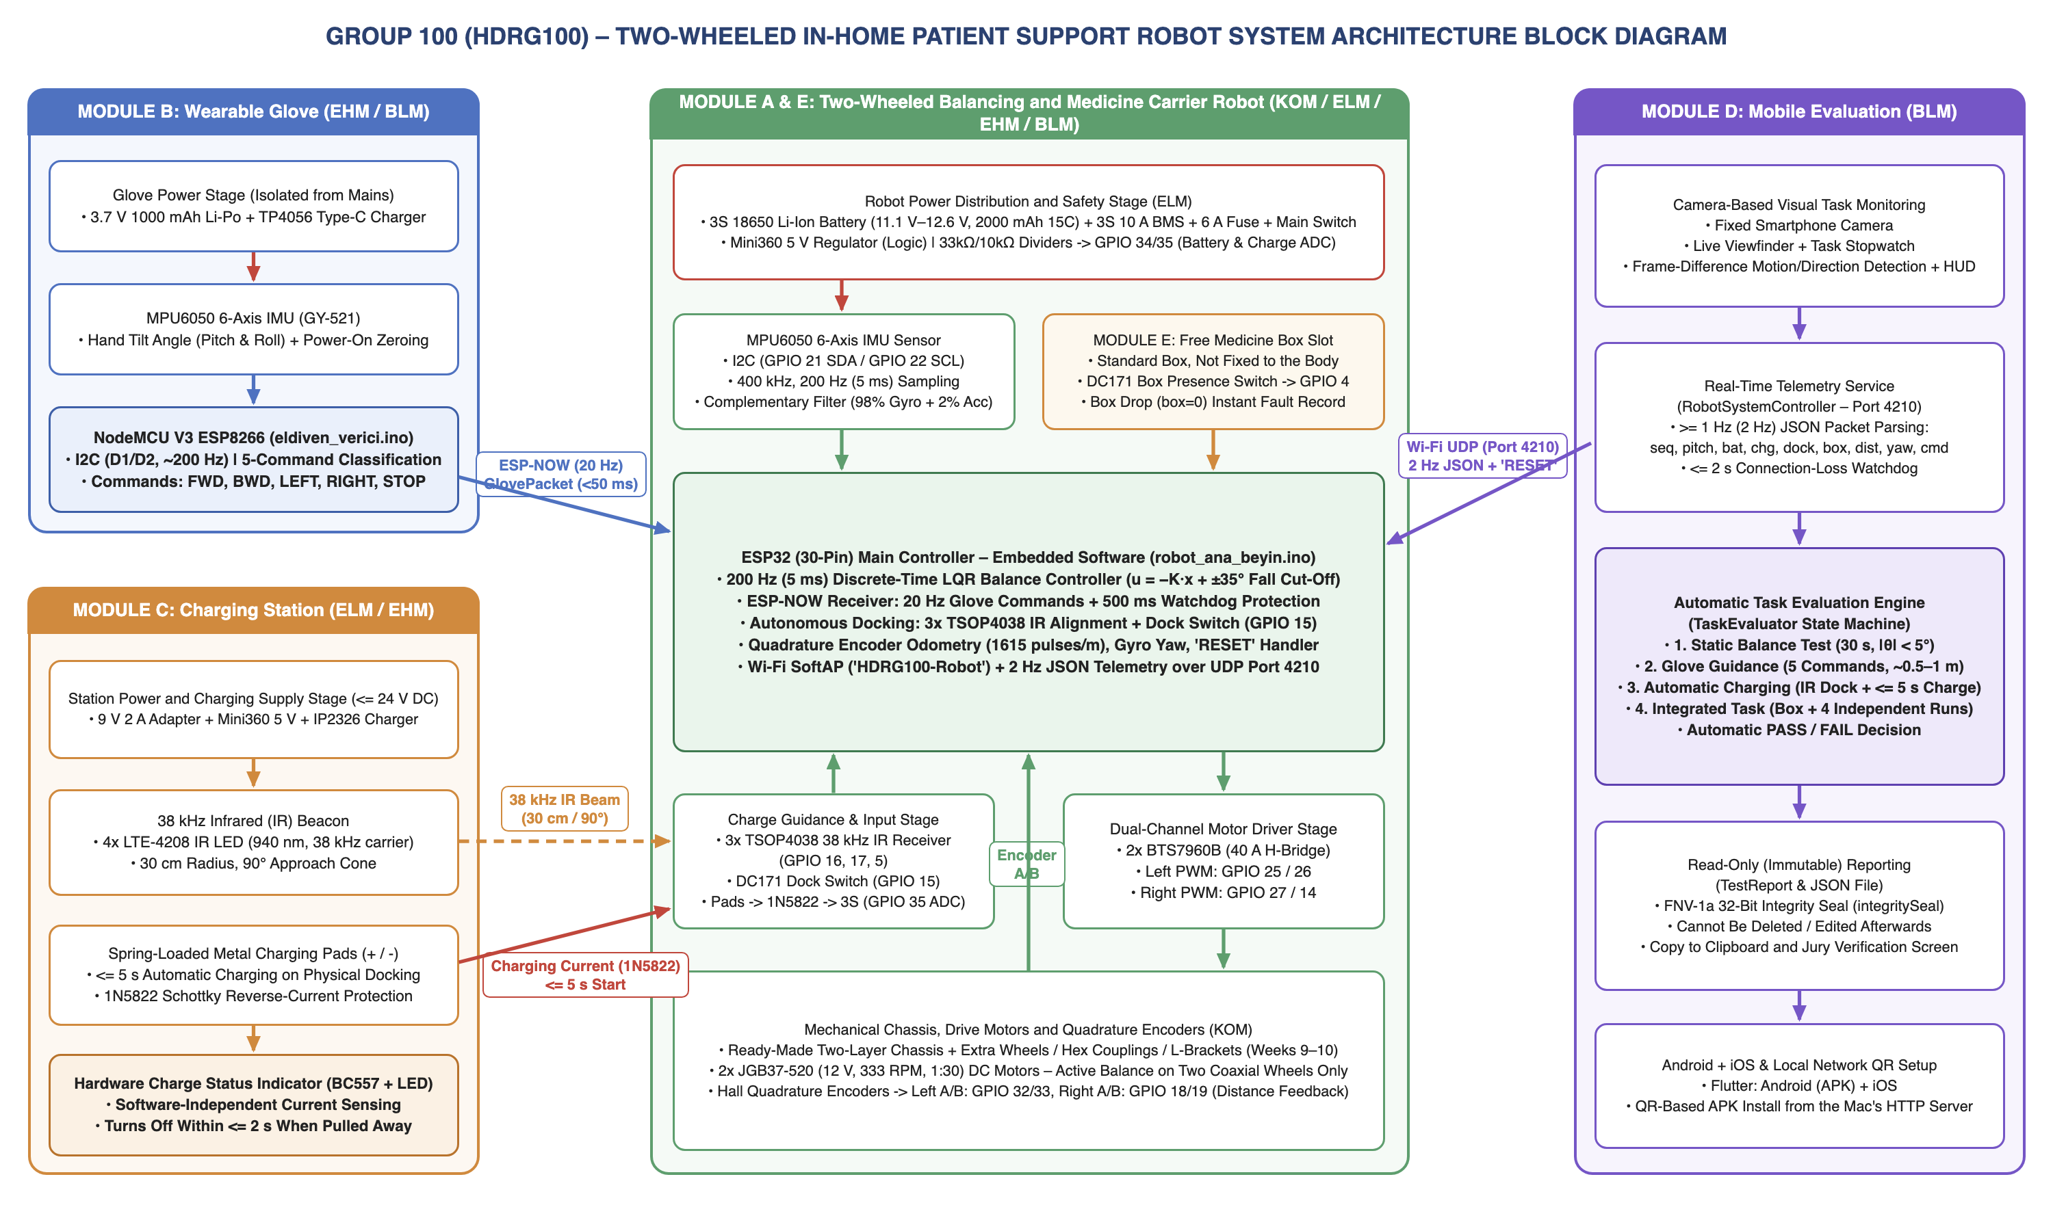
Figure 3.1: Architecture block diagram of the hardware, embedded software, wireless communication and mobile evaluation system of the Two-Wheeled In-Home Patient Support Robot.
3.1.2. Subsystems and Components
Describe the tasks of the main subsystems, their basic inputs/outputs and their connections with other subsystems. Depending on the type of project, hardware, software, electronic or mechanical components may be used.
Subsystem / Module | Function | Inputs / Outputs and Connections
Module A: Active Balance and Drive (ESP32 + MPU6050 + 2x BTS7960B + 2x JGB37-520)  Responsible: Kaan AKBIYIK, Uğur Can GENÇ | Balance on two wheels with 200 Hz LQR; execute glove commands; cut the motors beyond ±35°; measure distance with the encoders. | Inputs: MPU6050 (I2C: GPIO 21/22), encoder A/B (GPIO 32, 33, 18, 19), ESP-NOW command, UDP 'RESET'.  Outputs: BTS7960B PWM (GPIO 25/26, 27/14), UDP telemetry.
Module B: Wearable Glove (NodeMCU ESP8266 + MPU6050 + Li-Po)  Responsible: Ahmad KAZIMOV, Muhammed İSMAİL | Zero the hand posture at power-on; convert hand tilt into 5 commands (FWD, BWD, LEFT, RIGHT, STOP) and send them to the robot. | Inputs: MPU6050 (I2C: D1/D2), 3.7 V Li-Po.  Outputs: 20 Hz command packets via ESP-NOW (channel 1), status LED.
Module C: Power and Charging Station (3S BMS + fuse + LTE-4208 + 3x TSOP4038 + BC557)  Responsible: Doğa KILIÇ, Ahmad KAZIMOV | Power the robot safely; guide it to the station with 38 kHz IR; start charging and the hardware LED within ≤ 5 s of docking. | Inputs: 9 V 2 A adapter (station supply); 38 kHz IR → TSOP4038 (GPIO 16, 17, 5); DC171 docking switch (GPIO 15); battery and charge-input voltage dividers (GPIO 34, 35).  Outputs: charging current through the 1N5822, BC557 charge LED.
Module D: Mobile Application (Flutter)  Responsible: Murat AĞUŞ, Muhammed İSMAİL | Monitor the task with the phone camera, display telemetry, evaluate the 4 tasks automatically, save read-only reports. | Inputs: Wi-Fi UDP 4210 JSON telemetry, camera image.  Outputs: live screen, PASS/FAIL decision, 'RESET' command, immutable report.
Module E: Free Medicine Box Slot (DC171)  Responsible: Whole Team | Carry the box without fixing it and check whether it is in the slot. | Inputs: DC171 (GPIO 4).  Outputs: box: 1 / 0 flag (test FAILS if the box falls).
3.1.3. Interfaces and Communication
For each connection between subsystems, state the medium or protocol used, the data carried, and the targeted performance (delay, speed, error margin, etc.). These connections must be consistent with the task flow in 3.2.
Connection | Medium / Protocol | Data Content | Target
IMU Sensors → Microcontrollers (Robot & Glove) | Wired / I2C Bus (400 kHz Fast Mode) | 14 bytes of raw 3-axis accelerometer and 3-axis gyroscope register data (0x3B–0x48) from the MPU6050 at address 0x68. | Deterministic sampling at 200 Hz (5 ms) on the robot and ~200 Hz on the glove; < 1 ms read time.
Wearable Glove (ESP8266) → Robot Main Controller (ESP32) | Wireless / 2.4 GHz ESP-NOW (IEEE 802.11 MAC Layer, Channel 1) | 20-byte structured packet: sequence number (seq), command ('FWD', 'BWD', 'LEFT', 'RIGHT', 'STOP'), hand tilt angles (pitch, roll). | 20 Hz (50 ms) send rate, < 50 ms end-to-end latency (specification target ≤ 2 s); automatic STOP protection if no packet arrives for 500 ms.
Automatic Charging Station → Robot Guidance Receivers and Charging Line | Optical Wireless (38 kHz 940 nm IR) + Physical Spring-Loaded Metal Contacts | Directional active-low station detection signal on 3x TSOP4038; DC171 switch (GPIO 15) and 12.6 V charging current on docking. | 100% detection within the 30 cm radius, 90° approach zone regardless of ambient light; charge start within ≤ 5 s after docking.
Robot (ESP32) → Mobile Application | Wireless / Wi-Fi SoftAP – UDP Port 4210 (unicast to the phone) | UTF-8 JSON telemetry packet: {"seq":N, "pitch":deg, "bat":%, "chg":0/1, "dock":0/1, "box":0/1, "dist":m, "yaw":deg, "rst":n, "cmd":"..."} | Continuous 2 Hz (500 ms period) transmission (specification minimum ≥ 1 Hz); maximum allowed dropout during the task ≤ 2 s.
3.2. Operating Principle and Task Flow of the System
First, explain the general operating principle of the system: the parts that make up the system, the function of each, what information or energy flows between the parts, and how the system reaches its goal, referring to the boxes and arrows in the architecture diagram; state what the tables in 3.1.2 and 3.1.3 show. Then add a flow chart showing the task flow of the system from start to finish and describe the flow step by step; for each step, state which subsystem takes part and through which connection the data flows. Also describe how faults and safety-related conditions will be handled.
1. General Operating Principle of the System: The operation of the system is based on the simultaneous interaction of the four main hardware/software blocks shown in the Architecture Diagram in Section 3.1.1 (Figure 3.1): Module B Glove, Module A & E Balancing Robot, Module C Automatic Charging Station and Module D Mobile Evaluation System. The table in Section 3.1.2 defines the function, microcontroller pins and sensor/actuator connections of each module, while the table in Section 3.1.3 shows the wired (I2C) and wireless (ESP-NOW, 38 kHz IR, Wi-Fi UDP 4210) data packets and timing targets between these blocks. The ESP32 reads the MPU6050 data at 200 Hz, computes the tilt angle with the complementary filter, and keeps the robot upright on two wheels by driving the JGB37-520 motors with LQR state feedback (u = −K·x).
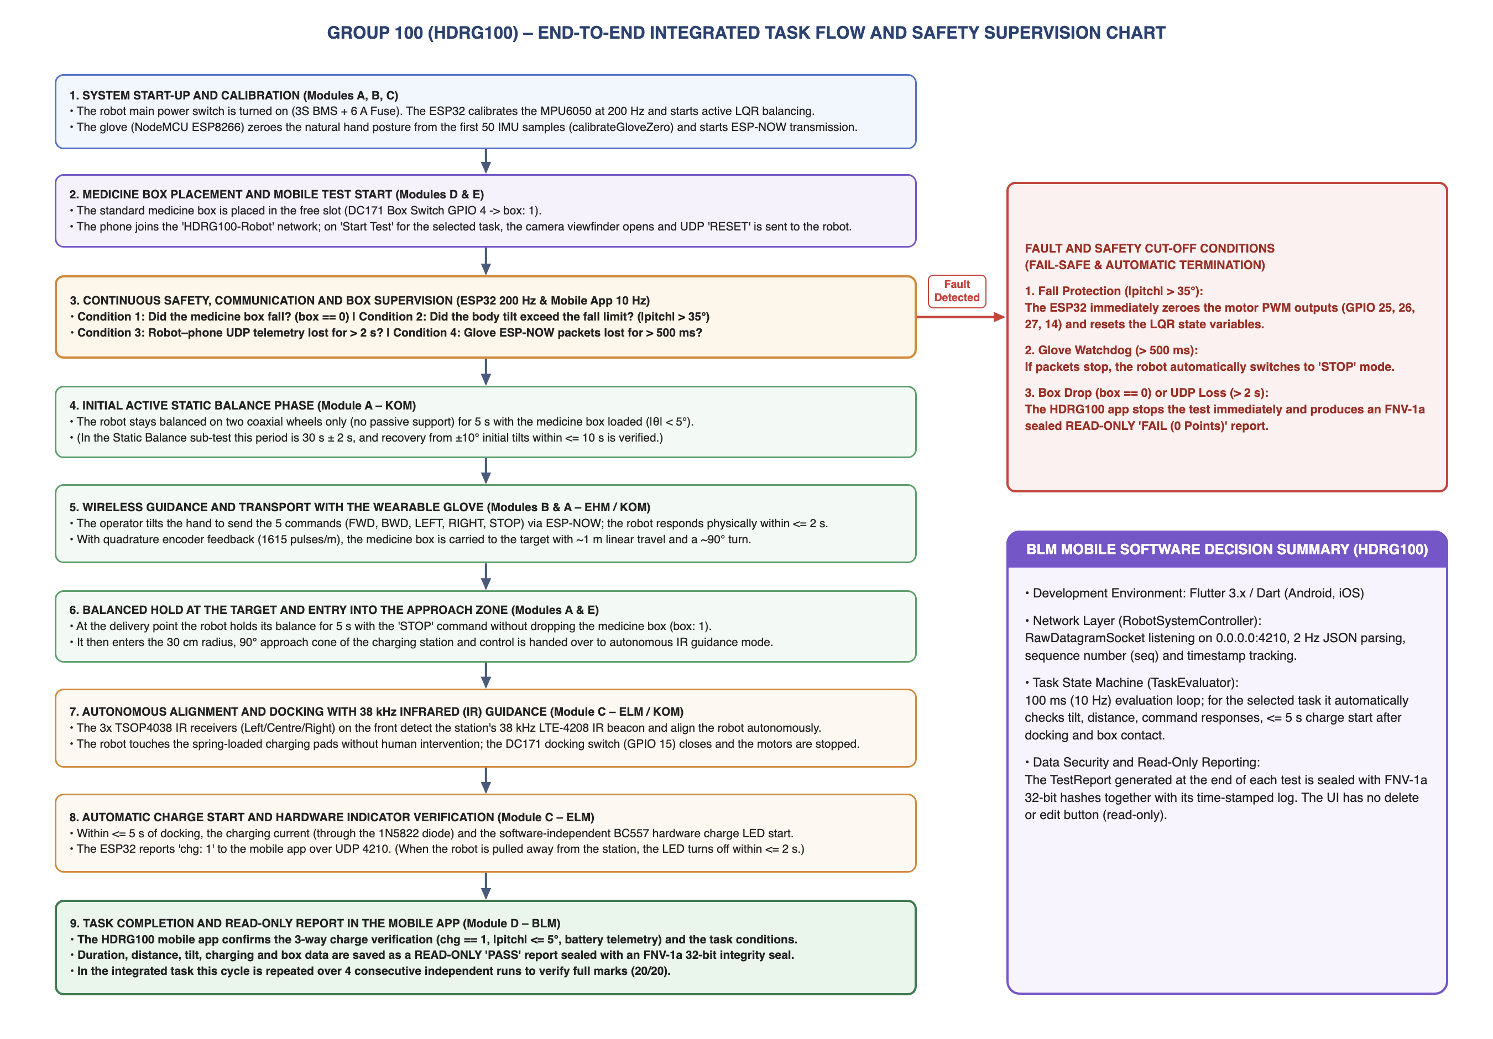
Figure 3.2: End-to-end task flow and fault/safety supervision chart of the Two-Wheeled In-Home Patient Support Robot.
2. Step-by-Step Task Flow: (1–2) The robot and glove are switched on; the ESP32 starts LQR balancing and the glove zeroes the hand posture. The medicine box is placed in the slot (box: 1); the phone connects to the robot’s Wi-Fi network, the task is selected, and 'Start Test' starts the camera and stopwatch and sends 'RESET' to the robot. (3–6) The robot first holds its balance; it responds within ≤ 2 s to the FWD/BWD/LEFT/RIGHT/STOP commands arriving from the glove via ESP-NOW, moves ~1 m forward with encoder feedback, turns ~90° and waits 5 s at the target. (7–9) In the approach zone, the 3x TSOP4038 detect the station’s 38 kHz IR beacon, the robot docks autonomously (dock: 1), charging (chg: 1) and the hardware LED start within ≤ 5 s; the mobile application verifies the criteria and saves a read-only PASS report.
3. Handling of Fault and Safety Conditions: (a) Fall Protection: If the body tilt exceeds ±35°, the ESP32 immediately zeroes the motor PWM outputs (GPIO 25, 26, 27, 14) to prevent the wheels from spinning freely. (b) Glove Communication Protection: If no ESP-NOW packet is received from the glove for 500 ms, the robot automatically switches to 'STOP'. (c) Mobile Telemetry and Box Drop Supervision: If the medicine box falls out of the slot during the task (box == 0) or the robot–phone UDP 4210 telemetry stream is interrupted for > 2 s, the mobile application stops the test automatically and produces an immutable 'FAIL (0 points)' report. (d) Electrical Protection: Full protection is provided by the 3S 10 A BMS, 6 A glass fuse, 1N5822 Schottky reverse-current diode and a physical main power switch.
REFERENCES
Data sheets, product pages, open-source repositories and similar studies used in the project are given with numbers and access dates. References must be cited in the text by their number.
[1] Segway Robotics, "Segway RMP Mobile Robotic Platforms Technical Documentation," [Online]. Available: https://www.segwayrobotics.com. [Accessed: 25.10.2026].
[2] Elegoo Inc., "Elegoo Tumbller Self-Balancing Robot Car Kit Manual and Control Architecture," [Online]. Available: https://www.elegoo.com. [Accessed: 25.10.2026].
[3] iRobot Corporation, "Autonomous Robot Auto-Docking and Energy Management System Using Modulated Infrared Beacons," U.S. Patent 7,332,890, 2008. [Accessed: 26.10.2026].
[4] Espressif Systems, "ESP-NOW User Guide – Connectionless Wi-Fi Communication Protocol for ESP32 and ESP8266," [Online]. Available: https://docs.espressif.com/projects/esp-idf/en/latest/esp32/api-reference/network/esp_now.html. [Accessed: 27.10.2026].
[5] InvenSense Inc., "MPU-6000 and MPU-6050 Product Specification and Register Map, Rev. 3.4," [Online]. Available: https://invensense.tdk.com/products/motion-tracking/6-axis/mpu-6050/. [Accessed: 27.10.2026].
[6] Infineon Technologies, "BTS7960B High Current PN Half Bridge NovalithIC Datasheet," [Online]. Available: https://www.infineon.com/cms/en/product/power/motor-control-ics/brushed-dc-motor-driver-ics/. [Accessed: 28.10.2026].
[7] Vishay Semiconductors, "TSOP4038 – IR Receiver Modules for Remote Control Systems (38 kHz) Datasheet," [Online]. Available: https://www.vishay.com/ppg?81926. [Accessed: 28.10.2026].
[8] Flutter Dev Team, "Flutter Cross-Platform UI Toolkit, Camera Plugin and RawDatagramSocket Documentation," [Online]. Available: https://docs.flutter.dev. [Accessed: 29.10.2026].
[9] K. Ogata, "Modern Control Engineering," 5th ed., Pearson, 2010, Chapter 10: Linear Quadratic Optimal Control Systems.

