**First of all, my computer has 8 core but the virtual machine has 4 core. Therefore i was able to try up to 4 cores max.**

2 Core

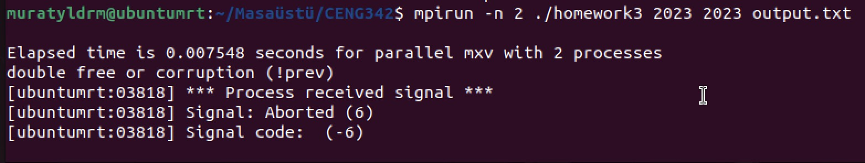3 Core

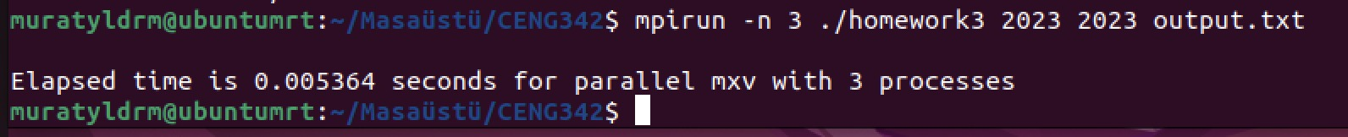4 Core

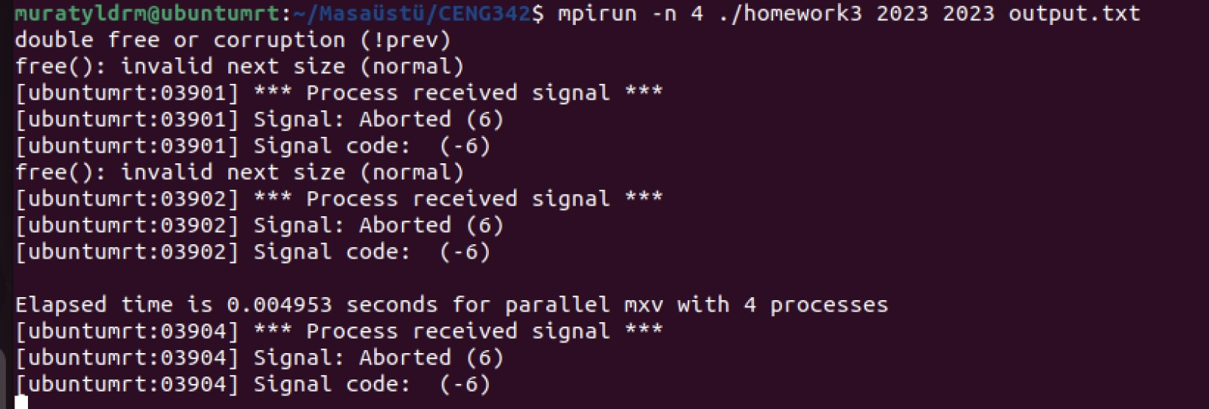5 Core

