

**BIM423 – SOFTWARE ENGINEERING**

**2022-2023 FALL SEMESTER**



**Fitness Tracker**

**Group 6**

**Report No: 1**

**17.10.2022 - 24.10.2022**

**Members:**

1. **Abdullah Enes Kocabuğa**
2. **Alper Arslan**
3. **Çağatay Karasu**
4. **Murat Yılmaz**
5. **Sinem Türkçü**
6. **Yusuf Mücahit Solmaz**

**Links:**

**Github:** https://github.com/muratyilmaz743/fitness-tracker

**Website Link:** https://muratyilmaz743.github.io/fitness-tracker/

**Repo Links:** https://github.com/muratyilmaz743/Fitness-Tracker-UI  
 https://github.com/sinemturkcu/fitness-tracker-backend

**Works Done:**

A meeting was held about the project. The websites related to our project were examined and the features that we should use in the project were determined. In this project process, the project construction path was determined. In the backend, it has been decided which classes will be in the entity section. An E/R diagram was created from a website on the Internet and the relations in this diagram were determined. The class structure in the Entity section has been started.

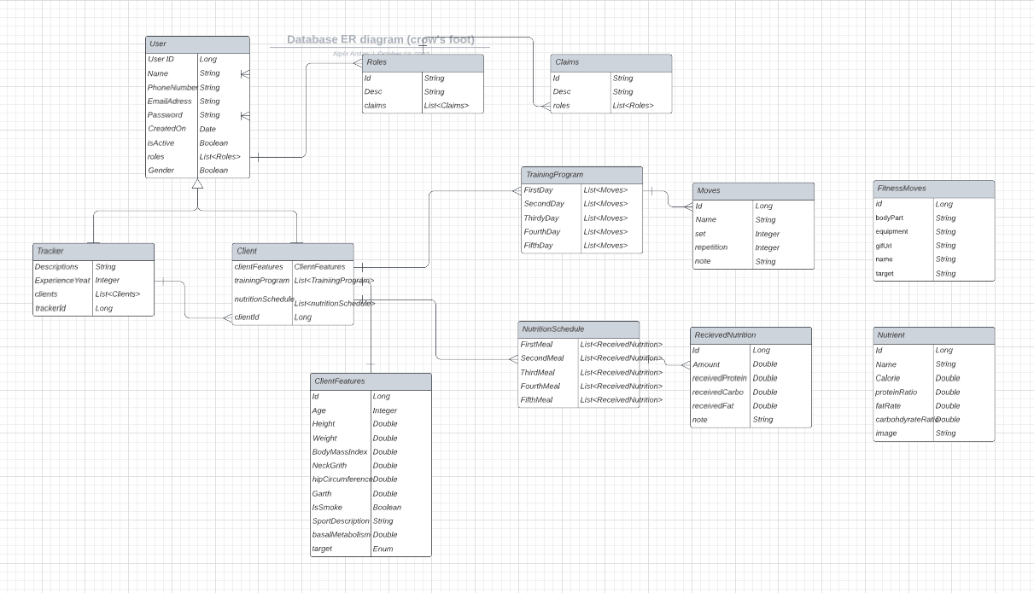

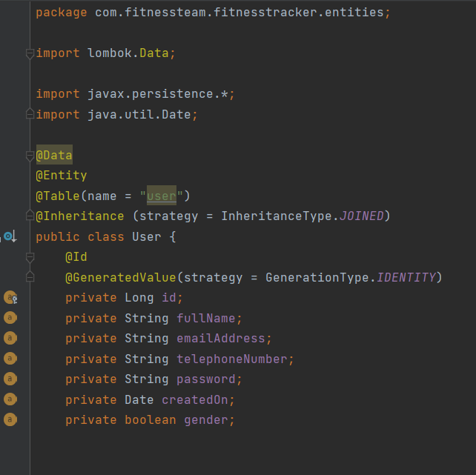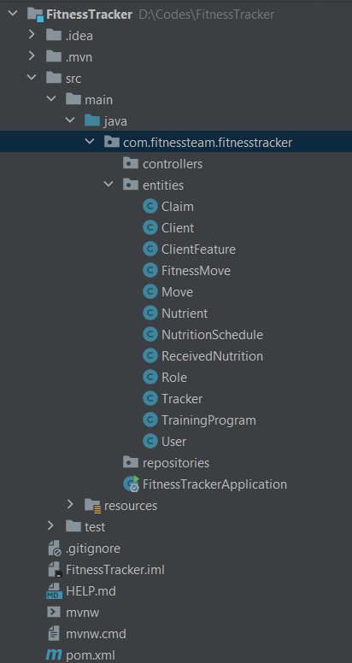

**Task Distribution:**

Abdullah Enes Kocabuğa: E/R Design

Alper Arslan: E/R Design

Çağatay Karasu: Creating Entities

Murat Yılmaz: UI Design

Sinem Türkçü: Data Resarching

Yusuf Mücahit Solmaz: UI Design

**Individual Contribution:**

Abdullah Enes Kocabuğa**: *%20***

Alper Arslan: ***%20***

Çağatay Karasu: ***%16***

Murat Yılmaz: ***%14***

Sinem Türkçü: ***%15***

Yusuf Mücahit Solmaz: ***%15***

**Plans for the Following Week:**

* **UI Design**
* **Completing Entity Design**
* **Starting Repositories**
* **Starting Database Developing**