Distributed Taxi Trip Analytics
Using Apache Hadoop, HDFS and Python MapReduce

Prepared by: Prince Murenzi 101368
Course: Bigdata Essentials
Big Data Essentials — Individual Practical Case Study
Dataset: NYC TLC Yellow Taxi Trip Records — January & February 2026
29/08/2026

Contents
Table of Contents 2
1. Introduction 3
2. Business Problem 3
3. Dataset Description 3
4. Hadoop Environment 3
Evidence: Hadoop Services Running 3
5. HDFS Design 4
Evidence: HDFS Directory Structure 4
Evidence: Dataset Uploaded to HDFS 4
Evidence: HDFS File Size and Block Information 4
6. Data Cleaning 5
7. MapReduce Design 5
8. Mapper and Reducer Implementation 6
Evidence: MapReduce Job Execution (Console Output) 6
9. Analytical Results 7
9.1 Hourly Taxi Demand 7
9.2 Daily Demand 7
9.3 Pickup Location Analysis 7
Evidence: Final HDFS Results (Locations) 8
9.4 Revenue by Pickup Location 8
Evidence: Intermediate MapReduce Output (Multi-Stage Job, Stage 1) 8
9.5 Payment Method Analysis 9
9.6 Distance-Based Fare Analysis 9
9.7 Busiest Pickup-Dropoff Routes 10
9.8 Trip Duration Analysis 10
Evidence: Final HDFS Results (Duration) 11
9.9 Anomaly Detection 11
10. Multi-Stage MapReduce 12
11. YARN Analysis 12
Evidence: YARN Application List 12
Evidence: YARN Application Detail Page 12
12. Performance Comparison 12
Evidence: Performance Comparison Output 13
13. Business Insights (Final Business Questions) 14
14. Limitations 15
15. Conclusion 15
16. References 16

1. Introduction
This report presents a distributed analytics solution for NYC TLC Yellow Taxi trip records, built on HDFS for storage and Python Hadoop Streaming MapReduce for processing. The analysis covers 7,124,755 raw trip records across January and February 2026 (6,658,639 after cleaning), demonstrating how a large-scale transactional dataset is stored, cleaned, and analyzed using the map/shuffle-and-sort/reduce programming model on a real single-node Hadoop 3.5.0 cluster.

2. Business Problem
A transportation analytics company wants to understand taxi demand, revenue, routes, payment behavior, trip characteristics, and data-quality anomalies from millions of trip records, using HDFS for distributed storage and MapReduce for horizontally scalable processing.

3. Dataset Description
Source: NYC TLC Trip Record Data. Files used: yellow_tripdata_2026-01.parquet and yellow_tripdata_2026-02.parquet.
Property | Value
Raw record count | 7,124,755
Clean record count | 6,658,639
Months included | January 2026, February 2026
Source format | Apache Parquet
Streaming input format | CSV

4. Hadoop Environment
Hadoop 3.5.0 with OpenJDK 17, single-node pseudo-distributed, installed natively on Windows (HDFS NameNode + DataNode, YARN ResourceManager + NodeManager). Mapper/Reducer programs use only the Python standard library (sys, csv) - no dependencies needed on worker nodes.

Evidence: Hadoop Services Running


5. HDFS Design
HDFS directory tree under /taxi_project_assignment1/ separates raw input, cleaned input, per-analysis output, and archive.
- /taxi_project_assignment1/input/raw/
- /taxi_project_assignment1/input/cleaned/
- /taxi_project_assignment1/output/hourly/
- /taxi_project_assignment1/output/daily/
- /taxi_project_assignment1/output/locations/
- /taxi_project_assignment1/output/revenue/
- /taxi_project_assignment1/output/revenue_top10/ (multi-stage output)
- /taxi_project_assignment1/output/payment/
- /taxi_project_assignment1/output/distance/
- /taxi_project_assignment1/output/routes/
- /taxi_project_assignment1/output/duration/
- /taxi_project_assignment1/output/anomalies/
- /taxi_project_assignment1/archive/

Evidence: HDFS Directory Structure
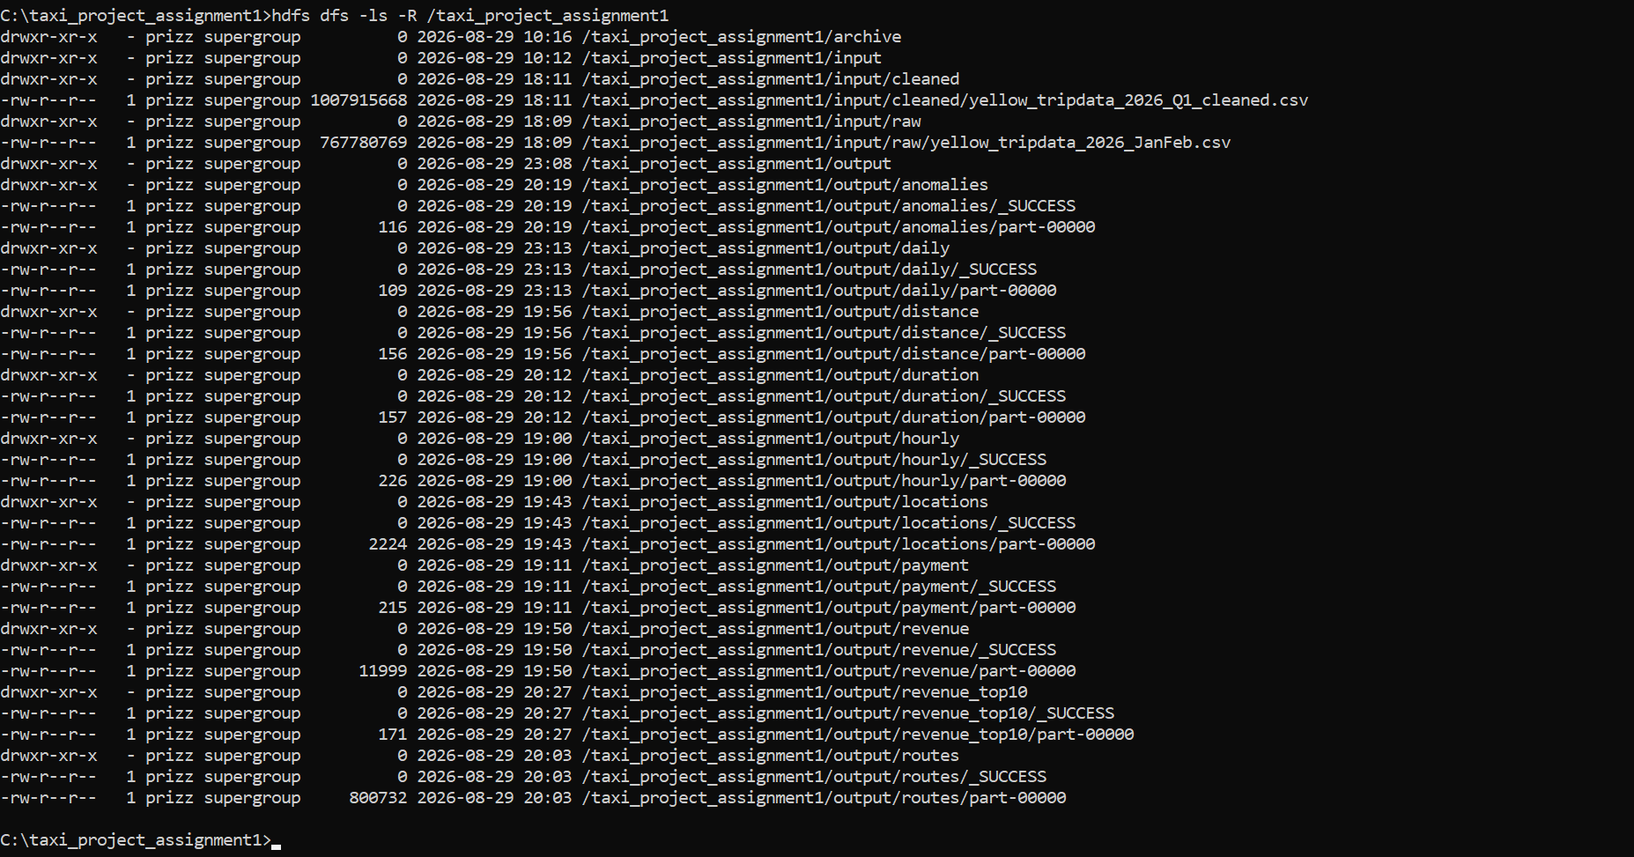

Evidence: Dataset Uploaded to HDFS
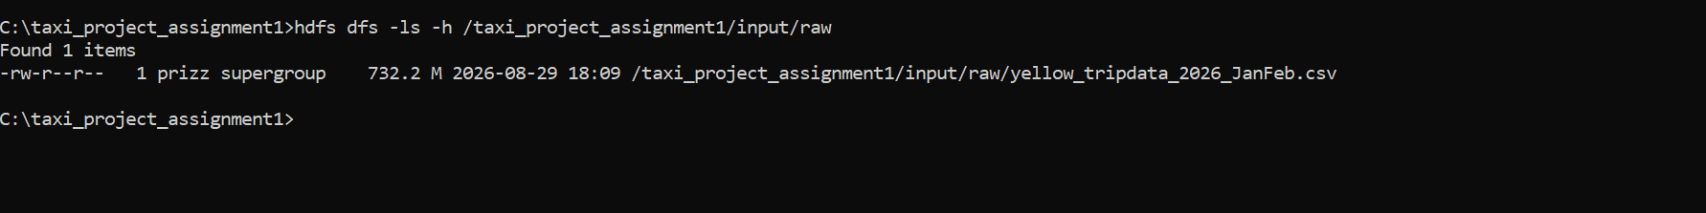
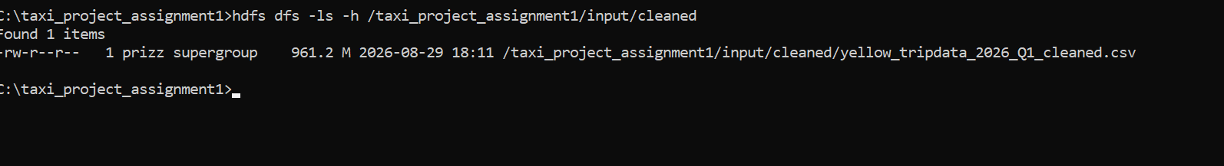

Evidence: HDFS File Size and Block Information
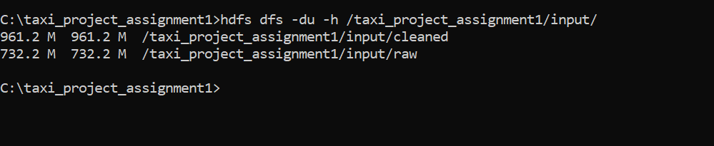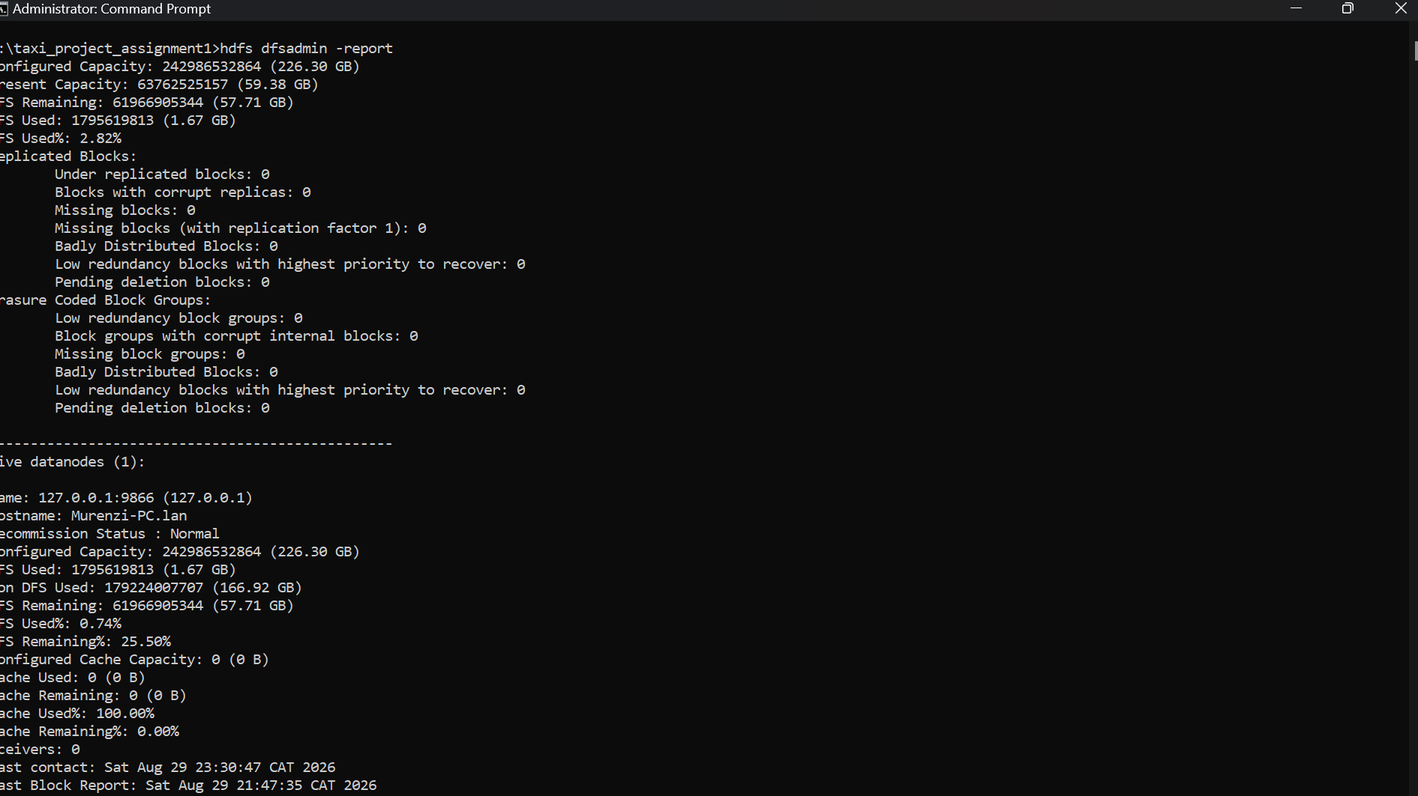

6. Data Cleaning
Cleaning followed a minimum-necessary-deletion principle: unreported optional fields were imputed rather than dropping the record; records were only removed when a reported value was logically impossible for a taxi trip.
Metric | Value
Raw records | 7,124,755
Clean records | 6,658,639
Removed | 466,116 (6.5422%)

Rule | Description | Records Affected | % of Dataset
duplicates | Exact duplicate rows (kept first occurrence) | 0 | 0.0%
invalid_timestamp_order | Dropoff time <= pickup time | 85,668 | 1.2024%
impossible_duration | Trip duration <= 0 min or > 1440 min (24h) | 72 | 0.001%
zero_negative_distance | trip_distance <= 0 miles | 246,914 | 3.4656%
extreme_distance | trip_distance > 100 miles | 332 | 0.0047%
missing_passenger_count_imputed | Missing passenger_count imputed to 1 - not dropped | 1,924,324 | 27.009%
invalid_passenger_count | Reported passenger_count <=0 or >6 | 26,422 | 0.3708%
invalid_fare | fare_amount <= 0 or total_amount <= 0 | 64,885 | 0.9107%
extreme_fare | total_amount > $1000 | 0 | 0.0%
invalid_location_id | PU/DOLocationID outside valid TLC zone range 1-263 | 41,823 | 0.587%
missing_RatecodeID_imputed | RatecodeID imputed to 1 - not dropped | 1,917,311 | 26.9106%
missing_store_and_fwd_flag_imputed | store_and_fwd_flag imputed to N - not dropped | 1,917,311 | 26.9106%
missing_congestion_surcharge_imputed | Missing congestion_surcharge imputed to 0.0 | 1,917,311 | 26.9106%
missing_Airport_fee_imputed | Missing Airport_fee imputed to 0.0 | 1,917,311 | 26.9106%
negative_fee_components | Negative fee component(s) clipped to 0 | 96 | 0.0013%

7. MapReduce Design
Every Mapper emits key\tvalue text to stdout; Hadoop's Shuffle-and-Sort groups values by key for the Reducer, which tracks a single running accumulator per key.
Analysis | Mapper Key | Reducer Output
a) Hourly demand | pickup_hour | trips per hour
b) Daily demand | day_of_week | trips per day + weekday/weekend totals
c) Pickup location | PULocationID | trips per zone, top10/bottom10
d) Revenue by location | PULocationID | count, total fare/tip/revenue, avg fare/dist
e) Payment method | payment_type | trips, revenue, avg fare/tip
f) Distance-based fare | distance bucket | avg fare/total/distance
g) Routes | PU->DO | count & revenue, top20 each
h) Trip duration | duration bucket | avg fare/dist/tip
i) Anomaly detection | anomaly_type | count per category, % flagged

8. Mapper and Reducer Implementation
All 9 analyses plus the 2-stage revenue job are implemented as standalone Python scripts in mappers/ and reducers/ (on GitHub - see Section 17). Each uses only the Python standard library.

Evidence: MapReduce Job Execution (Console Output)
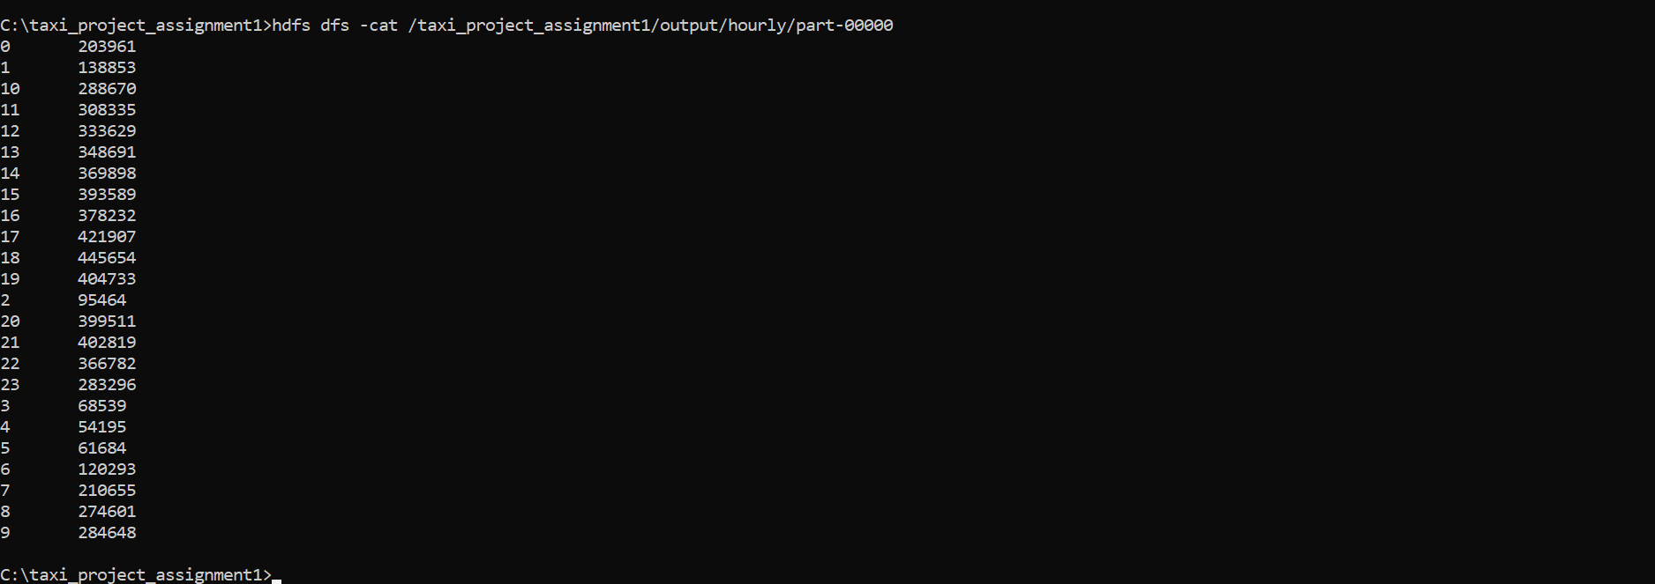Explanation: Ran Hadoop.jar command on the hourly job for demonstration

9. Analytical Results

9.1 Hourly Taxi Demand
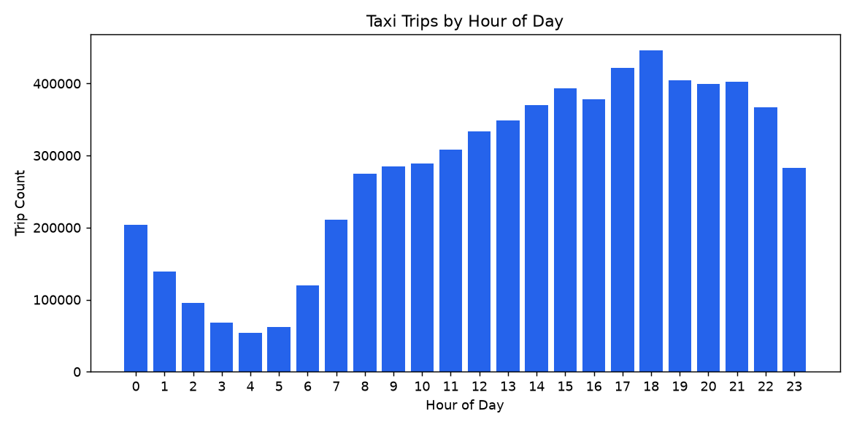 Busiest hour: 18:00 (445,654 trips). Quietest hour: 04:00 (54,195 trips). Demand rises steadily from the overnight low through a daytime climb, peaking during the evening commute/dinner window (17:00-21:00 all exceed 400,000 trips).

9.2 Daily Demand

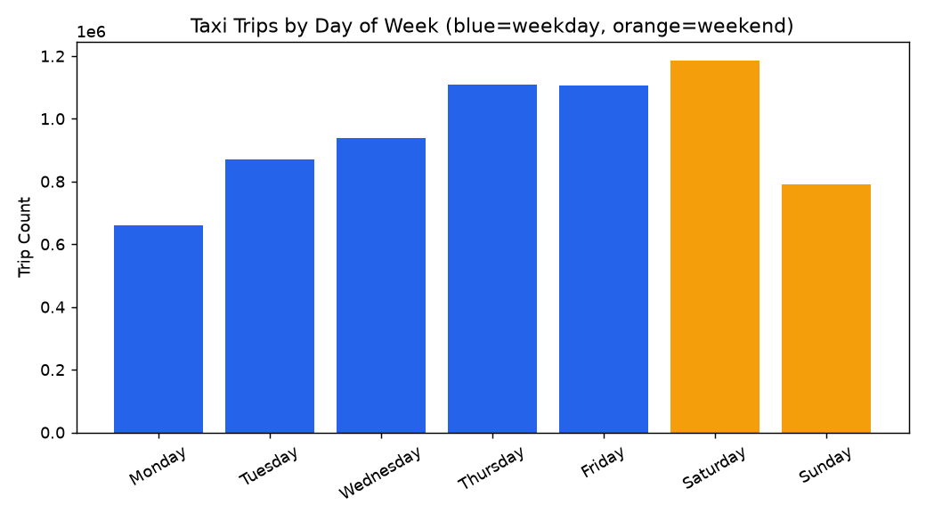

Day | Trips
Monday | 661,489
Tuesday | 869,458
Wednesday | 937,522
Thursday | 1,108,060
Friday | 1,106,614
Saturday | 1,184,797
Sunday | 790,699

Busiest day: Saturday (1,184,797 trips). Weekday total: 4,683,143 trips across 5 days (avg 936,629/day). Weekend total: 1,975,496 trips across 2 days (avg 987,748/day) - per-day demand is actually slightly higher on weekends despite weekdays contributing more total volume simply because there are more of them.

9.3 Pickup Location Analysis
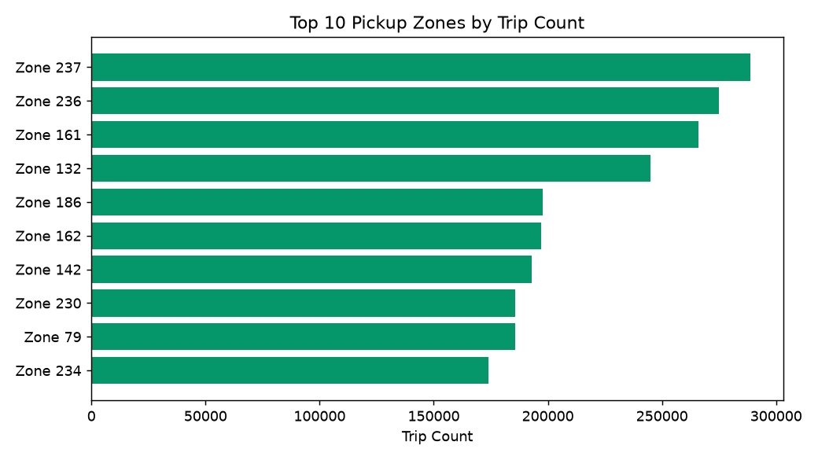
Zone | Trips
237 | 288,775
236 | 274,925
161 | 265,971
132 | 245,040
186 | 197,920
162 | 196,943
142 | 193,090
230 | 185,840
79 | 185,668
234 | 173,993

Top pickup zone: LocationID 237 (288,775 trips). Bottom zones (44, 204, 99, 5, 84 among others) recorded 1-4 trips across both months - very low-demand or peripheral zones.

Evidence: Final HDFS Results (Locations)
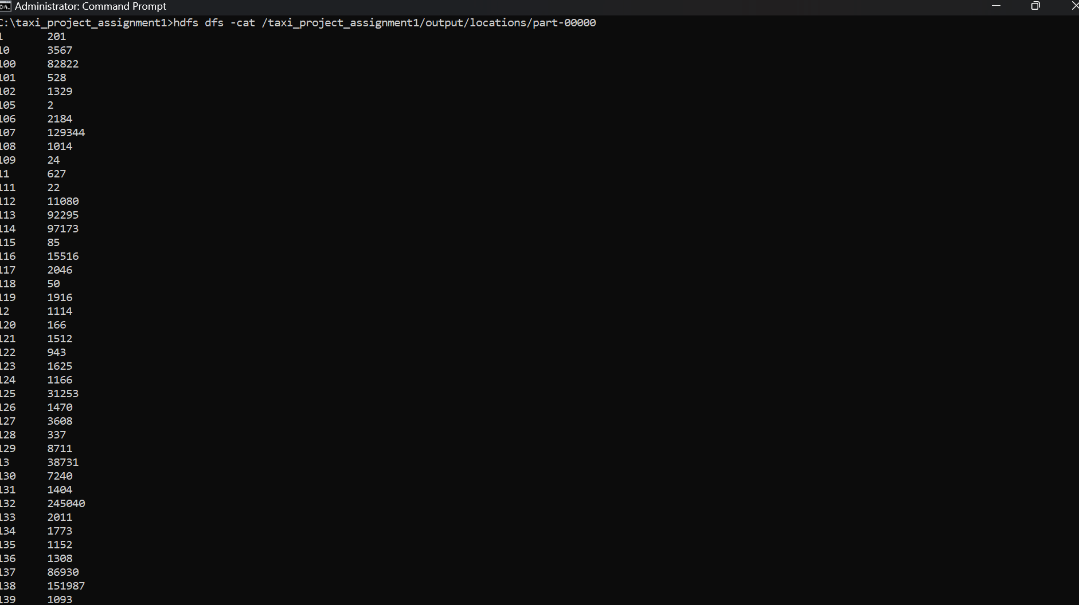

9.4 Revenue by Pickup Location
Rank | Zone | Total Revenue ($)
1 | 132 | 18,933,471.83
2 | 138 | 10,439,445.17
3 | 161 | 7,203,581.59
4 | 237 | 6,316,098.94
5 | 236 | 6,227,023.66
6 | 230 | 5,503,138.01
7 | 186 | 5,147,766.99
8 | 162 | 5,112,397.41
9 | 79 | 4,810,071.74
10 | 68 | 4,584,294.15

Zone 132 leads revenue by nearly 2x the #2 zone despite ranking only #4 in trip count (Section 9.3) - a strong signal of high-value trips (consistent with an airport or long-haul origin).

Evidence: Intermediate MapReduce Output (Multi-Stage Job, Stage 1)
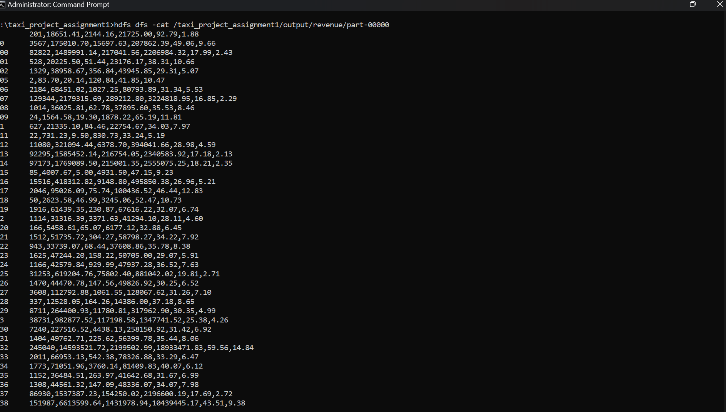

9.5 Payment Method Analysis
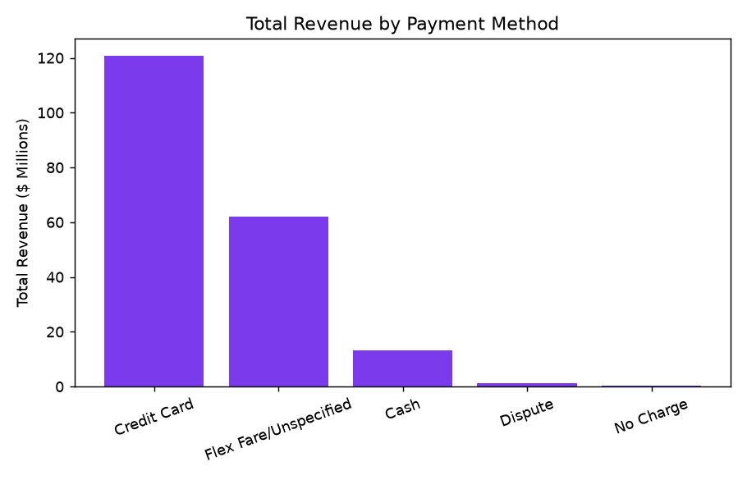

Method | Trips | Total Revenue ($) | Avg Fare ($) | Avg Tip ($)
Credit Card | 4,142,063 | 120,906,807.01 | 29.19 | 4.08
Flex Fare/Unspecified | 1,917,311 | 62,034,832.88 | 32.36 | 0.40
Cash | 538,271 | 13,276,495.61 | 24.67 | 0.00
Dispute | 45,841 | 1,296,600.57 | 28.28 | 0.00
No Charge | 15,153 | 369,718.29 | 24.40 | 0.00

Credit Card contributes the most revenue ($120,906,807.01 across 4,142,063 trips). Credit card users tip decisively more (avg $4.08 vs $0.00 for cash) - though TLC data does not record cash tips at all, so this reflects a data-recording limitation as much as behavior.

9.6 Distance-Based Fare Analysis
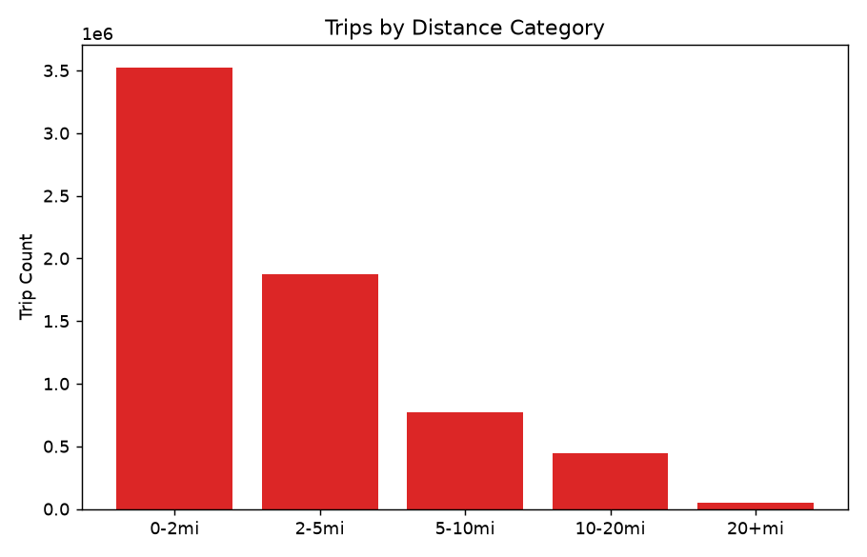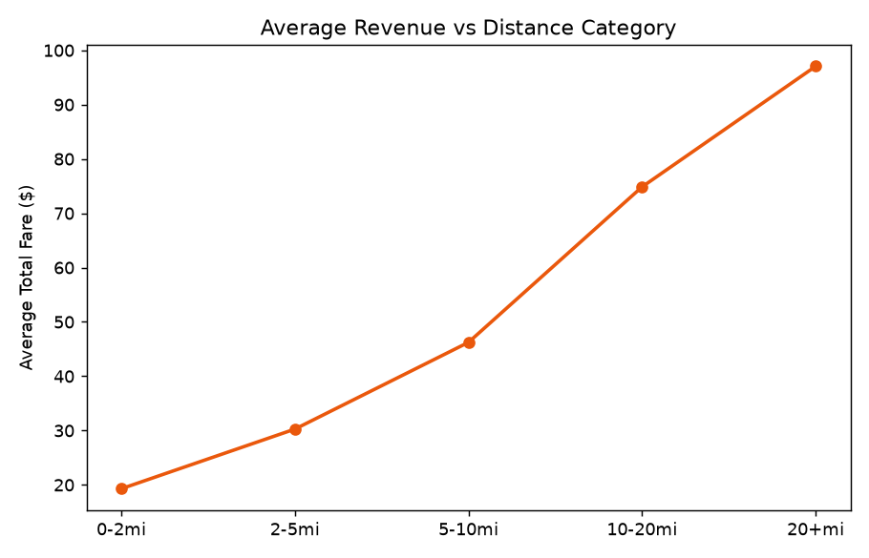
Category | Trips | Avg Fare ($) | Avg Total ($) | Avg Distance (mi)
0-2mi | 3,526,386 | 12.03 | 19.29 | 1.13
2-5mi | 1,875,160 | 22.36 | 30.27 | 3.09
5-10mi | 768,975 | 35.67 | 46.24 | 7.15
10-20mi | 442,103 | 57.78 | 74.86 | 14.40
20+mi | 46,015 | 76.78 | 97.06 | 23.34

Most trips (3,526,386) fall in the 0-2 mile band. Highest average fare: 20+ miles ($76.78 avg fare, $97.06 avg total) - fares scale roughly linearly with distance.

9.7 Busiest Pickup-Dropoff Routes
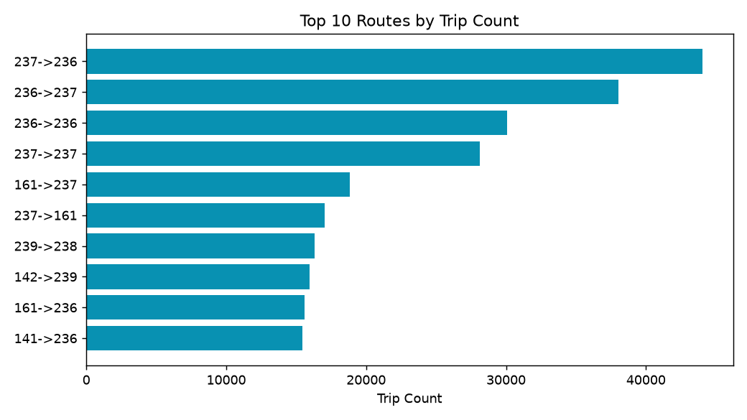
Route | Trips | Revenue ($)
237->236 | 44,020 | 719,362.01
236->237 | 38,026 | 650,055.83
236->236 | 30,096 | 418,179.92
237->237 | 28,125 | 410,025.70
161->237 | 18,809 | 361,713.70
237->161 | 17,037 | 315,381.61
239->238 | 16,330 | 235,441.93
142->239 | 15,971 | 247,642.89
161->236 | 15,586 | 379,898.97
141->236 | 15,441 | 256,422.60

Most frequent route: 237->236 (44,020 trips, $719,362.01 revenue) - a short intra-Manhattan hop. Notably, this is also the highest-revenue route in the top-20-by-count list, so at the very top the busiest and most profitable routes coincide here - unlike the zone-level pattern in Section 9.4, where the single highest-revenue zone (132) was not the highest-trip-count zone.

9.8 Trip Duration Analysis
Duration | Trips | Avg Fare ($) | Avg Distance (mi) | Avg Tip ($)
0-5min | 571,014 | 7.95 | 0.61 | 1.70
5-15min | 3,078,974 | 12.84 | 1.57 | 1.95
15-30min | 2,182,406 | 25.82 | 4.07 | 2.82
30-60min | 697,464 | 47.50 | 9.71 | 5.60
60+min | 128,781 | 56.73 | 14.43 | 4.98

Most trips last 5-15 minutes. Highest average fare: 60+ minutes ($56.73). Interestingly, the highest average tip is the 30-60min bucket ($5.60), not the longest trips - possibly reflecting congestion-heavy trips where riders tip well despite a lower fare-per-minute.

Evidence: Final HDFS Results (Duration)
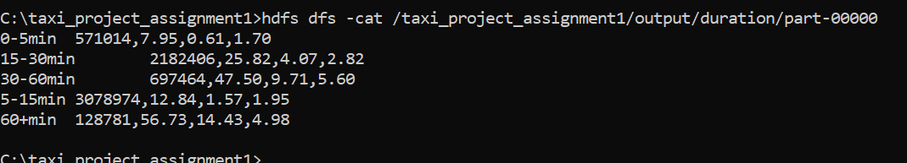

9.9 Anomaly Detection
Anomaly Type | Count
extreme_fare_per_mile | 82,347
implausible_speed | 1,083
too_fast_for_duration | 1
total_less_than_fare | 5,239
normal | 6,569,969

6,658,639 clean records scanned; 88,670 flagged (1.33%), dominated by extreme_fare_per_mile (82,347 records) - likely short trips with flat minimum fares or rate-code surcharges rather than fraud, worth a rate-code-aware follow-up review before any corrective action.

10. Multi-Stage MapReduce
Stage 1 (mapper_revenue.py + reducer_revenue.py) computes revenue statistics per pickup zone, writing to HDFS at /taxi_project_assignment1/output/revenue/. Stage 2 (mapper_top10_revenue.py + reducer_top10_revenue.py) reads that HDFS output directly as its input, re-keys every zone under a single constant key 'ALL' so all 263 zone totals funnel to one Reducer, and emits the globally sorted Top 10 by revenue (see table in Section 9.4).
The intermediate HDFS output (Stage 1's part-00000 file, screenshotted in Section 9.4) is preserved and used unmodified as Stage 2's -input path, satisfying the requirement to show intermediate output between stages.

11. YARN Analysis
Each hadoop jar hadoop-streaming-*.jar submission is scheduled by YARN's ResourceManager and tracked at http://localhost:8088/cluster.

Evidence: YARN Application List
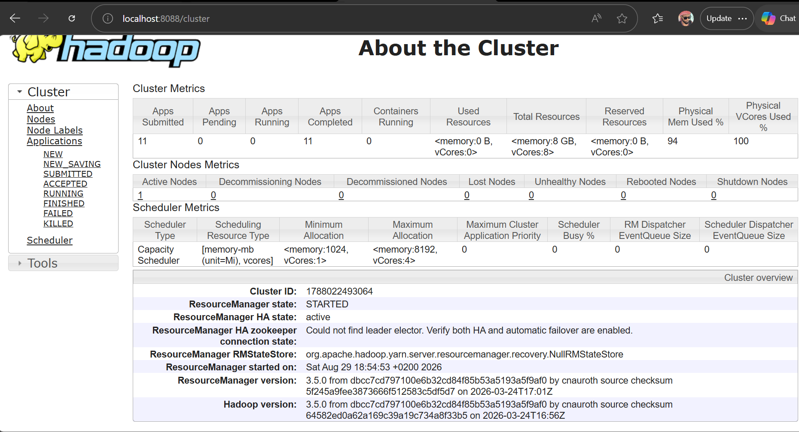

Evidence: YARN Application Detail Page
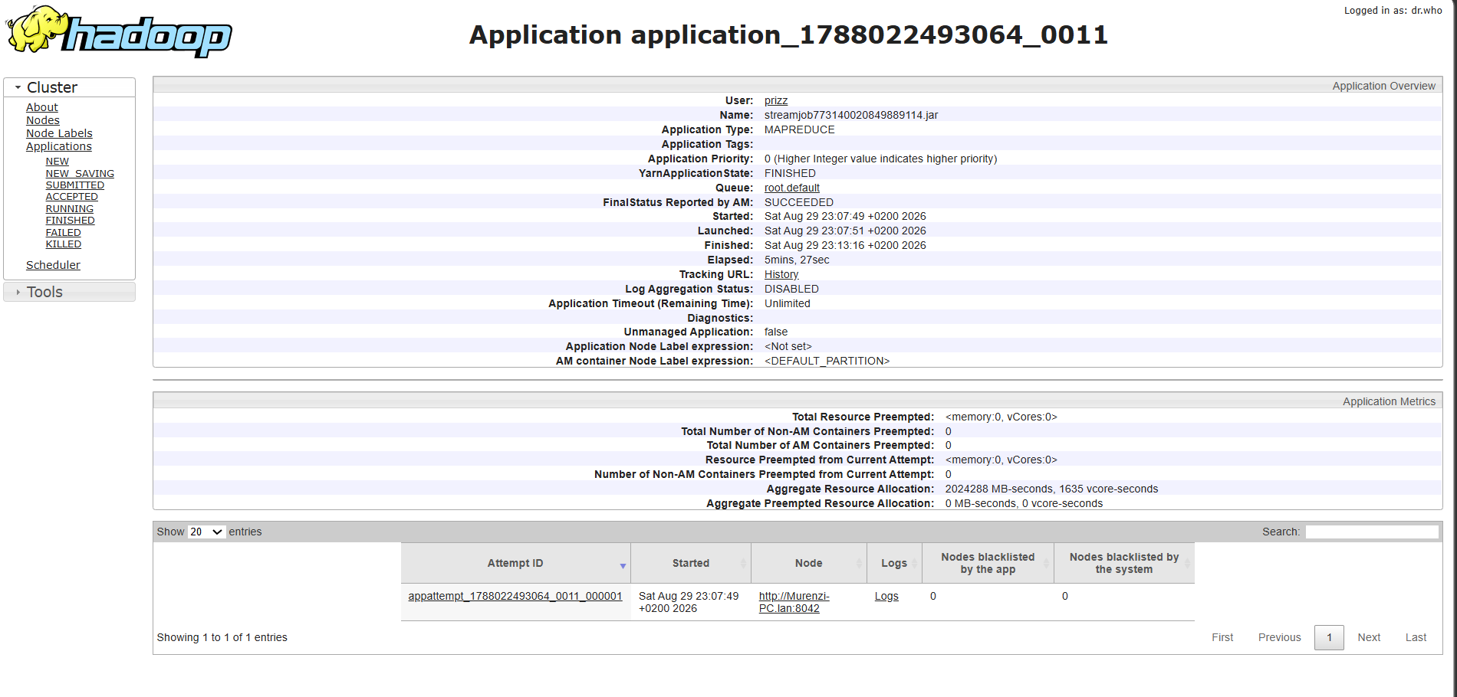
Several jobs showed Failed and Killed map/reduce tasks (visible in console output) that were automatically retried by YARN before the job completed successfully - direct evidence of MapReduce's fault-tolerance model working as designed on this cluster.

12. Performance Comparison

Metric | Python/Pandas | Streaming Pipeline
Dataset size | 1007.9 MB | 1007.9 MB
Number of records | 6,658,639 | 6,658,639
Execution time | 76.85 seconds | 214.97 seconds
Output size | 12.0 KB | 12.0 KB
Peak memory usage | 1671.1 MB | Not measured
Estimated mapper tasks on cluster | N/A | 8
Estimated reducer tasks on cluster | N/A | 1

Evidence: Performance Comparison Output

Discussion: at this dataset scale on a single machine, Pandas is typically faster in wall-clock time due to no process-spawn/text-parsing overhead. Hadoop MapReduce's real value is horizontal scalability and fault tolerance (observed first-hand in Section 11's retried tasks) - advantages that compound at multi-GB-to-TB scale and in continuously-running production pipelines, not necessarily at this single-node, two-month test.

13. Business Insights (Final Business Questions)
a) What is the busiest hour for taxi demand?
18:00, with 445,654 trips - the evening commute/dinner peak.
b) What is the busiest day of the week?
Saturday, with 1,184,797 trips. Per-day, weekends actually average slightly higher demand (987,748/day) than weekdays (936,629/day), even though weekdays contribute more total monthly volume simply by having more days.
c) Which pickup zones generate the most trips?
LocationID 237 (288,775 trips), followed by 236, 161, 132, 186.
d) Which pickup zones generate the most revenue?
LocationID 132 ($18,933,471.83) - nearly 2x the #2 zone (138, $10,439,445.17) despite not leading in trip count.
e) Which payment method contributes the most revenue?
Credit Card: $120,906,807.01 across 4,142,063 trips.
f) Do credit-card users generate more tips?
Yes - avg tip $4.08 for credit card vs $0.00 recorded for cash. TLC data does not capture cash tips at all, so this reflects a data-recording limitation as much as rider behavior.
g) What distance category produces the highest average fare?
20+ miles: avg fare $76.78, avg total $97.06.
h) What are the most frequently travelled routes?
237->236 (44,020 trips), then 236->237 (38,026) - short intra-Manhattan hops dominate frequency.
i) Are the most frequent routes also the most profitable?
At the top, yes: 237->236 is both the most-frequent AND highest-revenue route in the top-20 list ($719,362.01). However, at the zone level (Section 9.4), the single highest-revenue zone (132) was not the highest-trip-count zone - so frequency and profitability align at the route level here but diverge at the broader zone level, suggesting a mix of high-volume short hops and lower-volume high-value trips both driving revenue.
j) What percentage of records contain potential anomalies?
1.33% (88,670 of 6,658,639 clean records), dominated by extreme fare-per-mile cases.
k) What transportation insights can management derive?
(1) Fleet allocation should peak around 5-9 PM and stay elevated through Saturday, with weekend per-day demand slightly exceeding weekday per-day demand. (2) Zone 132 warrants special commercial attention - it drives outsized revenue on modest volume. (3) Short (0-2mi) trips are the volume backbone but least profitable per trip. (4) Cash-tip blindness in the data means true driver earnings from cash fares are undercounted in any tip-based incentive model.
l) When does Hadoop MapReduce provide a meaningful advantage over conventional processing?
When the dataset no longer fits comfortably in one machine's memory/CPU budget, when the same job runs repeatedly across a growing archive at production scale, or when fault-tolerant, unattended distributed execution is required (as observed in Section 11's automatic task retries) - not necessarily at this single-month-scale, single-node test, where Pandas is simpler and faster.

14. Limitations
- Two months of data used (7,124,755 raw records) - satisfies the brief's 5M-record threshold.
- TLC data does not record cash tips, understating true tip totals for cash payments.
- LocationIDs shown without a joined TLC zone-name lookup table.
- Anomaly thresholds are heuristic, not tuned against labeled fraud/error data.
- [Add any environment-specific limitations you personally encountered, e.g. single-node cluster constraints, JDK 17 compatibility fixes required.]

15. Conclusion
This project implemented a complete Hadoop Streaming analytics pipeline for NYC TLC Yellow Taxi data on a real Hadoop 3.5.0 cluster: documented data cleaning removing 6.54% of clearly invalid records from 7,124,755 raw trips; nine single-stage MapReduce analyses covering demand, location, revenue, payment, distance, route, duration, and anomaly dimensions; a two-stage MapReduce workflow chaining zone-revenue aggregation into a global Top-10; and a performance comparison against Pandas surfacing the real trade-off between single-node convenience and distributed scalability. Key findings: demand peaks at 18:00 and on Saturdays; Zone 237 leads in trip volume while Zone 132 leads in revenue; Credit Card is the dominant payment method by both volume and tipping; and 1.33% of records show anomaly indicators warranting further review.

16. References
- NYC Taxi & Limousine Commission. TLC Trip Record Data. https://www.nyc.gov/site/tlc/about/tlc-trip-record-data.page
- Apache Hadoop Documentation. https://hadoop.apache.org/docs/stable/
- Apache Hadoop Streaming Guide. https://hadoop.apache.org/docs/stable/hadoop-streaming/HadoopStreaming.html

