*Microprocessor Systems*

**Smart distillery**

Muresan Razvan , Lungu Ionut

User Requirements 3

Why and how it works 4

System overview 5

Hardware design 6

Repository 8

Results and further work 9

References 12

***User Requirements***

1. The system must stop when the alcohol is extracted from the

“ boasca”.

1. The system should be automated, the only intervention of an outside factor being when changing “boasca”.
2. The system should not be influenced by outside factors such as high temperatures.
3. The system must provide the temperature, the level o liquid in the recipient destined for collecting alcohol and for the automatic closing and opening of the gas.
4. The system may provide a module for data interpretation.
5. The temperature and the closing button should be accessible via a Web interface.
6. Must be easy to use and relatively cheap

***Why and how it works.***

In Romania a lot of people in rural areas make their own alcohol using coppers. During the process they have to sit near it and check if the fire is strong enough or if the alcohol produced has the quality required. It is a process that takes a lot of time and everyone does it as he thinks best .I thought that the IoT device used would be made of: raspberry pi, arduino leonardo, a sensor that measures the temperature, a motor, a driver for that motor, a gas burner and a switch for emergency stop button if something goes wrong with the sensors. The motor controls the gas burner based on the temperature in the copper measured by the sensor .

A proximity sensor measures the distance to the cork, the resting distance between the cork and the proximity sensor is around ~82 mm, and every 7 mm of distance means 100ml of liquid. The proximity sensor is connected to the i2c pins of the arduino. If the cork is raised by the output liquid to a certain height then the proximity sensor sends a signal that stops the process. A good thing about this is that the copper does not have to be modified and the device would be easy to be used.

The motor is driven by the DC driver that is powered by a 9V (0.5A) DC power supply (from an old router). The DC motor has a gearbox that increases the torque at the shaft that is connected to the valve of the gas burner.

The data is sent from the arduino board to the raspberry pi board via the i2c ports and the temperature is then uploaded on plot.ly in real time.

***System overview***

***Hardware design:***

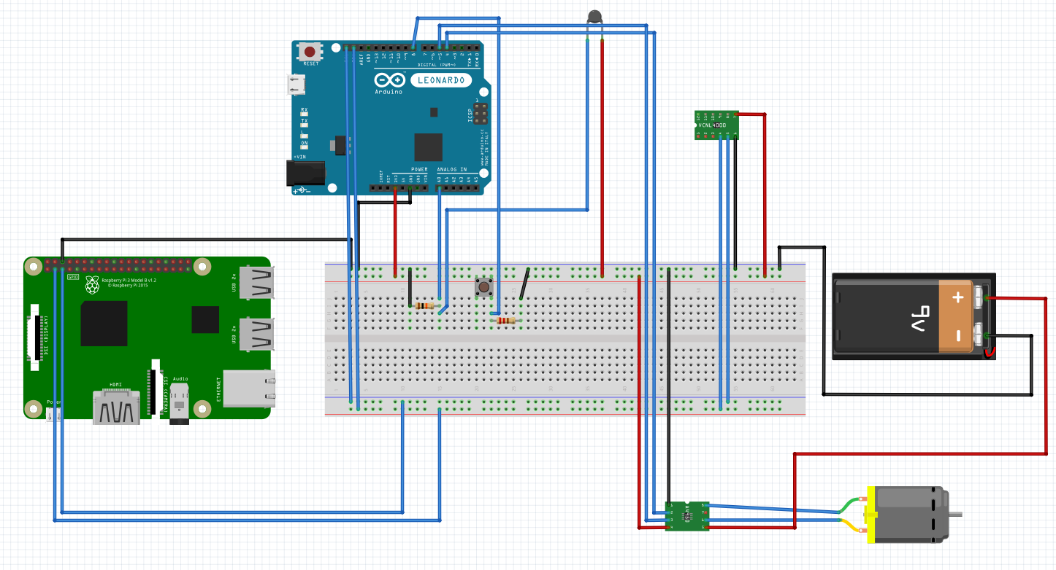

**DRV8838**

This tiny breakout board for TI’s DRV8838 motor driver can deliver a continuous 1.7 A (1.8 A peak) to a single brushed DC motor. With an operating voltage range from 0 V to 11 V and built-in protection against reverse-voltage, under-voltage, over-current, and over-temperature, this driver is a great solution for powering a small, low-voltage motor. The carrier board has the form factor of a 10-pin DIP package, which makes it easy to use with standard solderless breadboards and 0.1″ perfboards

# VL6180X

This sensor is a carrier/breakout board for ST’s VL6180X proximity and ambient light sensor, which measures the range to a target object up to **20 cm** away (or **60 cm with reduced resolution**). The VL6180X uses time-of-flight measurements of infrared pulses for ranging, allowing it to give accurate results independent of the target’s color and surface. Distance and ambient light level measurements can be read through a digital I²C interface. The board has a 2.8 V linear regulator and integrated level-shifters that allow it to work over an input voltage range of 2.7 V to 5.5 V, and the 0.1″ pin spacing makes it easy to use with standard solderless breadboards and 0.1″ perfboards.

**Motor 4 RPM Actobotics**

Supply voltage: 3-12 V. Transmission ratio: 900: 1. Stall Couple: 71 kg-cm (992 oz-in).(@ 12V). Speed: 4 RPM (@ 12V). Current: 160 mA (@ 12V).Current Stall: 0.5A (@ 12V).Insulation resistance: 10 MOhm. Dielectric Rigidity: 300Vdc .DC reversible.

**Raspberry Pi 3 Model B**

New version of Raspberry Pi 3 Model B (released February 29, 2016). Quad Core CPU.1GB RAM.1.2GHz Board Clock Speed ​​Broadcom BCM2837 64bit CPU.40 GPIO Pins. 4 x USB 2 Ports . 4 Stereo Output Field . HDMI Port.10/100 Ethernet. Micro SD Card Slot. BCM43143 WiFi and Bluetooth Low. Energy (BLE) on the board.

**SNS-TMP10K**

Temperature sensor for temperatures in range -30+110°C with 1% precision. Perfect for measuring of fluids, air temperature, refrigerators, freezers, water heaters, incubators etc. The resistance is 10K ±1% at 25C. The resistance goes down when warmer and up when colder.

**Arduino Leonardo**

Arduino Leonardo is the latest Arduino processing platform. It is based on the ATMega32U4 microcontroller. It has 20 digital input / output pins (of which 7 supports PWM and 12 of them can also be used as analog input pins), operates at 16 MHz, and has a connection to the computer via a micro USB jack. The product contains everything you need to use in any conditions. All you have to do is connect it to your PC or to an external power supply (7V - 12V).

***Repository***

***https://github.com/muresanrazvan/MS***

***Results and further work***

The submitted version of the project offers the following functionalities:

* Reliable reading of the temperature ,of the output liquid and automatic closing and opening of the gas
* Alcohol evaporates and actually reaches the other side

The following list of extensions and/or improvements are planned for the next iteration:

* Automated refill of the cauldron.
* Guide for users how to install the device and how to use it(pictures)

***References***

<https://sites.google.com/site/claudiudgroza/internet-of-things/week-06>

<https://az835927.vo.msecnd.net/sites/iot/Resources/images/PinMappings/RP2_Pinout.png>

<https://stackoverflow.com/questions/18937058/clear-screen-in-shell>

<http://fritzing.org/home/>

<https://www.olimex.com/Products/Components/Sensors/SNS-TMP10K/>

<https://www.arduino.cc/en/Reference/Board>

<https://github.com/muresanrazvan/MS>