**DEVS**

**Aircraft Transponder**

Prepared by:

Mark Murphy

Student ID: 100603616

Assignment 1  
SYSC 5104 – Winter 2025

**Part I: Description of the Conceptual Model**

Aircraft Transponder (Mode 3)

Aircraft transponders are used by military and civilian Air Traffic systems wordwide. The Air Traffic Control Radar Beacon System (ATCRBS) has been in use since the 1950s, it has Modes 1,2 and 4 for military use, and Mode 3A and 3C (also known as Mode A and Mode C) for civilian use. ATCRBS it is still in use but is slowly being replaced by Mode 5 for military applications, and Mode-S and ADS-B for civilian aviation.

The proposed model simulates the interrogation and reply of the ATCRBS system. All aircraft in civilian airspace are required to have transponders which reply to interrogation of Mode A and Mode C. The Mode A reply is a four-digit octal (0-7) code, input by the pilot, which identifies the aircraft. The Mode C reply is the aircraft altitude, denoted in hundreds of feet. A Secondary Surveillance Radar (SSR) sends an interrogation signal, and all aircraft who receive the signal will reply. A typical SSR spins such that a 360° scan takes between 5 and 12 seconds. Modern SSR radars will interrogate

The Mode A and Mode C interogation signals occur at 1030MHz and is made up of a series of 0.8µs pulses. The first and third pulses (P1 and P3) use a directional antenna, if the pulses are 8µs apart the radar is interrogating Mode A, and if they are 21µs apart it is interrogating Mode C. The first signal P1 is followed 0.02µs later by a second signal P2, which comes from an omni directional antenna; P2 occurs at a lower power than P1, but at a higher power than the sidelobe created by P1. If the transponder receives P2 with higher power than P1 it assumes it is a sidelobe and ignores the interrogation.

If the transponder receives a valid interrogation for Mode A or Mode C it will respond after 3µs with its identity code or altitude using a sequence of pulses; two framing pulses 20.3µs apart, with twelve 0.45µs time slots in between for the data, as shown in the figure below.

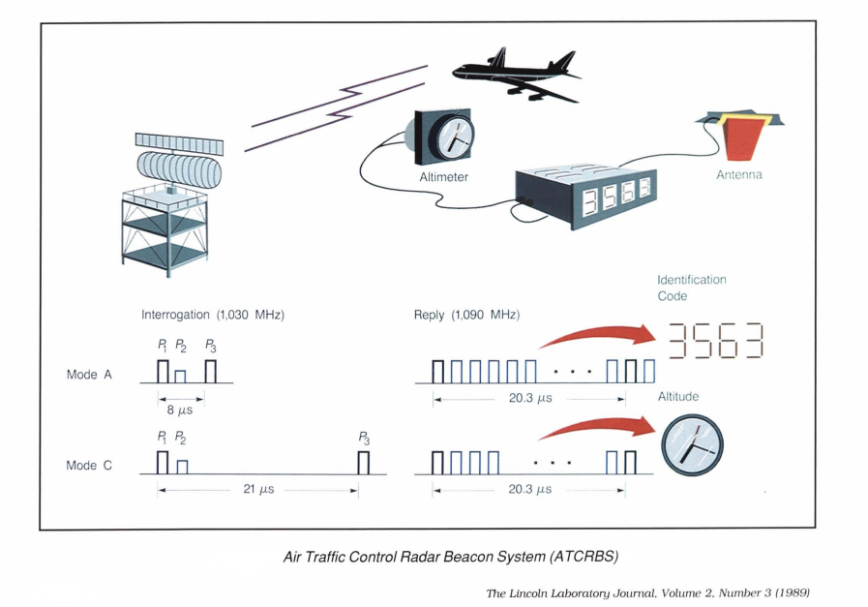

The model takes the following form:

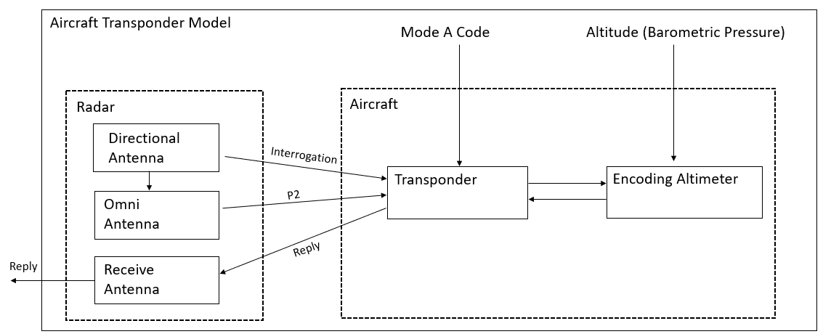

Model components:

*Radar* – A coupled model of the three different antennas. The Radar will output interrogations of Mode A transponder code and Mode C altitude, as well as sidelobe suppression interrogations on a schedule provided by IEStream; the radar will then wait for the replies. When the *Directional Antenna* sends P1 it will send a message to the *Omni Antenna*, which will send its own pulse, P2, after 2µs. The directional antenna will send another pulse, P3, at 8 or 21 µs. The *Receive Antenna* will receive replies from the Transponder. In the most basic implementation of the model the Transponder function is the focus and the radar does not spin, track return times, calculate azimuth or range, or forward the data to a control system.

*Aircraft*- Consists of the Transponder and Altimeter.

*Transponder* – Starts in waiting mode with an initial transponder code. Upon receipt of a new transponder code it will update its code. Upon receipt of an interrogation pulse (P1) it will start a timer. If a second pulse (P2) is received at 2µs and it is greater power than P1 it will ignore the P3 pulse; if P1 power is less than P2, or if no P2 is received, it will continue counting. If a pulse (P3) is received at 8µs it will return the Mode A transponder code after 3µs, if not it will continue its timer. If a pulse is received at 21µs it wil send a request for Altimeter reading, receive the altimeter reading back from the Altimeter, and after 3µs will return the altitude. If no second pulse is received it will return to waiting mode.

*Altimeter* – When it receives a request for altitude from the transponder it will take the current altimeter reading and send it to the Transponder for transmission.

**Part II: Model Specification**

### Atomic Models

### Directional Antenna = <X, Y, S, δext, δint, λ, ta>

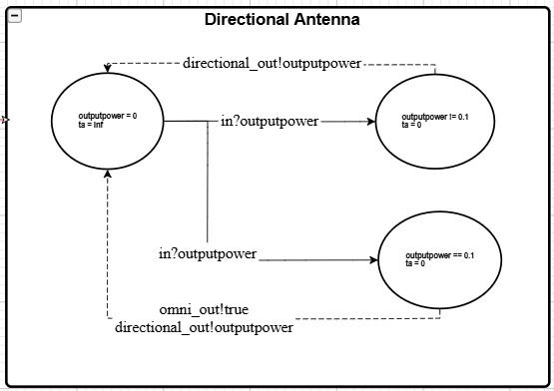

|  |  |
| --- | --- |
| **State Variables** | **Formal Specification** |
| Sigma = ∞  outputpower = 0.0 | X = {Outputpower}  Y = {Outputpower, Cueing Signal}  S = {Sigma, Outputpower} |
| **Functions** | |
| **δext (s, e, x =outputpower)**  {  Outputpower = x  Sigma = 0  }  **δint (s)**  {  Sigma = ∞;  }  **λ(s)**  {  Send a signal of strength *outputpower* to port *directional_out;*  if outputpower == 0.1dB {  Send a Cueing signal to port *cue_omni_out;*  *}*  }  **ta =** sigma | |
| **Experimentation Strategy** | |
| 1. Confirm that the model outputs the power as specified in the IEStream file. All of the experiments for the other modules rely on the correct functioning of the directional antenna, a problem will lead to failure of the other experiments and will be identified quickly. | |

### Omni Antenna = <X, Y, S, δext, δint, λ, ta>

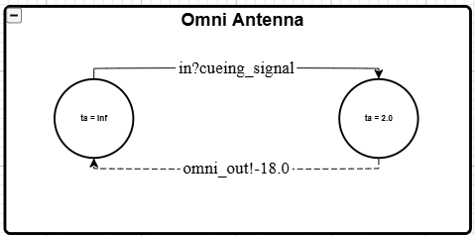

|  |  |
| --- | --- |
| **State Variables** | **Formal Specification** |
| Sigma = ∞ | X = {Cueing Signal}  Y = {Sidelobe Suppression Signal}  S = {Sigma} |
| **Functions** | |
| **δext (s, e, x = cueing signal)**  {  Sigma = 2.0;  }  **δint (s)**  {  Sigma = ∞;  }  **λ(s)**  {  Send sidelobe suppression signal at -18.0 to port *omni_out;*  }  **ta =** sigma | |
| **Experimentation Strategy** | |
| 1. Confirm that the omni antenna sends the sidelobe suppression signal at 2.0 µs after it receives a cueing signal from the directional antenna. | |

### Receive Antenna = <X, Y, S, δext, δint, λ, ta>

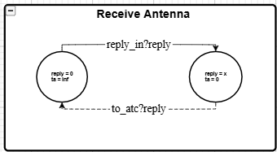

|  |  |
| --- | --- |
| **State Variables** | **Formal Specification** |
| sigma = ∞  reply = 0 | X = {transponder reply}  Y = {Ø}  S = {sigma} |
| **Functions** | |
| **δext (s, e, x =transponder reply)**  {  Sigma = 0;  }  **δint (s)**  {  Reply = 0;  Sigma = ∞;  }  **λ(s)**  {  Send reply to port out_*to_atc;*  }  **ta =** sigma | |
| **Experimentation Strategy** | |
| 1. Confirm that the receive antenna receives the replies as scheduled. | |

### Transponder = <X, Y, S, δext, δint, λ, ta>

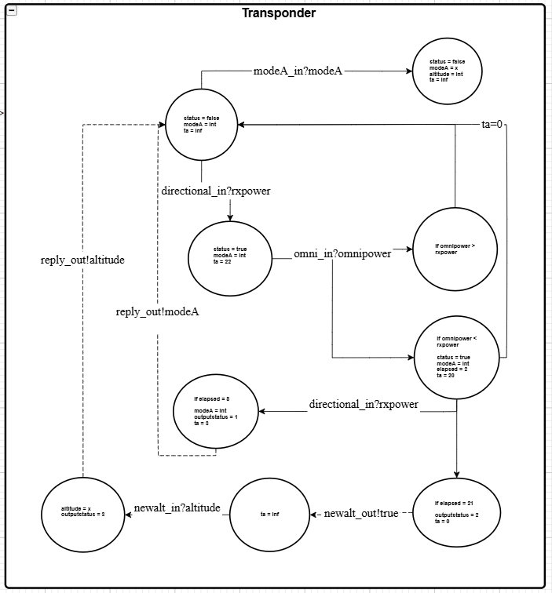

|  |  |
| --- | --- |
| **State Variables** | **Formal Specification** |
| sigma = ∞  status = false  elapsed = 0.0  rxpower = 0.0  omnipower = 0.0  modeA = 0  altitude = 0  outputstatus = 0 | X = {rxpower, omnipower, altimeter, mode A }  Y = {altitude request, transponder reply}  S = {sigma, status, elapsed, rxpower, omnipower,modeA,altitude, outputstatus} |
| **Functions** | |
| **δext (s, e, x )**  {  if x from port modeA*_in*:  modeA = x;  if x from port *newalt_in*:  altitude = x;  if x is from *directional_in* or *omni_in*:  if status == 0 {  status = 1;  rxpower = x;  sigma = 22.0;  }  else if status == 1 {  if e == 2.0 {  omnipower = x;  if rxpower > omnipower {  elapsed += e;  sigma -= e;  }  else {  status = 2;  elapsed += e;  sigma -= e;  }  }  else if (elapsed+e) == 8.0 {  outputstatus = 1;  sigma = 3.0;  }  else if (elapsed+e) == 21.0 {  outputstatus = 2;  sigma = 0.0;  }  else {  elapsed += e;  sigma -= e;  }  else if status ==2 {  sigma = 0.0 ;  }  }  if x from port *newalt_in:*  altitude = x;  outputstats = 3:  sigma = 3.0;    **δint (s)** {  if outputstatus == 2:  sigma = ∞;  All other cases:  status = false;  elapsed = 0.0;  rxpower = 0.0;  outputstatus = 0.0;  sigma = ∞;  **λ(s)**  {  if outputstatus == 0 : don’t do anything;  if outputstatus == 1: send *modeA* out of port *reply*_*out;*  if outputstatus == 2: send a request out of port *altreq_out;*  if outputstatus == 3: send *altitude* out of port *reply_out;*  }  **ta =** sigma | |
| **Experimentation Strategy** | |
| 1. Test that a modeA request works with two directional pulses 8 nanoseconds apart at a higher power than the sidelobe suppression pulse. 2. Test that an altitude request works with two directional pulses 21 nanoseconds apart at a higher power than the sidelobe suppression pulse. 3. Test that sidelobe suppression works with directional pulses 8 nanoseconds apart at a lower power than the sidelobe suppression pulse, confirm nothing is returned. 4. Test the timeout feature of the radar by waiting for 22 seconds after a single pulse and ensuring it resets. 5. Test the modeA input by changing to a new mode A code and interrogating it. 6. Test the altitude input by changing the altimeter altitude and interrogating it. 7. Test for receipt of signal at unexpected time during the cycle. | |

### Altimeter = <X, Y, S, δext, δint, λ, ta>

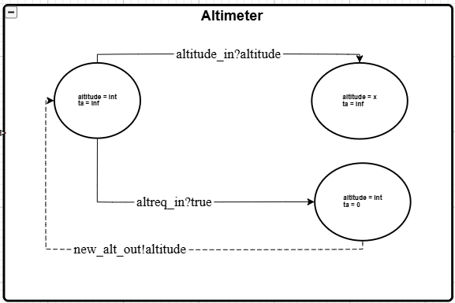

|  |  |
| --- | --- |
| **State Variables** | **Formal Specification** |
| Sigma = ∞  Altitude = 0 | X = {Altimeter Request, Altitude}  Y = { Altitude }  S = {Sigma, Altitude} |
| **Functions** | |
| **δext (s, e, x)**  {  if x from port *altreq_in:*  sigma = 0;  if x from port *altitude_in:*  altitude = x;  sigma = ∞;  }  **δint (s)**  {  sigma = ∞:  }  **λ(s)**  {  Send *altimeter* out of port *out;*  }  **ta =** sigma | |
| **Experimentation Strategy** | |
| 1. Send a request from the transponder for a new altimeter reading, ensure the message is received and the altitude is output. 2. Send a new altitude to the altimeter, ensure that it is received and the state is updated. | |

Coupled Models

### Radar = < X, Y, M, EIC, EOC, IC, SELECT >

|  |  |
| --- | --- |
| X: | {Interrrogation schedule, transponder replies} |
| Y: | {directional_pulse, omni_pulse} |
| M: | {directional_antenna,  omni_antenna,  receive_antenna} |
| EIC: | {(radar.radar_reply_in , receive_antenna.reply_in),  (radar.directional_file_in, directional_antenna.interrogation_list_in)} |
| EOC: | { (directional_antenna.directional_out, radar.directional_out),  (omni_antenna.omni_out, radar.radar_omni_out),  (receive_antenna.out_to_atc, radar.radar_reply_out} |
| IC: | {(directional_antenna.cue_omni_out , omni_antenna.cue_omni_in)} |
| SELECT: | {directional_antenna , omni_antenna, receive_antenna} = receive_antenna  {directional_antenna, omni_antenna) = directional_antenna |
| **Experimentation Strategy** | |
| 1. Confirm the signals are being sent and receive as planned. | |

### Aircraft = < X, Y, M, EIC, EOC, IC, SELECT >

|  |  |
| --- | --- |
| X: | {directional_pulse, omni_pulse, altimeter, modeA} |
| Y: | {transponder_reply} |
| M: | {transponder,  altimeter} |
| EIC: | {(aircraft.ac_omni_in , transponder.omni_in),  (aircraft.ac_directional_in , transponder.directional_in),  (aircraft.ac_modeA_in, transponder.modeA_in),  (aircraft.ac_altimeter_in, altimeter.altitude_In)} |
| EOC: | { transponder.reply_out, aircraft.ac_reply_out} |
| IC: | {(transponder.altreq_out, altimeter.altreq_in)  (altimeter.newalt_out, transponder.newalt_in)} |
| SELECT: | {transponder, altimeter} = transponder |
| **Experimentation Strategy** | |
| 1. Confirm the signals are being sent and receive as planned. | |

### Aircraft_transponder_top = < X, Y, M, EIC, EOC, IC, SELECT >

|  |  |
| --- | --- |
| X: | {} |
| Y: | {tranponder_reply} |
| M: | {aircraft,  radar} |
| EIC: | {} |
| EOC: | {(radar.radar_reply_out, aircraft_transponder_top.reply_out} |
| IC: | {(IEStream.modeAgen, aircraft.modeA_in),  (IEStream.altitudegen, aircraft.ac_altimeter_in),  (IEStream.directional_file, radar.directional_file_in),  (radar.radar_directional_out, aircraft.ac_directional_in),  (radar.radar_omni_out, aircraft.ac_omni_in),  (aircraft.ac_reply_out,radar.radar_reply_in)} |
| SELECT: | {radar, aircraft} = aircraft |
| **Experimentation Strategy** | |
| 1. Confirm the signals are being sent and receive as planned. | |

**Part III: Experiments and Results**

Experiment 1 - Mode A interrogation and reply:

|  |  |  |
| --- | --- | --- |
| **Time (µs)** | **Input** | **Expected Outcome** |
| 1.0 | Directional Antenna receives direction to send P1 with power 0.1dB | Directional Antenna sends interrogation pulse to Aircraft and cues the Omni Antenna, Transponder receives and changes status to on and starts a timer to count elapsed time |
| 3.0 |  | Omni antenna sends pulse P2 to Aircraft, Transponder confirms that power of P2 is less than P1 |
| 9.0 | Directional Antenna receives direction to send pulse P3 with power 0.1dB | Directional Antenna sends interrogation pulse to Aircraft, Transponder sets output for modeA and waits for 3 nanoseconds to reply |
| 12.0 |  | Transponder to reply with Mode A code, reply to be sent to Receive Antenna and forwarded out of the system (to ATC) |

Output:

|  |  |  |  |  |
| --- | --- | --- | --- | --- |
| **time** | **model_id** | **model_name** | **port_name** | **data** |
| 1 | 2 | IEStream Directional Antenna | out | 0.1 |
| 1 | 2 | IEStream Directional Antenna |  | 8 |
| 1 | 10 | Directional Antenna Model |  | {Power Setting: 0.1} |
| 1 | 5 | Transponder |  | {Status: 1, Elapsed: 0, Mode A:1200, Altitude: 0, OutputStatus: 0} |
| 1 | 9 | Omni Antenna Model |  | Preparing sidelobe suppression pulse |
| 1 | 10 | Directional Antenna Model | Directional - Cue to omni out | 1 |
| 1 | 10 | Directional Antenna Model | Directional - Interrogation pulse out | 0.1 |
| 1 | 10 | Directional Antenna Model |  | {Power Setting: 0} |
| 3 | 5 | Transponder |  | {Status: 1, Elapsed: 2, Mode A:1200, Altitude: 0, OutputStatus: 0} |
| 3 | 9 | Omni Antenna Model | Omni - Sidelobe suppression pulse out | -18 |
| 3 | 9 | Omni Antenna Model |  | Passive |
| 9 | 2 | IEStream Directional Antenna | out | 0.3 |
| 9 | 2 | IEStream Directional Antenna |  | 4 |
| 9 | 10 | Directional Antenna Model |  | {Power Setting: 0.3} |
| 9 | 5 | Transponder |  | {Status: 1, Elapsed: 8, Mode A:1200, Altitude: 0, OutputStatus: 1} |
| 9 | 10 | Directional Antenna Model | Directional - Interrogation pulse out | 0.3 |
| 9 | 10 | Directional Antenna Model |  | {Power Setting: 0} |
| 12 | 5 | Transponder | Transponder - Reply to radar out | 1200 |
| 12 | 5 | Transponder |  | {Status: 0, Elapsed: 0, Mode A:1200, Altitude: 0, OutputStatus: 0} |
| 12 | 8 | Receive Antenna Model |  | {REPLY FROM AIRCRAFT: 1200} |
| 12 | 8 | Receive Antenna Model | Receive - Send reply out to ATC | 1200 |
| 12 | 8 | Receive Antenna Model |  | Passive |

The goal was achieved, 3 µs after the P3 pulse the transponder sent back the Mode A code and it was received and forwarded to ATC.

Experiment 2 – Altitude interrogation with no sidelobe suppression and reply:

|  |  |  |
| --- | --- | --- |
| **Time (µs)** | **Input** | **Expected Outcome** |
| 13.0 | Directional Antenna receives direction to send P1 with power 0.1dB | Directional Antenna sends interrogation pulse to Aircraft and cues the Omni Antenna, Transponder receives and changes status to on and starts a timer to count elapsed time |
| 34.0 | Directional Antenna receives direction to send pulse P3 with power 0.1dB | Directional Antenna sends interrogation pulse to aircraft, Transponder requests altitude from the Altimeter, and when it receives the new altitude it will set output for altitude and wait for 3 nanoseconds to reply |
| 37.0 |  | Transponder to reply with altitude, reply to be sent to Receive Antenna and be forwarded out of the system (to ATC) |

Output:

|  |  |  |  |  |
| --- | --- | --- | --- | --- |
| **time** | **model_id** | **model_name** | **port_name** | **data** |
| 13 | 2 | IEStream Directional Antenna | out | 0.3 |
| 13 | 2 | IEStream Directional Antenna |  | 21 |
| 13 | 10 | Directional Antenna Model |  | {Power Setting: 0.3} |
| 13 | 5 | Transponder |  | {Status: 1, Elapsed: 0, Mode A:1200, Altitude: 0, OutputStatus: 0} |
| 13 | 10 | Directional Antenna Model | Directional - Interrogation pulse out | 0.3 |
| 13 | 10 | Directional Antenna Model |  | {Power Setting: 0} |
| 34 | 2 | IEStream Directional Antenna | out | 0.3 |
| 34 | 2 | IEStream Directional Antenna |  | 6 |
| 34 | 10 | Directional Antenna Model |  | {Power Setting: 0.3} |
| 34 | 5 | Transponder |  | {Status: 1, Elapsed: 21, Mode A:1200, Altitude: 0, OutputStatus: 2} |
| 34 | 10 | Directional Antenna Model | Directional - Interrogation pulse out | 0.3 |
| 34 | 10 | Directional Antenna Model |  | {Power Setting: 0} |
| 34 | 5 | Transponder | Transponder - Altitude request out | 1 |
| 34 | 5 | Transponder |  | {Status: 1, Elapsed: 21, Mode A:1200, Altitude: 0, OutputStatus: 2} |
| 34 | 6 | Altimeter |  | {Altitude: 290} |
| 34 | 5 | Transponder |  | {Status: 1, Elapsed: 21, Mode A:1200, Altitude: 290, OutputStatus: 3} |
| 34 | 6 | Altimeter | Altimeter - Altitude Out | 290 |
| 34 | 6 | Altimeter |  | {Altitude: 290} |
| 37 | 5 | Transponder | Transponder - Reply to radar out | 290 |
| 37 | 5 | Transponder |  | {Status: 0, Elapsed: 0, Mode A:1200, Altitude: 0, OutputStatus: 0} |
| 37 | 8 | Receive Antenna Model |  | {REPLY FROM AIRCRAFT: 290} |
| 37 | 8 | Receive Antenna Model | Receive - Send reply out to ATC | 290 |
| 37 | 8 | Receive Antenna Model |  | Passive |

The goal was achieved, the lack of sidelobe suppression signal didn’t cause any issues for the Transponder. Upon receipt of P3 the Transponder requested and received the current altitude from the transponder, and 3µs after the transponder sent back the altitude, and it was received and forwarded to ATC.

Experiment 3 – update the Mode A code and confirm it works correctly:

|  |  |  |
| --- | --- | --- |
| **Time (µs)** | **Input** | **Expected Outcome** |
| 39.0 | Transponder to receive new Mode A code 7500 | Transponder to update the Mode A state to 7500 |
| 40/42/48 | Directional Antenna receives direction to send P1 and P3 spaced 8µs apart | Pulse sequence for Mode A interrogation |
| 51.0 |  | Transponder to reply with Mode A 7500, reply to be sent through Receive Antenna and out of the system (to ATC) |

Output:

|  |  |  |  |  |
| --- | --- | --- | --- | --- |
| **time** | **model_id** | **model_name** | **port_name** | **data** |
| 39 | 3 | IEStream Mode A generator file | out | 7500 |
| 39 | 3 | IEStream Mode A generator file |  | inf |
| 39 | 5 | Transponder |  | {Status: 0, Elapsed: 0, Mode A:7500, Altitude: 0, OutputStatus: 0} |
| 40 | 2 | IEStream Directional Antenna | out | 0.1 |
| 40 | 2 | IEStream Directional Antenna |  | 8 |
| 40 | 10 | Directional Antenna Model |  | {Power Setting: 0.1} |
| 40 | 5 | Transponder |  | {Status: 1, Elapsed: 0, Mode A:7500, Altitude: 0, OutputStatus: 0} |
| 40 | 9 | Omni Antenna Model |  | Preparing sidelobe suppression pulse |
| 40 | 10 | Directional Antenna Model | Directional - Cue to omni out | 1 |
| 40 | 10 | Directional Antenna Model | Directional - Interrogation pulse out | 0.1 |
| 40 | 10 | Directional Antenna Model |  | {Power Setting: 0} |
| 42 | 5 | Transponder |  | {Status: 1, Elapsed: 2, Mode A:7500, Altitude: 0, OutputStatus: 0} |
| 42 | 9 | Omni Antenna Model | Omni - Sidelobe supression pulse out | -18 |
| 42 | 9 | Omni Antenna Model |  | Passive |
| 48 | 2 | IEStream Directional Antenna | out | 0.3 |
| 48 | 2 | IEStream Directional Antenna |  | 7 |
| 48 | 10 | Directional Antenna Model |  | {Power Setting: 0.3} |
| 48 | 5 | Transponder |  | {Status: 1, Elapsed: 8, Mode A:7500, Altitude: 0, OutputStatus: 1} |
| 48 | 10 | Directional Antenna Model | Directional - Interrogation pulse out | 0.3 |
| 48 | 10 | Directional Antenna Model |  | {Power Setting: 0} |
| 51 | 5 | Transponder | Transponder - Reply to radar out | 7500 |
| 51 | 5 | Transponder |  | {Status: 0, Elapsed: 0, Mode A:7500, Altitude: 0, OutputStatus: 0} |
| 51 | 8 | Receive Antenna Model |  | {REPLY FROM AIRCRAFT: 7500} |
| 51 | 8 | Receive Antenna Model | Receive - Send reply out to atc | 7500 |
| 51 | 8 | Receive Antenna Model |  | Passive |

The Mode A code was successfully update and the interrogation worked as planned.

Experiment 4 – update the altitude and confirm it works correctly:

|  |  |  |
| --- | --- | --- |
| **Time (µs)** | **Input** | **Expected Outcome** |
| 54.0 | Altimeter receives a new altitude level 360 | Altimeter to update the altitude state |
| 55/57/76 | Directional Antenna receives direction to send P1 and P3 spaced 21µs apart | Pulse sequence for Mode C altitude interrogation |
| 79.0 |  | Transponder to reply with new altitude 360, reply to be sent through Receive Antenna and out of the system (to ATC) |

Output:

|  |  |  |  |  |
| --- | --- | --- | --- | --- |
| **time** | **model_id** | **model_name** | **port_name** | **data** |
| 54 | 1 | IEStream Altitude generator file | out | 360 |
| 54 | 1 | IEStream Altitude generator file |  | inf |
| 54 | 6 | Altimeter |  | {Altitude: 360} |
| 55 | 2 | IEStream Directional Antenna | out | 0.1 |
| 55 | 2 | IEStream Directional Antenna |  | 21 |
| 55 | 10 | Directional Antenna Model |  | {Power Setting: 0.1} |
| 55 | 5 | Transponder |  | {Status: 1, Elapsed: 0, Mode A:7500, Altitude: 0, OutputStatus: 0} |
| 55 | 9 | Omni Antenna Model |  | Preparing sidelobe suppression pulse |
| 55 | 10 | Directional Antenna Model | Directional - Cue to omni out | 1 |
| 55 | 10 | Directional Antenna Model | Directional - Interrogation pulse out | 0.1 |
| 55 | 10 | Directional Antenna Model |  | {Power Setting: 0} |
| 57 | 5 | Transponder |  | {Status: 1, Elapsed: 2, Mode A:7500, Altitude: 0, OutputStatus: 0} |
| 57 | 9 | Omni Antenna Model | Omni - Sidelobe supression pulse out | -18 |
| 57 | 9 | Omni Antenna Model |  | Passive |
| 76 | 2 | IEStream Directional Antenna | out | 0.3 |
| 76 | 2 | IEStream Directional Antenna |  | 4 |
| 76 | 10 | Directional Antenna Model |  | {Power Setting: 0.3} |
| 76 | 5 | Transponder |  | {Status: 1, Elapsed: 21, Mode A:7500, Altitude: 0, OutputStatus: 2} |
| 76 | 10 | Directional Antenna Model | Directional - Interrogation pulse out | 0.3 |
| 76 | 10 | Directional Antenna Model |  | {Power Setting: 0} |
| 76 | 5 | Transponder | Transponder - Altitude request out | 1 |
| 76 | 5 | Transponder |  | {Status: 1, Elapsed: 21, Mode A:7500, Altitude: 0, OutputStatus: 2} |
| 76 | 6 | Altimeter |  | {Altitude: 360} |
| 76 | 5 | Transponder |  | {Status: 1, Elapsed: 21, Mode A:7500, Altitude: 360, OutputStatus: 3} |
| 76 | 6 | Altimeter | Altimeter - Altitude Out | 360 |
| 76 | 6 | Altimeter |  | {Altitude: 360} |
| 79 | 5 | Transponder | Transponder - Reply to radar out | 360 |
| 79 | 5 | Transponder |  | {Status: 0, Elapsed: 0, Mode A:7500, Altitude: 0, OutputStatus: 0} |
| 79 | 8 | Receive Antenna Model |  | {REPLY FROM AIRCRAFT: 360} |
| 79 | 8 | Receive Antenna Model | Receive - Send reply out to atc | 360 |
| 79 | 8 | Receive Antenna Model |  | Passive |

The altitude was updated in the Altimeter, and the interrogation worked as planned.

Experiment 5 – test a sidelobe suppression pulse and the Transponder timeout function:

|  |  |  |
| --- | --- | --- |
| **Time (µs)** | **Input** | **Expected Outcome** |
| 80.0 | Directional Antenna receives direction to send P1 with power -20dB | Directional Antenna sends interrogation pulse to Aircraft and cues the Omni Antenna, Transponder receives and changes status to "true" and starts a timer to count elapsed time |
| 82.0 |  | Omni Antenna sends pulse P2 to aircraft, Transponder finds that P2>P1 and that the original pulse was a sidelobe, it resets its status to "false" |
| 88.0 | Directional Antenna receives direction to send P3 with power -19dB | Directional Antenna sends interrogation pulse to Aircraft, Transponder in status 2 ignores the next pulse and resets. |
| 92.0 | Directional Antenna receives direction to send P1 with power 0.1dB | Directional antenna sends P1 |
| 114.0 |  | Transponder doesn't receive a pulse P3 in 22 seconds, so it resets status to 0 and passivates. |

Output:

|  |  |  |  |  |
| --- | --- | --- | --- | --- |
| **time** | **model_id** | **model_name** | **port_name** | **data** |
| 80 | 2 | IEStream Directional Antenna | out | -20 |
| 80 | 2 | IEStream Directional Antenna |  | 8 |
| 80 | 10 | Directional Antenna Model |  | {Power Setting: -20} |
| 80 | 5 | Transponder |  | {Status: 1, Elapsed: 0, Mode A:7500, Altitude: 0, OutputStatus: 0} |
| 80 | 9 | Omni Antenna Model |  | Preparing sidelobe suppression pulse |
| 80 | 10 | Directional Antenna Model | Directional - Cue to omni out | 1 |
| 80 | 10 | Directional Antenna Model | Directional - Interrogation pulse out | -20 |
| 80 | 10 | Directional Antenna Model |  | {Power Setting: 0} |
| 82 | 5 | Transponder |  | {Status: 2, Elapsed: 2, Mode A:7500, Altitude: 0, OutputStatus: 0} |
| 82 | 9 | Omni Antenna Model | Omni - Sidelobe suppression pulse out | -18 |
| 82 | 9 | Omni Antenna Model |  | Passive |
| 88 | 2 | IEStream Directional Antenna | out | -19 |
| 88 | 2 | IEStream Directional Antenna |  | 4 |
| 88 | 10 | Directional Antenna Model |  | {Power Setting: -19} |
| 88 | 5 | Transponder |  | {Status: 2, Elapsed: 2, Mode A:7500, Altitude: 0, OutputStatus: 0} |
| 88 | 10 | Directional Antenna Model | Directional - Interrogation pulse out | -19 |
| 88 | 10 | Directional Antenna Model |  | {Power Setting: 0} |
| 88 | 5 | Transponder |  | {Status: 0, Elapsed: 0, Mode A:7500, Altitude: 0, OutputStatus: 0} |
| 92 | 2 | IEStream Directional Antenna | out | 0.1 |
| 92 | 2 | IEStream Directional Antenna |  | inf |
| 92 | 10 | Directional Antenna Model |  | {Power Setting: 0.1} |
| 92 | 5 | Transponder |  | {Status: 1, Elapsed: 0, Mode A:7500, Altitude: 0, OutputStatus: 0} |
| 92 | 9 | Omni Antenna Model |  | Preparing sidelobe suppression pulse |
| 92 | 10 | Directional Antenna Model | Directional - Cue to omni out | 1 |
| 92 | 10 | Directional Antenna Model | Directional - Interrogation pulse out | 0.1 |
| 92 | 10 | Directional Antenna Model |  | {Power Setting: 0} |
| 94 | 5 | Transponder |  | {Status: 1, Elapsed: 2, Mode A:7500, Altitude: 0, OutputStatus: 0} |
| 94 | 9 | Omni Antenna Model | Omni - Sidelobe suppression pulse out | -18 |
| 94 | 9 | Omni Antenna Model |  | Passive |
| 114 | 5 | Transponder |  | {Status: 0, Elapsed: 0, Mode A:7500, Altitude: 0, OutputStatus: 0} |
| 114 | 1 | IEStream Altitude generator file |  | inf |
| 114 | 2 | IEStream Directional Antenna |  | inf |
| 114 | 3 | IEStream Mode A generator file |  | inf |
| 114 | 5 | Transponder |  | {Status: 0, Elapsed: 0, Mode A:7500, Altitude: 0, OutputStatus: 0} |
| 114 | 6 | Altimeter |  | {Altitude: 360} |
| 114 | 8 | Receive Antenna Model |  | Passive |
| 114 | 9 | Omni Antenna Model |  | Passive |
| 114 | 10 | Directional Antenna Model |  | {Power Setting: 0} |

At time 82.0 the sidelobe suppression pulse power was found to be higher than the received P1, the Transponder reset. Upon receipt of the low power P3 pulse, the Transponder did not respond and reset. When P1 was sent at time 92 and was not followed by a P3, after 22µs it reset.

**Part IV: Model Limitations and Future Work**

In real life the power received by the aircraft is a function of the power of the radar and the aircraft’s position relative to the radar (azimuth, range and direction of antenna). At longer distances an omni signal would not be received at all. A more complicated model would compute this power. In this case it was simpler to provide the power and use its value to differentiate between P1, P3 and sidelobe pulses.

In this case the Transponder was only tracking one radar, in a congested area it may be required to keep track of more than one signal, or deal with radar reflections. In these cases, a more complex logic with tracking of multiple pulses may be required, the current system is assuming the first pulse from a passive state is P1 and is ignoring other pulses that don’t arrive at 8 or 21µs. In the model the Transponder sent back integer value for the altitude and the Mode A code, when in reality it would send a series of pulses which would need to be decoded by the Radar.

The ATCRBS system is still in use but is being replaced by Mode S and ADS-B. The Mode S system is compatible with the ATCRBS system and uses the same frequencies. One limitation of the ATC system is congestion of the frequencies; modelling busy airspaces with many sensors in close proximity is one important area of study for ATC. Mode S radars and transponders are more complicated than the system modelled here, they have the ability to vary both the information that is being requested and the replies

One additional feature of the aircraft transponder is the Traffic Alert and Collision Avoidance System (TCAS). The transponders of aircraft in the same vicinity communicate with each other and provide warnings to the pilots when their paths are going to come too close; if the aircraft don’t correct the path and become dangerously close, the TCASs will decide on an optimal solution for both pilots, and provide them instructions on how to avoid collision. The TCAS systems must work correctly, and are very dangerous and expensive to test in real life, therefore rely on modelling and simulation for development and improvement.