MUNICIPALITIES PRESENCE IN FACEBOOK

**Evelina Nozhcheva**, Faculty of Mathematics and Informatics, Sofia University St. Kliment Ohridski, Bulgaria  
 evelina.nozhcheva@gmail.com

Abstract

Businesses already entered social networks and use them actively as communication, marketing, sales, and customer support channels. In the recent years, municipalities and state administrations started to use social networks to reach their constituents although this practice is not consistent. The research is devoted on a development of a platform that allows to monitor and to analyze the presence of municipalities in Facebook. The platform http://socialpresence.azurewebsites.net/ is open to monitor and analyze municipalities’ presence and performance in Facebook of municipalities all over the world. Some initial results are presented. The presence in Facebook of 265 municipalities in Bulgaria was monitored and analyzed in years 2014 and 2016

.

# Overview

Facebook is the biggest online social network which supports more than 70 languages. Launched in 2004, today there are more than 223 million of people in Europe using it (Zephoria Digital Marketing, 2015). In August last year Facebook hits a new peak of 1 billion active users for a day (Matney, 2015). More than 70% of Facebook users state that they log in the social network at least once a day and over 45% of them are using Facebook several times per day. This is one of the social networks with the most user friendly interface for information presence and communication (Statista, 2016).

These advantages make Facebook the most desirable network for municipalities all over the world as place for their social presence and communication with interested in their work Facebook users.

Municipalities’ presence in this social network gives an opportunity for analyses over their current presentation, comparison between municipalities all over the world, how their Facebook presence can become more profitable, their Facebook sites become more popular and their Facebook followers become more active.

A pilot research was conducted in the summer of 2014 on all 264 municipalities in Bulgaria (Spassov & Mladenova, 2015). All data were collected and stored in Excel spreadsheets. For the purpose of the pilot project, this was good enough and allowed for easy processing of the collected data. Only 73 (23%) of Bulgarian municipalities had official Facebook pages. Another 23 (9%) were also presented, but their presence was inconsistent: Facebook profiles were created instead of Facebook pages; Facebook profiles or pages were created for departments or for the Mayor instead of for Municipality; etc.

# Social Presence Editor

The Social Presence Editor is a web application that helps analyzing the data for different municipalities. Users are able to log in the application with their Facebook accounts and enter information for municipalities’ pages in Facebook. The data is reviewed by administrators and the information is used for comparison between different municipalities all over the word. There is an interface for review of the trends of these Facebook pages, sorting of the data and methods for free reuse of the gathered data. Finally, the collected data is used for comparative analysis of the state of municipality presence in the past two years – from 2014 to 2016.

The web application is developed using

* the ASP.NET web development platform,
* Microsoft Entity Framework library for Object/Relation Mapping
* ASP.NET Dynamic Data for automated generation and synchronization of presentation with the concept model

The application was rapidly deployed on a cloud platform Microsoft Azure using the design on Figure 1.

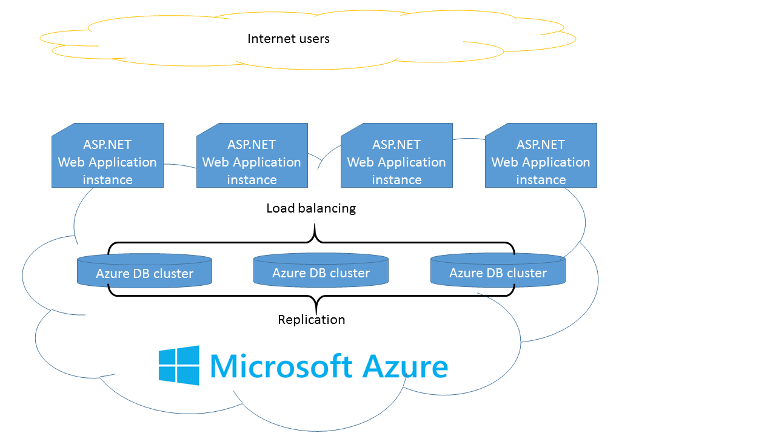

Figure 1: Deployment diagram on Azure cloud platform

# Methodologies: Crowdsourcing and open data

The Social Presence Editor relies on crowdsourcing to amass the required data for analysis of the municipalities’ presence in social networks. Adding data is open to all internet users that can be authenticated using their Facebook account. The accessibility of the site can lead to inaccurately entered data, so the editor uses a validation workflow that add a review step by an administrator.

The value of the data collected in the web application is greatly increased by implementing the open data methodology. The editor is linked from Bulgarian Open Data portal. In addition, the web application provides tools for embedding its contents, including data tables and charts into any other open data portal, site or application. Finally, any data collected by the application can be exported in an open format – CSV – so it can be imported for another database system for additional analysis.

The portal for Open Data (opendata.government.bg) is a unified, centralized and public web-based information system that enables publishing and management of information using an open machine-readable format. The platform allow full or partial extraction of public data. Connecting the Social Presence Editor to the portal enables all open data users to analyse the data collected there (About opendata.government.bg, n.d.).

# Analysis of the collected data on municipalities presence in Facebook

After the Social Presence Editor was successfully deployed, tested and used by multiple contributors, the amount of data collected allowed analysis of the municipality participation in the social network in the past 7 years - from 2009 to 2016. The data is especially rich for the period spanning 2014 to 2016. Over 150 Facebook pages were recorded by the site users and the automated Facebook post retrieval imported over 7000 posts.

The trends in data show that Facebook presence was steadily climbing in the past several years but doubled in 2016 (Figure 2).

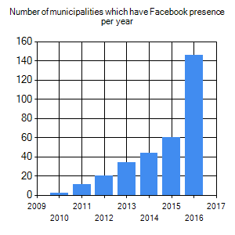

Figure 2: Trend of Facebook presence per municipality since 2009

Although that trend is positive, other analysis shows that there is still significant room for improvement. When state administrators create Facebook presence, they should be careful to create a “page” which represents an organization, not a “profile” which identifies a particular person. Aggregation over the data shows that just over half of the municipality presence is correct in that regard. Instead of organization page, we observe many personal profile which serve as a municipality page (Figure 3).

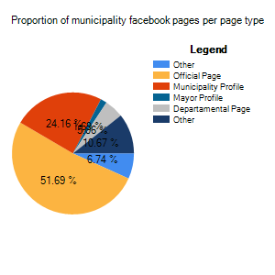

Figure 3: Comparison of different types of municipality presence

**Conclusions**

The system for tracking social network presence was successfully deployed and collected data for multiple contributors to the system. Over 150 Facebook pages were recorded by the site users and the automated Facebook post retrieval imported over 7000 posts. Analysis on the data shows doubling of the presence of municipalities. Despite the activity, a significant number of municipalities don’t use the appropriate tools provided by the social network. Close to 50% use a personal profile instead of organization page. Municipalities should use results from this study to improve their presence in the future.

**References**

*About opendata.government.bg*. (n.d.). Retrieved from http://opendata.government.bg/about

Matney, L. (2015, November). *Facebook Hits New Peak Of 1 Billion Users On A Single Day*. Retrieved from http://techcrunch.com/2015/08/27/facebook-hits-1-billion-users-in-a-single-day/

Spassov, K., & Mladenova, M. (2015, April). Analysis of the Municipalities’ Presence in Facebook. Retrieved from https://www.researchgate.net/profile/Kamen_Spassov/publications?pubType=artifact

Statista. (2016, September). *Most famous social network sites worldwide as of September 2016, ranked by number of active users (in millions) .* Retrieved from Statista - The Statistics Portal: http://www.statista.com/statistics/272014/global-social-networksnumber-of-users/

Zephoria Digital Marketing. (2015, November). *The Top 20 Valuable Facebook Statistics*. Retrieved from https://zephoria.com/top-15-valuable-facebook-statistics/