Appendix:

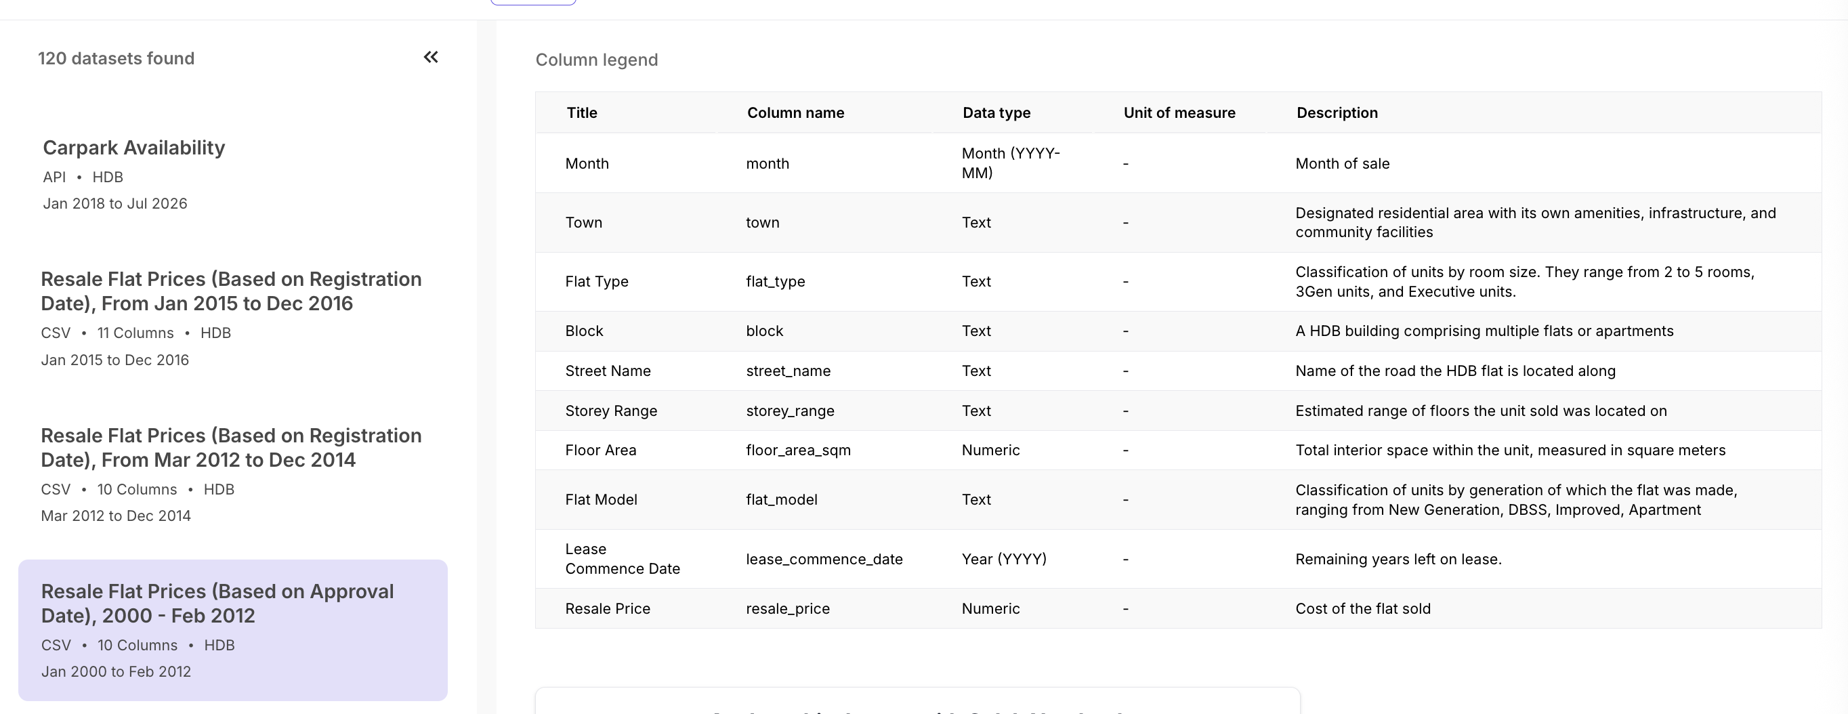
https://data.gov.sg/datasets?agencies=Housing+%26+Development+Board+(HDB)&resultId=d_43f493c6c50d54243cc1eab0df142d6a

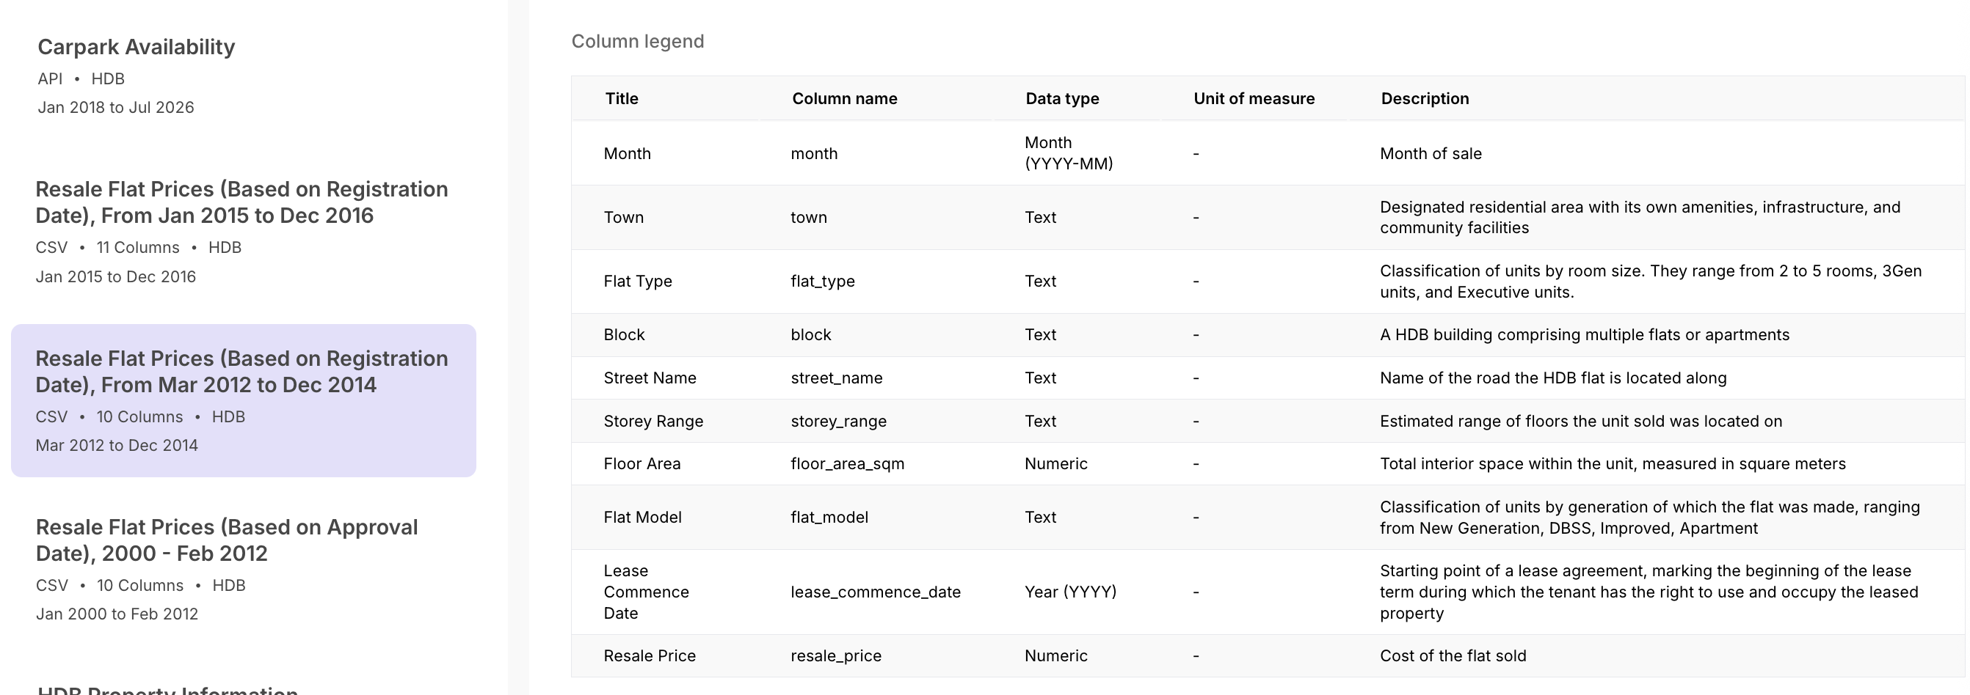
https://data.gov.sg/datasets?agencies=Housing+%26+Development+Board+(HDB)&resultId=d_2d5ff9ea31397b66239f245f57751537

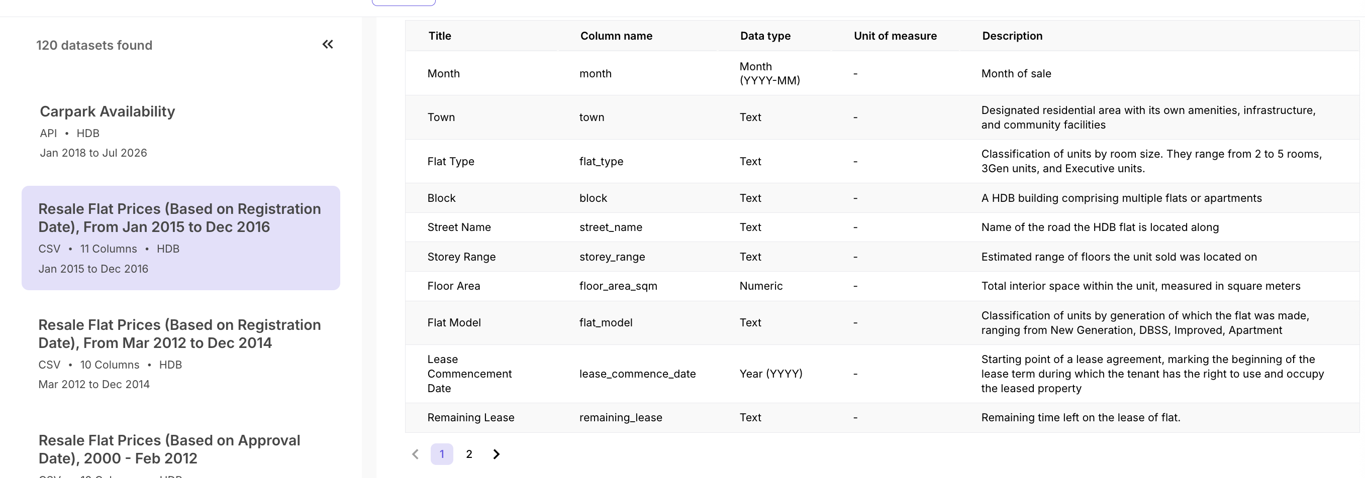
https://data.gov.sg/datasets?agencies=Housing+%26+Development+Board+(HDB)&resultId=d_ea9ed51da2787afaf8e51f827c304208

We took context not only from the column name, but from the official docs as shown above. Since they exist in for the data source of this project.

Profiling System (For String Columns):
- Missing (%): Is it Zero
- Distinct: Is the amount sensible to the context of what the column is representing?
- Distinct (%): If a distinct count is a lot, Is it close to 100% of the data set? If so
- it could actually be functioning as a primary key. Alert.
- It’s input is a random text form. And needs cleaning to become actual categorical attribute. Alert.

- Quick Value Format Description:
- Looking at the most common values to take note how the attribute is being represented. For example: MATTAR STREET 12, says it represents Singapore official street names, with uppercase.
- Judge if there are intended restriction on allowed values for the validation downstream.

Look at YELLOW parts for actionables.
Or search: downstream to jump to actionables

Profiling (Missing values)
Except for lease_remaining
All columns’ missing (%) are 0, verifiable by the views below. Hence we conclude here that:
Null values are currently of no concern.
Downstream validation rule: Except for lease_remaining , let all columns be subjected to [Null not allowed] during validation.

We are also recomputing lease_remaining from other attributes within the data later. So effective to ignore the profiling missing value for lease_remaining.

Profiling (String columns)

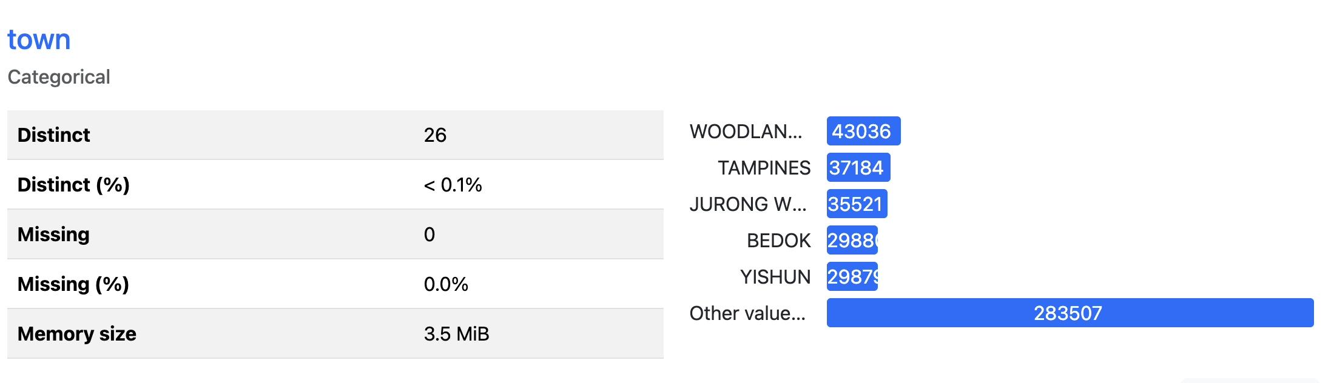
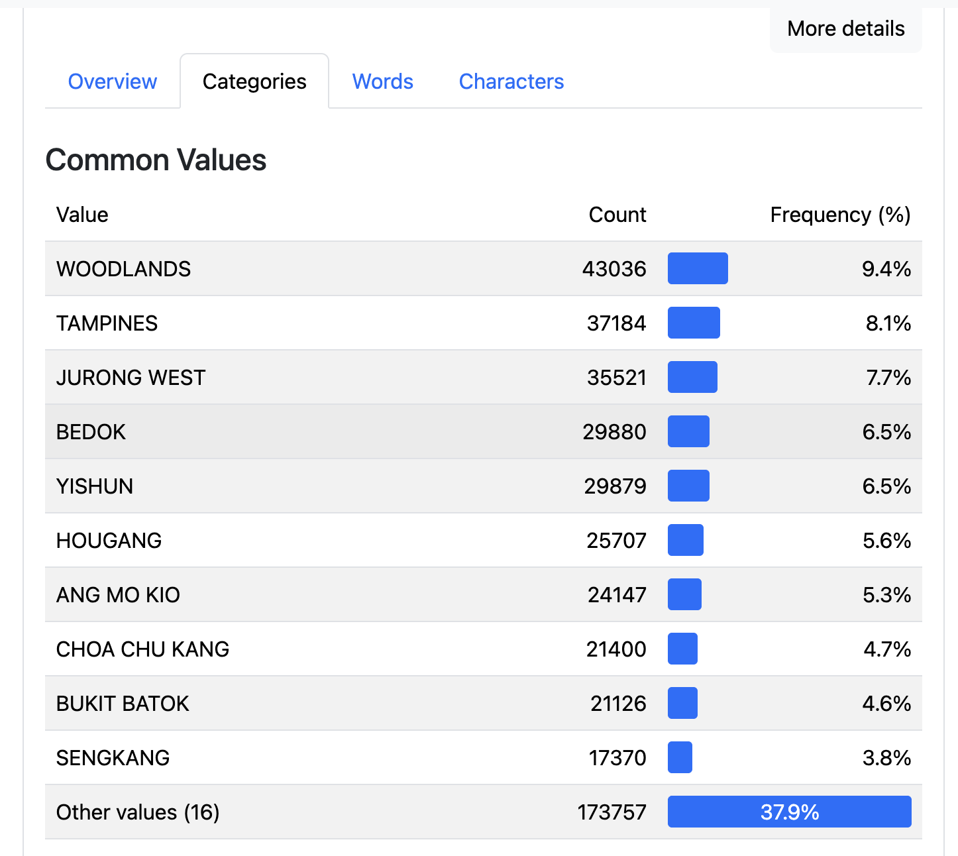
Distinct = 26. No concerns. 26 seems like a sensible count for official Singapore town names.
Quick Value Format Description: Values are really town names of Singapore, likely formatted to upper case.

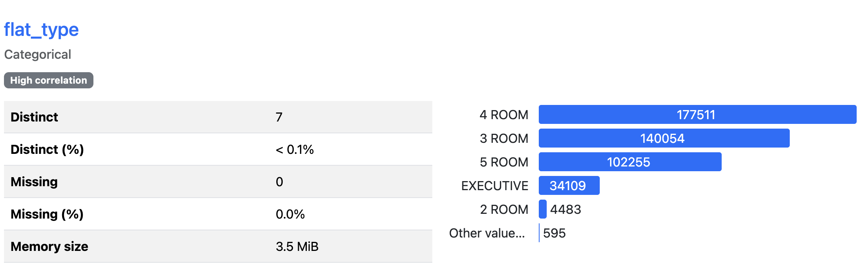
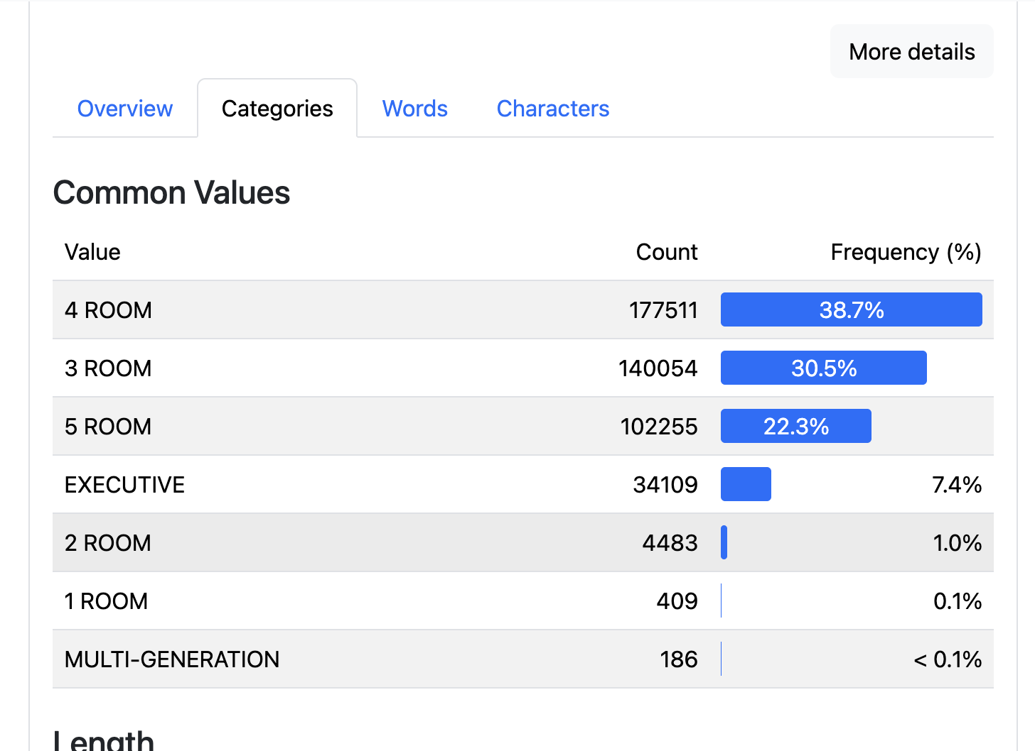
Distinct = 7. No concerns.
Quick Value Format Description: Does show valid Singapore flat type names. Cleaned to be only one allowed name for each flat type.
Downstream validation rule: Let these be the only values allowed during validation.

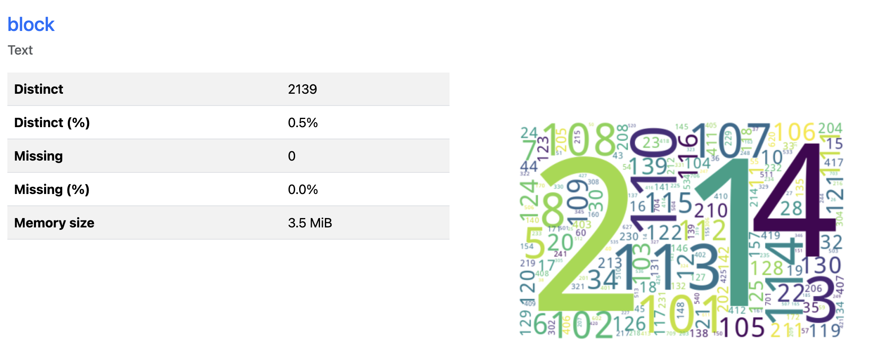
Distinct = 2139. No concerns. Many block numbers in Singapore.
Distinct (%) not > 95%. No concerns. Is not a equalling a primary key.
Quick Value Format Description: Shows valid Singapore block numbers. We only see numbers. Block numbers start from 101 ++ or start from 1 ++, and exists sequentially. Hence we see 1,2,3,4,5 and 101,102,103,104 as the big visible counts.

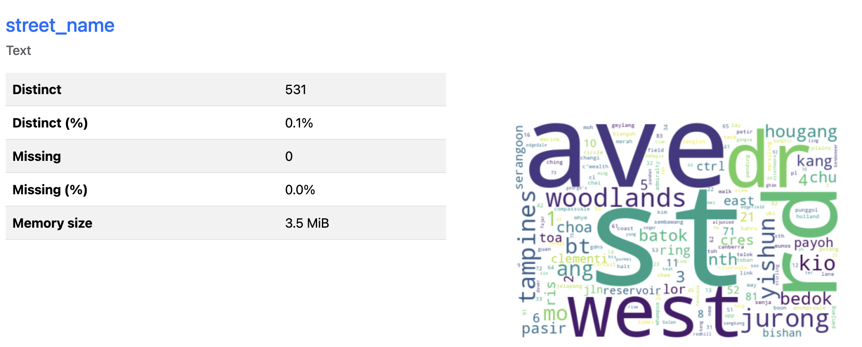
Distinct = 531. No concerns yet. Sensibly it is that many street names in Singapore.
Distinct (%) not > 95%. No concerns. Is not a equalling a primary key.
Quick Value Format Description: This output does not show any string. But we can assume they are like Tampines West Ave 3 or Jurong West Street 12. No concerns here.

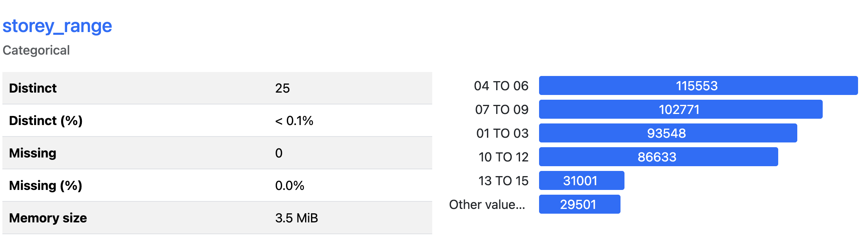

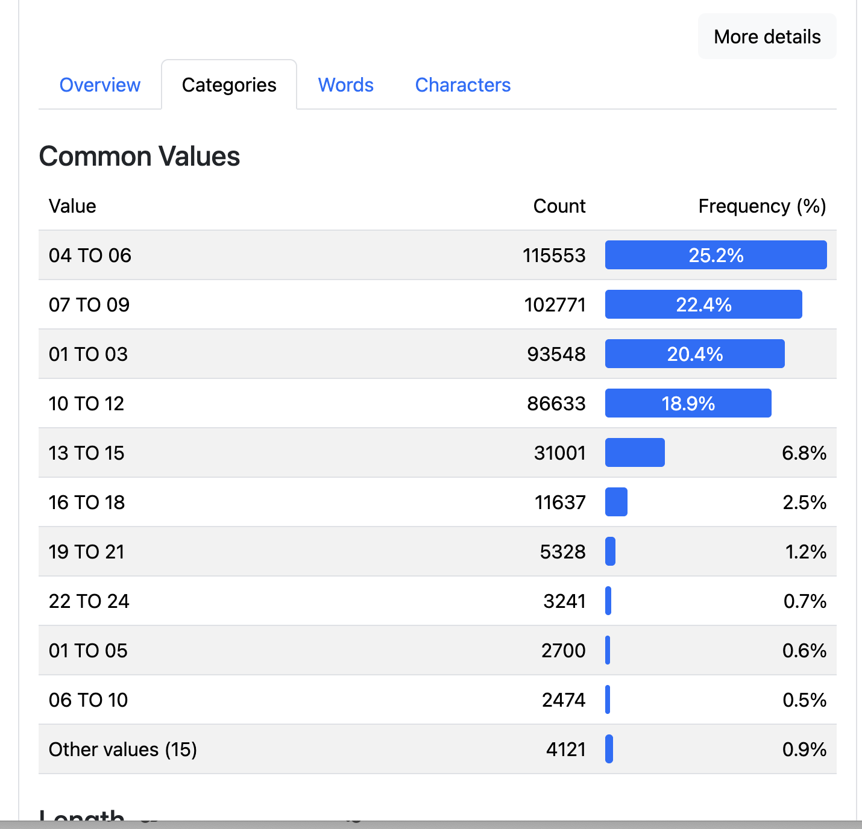
Distinct = 25. No concerns
Quick Value Format Description: 07 TO 09 for example means 7th to 9th floors.
The format is two digits even if it is single digit floor.
Downstream profiling: We will investigate in code if all values are of this pattern dd TO dd.

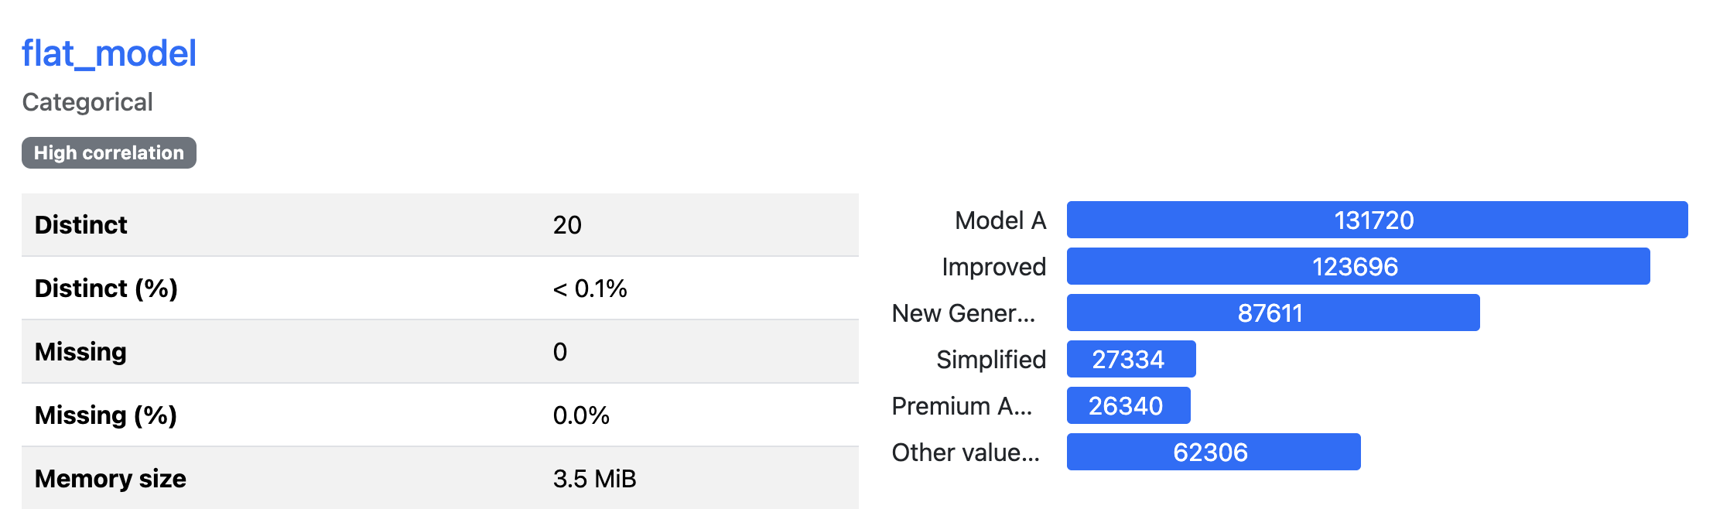
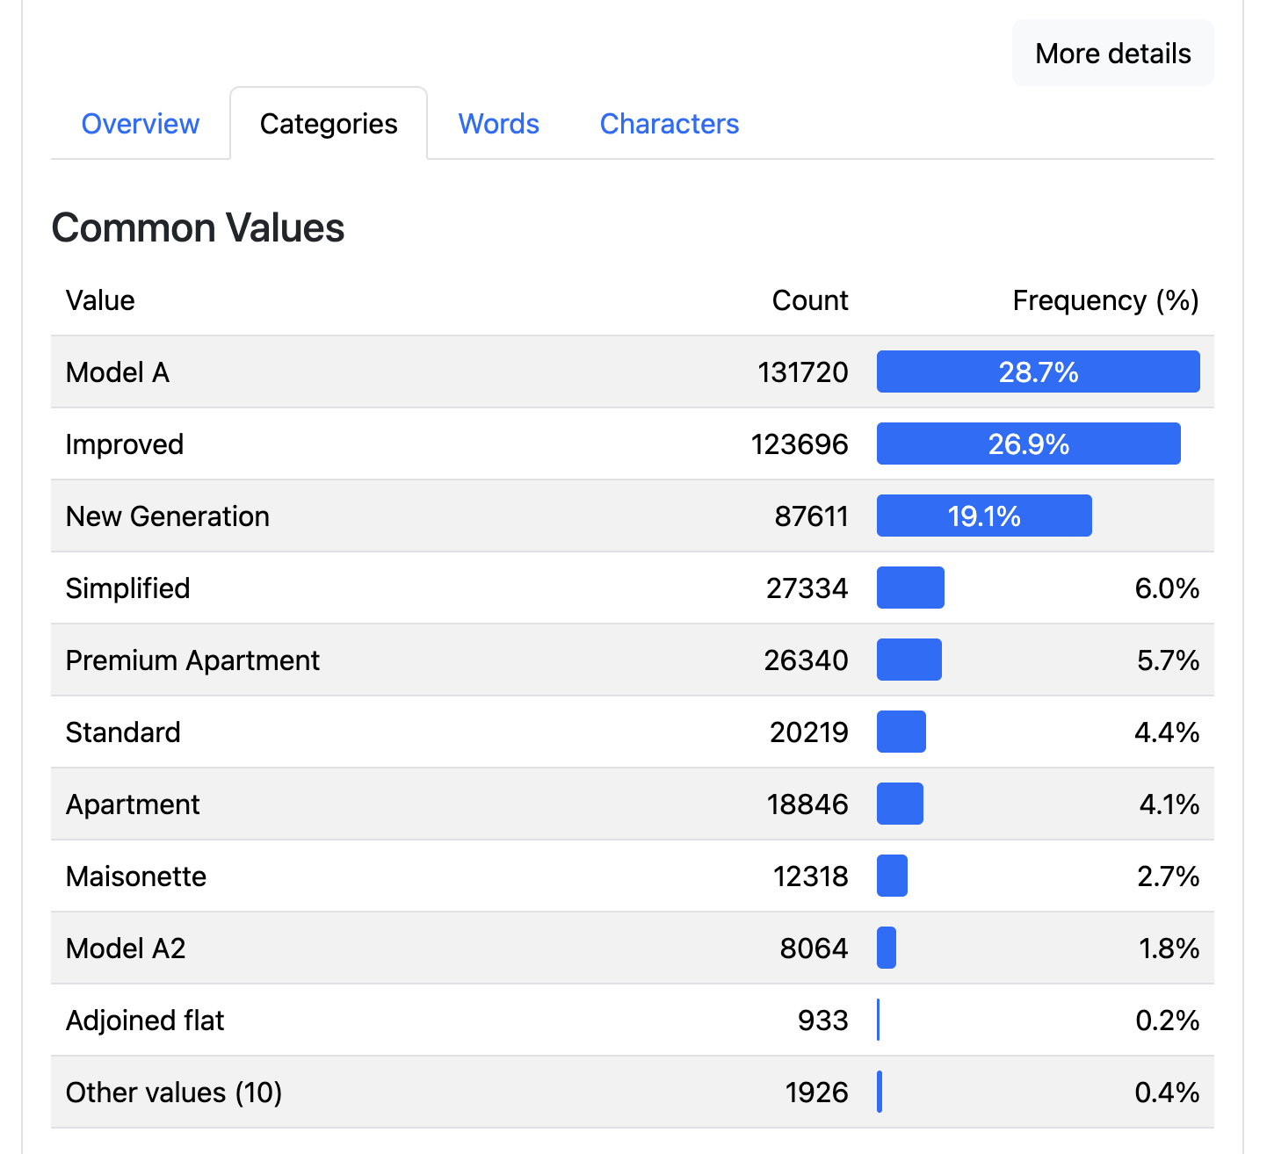
Distinct = 20. No concerns
Distinct (%) not > 95%. No concerns
Downstream profiling: We will investigate in code if there are long tail of rare values, which then we ask a) if they are candidates for merging with other values.

