describe oradores;

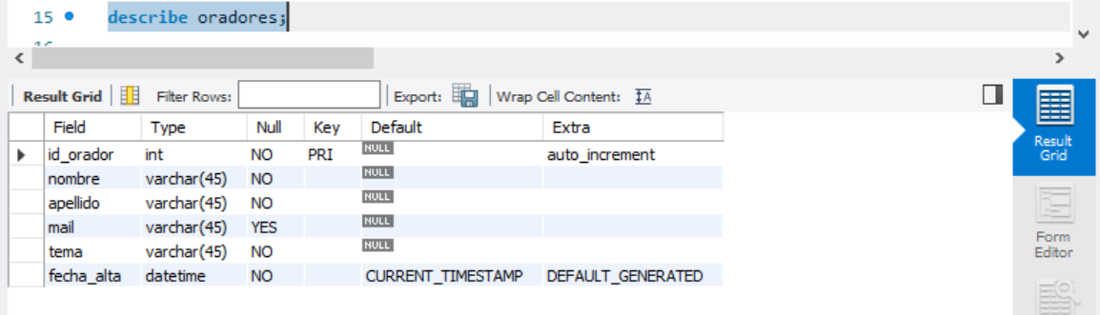

select \* from oradores;

