Que 1: How to compare two JSON have the same properties without order?

Ans:

**Code:**

var obj1 = { name: "Person 1", age:5 };

var obj2 = { age :5 , name:"Person 1"};

//fetch properties

let prop1 = Object.getOwnPropertyNames(obj1);

let prop2 = Object.getOwnPropertyNames(obj2);

//will loop in for loop, iterating the list of properties and then comparing their values

for (let i = 0; i <obj1.length; i++) {

let obj = obj1[i];

if (obj1[prop] !== obj2[prop]) {

console.log("false");

}

}

console.log("true");

**Output:**

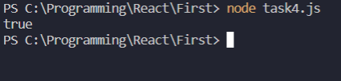

Que 2: Use the rest countries’ API URL -> https://restcountries.eu/rest/v2/all and display all the country lags in the console

**Code:**

let xhr=new XMLHttpRequest();

// Request to get data

xhr.open("GET","https://restcountries.com/v3.1/all");

// Request to load data

xhr.onload=function(){

let data=JSON.parse(xhr.responseText);

for(let i=0;i<data.length;i++){

console.log(`

Name:${data[i].name.common}

Flag:${data[i].flag}

`)

}

};

//Request to send data

xhr.send();

**Output:**

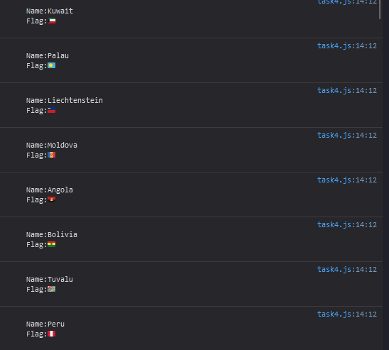

**Que3:** Use the same rest countries and print all country's names, regions, sub-region and population**s**

**Ans:**

**Code:**

let xhr=new XMLHttpRequest();

// Request to get data

xhr.open("GET","https://restcountries.com/v3.1/all");

// Request to load data

xhr.onload=function(){

let data=JSON.parse(xhr.responseText);

for(let i=0;i<data.length;i++){

console.log(`

Name:${data[i].name.common}

Region:${data[i].region}

Subregion: ${data[i].subregion}

Populatio: ${data[i].population}

`)

}

};

//Request to send data

xhr.send();

**Output:**

