Algorithm of subroutine int r2i(String roman) of class RomanToInteger.java.

1. Loop from left, read character wise and determine its corresponding Integer equivalent.
2. If current number is lesser than next number apply subtractive rules. Following rules are accepted for this combination.
- Only one I, X, and C can be used as the leading numeral in part of a subtractive pair.
- I can only be placed before V and X.
- X can only be placed before L and C.
- C can only be placed before D and M.
Following subroutine does this job : private static void validateSubtractiveRules(String roman, int index)
3. If Subtractive pair is valid add the difference between next and current value and add the difference to running sum.
4. If numbers in descending order keep adding values to running sum.
5. Once the running sum is obtained, now validate below rules. If rule validation fails raise exception.
1. Numerals must be arranged in descending order of size.
2. M, C, and X cannot be equaled or exceeded by smaller denominations.
- If No. of I >= 10 input is invalid.
- if No. of V >= 2 input is invalid. (Covered in RULE-3)
- if No. of X >= 10 input is invalid.
- If No. of L >= 2 input is invalid. (Covered in RULE-3)
- if No. of C >=10 input is invalid.
- if No. of D >=2 input is invalid. (Covered in RULE-3)
3. D, L, and V can each only appear once.
Code execution results:
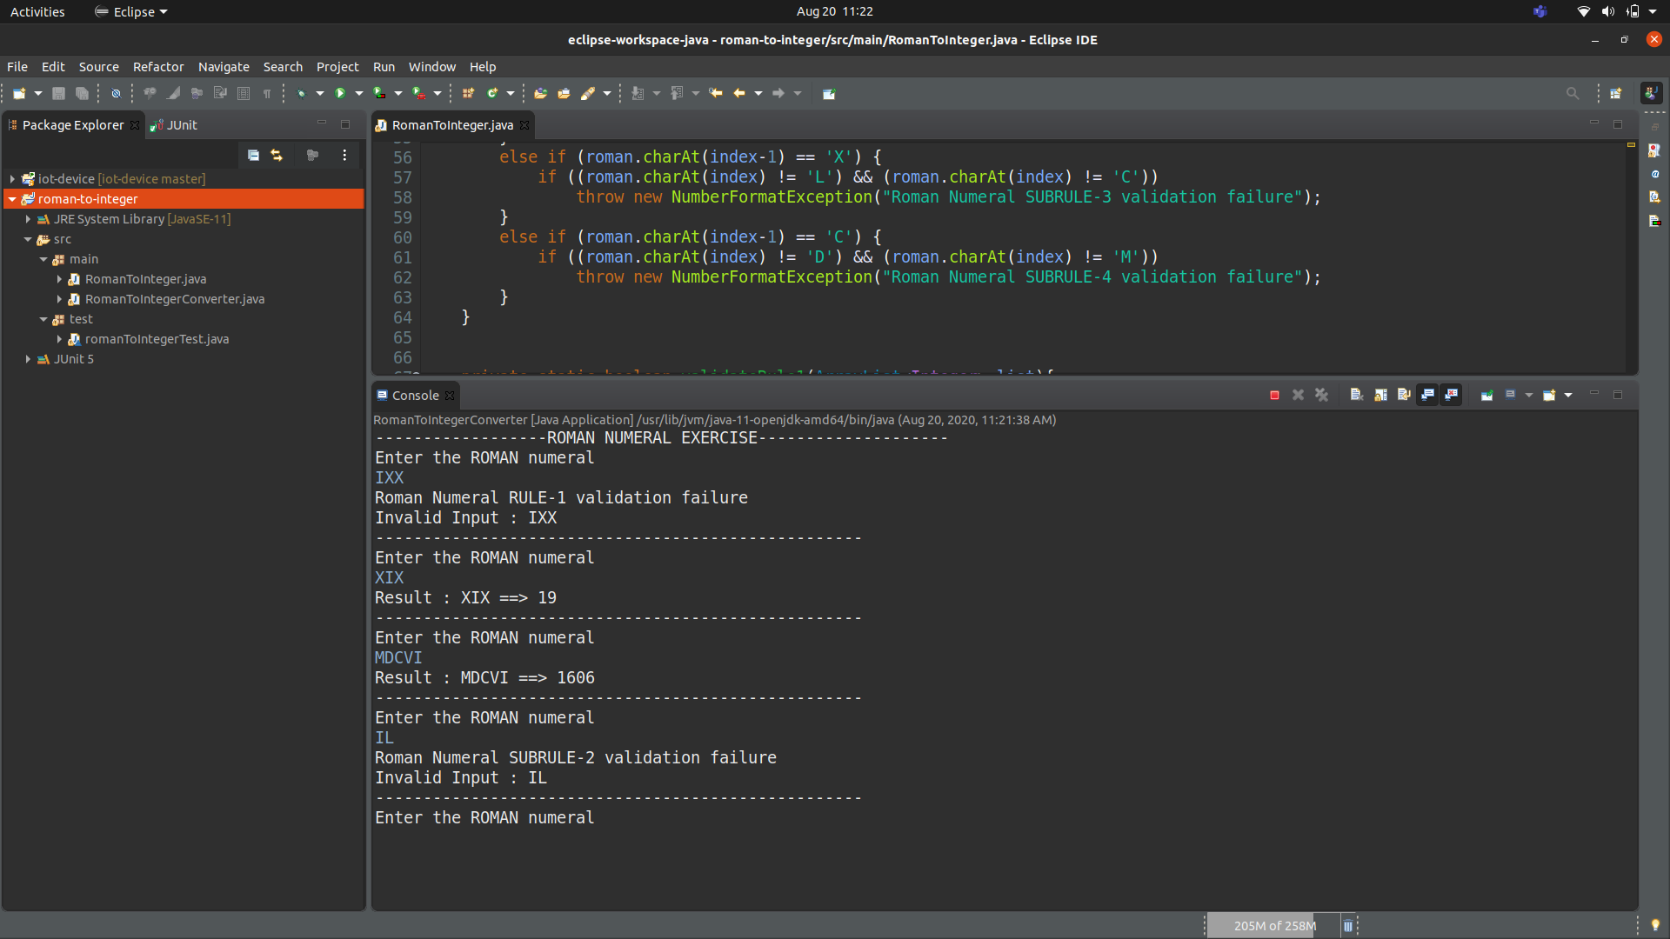

Unit tests:
Please refer romanToIntegerTest.java for unit tests.
Tests are self explanatory.
