Covid19 - Brasil

Mauricio Uriona Maldonado

4/7/2020

## 1. Brasil

##   
## ********************************************************

## Note: As of version 1.0.0, cowplot does not change the

## default ggplot2 theme anymore. To recover the previous

## behavior, execute:  
## theme_set(theme_cowplot())

## ********************************************************

## Loading required package: magrittr

##   
## Attaching package: 'ggpubr'

## The following object is masked from 'package:cowplot':  
##   
## get_legend

##   
## Attaching package: 'readr'

## The following object is masked from 'package:scales':  
##   
## col_factor

##   
## Attaching package: 'dplyr'

## The following object is masked from 'package:gridExtra':  
##   
## combine

## The following objects are masked from 'package:stats':  
##   
## filter, lag

## The following objects are masked from 'package:base':  
##   
## intersect, setdiff, setequal, union

## Parsed with column specification:  
## cols(  
## regiao = col_character(),  
## sigla = col_character(),  
## data = col_character(),  
## casosNovos = col_double(),  
## casosAcumulados = col_double(),  
## obitosNovos = col_double(),  
## obitosAcumulados = col_double()  
## )

Resumo dos casos por Estado

|  |  |
| --- | --- |
| estado | acumulado |
| AC | 62 |
| AL | 37 |
| AM | 899 |
| AP | 128 |
| BA | 559 |
| CE | 1425 |
| DF | 527 |
| ES | 273 |
| GO | 179 |
| MA | 273 |
| MG | 655 |
| MS | 89 |
| MT | 108 |
| PA | 168 |
| PB | 55 |
| PE | 555 |
| PI | 38 |
| PR | 609 |
| RJ | 2216 |
| RN | 261 |
| RO | 28 |
| RR | 52 |
| RS | 618 |
| SC | 501 |
| SE | 39 |
| SP | 7480 |
| TO | 23 |

Resumo dos casos no Brasil

|  |  |
| --- | --- |
| date | casos |
| 2020-01-30 | 0 |
| 2020-01-31 | 0 |
| 2020-02-01 | 0 |
| 2020-02-02 | 0 |
| 2020-02-03 | 0 |
| 2020-02-04 | 0 |
| 2020-02-05 | 0 |
| 2020-02-06 | 0 |
| 2020-02-07 | 0 |
| 2020-02-08 | 0 |
| 2020-02-09 | 0 |
| 2020-02-10 | 0 |
| 2020-02-11 | 0 |
| 2020-02-12 | 0 |
| 2020-02-13 | 0 |
| 2020-02-14 | 0 |
| 2020-02-15 | 0 |
| 2020-02-16 | 0 |
| 2020-02-17 | 0 |
| 2020-02-18 | 0 |
| 2020-02-19 | 0 |
| 2020-02-20 | 0 |
| 2020-02-21 | 0 |
| 2020-02-22 | 0 |
| 2020-02-23 | 0 |
| 2020-02-24 | 0 |
| 2020-02-25 | 0 |
| 2020-02-26 | 1 |
| 2020-02-27 | 0 |
| 2020-02-28 | 0 |
| 2020-02-29 | 1 |
| 2020-03-01 | 0 |
| 2020-03-02 | 0 |
| 2020-03-03 | 0 |
| 2020-03-04 | 1 |
| 2020-03-05 | 4 |
| 2020-03-06 | 6 |
| 2020-03-07 | 6 |
| 2020-03-08 | 6 |
| 2020-03-09 | 0 |
| 2020-03-10 | 9 |
| 2020-03-11 | 18 |
| 2020-03-12 | 25 |
| 2020-03-13 | 21 |
| 2020-03-14 | 23 |
| 2020-03-15 | 79 |
| 2020-03-16 | 34 |
| 2020-03-17 | 57 |
| 2020-03-18 | 137 |
| 2020-03-19 | 193 |
| 2020-03-20 | 283 |
| 2020-03-21 | 224 |
| 2020-03-22 | 418 |
| 2020-03-23 | 345 |
| 2020-03-24 | 310 |
| 2020-03-25 | 232 |
| 2020-03-26 | 482 |
| 2020-03-27 | 502 |
| 2020-03-28 | 486 |
| 2020-03-29 | 353 |
| 2020-03-30 | 323 |
| 2020-03-31 | 1138 |
| 2020-04-01 | 1117 |
| 2020-04-02 | 1076 |
| 2020-04-03 | 1146 |
| 2020-04-04 | 1222 |
| 2020-04-05 | 852 |
| 2020-04-06 | 926 |
| 2020-04-07 | 1661 |
| 2020-04-08 | 2210 |
| 2020-04-09 | 1930 |

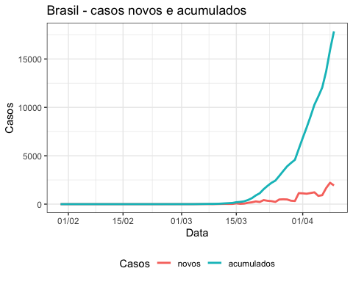

### Dados separados

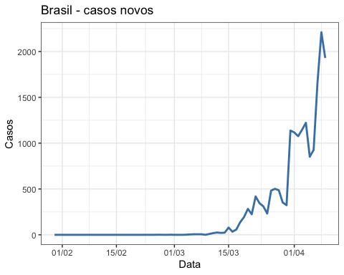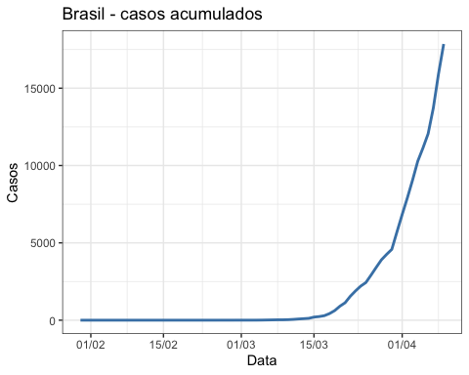

## 2. SC - Santa Catarina

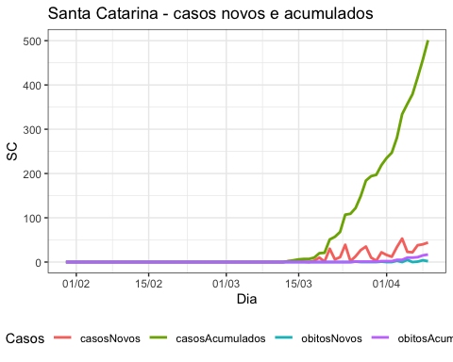

### Valores por separado

