For this lab, we will be working with a CSV file named customers.csv. This dataset, called customers.csv, contains information about 1,000 customers from different parts of the United States. These customers live in 300 different places, which are identified by their city and state. Some cities are listed in more than one state, so we need to be careful when looking at that.
We want to plan a roadshow to visit these areas. We can’t visit all 300 places in one year—because it would be too tiring and would involve too much travel and cost.
The main goal is to find locations that have at least 10 customers. This way, we can make the most of our trip and reach as many customers as possible.
So, how many locations will we visit, and how many customers will we reach by focusing only on locations with at least 10 customers?
Let’s do some data wrangling and find out.

Steps:

Input Data:

- You can either drop the customer.csv file directly on the Alteryx canvas or drag and drop (or double click) the Input Data tool on the canvas.
- If you drop the csv file directly you do not need to configure the input tool.
- If you want to use the Input Tool, you will need to locate the file on your system.
- Click on the input tool and click on Set Up a Connection in the configuration window on the left.

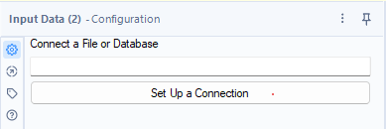

Click on files > Select File

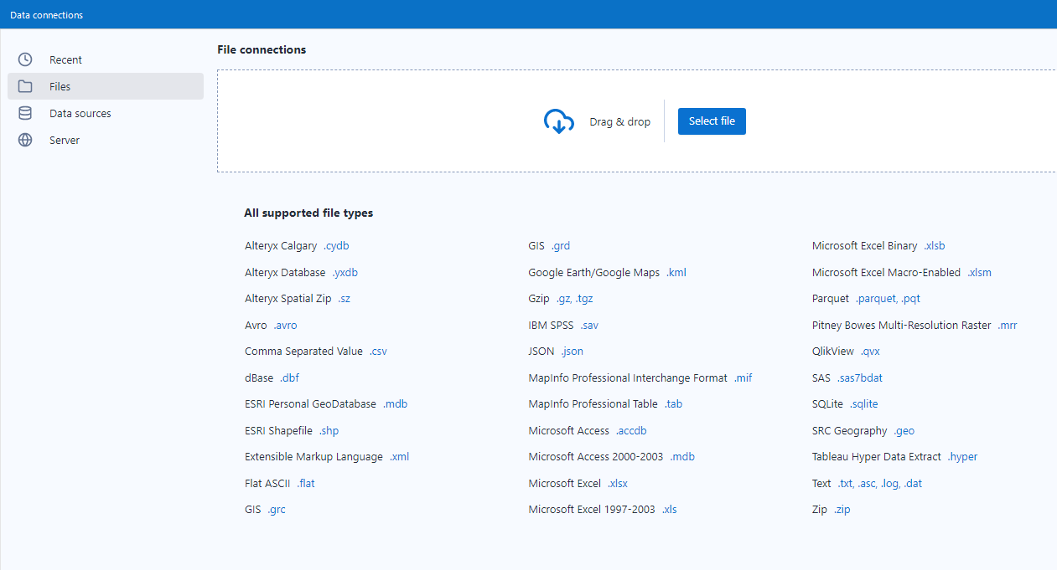

And locate your Customer.csv file on your laptop.

You can see all the data types and data sources Alteryx can read from.
Once successfully located, you should see a preview of your data in the configuration window

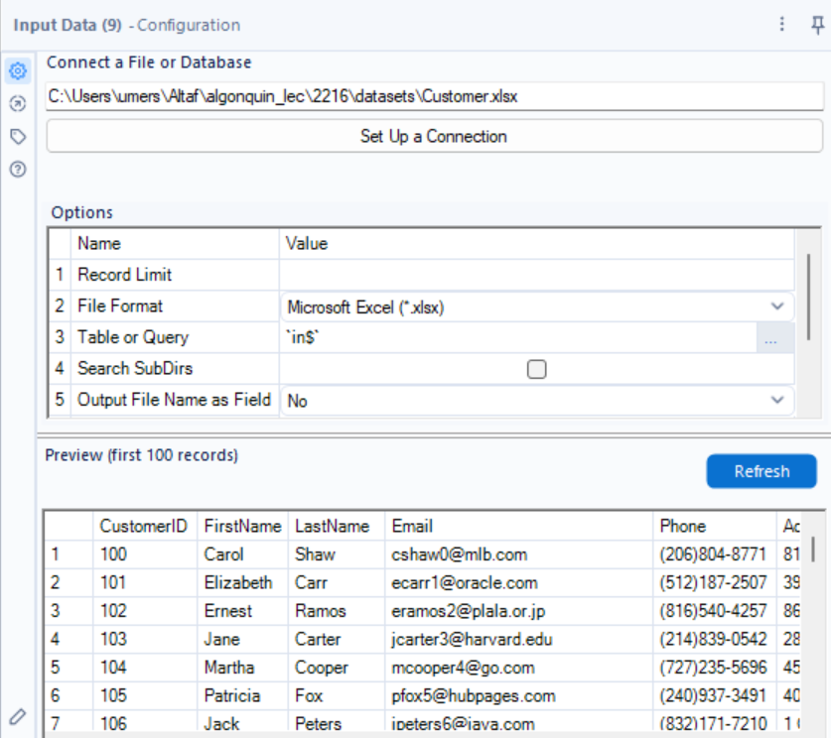

Next, click on the empty space in the canvas, and the workflow configuration window will show the following options on the left. Make sure your settings align with the following

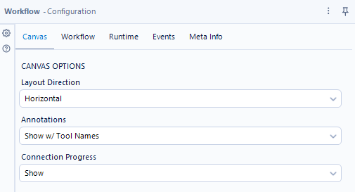

Let’s change the data types of the columns as per data types mentioned in the data dictionary

Select Tool
Read more about this tool here:
https://help.alteryx.com/20232/en/designer/tools/preparation/select-tool.html
Connect a Select tool to the Input tool. The select tool should be in your favourites (or in the Preparation Tab).
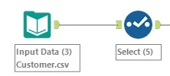

When you click on Select tool, you will see on the left
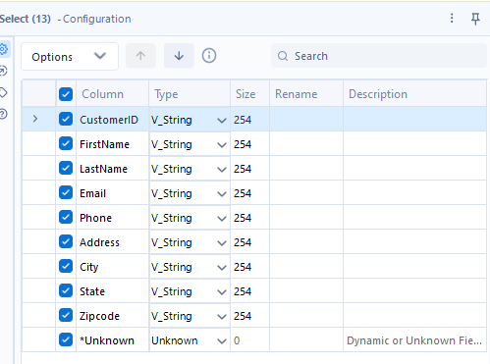

Change the data types to the following and uncheck the unwanted columns. (You can also use select tool to filter columns.)
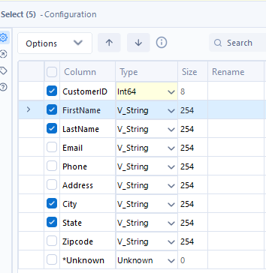

Next, connect the Formula tool to the output of the Select Tool
Formula Tool
Read more about this tool here:
https://help.alteryx.com/current/en/designer/tools/preparation/formula-tool.html
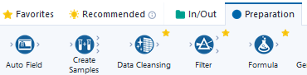

Click on the Formula Tool > Configuration Window > Select Column dropdown > Add Column
Give the Column Name as Location
Click on Columns & Constants (the big X) and by selecting columns create this formula
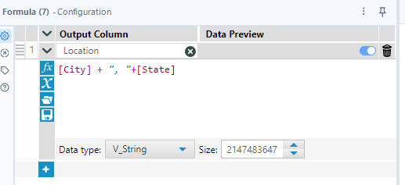

[City] + ", "+[State]

Add a browse node and click on Run. If you did everything right, you should see the new column in the results window as below

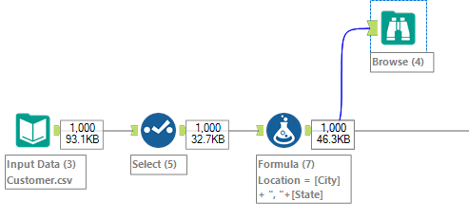

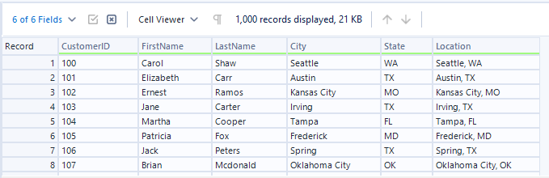

Summarize Tool
Read more about this tool here:
https://help.alteryx.com/20232/en/designer/tools/transform/summarize-tool.html
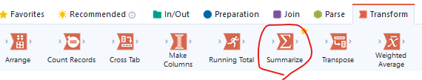

Add a summarize tool to the output of the Formula Tool
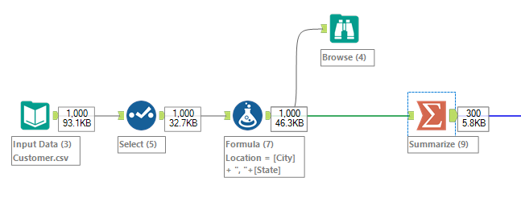
Group by Location and count the number of customers

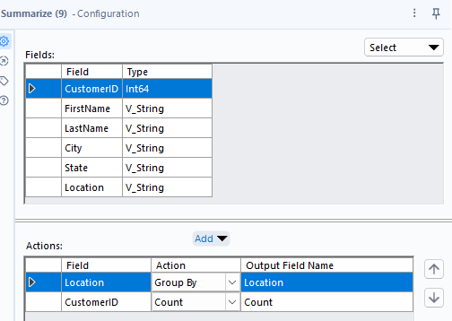

Click on Run and you should see this in the results window
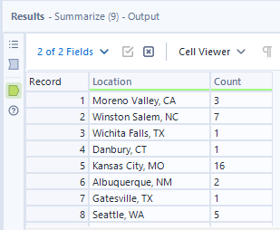
This tells you that Moreno Valley, CA location has 3 customers.

Filter Tool
Read more about this tool here:
https://help.alteryx.com/20232/en/designer/tools/preparation/filter-tool.html
Add a Filter Tool to the output of the Summarize Tool.

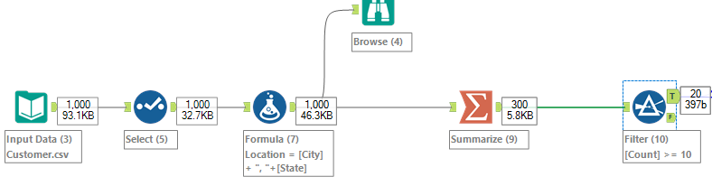

Since we are only interested in locations where there are 10 or more customers, we will filter the the records using the count column
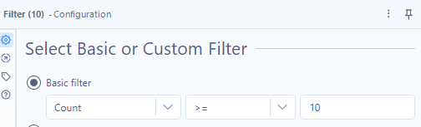

Note: After every transformation you can use the Browse tool to check the output of your previous tool.

Add a browse tool and click on Run.
It should show you these 20 locations with 10 or more customers

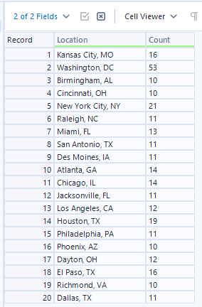
Save this data as a csv file

Add a Output Data tool after the Filter tool

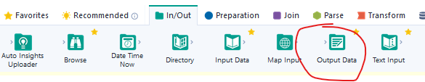

Add an Output Data tool to the end of the workflow
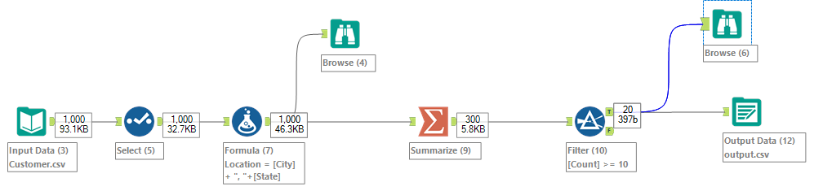

Click on the Output Data tool and on the configuration, window click on Set up a connection

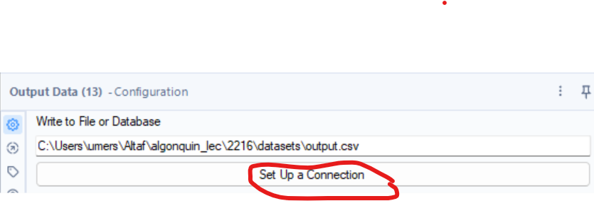

Then click on Select File
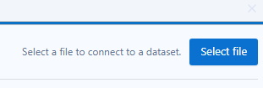
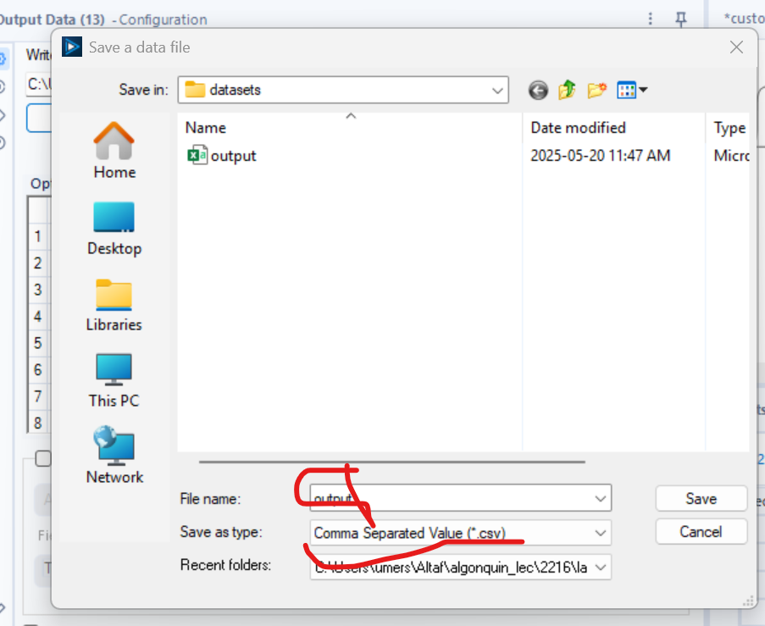
Click on Save and make sure the configuration changes to

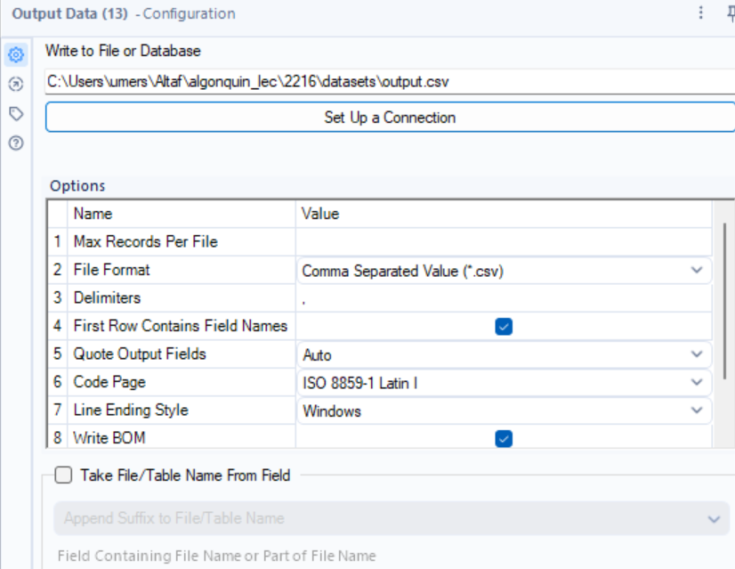

Then click on Run. This will generate the output.csv file in your laptop.

The final data should look like this:

Verify it with the Browse tool before you run the workflow and save the csv file.
Also, save the workflow as customers.yxmd
Click on File > Save as > Browse

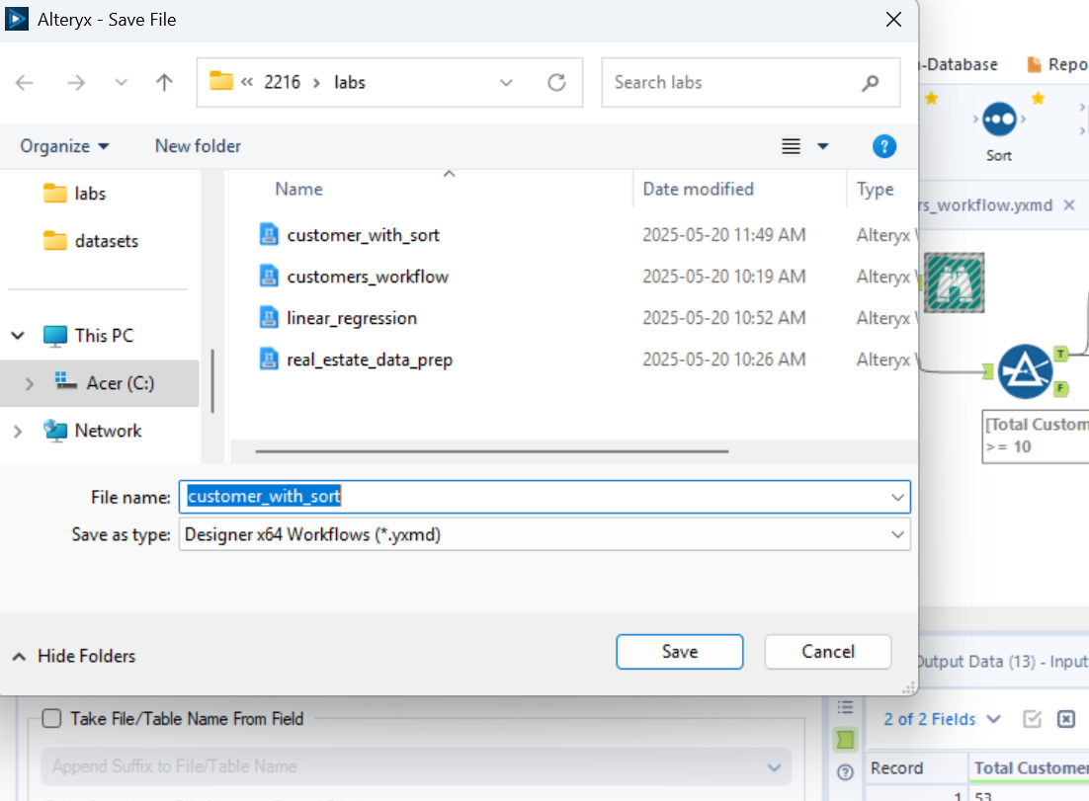

Credits: Introduction to Alteryx by Aaron Harter on LinkedIn Learning

