Steps:

Input Data:

- You can either drop the real_estate.csv file directly on the Alteryx canvas or drag and drop (or double click) the Input Data tool on the canvas.
- If you drop the csv file directly you do not need to configure the input tool.
- If you want to use the Input Tool, you will need to locate the file on your system.
- Click on the input tool and click on Set Up a Connection in the configuration window on the left.

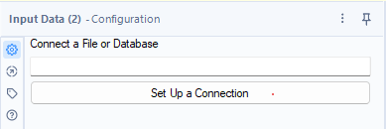

Click on files > Select File

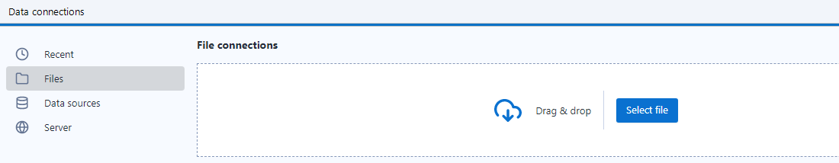

And locate your real_estate.csv file on your laptop.

Once successfully located, you should see a preview of your data in the configuration window

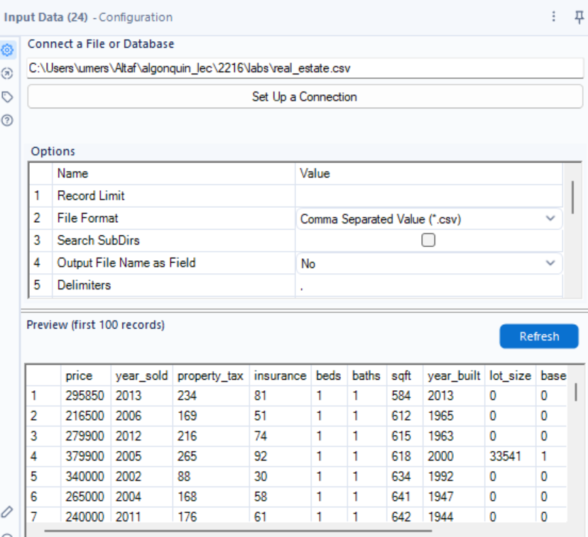

Let’s change the data types of the columns as per data types mentioned in the data dictionary

Select Tool
Read more about this tool here:
https://help.alteryx.com/20232/en/designer/tools/preparation/select-tool.html
Connect a Select tool to the Input tool. The select tool should be in your favourites (or in the Preparation Tab).
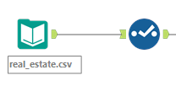

When you click on Select tool, you will see on the left
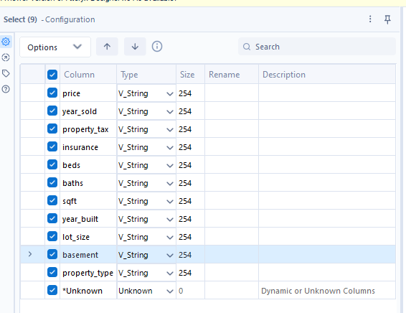

Change the data types to the following and uncheck the *Unknown column. You can also use select tool to filter columns.
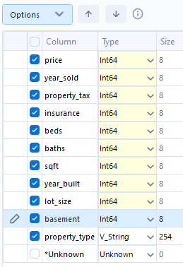

Next, connect the Field summary tool to the select tool.

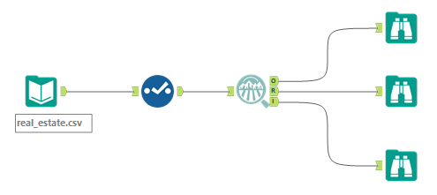

Field Summary tool

Read more about this tool here: https://help.alteryx.com/2019.3/Field_Summary_Report.htm#:~:text=The%20Field%20Summary%20tool%20analyzes,are%20supported%20in%20this%20tool

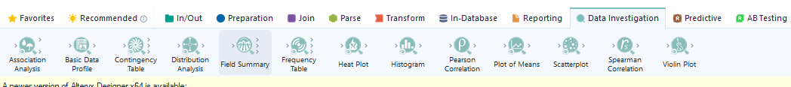

- Add this tool to your favourites by clicking on the star on top of the tool.

Click on the Field Summary Tool and in the Configuration window, select All (click on all to select all columns)
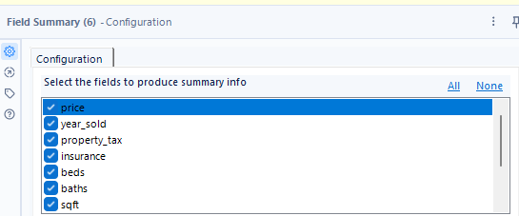
Next, connect 3 Browse tools to the three outputs (O, I , R) of the field summary tool.
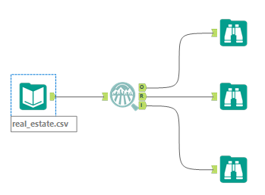
- The browse tool should be in your favourites.
Now click on Run
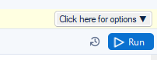
Click on every browse tool one by one and observe the output in the configuration Window and the results window. It gives you all the statistical information about your data.

For e.g. the R output gives you the static report of your data as below (expand the window)
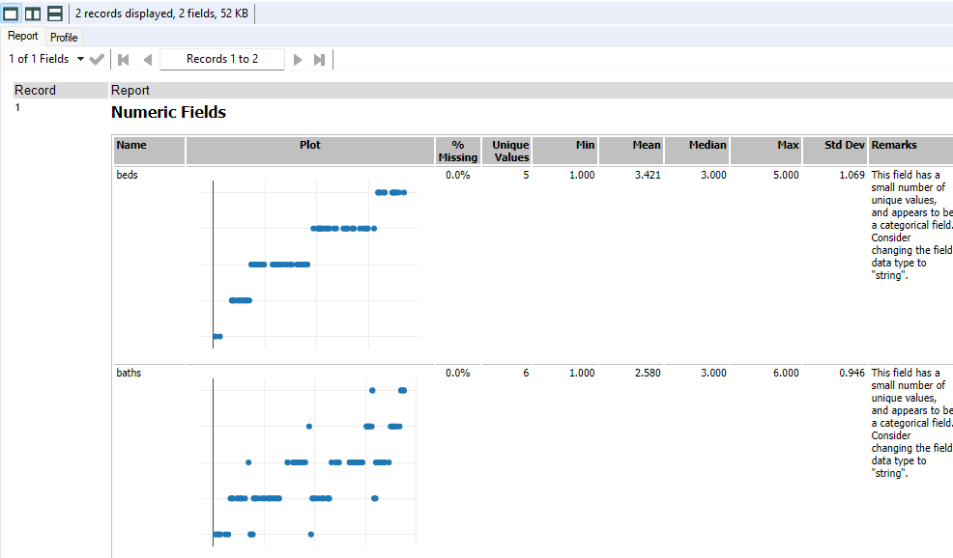

The I output gives you the distributions of the data. (expand the window)

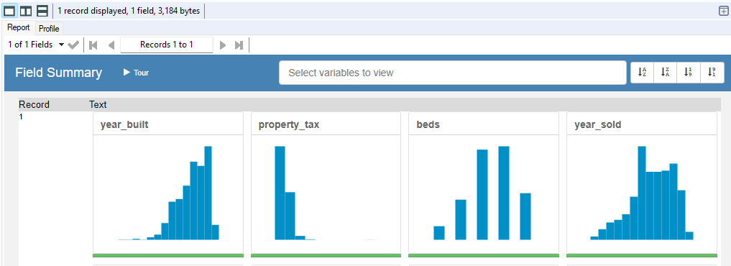
Analysis:
As you can see, the O output now shows you that all the columns are fixed.
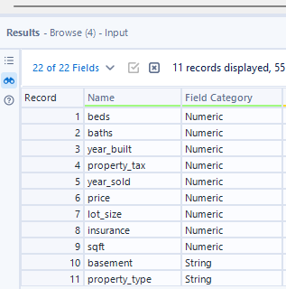

How to generate Interactive Charts

Interactive Chart Tool
Read more about this tool here:
https://help.alteryx.com/20232/en/designer/tools/reporting/interactive-chart-tool.html
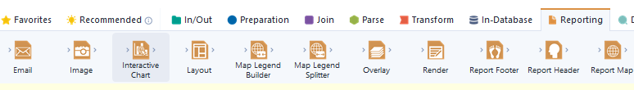

First click inside the white space on canvas. (nothing should be selected)

Then drag the Interactive chart on the canvas and connect the output anchor of the select tool to the input anchor of the Interactive Chart tool as below
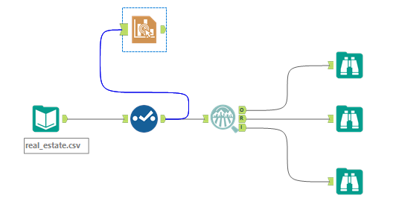
If you want a box plot of Sqft vs Property-Type.
(revise the data visualization slides to understand what types of charts apply to different data types)
Click on the Interactive chart and on the configuration Window, select Configure Chart. A new window will pop open. Apply the settings as shown

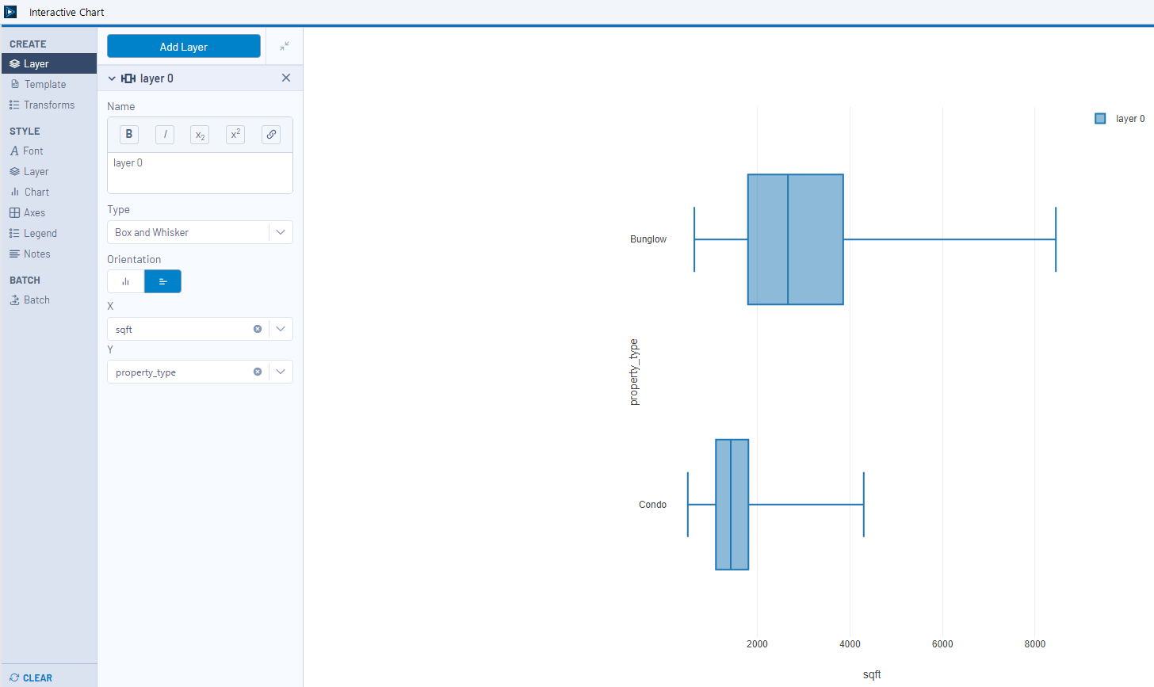

Practice with the other options to add title, labels etc.
Th above chart tells you that the sqft of Bunglows is usually higher than those of the Condos.
You can also try a Bar plot for Property type to see the different properties in the data and their count
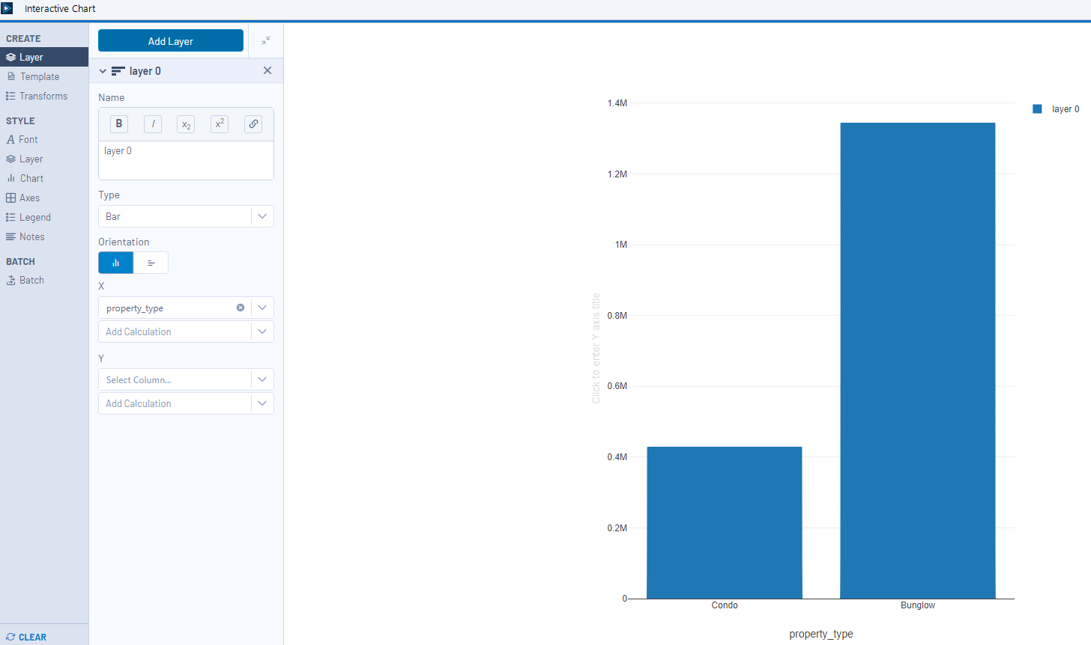

Data Preparation
Let’s Fix the Missing values in the Basement column.

Imputation Tool
Read more about this tool here:
https://help.alteryx.com/20232/en/designer/tools/preparation/imputation-tool.html
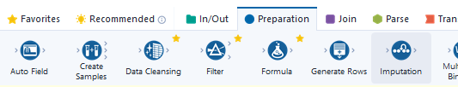

First click inside the white space on canvas. (nothing should be selected)
Then drag the Imputation Tool chart on the canvas and connect the output anchor of the select tool to the input anchor of the Imputation tool as below
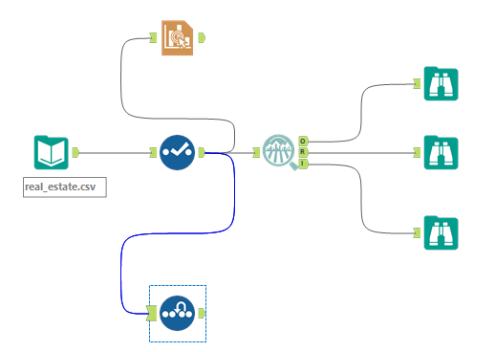

When you click on the Imputation tool you will see the null values in the basement column in the results window
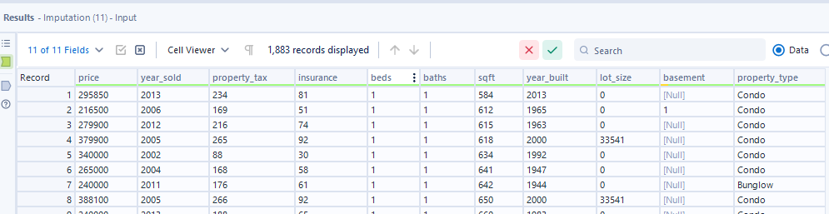

To fix those, on the configuration window apply the following settings. Select the basement column and replace nulls with 0

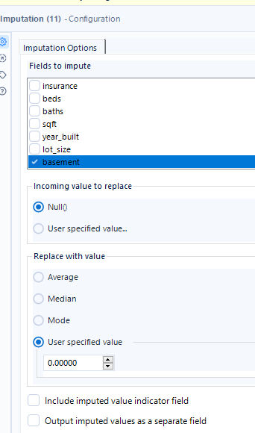

Outliers
In our dataset we have a record with lot_size = 1220551
This is an unusual lot size for a Condo. Let’s drop this record(row)

Filter Tool
Read more about this tool here:
https://help.alteryx.com/20232/en/designer/tools/preparation/filter-tool.html
By now you should know how to add tools downstream. Add a Filter Tool to the output of the Imputation Tool.
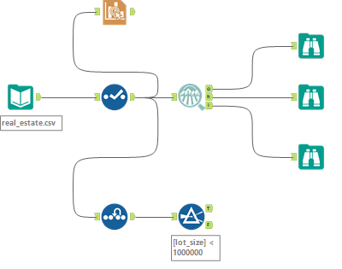
Configure with a basic filter where lot_size < 1000000
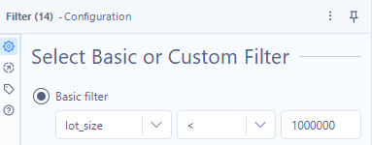

Note: After every transformation you can use the Browse tool to check the output of your previous tool.

Create new columns or Features

Let’s create 3 new columns, Age of the house, Popular_Property, Recession_Period

Formula Tool
Read more about this tool here:
https://help.alteryx.com/current/en/designer/tools/preparation/formula-tool.html
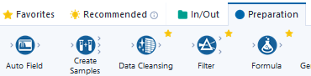

To the T anchor of the Filter tool connect a Formula Tool
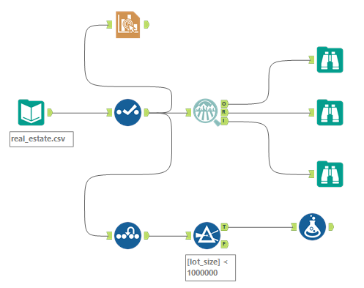
Click on the Formula Tool > Configuration Window > Select Column dropdown > Add Column
Give the Column Name as Age
Click on Columns & Constants (the big X) and by selecting columns create this formula
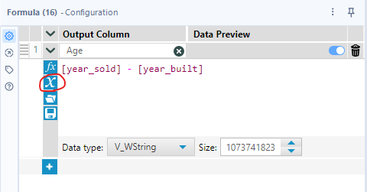

Click on the + sign to create another colum

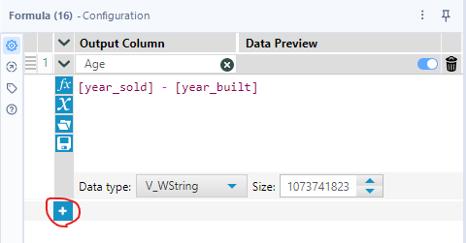

Repeat the steps to create 2 new columns as below

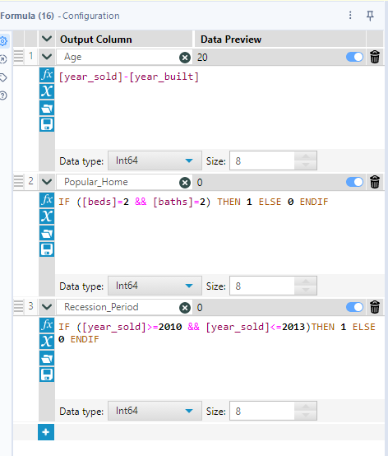
Popular_Home
IF ([beds]=2 && [baths]=2) THEN 1 ELSE 0 ENDIF
Recession_period
IF ([year_sold]>=2010 && [year_sold]<=2013)THEN 1 ELSE 0 ENDIF

Make sure you change the data type to Int64 for all 3 columns.
Add a browse node and click on Run. If you did everything right, you should see the 3 new columns in the results window as below
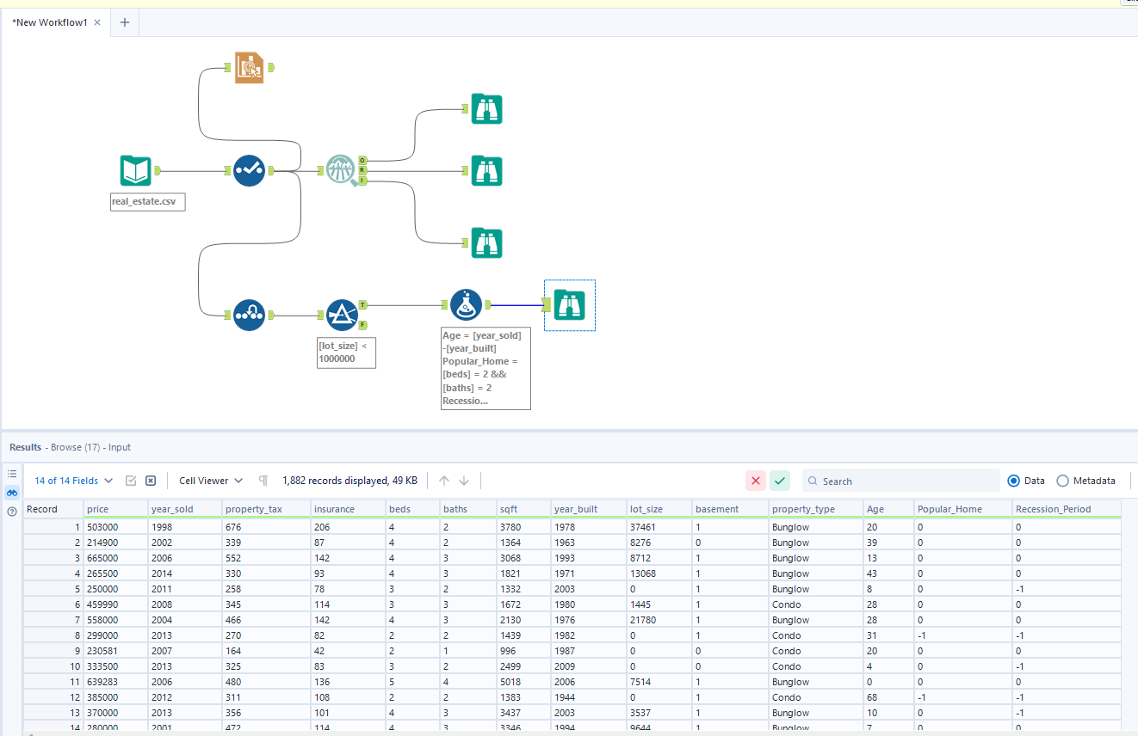

Next, click on the browse tool and in the results window, sort the Age column by Ascending.
Click on the 3 dots > Sort > Sort Ascending > Apply
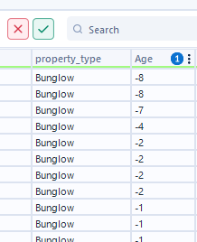
You will see some homes have negative Age.
Let’s drop those records.

Apply a filter tool to the output anchor of the Formula tool and apply the formula

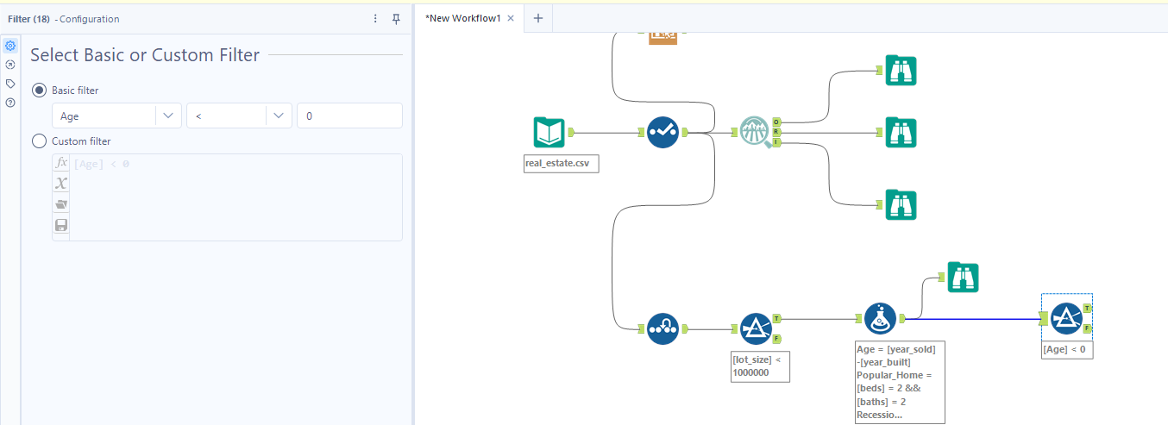

Next, we currently have a categorical column Property_type in our dataset which has 2 unique values Bunglow and Condo
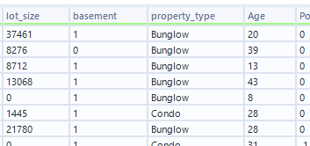

Let’s create Flag columns for every record to convert this Categorical column to a Numerical representation.
To the Output of the False anchor of the Filter tool (remember we want records where Age > 0 to drop the negative age value homes) add a Formula tool
And create 2 columns as
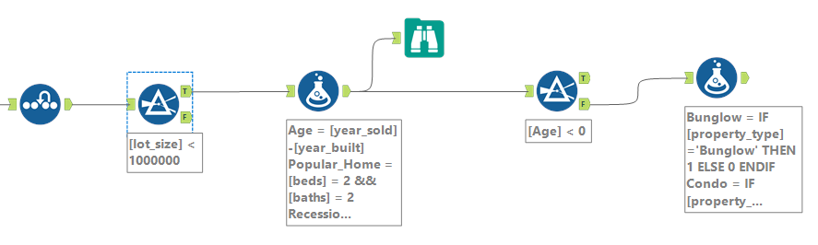

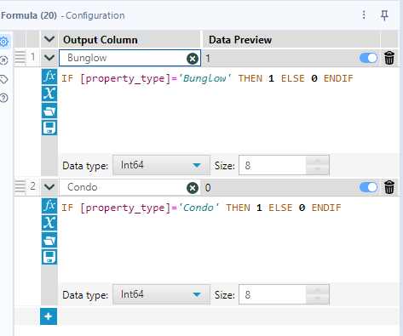

Bunglow
IF [property_type]='Bunglow' THEN 1 ELSE 0 ENDIF

Condo
IF [property_type]='Condo' THEN 1 ELSE 0 ENDIF
Remember to change the Data Type to Int64
Then add a select tool.
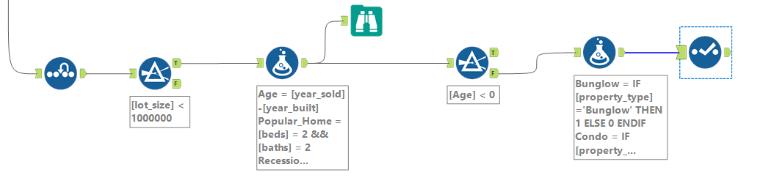
Drop the property_type column that has the string data and uncheck the Unknown and the property_type columns.

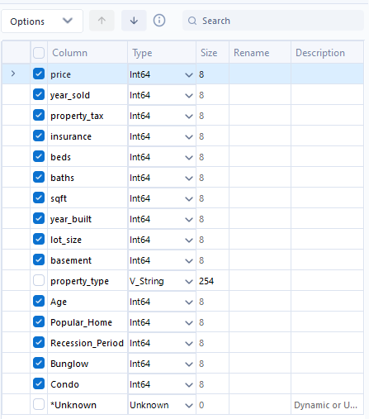

Your data is now cleaned and Ready for machine learning algorithms

Save this dataset

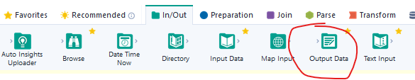

Add an Output Data tool to the end of the workflow
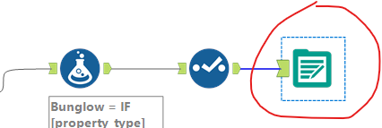

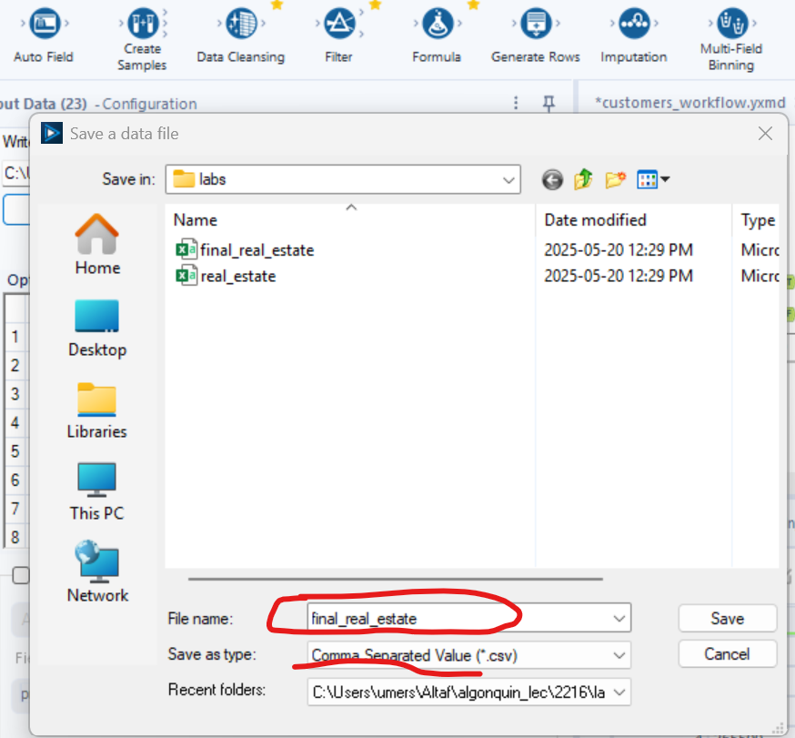

Click on Save and make sure the configuration changes to
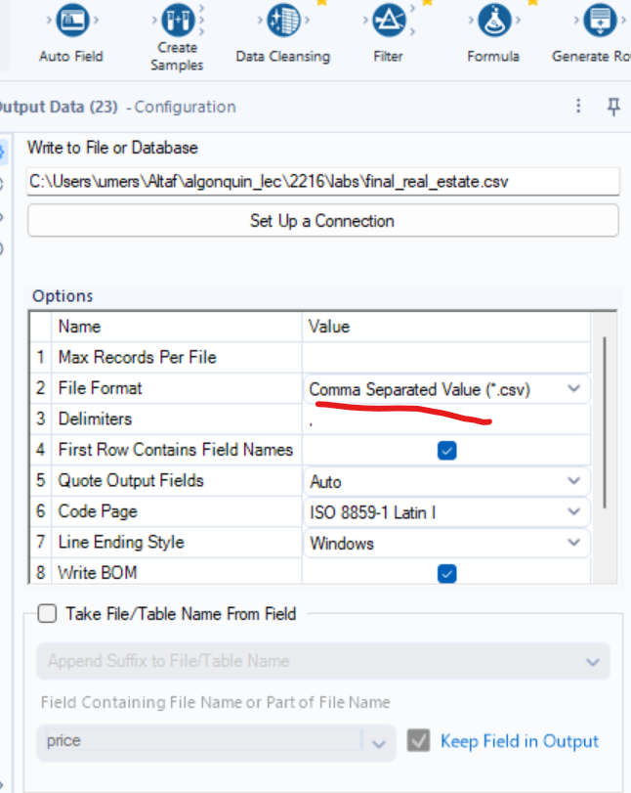

Then click on Run. This will generate the final_real_estate.csv file in your laptop.

The final data should look like this:

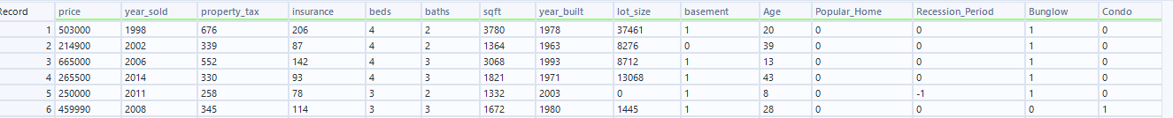

Verify it with the Browse tool before you run the workflow and save the csv file.
We will use this file as in input to create the Linear Regression Model in our Next Lab.

Also, save the workflow as Data_prep
Click on File > Save as > Browse

