Network Sentinel

Phase 1 – Data Exploration Report

Key Trends and Insights
The dataset contains 692,703 network flow records with 79 traffic-related features. The label distribution shows that benign traffic represents the majority class (440,031 records), while DoS Hulk is the dominant attack type (231,073 records). Other attack types such as GoldenEye, Slowloris, Slowhttptest, and Heartbleed appear in significantly smaller quantities.
The dataset demonstrates clear class imbalance, particularly with rare attacks such as Heartbleed. This indicates that anomaly detection or imbalance-aware classification techniques will be required during model development.
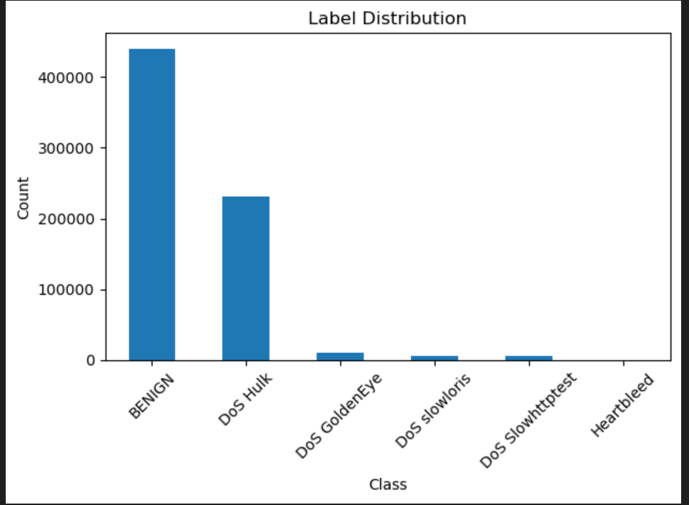
The dataset is high-dimensional, providing sufficient feature richness for predictive modeling. The presence of multiple attack categories supports multi-class classification analysis.

Data Issues and Handling Strategy
The following data quality issues were identified during exploration:
- Missing Values
1008 missing values were identified in the feature "Flow Bytes/s".
Handling Strategy: Missing values will be addressed during preprocessing using either removal of affected rows or imputation depending on model performance impact.
- Duplicate Records
81,909 duplicate records were detected.
Handling Strategy: Duplicate records will be removed prior to model training to prevent bias and improve model reliability.
- Class Imbalance
The dataset shows imbalance between benign and attack classes.
Handling Strategy: Techniques such as stratified train-test splitting and potential resampling methods will be applied in later phases.

