API Documentation
The Network Sentinel system does not use external or REST APIs. Instead, the components are integrated internally within a Python-based architecture. The communication between different layers (Streamlit UI, ML model, and RAG agent) is handled through direct function calls and in-memory data exchange.

Integration Approach

Streamlit UI
- Acts as the frontend interface
- Captures user input and displays results

ML Model Integration
- Invoked directly using Python functions
- Generates predicted attack labels

RAG Agent Integration
- Receives predicted attack and user query
- Performs semantic search using Chroma DB
- Generates explanation and troubleshooting steps

Why APIs were not used
- System is implemented as a single integrated application
- No need for network-based communication between components
- Faster execution using direct function calls
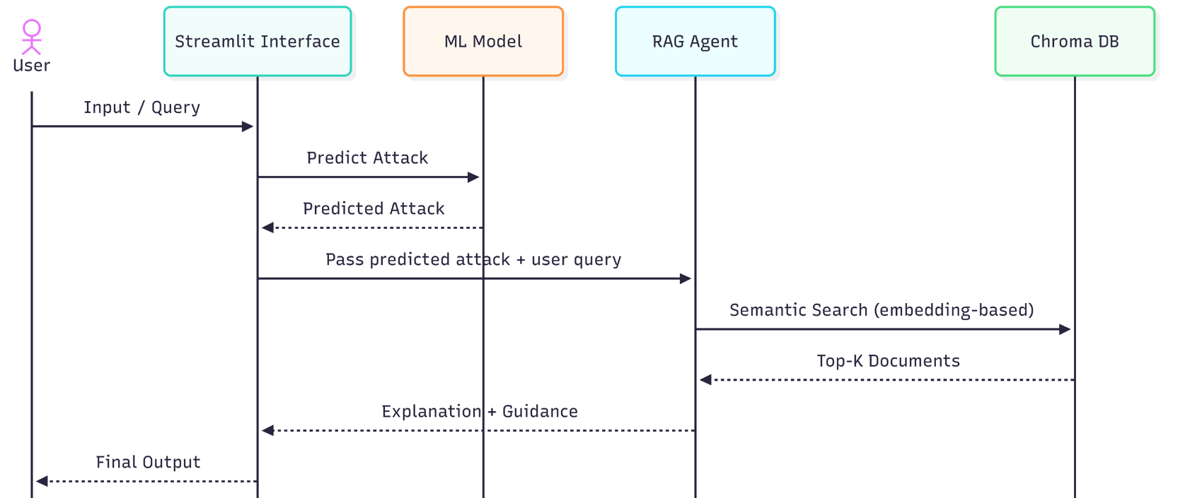
Figure 1: UML diagram

Interface / Endpoint | Method | Input | Output | Purpose
load_dataset | Internal | CSV path / uploaded file | DataFrame | Loads raw network data.
clean_data | Internal | Raw DataFrame | Cleaned DataFrame | Handles duplicates, missing values, and infinities.
engineer_features | Internal | Cleaned DataFrame | Enhanced DataFrame | Creates derived features such as Total Packets and Packets per Second.
predict_attack | Internal | Processed record(s) | Predicted label | Returns the most likely attack class or normal traffic label.
query_rag | Internal | Predicted label + user query | Summary, explanation, troubleshooting | Retrieves relevant documents from Chroma DB and generates response.
app | Web UI | User interaction in Streamlit | Rendered dashboard | Displays final results to the analyst.

Table 1: API Documentation

