Exploratory Data Analysis Report

Objective
The purpose of this analysis is to identify patterns, relationships, and distributions in the dataset.

Key Visualizations

Correlation Analysis
A correlation matrix was generated to identify relationships between features. Several features showed strong correlations, especially timing-related variables.

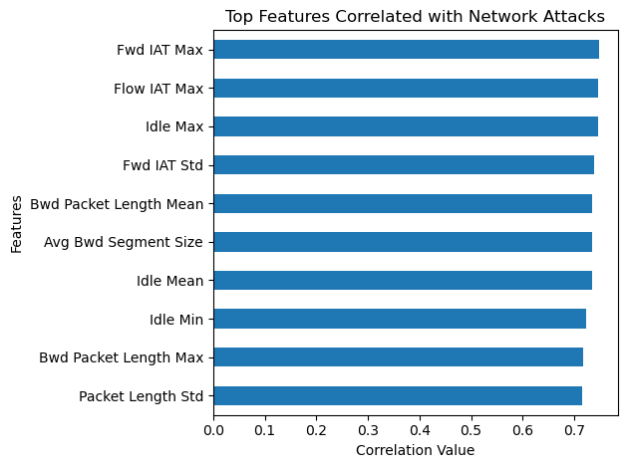

Flow Duration Distribution
Most network flows have short durations, while a small number of flows have very long durations, indicating skewed distribution.

Observations
Timing-related features play a critical role in distinguishing between normal and attack traffic. Packet behavior and flow characteristics are also important indicators.

Conclusion
EDA revealed strong patterns in the dataset and identified key features that will be useful for modeling and analysis.

