Initial Frontend and Backend Implementation Report

2.1 Frontend Status
- A Streamlit-based presentation layer is planned as the sole user interface.
- The UI displays the predicted attack label, generated summary, explanation, and troubleshooting steps.
- A query input component allows the user/analyst to ask follow-up questions about the detected attack.
- Phase 2 frontend can demonstrate static placeholders or proxy

2.2 Backend Status
- Raw CSV data has been loaded and cleaned.
- Two engineered features have been added to improve attack analysis readiness.
- Chroma DB has been connected successfully.
- Proxy outputs have been used to verify the RAG agent connection and retrieval workflow.
- The next backend milestone is replacing proxy labels with actual model predictions.

2.3 Current Integration Summary
Current state: The data preparation pipeline and knowledge retrieval pipeline have both been validated independently. This indicates that the project has a functional backbone for Phase 2, even if the final end-to-end orchestration is not yet complete.
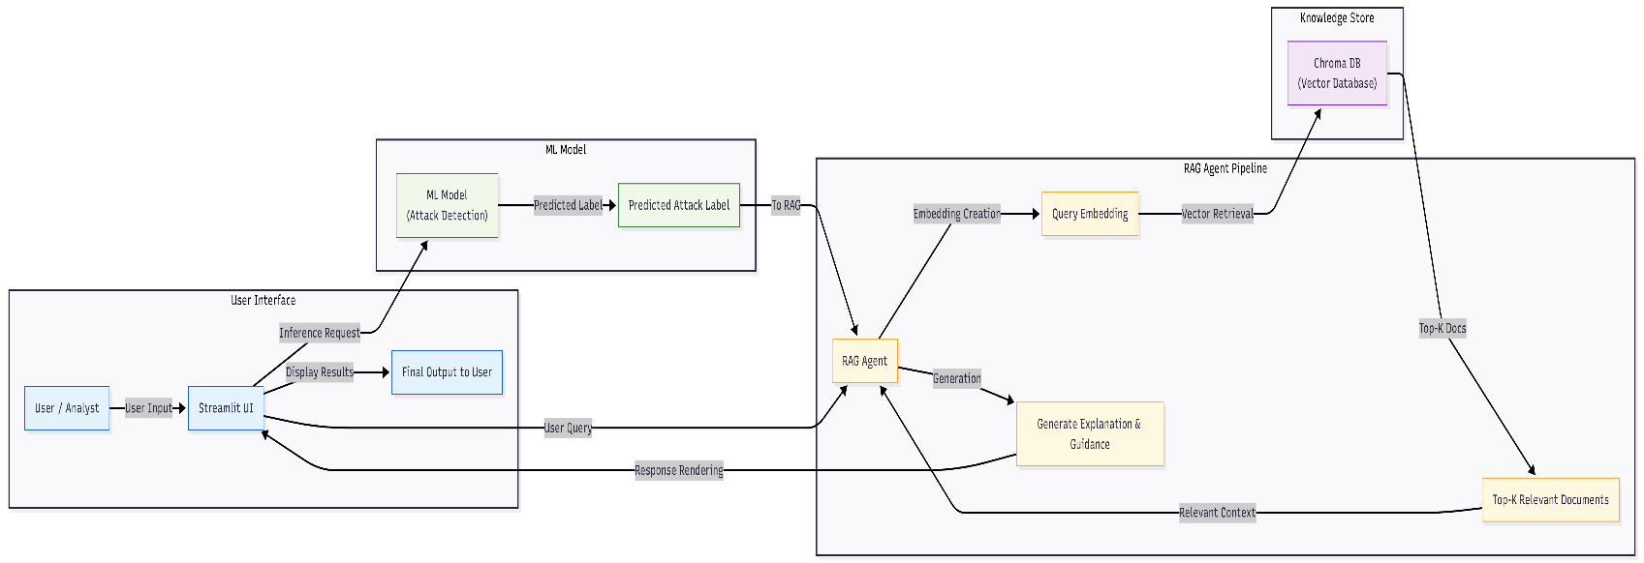
Figure 1: Workflow Diagram

