System Architecture and Database Design

Overview
The system is designed to analyze network traffic data and provide intelligent insights using preprocessing, feature engineering, and a retrieval-based agent.

Architecture Components
1. Data Layer
- Raw network dataset
- Processed dataset stored in CSV format
2. Processing Layer
- Data cleaning (duplicates, missing values, infinities)
- Feature engineering (Total Packets, Packets per Second)
- Feature scaling
3. Analysis Layer
- Correlation analysis
- Feature selection
4. Intelligence Layer
- Chroma DB used as a vector database
- Stores attack descriptions and troubleshooting steps
5. Agent Layer
- AI agent (RAG-based) processes predicted attack and user query
- Retrieves relevant information from Chroma DB using semantic search
- Generates summary, explanation, and troubleshooting guidance
6. Presentation Layer
- Streamlit-based user interface
- Displays:
  - Predicted attack label
  - Attack summary
  - Explanation
  - Troubleshooting steps
- Accepts user queries for interactive analysis
- Serves as the final output layer of the system
- Integrates outputs from:
  - ML detection module
  - RAG-based agent

Refer to Figure 1 diagram for System architecture

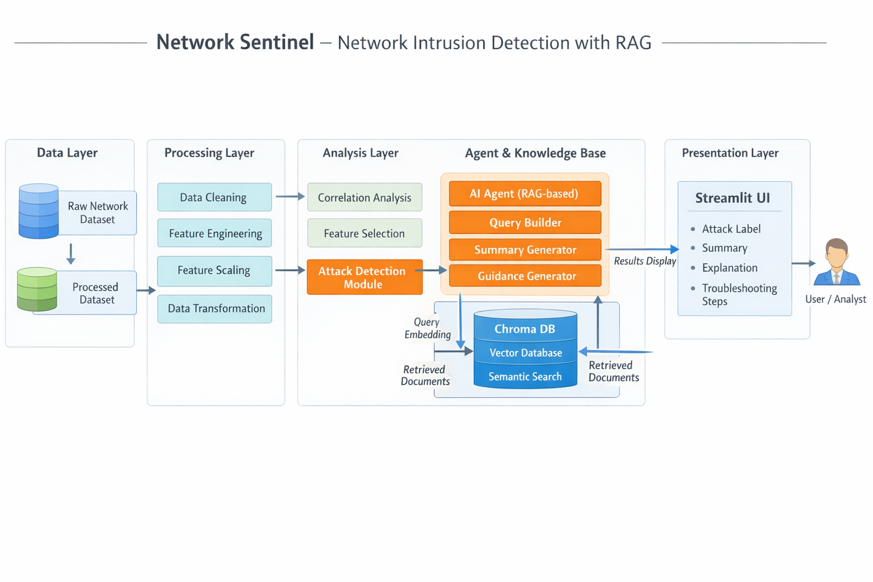
Figure 1: System Architecture

Database Design

- Type: Vector Database (Chroma DB)
- Collection: network_security
- Data Stored:
  - Attack descriptions
  - Troubleshooting steps
Refer to Figure 2 diagram for Database Design

Conclusion
The system integrates data preprocessing and intelligent retrieval to support network security analysis.

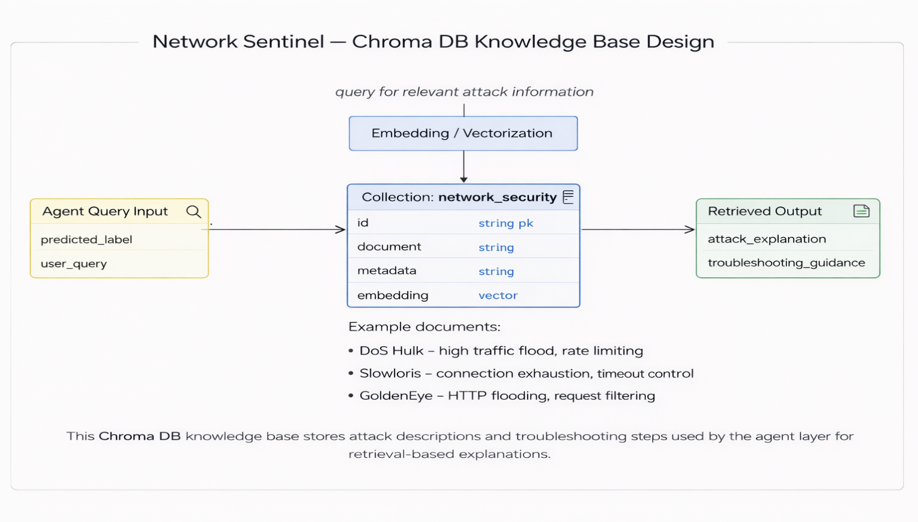
Figure 2: Database Design

