Network Sentinal – Phase II Project Report

Data Cleaning and Preprocessing Report

  - Introduction
The objective of this phase is to prepare the network intrusion dataset for analysis and modeling. Data preprocessing ensures data quality, consistency, and reliability.
1.2 Dataset Overview
The dataset contains network traffic flow records with 79 features representing packet behavior, flow statistics, and timing metrics. The target variable is "Label", representing different types of network traffic.
1.3 Data Cleaning
Duplicate Removal
A total of 81,909 duplicate records were identified and removed. This reduces redundancy and prevents bias in analysis.
Missing Values
Missing values were found in the "Flow Bytes/s" feature. These were replaced with 0, assuming no measurable flow in those cases.
Infinite Values
A total of 543 infinite values were detected in numeric columns. These were replaced with valid numeric values to ensure compatibility with scaling and modeling.
Data Type Validation
The dataset includes integer, float, and categorical variables. Numerical columns were verified for preprocessing and analysis.
Feature Scaling
StandardScaler was applied to normalize numerical features. This ensures all features contribute equally and improves model performance.
1.4 Conclusion
The dataset has been successfully cleaned and prepared. It is now consistent, complete, and suitable for further analysis and modeling.

Integrated Dataset and Transformation Documentation

2.1 Objective
The goal is to create a structured and clean dataset by applying necessary transformations to the raw data.

2.2 Transformations Applied

1. Duplicate Removal
81,909 duplicate rows were removed.

2. Missing Value Handling
Missing values in "Flow Bytes/s" were replaced with 0.

3. Infinite Value Handling
Infinite values were replaced with valid numeric values.

4. Feature Engineering
Two new features were created:
- Total Packets
- Packets per Second

5. Encoding
The "Label" column was converted into a numerical format (Label_encoded).

6. Scaling
StandardScaler was applied to normalize numerical features.

2.3 Final Dataset
The final dataset contains clean, structured, and transformed data ready for analysis and modeling.

2.4 Conclusion
The integration and transformation process ensures the dataset is reliable, consistent, and ready for advanced analytics.

3. Exploratory Data Analysis Report

3.1 Objective
The purpose of this analysis is to identify patterns, relationships, and distributions in the dataset.

3.2 Key Visualizations

Correlation Analysis
A correlation matrix was generated to identify relationships between features. Several features showed strong correlations, especially timing-related variables.

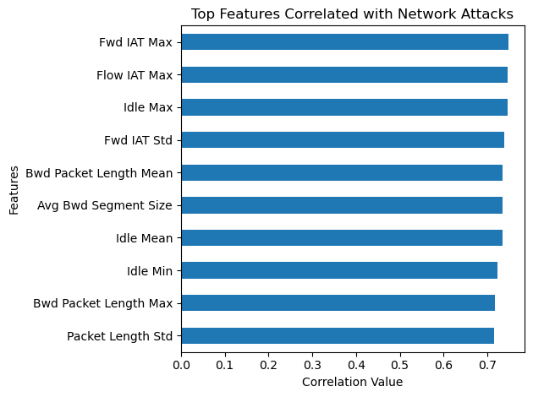
Figure 1: Correlation Analysis

3.3 Flow Duration Distribution
Most network flows have short durations, while a small number of flows have very long durations, indicating skewed distribution.

3.4 Observations
Timing-related features play a critical role in distinguishing between normal and attack traffic. Packet behavior and flow characteristics are also important indicators.

3.5 Conclusion
EDA revealed strong patterns in the dataset and identified key features that will be useful for modeling and analysis.

4. Feature Selection and Engineering Documentation

4.1 Objective
The objective is to enhance the dataset by creating meaningful features and selecting important variables.

4.2 Feature Engineering
Total Packets
- Total Packets = Total Fwd Packets + Total Backward Packets
This feature represents the total number of packets in a network flow.
Packets per Second
- Packets per Second = Total Packets / Flow Duration
This feature represents traffic intensity and helps detect abnormal patterns.

4.3 Feature Selection
Important features were selected based on correlation with the target variable, including:
- Fwd IAT Max
- Flow IAT Max
- Idle Max
- Packet Length Std

4.4 Justification
These features capture timing behavior, traffic intensity, and packet characteristics, which are key indicators of network attacks.

4.5 Conclusion
Feature engineering improved the dataset by adding meaningful attributes, and feature selection helped identify the most relevant variables.

5. Summary of Preliminary Insights and Hypothesis Testing

5.1 Key Insights
1. Timing Features are Important
Features such as Fwd IAT Max and Flow IAT Max show strong correlation with attack behavior.
2. High Traffic Intensity Indicates Attacks
Higher packet rates are often associated with Denial of Service attacks.
3. Idle Time Patterns are Significant
Irregular idle time patterns help distinguish attack traffic from normal traffic.

5.2 Hypotheses
- H1: Higher packet rate indicates attack traffic supported by the data.
- H2: Longer flow duration indicates attacks, Partially supported.
- H3: Timing variability differentiates attack and normal traffic, Strongly supported.

5.3 Conclusion
The dataset shows clear patterns in timing and packet behavior. These insights can be used to build effective machine learning models for intrusion detection.

6. System Architecture and Database Design

6.1 Overview
The system is designed to analyze network traffic data and provide intelligent insights using preprocessing, feature engineering, and a retrieval-based agent.

6.2 Architecture Components
1. Data Layer
- Raw network dataset
- Processed dataset stored in CSV format
2. Processing Layer
- Data cleaning (duplicates, missing values, infinities)
- Feature engineering (Total Packets, Packets per Second)
- Feature scaling
3. Analysis Layer
- Correlation analysis
- Feature selection
4. Intelligence Layer
- Chroma DB used as a vector database
- Stores attack descriptions and troubleshooting steps
5. Agent Layer
- AI agent (RAG-based) processes predicted attack and user query
- Retrieves relevant information from Chroma DB using semantic search
- Generates summary, explanation, and troubleshooting guidance
6. Presentation Layer
- Streamlit-based user interface
- Displays:
  - Predicted attack label
  - Attack summary
  - Explanation
  - Troubleshooting steps
- Accepts user queries for interactive analysis
- Serves as the final output layer of the system
- Integrates outputs from:
  - ML detection module
  - RAG-based agent

Refer to Figure 1 diagram for System architecture

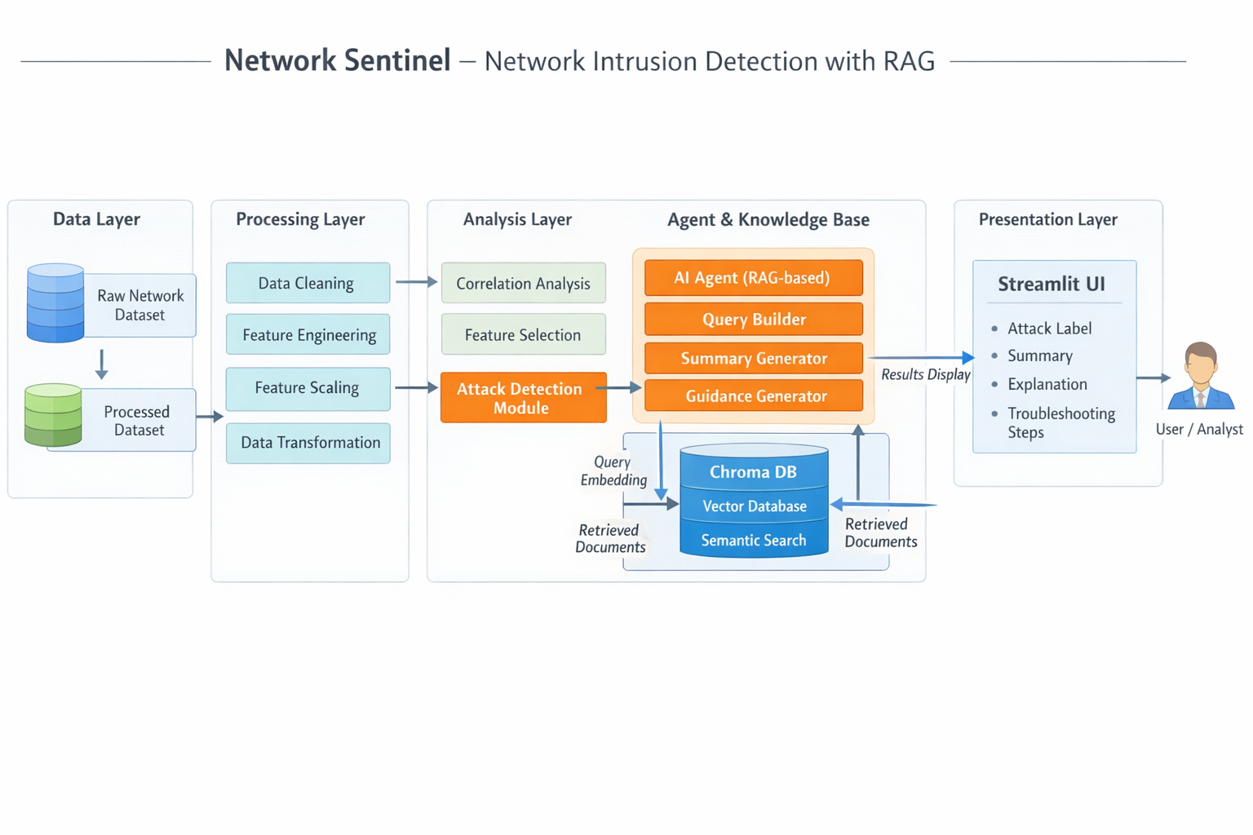
Figure 2: System Architecture

6.3 Database Design

- Type: Vector Database (Chroma DB)
- Collection: network_security
- Data Stored:
  - Attack descriptions
  - Troubleshooting steps
Refer to Figure 2 diagram for Database Design

6.4 Conclusion
The system integrates data preprocessing and intelligent retrieval to support network security analysis.

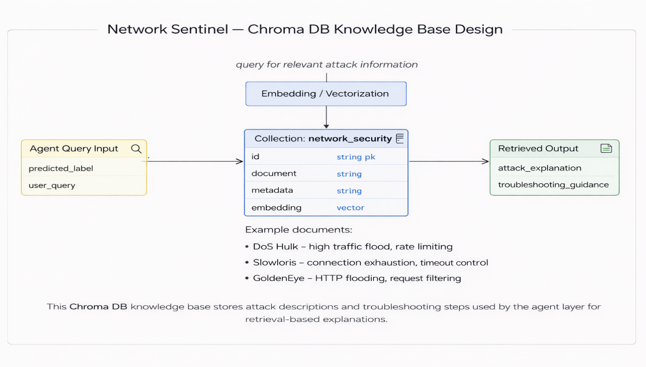
Figure 3: Database Design

7. Initial Frontend and Backend Implementation Report

7.1 Frontend Status
- A Streamlit-based presentation layer is planned as the sole user interface.
- The UI displays the predicted attack label, generated summary, explanation, and troubleshooting steps.
- A query input component allows the user/analyst to ask follow-up questions about the detected attack.
- Phase 2 frontend can demonstrate static placeholders or proxy

7.2 Backend Status
- Raw CSV data has been loaded and cleaned.
- Two engineered features have been added to improve attack analysis readiness.
- Chroma DB has been connected successfully.
- Proxy outputs have been used to verify the RAG agent connection and retrieval workflow.
- The next backend milestone is replacing proxy labels with actual model predictions.

7.3 Current Integration Summary
Current state: The data preparation pipeline and knowledge retrieval pipeline have both been validated independently. This indicates that the project has a functional backbone for Phase 2, even if the final end-to-end orchestration is not yet complete.
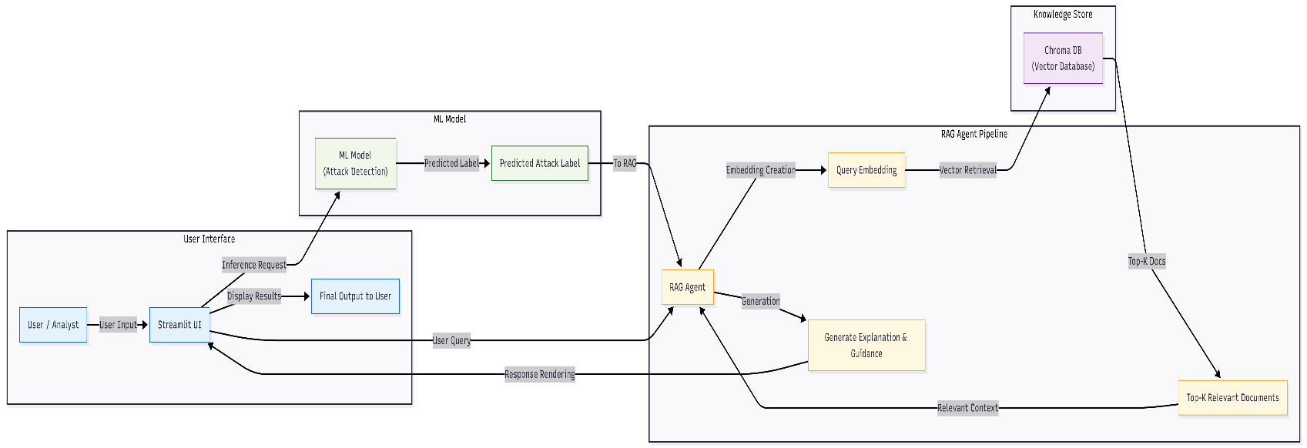
Figure 4: Workflow Diagram

8. API Documentation
The Network Sentinel system does not use external or REST APIs. Instead, the components are integrated internally within a Python-based architecture. The communication between different layers (Streamlit UI, ML model, and RAG agent) is handled through direct function calls and in-memory data exchange.

8.1 Integration Approach

Streamlit UI
- Acts as the frontend interface
- Captures user input and displays results

ML Model Integration
- Invoked directly using Python functions
- Generates predicted attack labels

RAG Agent Integration
- Receives predicted attack and user query
- Performs semantic search using Chroma DB
- Generates explanation and troubleshooting steps

8.2 Why APIs were not used
- System is implemented as a single integrated application
- No need for network-based communication between components
- Faster execution using direct function calls
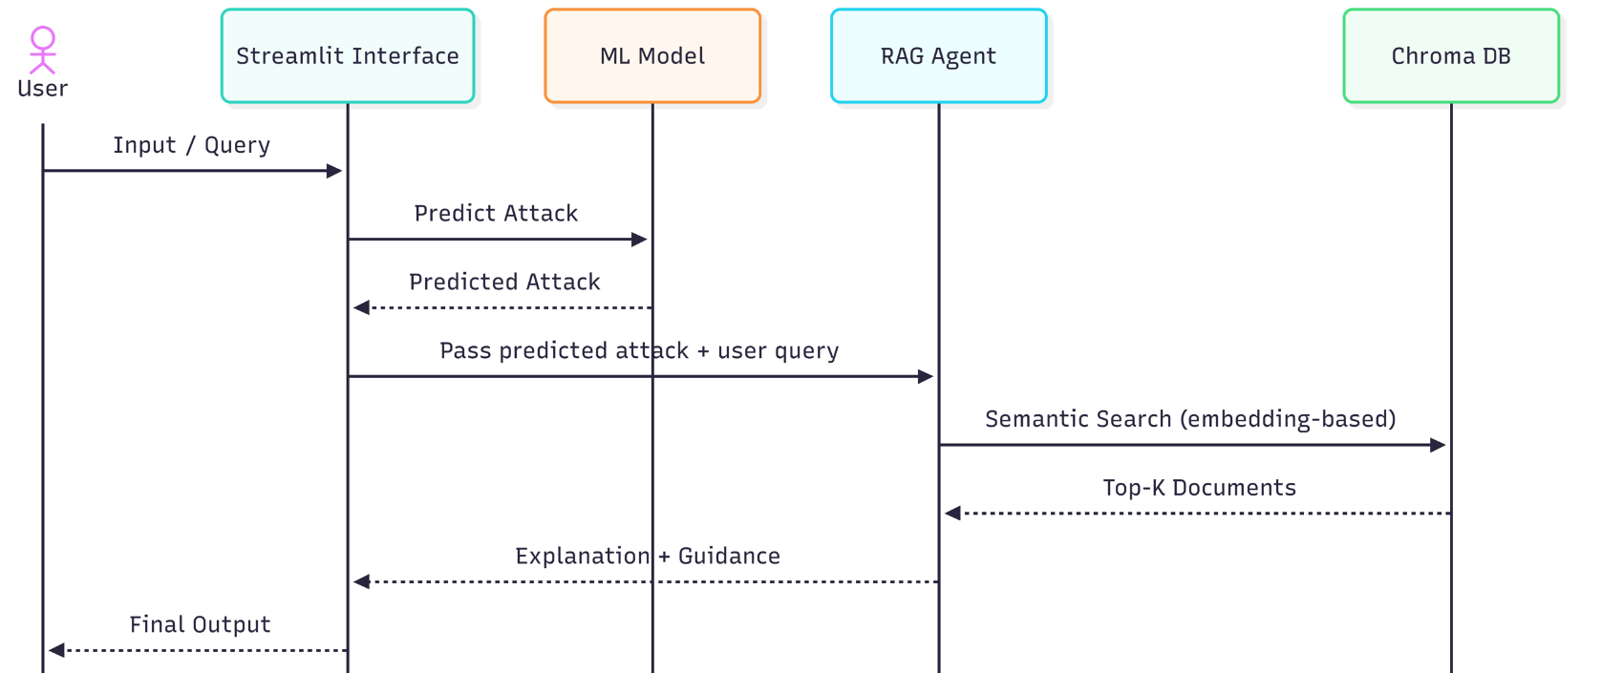
Figure 5: UML diagram

Interface / Endpoint | Method | Input | Output | Purpose
load_dataset | Internal | CSV path / uploaded file | DataFrame | Loads raw network data.
clean_data | Internal | Raw DataFrame | Cleaned DataFrame | Handles duplicates, missing values, and infinities.
engineer_features | Internal | Cleaned DataFrame | Enhanced DataFrame | Creates derived features such as Total Packets and Packets per Second.
predict_attack | Internal | Processed record(s) | Predicted label | Returns the most likely attack class or normal traffic label.
query_rag | Internal | Predicted label + user query | Summary, explanation, troubleshooting | Retrieves relevant documents from Chroma DB and generates response.
app | Web UI | User interaction in Streamlit | Rendered dashboard | Displays final results to the analyst.

Table 1: API Documentation

9. Feature Implementation Report

9.1 Overview
New features were created to improve data representation and analysis.

9.2 Features Implemented
1. Total Packets
Total Packets = Total Fwd Packets + Total Backward Packets
Purpose:
Represents total communication volume.
2. Packets per Second
Packets per Second = Total Packets / Flow Duration
Purpose:
Captures traffic intensity and helps detect abnormal behavior.
Additional Implementation
- Feature scaling using StandardScaler
- Label encoding for target variable

9.3 Conclusion
Feature implementation improved the dataset by adding meaningful and interpretable variables.

9.4 Implemented Features
Feature | Status | Description
CSV data loading | Completed | Reads raw network traffic data from source file(s).
Data cleaning | Completed | Handles duplicates, missing values, and invalid numeric values.
Feature engineering | Completed | Adds two derived fields for improved analytical readiness.
Chroma DB connection | Completed | Initializes vector store and validates retrieval access.
RAG agent proxy test | Completed | Uses proxy attack result to verify response generation.
End-to-end prediction to RAG | In progress | Will connect model output directly to the retrieval flow.
Table 2: Implemented features

10. Testing Report and Bug Fixes

10.1 Overview
Testing was conducted to ensure system functionality and correctness.

10.2 Tests Performed
1. Data Cleaning Validation
- Verified duplicate removal
- Checked missing values handling
2. Feature Engineering Validation
- Verified correctness of new features
3. Retrieval System Testing
- Tested query-based retrieval from Chroma DB
- Verified correct responses

10.3 Bugs Encountered
1. Module Import Error
- Issue: No module named 'rag'
- Fix: Adjusted import paths and project structure
2. Collection Not Found Error
- Issue: Chroma collection did not exist
- Fix: Used get_or_create_collection()
3. PATH Warnings
- Issue: Scripts not added to PATH
- Fix: Ignored as non-critical

10.4 Conclusion
All major issues were resolved, and the system is functioning correctly.

Test Case | Expected Result | Observed Result | Status
Dataset load test | File loads successfully | Passed on current CSV sample | Pass
Cleaning pipeline test | No blocking invalid values remain | Duplicates/null handling completed | Pass
Feature calculation test | Derived columns computed correctly | Verified on sample rows | Pass
Chroma DB connectivity test | Connection accessible and queryable | Connection validated | Pass
Proxy RAG response test | Agent returns explanation and guidance | Response generated | Pass
Full prediction integration test | Model prediction triggers RAG automatically | Pending final integration | Open
Table 3: Testing report

