Social Intelligence and Social Networks Predict Group Collective Intelligence

**Authors:** Jennifer S. Labrecque,a,[1] Young Ji Kim,b,c,[2] Thomas Malone,b,c & Kayla de la Hayea

**Affiliations:**

aDepartment of Preventive Medicine, Keck School of Medicine, University of Southern California, 2001 N. Soto St., Los Angeles, CA, 90089-9239, USA. Email: jen.labrecque@okstate.edu, delahaye@usc.edu.

bSloan School of Management, Massachusetts Institute of Technology, 30 Memorial Dr, Cambridge, MA, 02142, USA. Email: ykim@comm.ucsb.edu, malone@mit.edu.

cCenter for Collective Intelligence, Massachusetts Institute of Technology, 245 First Street, E94-1509, Cambridge, MA, 02142, USA.

Author Note

Funding: This material is based upon work supported by, or in part by, the U.S. Army Research Laboratory and the U.S. Army Research Office under grant number W911NF-15-1-0577. The funding agency had no role in conducting this research or preparing the article for publication. The authors would additionally like to thank Naomi Abella, Mikel Brown, Taylor Harris, Kacie Kline, and Aisha Vaiyani for their assistance running the study.

Correspondence concerning this article should be addressed to Kayla de la Haye, Department of Preventive Medicine, Keck School of Medicine, University of Southern California, 2001 N. Soto St., Los Angeles, CA, 90089-9239. Email: delahaye@usc.edu, Phone: 323-442-8228, Fax: 323-865-0854.

Declarations of conflict of interest: none

Social Intelligence and Social Networks Predict Group Collective Intelligence

**Abstract**

Investigations of group performance have traditionally focused on cognitive ability and skill; however recent studies have identified social abilities as important predictors of performance and group collective intelligence (CI). We predict that several social ability domains will directly influence CI as well as shape group social network structures that influence performance capacity. We tested this relationship using an exploratory experimental design in which 42 mixed-gender groups of three to five participants worked together on problem-solving tasks and individually completed social intelligence assessments. We also assessed group influence networks, and identified their structural features (e.g., density, transitivity, centralization). Social intelligence was found to influence CI through dual pathways: a direct path in which greater diversity on some social abilities directly increased CI; and an indirect path in which social abilities improved CI through the way they shaped network structure. The findings provide insights into how group performance is influenced by social intelligence and social networks.

Keywords: social network, social intelligence, group performance, collective intelligence, team

Social Intelligence and Social Networks Predict Group Collective Intelligence

**INTRODUCTION**

Social intelligence, or the learned abilities and skills that allow people to successfully navigate social situations (Riggio, 2014), is emerging as an important contributor to group performance, distinct from the kind of cognitive intelligence measured by traditional intelligence tests (Engel, Woolley, Jing, Chabris, & Malone, 2014; Woolley, Chabris, Pentland, Hashmi & Malone, 2010). Traditionally, key individual-level predictors of group performance focused on members’ cognitive (academic) intelligence ability or general mental ability (Devine & Philips, 2001; Stewart, 2006). However, there is a long history in the psychological literature of exploring the role of personality in group performance (Barrick, Stewart, Neubert & Mount, 1998; Bell, 2007; Mann, 1959; Peeters, Van Tuijl, Rutte, & Reymen, 2006) and a more recent interest specifically in social and emotional intelligence as predictors of group performance (Bell et al., 2007; Day & Carroll, 2004; Feyerhem & Rice, 2002; Jordan, Ashkanasy, Härtel, & Hooper, 2002). There is growing evidence that group members’ personality traits related to interpersonal skills (e.g., agreeableness, extraversion) contribute not only to social cohesion but to performance of the group, which suggests that members’ social abilities may contribute to group performance through increased cooperation and interpersonal facilitation in groups (Barrick et al., 1998; Bell, 2007).

This study examines whether individual group members’ social intelligence would affect the group’s intelligence, specifically the so-called *collective intelligence* (CI)[3] of the group (Woolley et al., 2010). Researchers have found that similar to individual cognitive intelligence, there is a general CI factor that explains a group’s performance on a wide variety of tasks, and that this factor indeed predicts the group’s future performance on complex tasks (Engel et al., 2014; Kim, Engel, Woolley, Lin, McArthur, & Malone, 2017; Woolley et al., 2010). Previous research has found that social perceptiveness, which is the ability to accurately perceive or make inferences about others’ moods or emotional states, is one of the strongest predictors of CI (Woolley et al., 2010). In these studies, groups with higher average social perceptiveness have higher CI. Research has also shown that social perceptiveness is equally predictive of CI when groups are working face-to-face and online, both in the lab and field, indicating that these social abilities are critical to group interaction and coordination across various contexts (Engel et al., 2014; Kim et al., 2017; Meslec, Aggarwal, & Curseu, 2016; Woolley et al., 2010). Contrary to intuition, a meta-analysis shows that individual cognitive intelligence has only a small to moderate effect on group performance (Bell, 2007; but see Bates & Gupta, 2017). Although past studies have often used a criterion measure of group performance as an outcome that is predicted by a group’s CI, in the current study, CI itself is the outcome measure, predicted by social intelligence and the related social network structures that emerge in groups.

There is an extensive literature in social psychology (Kihlstrom, & Cantor, 2000; Marlowe, 1986) that defines social intelligence as multidimensional, comprised of multiple domains of cognitive abilities (one being social perceptiveness, which has been most extensively studied in relation to CI) and behavioral abilities that have yet to be considered as predictors of CI. The key components of social intelligence, which span cognitive to behavioral abilities, include: perceptiveness of others’ states and moods; knowledge of social rules and social contexts; insight into complex social situations; empathy and perspective taking; verbal fluency and conversation skills; abilities to deal with others; use of social techniques; and adaptation of social techniques to various contexts and settings (Riggio, 2014; Silvera, Martinussen, & Dahl, 2001). This definition suggests that social intelligence encompasses constructs from emotional intelligence, but can accommodate a more diverse and complex range of social phenomena. Rather than following Mayer & Salovey (1997)’s ability-based theory of emotional intelligence, our theorizing embraces trait theory, conjecturing that there is significant overlap in traits represented in personality, emotional, and social intelligence (Goleman, 2006). Therefore, the current study includes multiple measures spanning each of these constructs in an attempt to best address the broad array of intra- and interpersonal characteristics underlying social intelligence that may be relevant to CI.

Given the multidimensionality of social intelligence, having strong abilities in a single social intelligence domain may not make a person “socially intelligent” overall. People with Antisocial Personality Disorder, for example, habitually behave in unethical and even criminal ways. They may have strong skills in social perceptiveness that allow them to accurately read and understand others’ states and motivations, but they tend to use this knowledge to manipulate and hurt others, for their own gain. This is because they lack complimentary affective and empathic social abilities that would motivate them to avoid hurting others and enable them to feel remorse; and they don’t possess an overall combination of social abilities that would allow them to live within society’s social norms and laws (American Psychiatric Association, 2013). These distinctions in social abilities are also meaningful in non-clinical cases, where, for example, individuals may be socially perceptive but nonetheless behave in ways that disregard others’ needs. These individuals may be successful in many life domains; however their ability to succeed in collective, group enterprises may be compromised. In the current work, we consider social intelligence as a multi-faceted construct encompassing a number of domains (empirically evaluated through factor analysis), and explore whether a group’s abilities across these varied domains predict the group’s CI.

Finally, although several researchers have noted the important distinction between the social intelligence of individuals and the more complex social intelligence of groups (e.g., involving awareness of emotions both within and between teams as well as within and between individuals who belong to a team, Druskat & Wolff, 2011), the current study focuses only on testing if individual social intelligence predicts group CI.

**Social Intelligence, Social Networks, and Group Collective Intelligence**

In this exploratory study, we investigate two paths through which social intelligence may shape the CI of groups. First, we look for a direct path in which the social intelligence of individual group members allows the group to effectively work together to complete tasks. The aforementioned research on social perceptiveness and CI appears to work through this direct path: groups higher in social perceptiveness had higher CI. In addition to social perceptiveness, we investigate what other broader social intelligence domains similarly directly and positively predict CI.

We additionally investigate whether social intelligence can impact group CI through a second, indirect path involving social network structures. Studies of group performance have traditionally focused on summarizing characteristics of individuals in the group (e.g., average intelligence, or average social perceptiveness) as predictors of performance, but there has been limited exploration of how the characteristics of the individuals combine to produce emergent group properties, such as patterns of interaction and influence within groups---i.e., group *social networks--*that in turn shape group performance. Social networks are likely to be key mechanisms through which group members’ social abilities impact group performance because a) individual social abilities of group members are likely to impact the social network structure that emerges within groups, and b) because group social networks are known to impact group performance. Moreover, because this study involves new groups that have never worked together before, we are uniquely able to observe these phenomena as they develop.

There is theoretical and empirical evidence that some psychological and social traits and states, including personality domains and self-monitoring, impact social interactions and social network structures (e.g, Fang, Landis, Zhang, Anderson, Shaw, & Kilduff, 2015; Kadushin, 2002; Kalish & Robins, 2006; Mehra et al. 2001). Findings emerging from this research show that *neuroticism*, characterized by depressed mood, low self-esteem, and pessimistic attitudes (McCrae & Costa, 1999), is consistently linked to social network structure. Individuals high on neuroticism tend to occupy less central positions in various types of social networks (Fang, 2015; Klein, 2004), and they have weaker connections among their different social contacts; which is referred to in the social networks literature as more *structural holes* (Burt, 2009; Kalish & Robins, 2006). Individuals high on *extraversion,* meaning they are gregarious, have lots of friends, and regularly participate in group activities (McCrae & Costa, 1999), tend to have greater connections among their different social contacts (i.e., fewer structural holes; Kalish & Robins, 2006), and they may be more accurate in perceiving their social networks (Casciaro, 1998). However, a recent meta-analysis failed to find an association between extraversion and the extent to which someone is highly connected and central in a social network (Fang, 2015). This may be because extroverts have been found to have more social connections initially, but then fail to maintain their more socially connected, popular positions over time (Selfhout, 2010). Finally, individuals high in self-monitoring have consistently been found to occupy more central positions in both expressive (e.g., friendship) and instrumental (e.g., advice) social networks (Fang, 2015; Mehra et al., 2001).

In the second stage of the indirect process, the structure of group social networks impacts group performance. Research on CI found that groups in which all members contributed to the conversation rather than a few dominating the conversation performed better (Engel et al., 2014; Woolley et al., 2010). Although social networks weren’t explicitly measured in these studies, the findings suggest that group communication networks may be more effective if they have greater density (i.e., more communication ties), and are structured so that communication ties are more evenly distributed among team members (i.e., the networks are less centralized) compared to groups where communication ties are more concentrated around a small number of group members (i.e., the networks are more centralized).

Research supporting this path also comes from studies that employ social network analysis to examine communication, collaboration, and influence networks in groups and teams. Studies of communication and collaboration networks have generated evidence that greater network density has a positive impact on group performance (Beal, Cohen, Burke, & McLendon, 2003; Evans & Dion, 2012), although some research suggests that this relationship is curvilinear; e.g., in a study of team communication the most effective network structures were those with moderate network density, while team performance was hindered by very sparse, and very dense, communication networks (Wise, 2014).

Transitive network structures, where social ties forms among triads (where A is tied to B, B is tied to C, and C is tied to A) have also been positively linked to group performance. Social network theory proposes that people have a tendency towards transitivity because it serves a social function of reducing tension and interpersonal conflict, and creates more equilibrium and balance in social groups (Cartwright & Harary, 1956; Heider, 1979). Researchers have proposed that transitivity in group communication or influence networks is important for coordinating and integrating information, and enabling the group to reach a consensus or make decisions that are needed when completing tasks (e.g., Yang & Tang, 2004). Indeed, transitivity in information exchange networks has been found to positively impact group performance, because of its positive influence on group-level information processing (specifically, transactive memory systems; Lee, Bachrach, & Lewis, 2014).

Although relationships that involve communication and information exchange enable the flow of information in groups, networks that explicitly entail *interpersonal influence*, which arise through group members’ interactions, may be particularly potent predictors of performance because they play an important role in shaping attitudes, beliefs, and behaviors (Friedkin & Johnsen, 2011). In studies that assess teammates’ perceptions of who influences their decisions or actions during group tasks, the structure of influence networks has been found to shape individual beliefs and group convergence on opinions (e.g., Friedkin & Johnsen, 2011; Friedkin, Proskurnikov, Tempo, & Parsegov, 2016).

Finally, although it focused on cultural diversity rather than social intelligence to predict performance, a recent study found a similar indirect relationship in which social network structure modified the effect of group member characteristics on group performance. In this study, groups with greater cultural diversity required more centralized workflow networks for optimal performance (Tröster, Mehra, & van Knippenberg, 2014).

Taken together, this research indicates that several individual characteristics related to personality and social traits play a role in shaping social networks, and that social network structures matter to group performance. The structural features of communication and influence networks that appear to benefit group performance include greater density, greater transitivity, and less centralization, although there are often mixed findings, and the most “effective” network structure may vary depending on the characteristics of the group or organization and the context in which the group is operating.

**Current Research**

In the current work, we investigate whether or not multiple social intelligence domains, in addition to social perceptiveness, directly predict group CI. We hypothesize that groups whose members have greater social intelligence abilities will have better CI. We further conduct exploratory analyses to investigate the indirect effects of how group influence networks mediate the relationship between social intelligence and CI. When assessing these indirect effects, we are testing structural features of networks that have been empirically or theoretically linked to group performance: network density, transitivity (reflecting the local clustering of network ties), and centralization. Group performance and network structure are assessed at two time points to evaluate the temporal dynamics of changes in group interactions over time.

**METHOD**

**Participants**

Forty-two groups[4] composed of 178 university students (97 women, *Mage* = 20.87), recruited through the Psychology Subject Pool and a university announcements website, completed the study for payment or partial course credit. The final sample analyzed excluded one additional group (5 participants) that experienced equipment failure. Students were eligible to participate in the study if they were at least 18 years old and native English speakers.

**Procedure**

Eligible participants signed up to participate in a single-session two-hour group experiment. Groups were required to have at least one male and one female participant, and to have a minimum of 3 and maximum of 5 participants. Group sessions were conducted in a university laboratory, and participants provided their informed consent to participate in the study upon arrival at the scheduled group session. During each 2-hour session, participants completed group and individual tasks in the following order: (1) a first set of 6 group tasks to assess CI (30 minutes); (2) an assessment of group influence networks; (3) individual reports of demographics; (4) a second set of 6 group tasks to assess CI (30 minutes); (5) a second assessment of group influence networks; and (6) individual assessments of social intelligence. All protocols were approved by the University IRB.

**Measures**

Group CI and influence network assessments were made at two time points (Time 1, Time 2) so that we could evaluate if there were changes in the predictors of CI as group members worked together and became familiar with each other. In contrast, personality, emotional, and social intelligence were evaluated only once – at the end of the study – because these are considered to be more stable, trait-like attributes that are unlikely to shift significantly during the course of the study.

***Collective Intelligence (CI).*** As a group, participants completed the Test of Collective Intelligence (TCI), an online version of tasks designed to measure CI at two time points, referred to as ‘TCI Time 1’ and ‘TCI Time 2’ (Engel et al., 2014; Woolley et al., 2010). Each TCI requires about 30 minutes for groups to complete, and contains six tasks from a variety of task types inspired by the McGrath’s Task Circumplex (1984) and Larson (2010): group typing, problem solving, brainstorming, picture memory, unscrambling words, and Sudoku (see Engel et al., 2014 for full task descriptions). The TCI contains the same task types at Time 1 and Time 2 but presents different task stimuli at each time point. The TCI was conducted using the Platform for Online Group Studies (POGS), which allowed for synchronous collaboration by multiple participants and automatically administered the six tasks with preset duration (Engel et al., 2014; Engel et al., 2015). Participants sat around a table and completed the TCI using laptops, while talking freely with their group members, similar to the talking condition in Engel et al. (2014).

To calculate a group’s CI score, we adopted the same procedure outlined by Wolley, Malone, and colleagues in their work developing and validating CI (Woolley et al., 2010). First, the raw group scores were computed for each of the six tasks: typing, problem solving, brainstorming, picture memory, unscramble words, and Sudoku (for the details of each task and how it was scored, see Engel et al. (2014)). Next, the group’s raw scores on each task were standardized. Then, we performed a factor analysis on all the groups’ standardized scores on all the tasks. A group’s factor score on the first factor that emerged from this analysis served as a measure of the group’s collective intelligence (Woolley et al., 2010). This procedure was followed separately to compute CI for the data from Time 1 and Time 2 respectively. As expected, groups performed similarly across all six of the tasks: alpha = .74 (range: *r* = -.01 for Typing at Time 1 with Sudoku at Time 2 to *r* = .42 for Memory at Time 1 with Typing at Time 2; excludes intra-task reliability).

***Social network.*** Immediately after completing the TCI (both at Time 1 and Time 2), participants individually answered a short survey to assess their perceptions of the influence network within their group. They were instructed to reflect on their experience working with their teammates during the set of tasks they had just completed, and to select the teammate(s), one or more than one, who were the best fit for the following name generator (Carrington et al., 2005): “*My opinions and group work were influenced by this teammate / these teammates the most*”. Participants nominated an average of 26% of their teammates as influence ties at Time 1 and 28% at Time 2 (range for both Time 1 and Time 2: 0% to 80%).

Influence networks within each group, at Time 1 and Time 2, were represented as separate directed adjacency matrices, where an influence nomination between teammate *i* and teammate *j* was coded as *xij* = 1 if the tie was reported, and 0 if there was no reported tie.

***Personality, emotional and social intelligence.*** Personality was measured using the Ten-Item Personality Inventory (TIPI; Gosling, Rentfrow, & Swann, 2003), generating scores on 5 personality domains: extraversion, agreeableness, conscientiousness, emotional stability, and openness to experiences. The brief TIPI, with its good validity, was used in lieu of more comprehensive personality measures to prevent extending the lengthy battery. Emotional and social intelligence were measured using the following: the Reading the Mind in the Eyes test (RME; Baron-Cohen, Wheelwright, Hill, Raste, & Plumb, 2001), to assess social perceptiveness; the Tromso Social Intelligence Scale (TSIS; Silvera et al., 2001), and the Interpersonal Skills subscale of the Emotional Quotient Inventory – Short Form (EQ-i:S; Parker, Keefer, & Wood, 2011). The RME generates one score for social perceptiveness (where low social perceptiveness is represented by a low score). Both the TSIS and the EQ-i:S Interpersonal Skills subscale have three subscales (TSIS: Social Information Processing, Social Skills, and Social Awareness; EQ-i:S: Empathy, Social Responsibility, and Interpersonal Relationships), and scores were computed for each of these 6 subscales. Although social intelligence scores were measured at the individual level, these scores were aggregated to the group level for analysis (group mean and range).

***Demographics.*** Demographic measures included age in years, gender (female = 0, male = 1), race (0 = white, 1 = nonwhite), and country in which the participants spent most of the last 5 years (United States (U.S.) = 0, non-U.S. = 1). Participants reported their current GPA (1 = 0.0-0.5 to 9 = greater than 4.0), which was used as a proxy for cognitive intelligence.

**ANALYTIC STRATEGY**

**Computing Predictor Variables**

***Social intelligence*.** To assess whether various scales and dimensions of established social abilities can be collapsed into underlying factors*,* a factor analysis was performed in SPSS (IBM SPSS Statistics, Version 24) to identify social intelligence factor(s) based on the following variables: the TIPI 5 personality domains (extraversion, agreeableness, conscientiousness, emotional stability, openness to experiences); the RME score (social perceptiveness); the three subscales from the TSIS (Social Information Processing, Social Skills, and Social Awareness); and the three subscales from the EQ-i:S (Empathy, Social Responsibility, and Interpersonal Relationships). Initial analyses indicated that the RME score was not correlated with the other variables, and so it was excluded from the factor analysis. One, two and three-factor solutions were explored for the remaining variables, and these analyses identified a 3-factor solution using a principal component analysis extraction method. A Varimax orthogonal rotation was used for interpretation of the factors, and no items needed to be removed due to low-loadings or high cross-loading on multiple factors. The three distinct factors identified were: (1) “social accommodation”, explaining 24.6% of variance (2) “social gregariousness”, explaining 24.1% of variance, and (3) “social awareness”, explaining 16.9% of variance. The Standardized factor loadings are summarized in Figure 1, and scores for each social intelligence factor based on these factor loadings were used in all subsequent analyses alongside the score for social perceptiveness.

_______________________

Insert Figure 1 about here

______________________

To compute group-level variables, each of these three social intelligence factors, and the score for social perceptiveness, was summarized as the group mean and range (i.e., maximum – minimum score).[5]

***Influence network statistics.***Structural features of group social networks that are theoretically relevant to group performance were computed using the *igraph* package in R. Three network statistics—density, transitivity, and centralization—were computed for the influence network for each group, at Time 1 and Time 2. *Density* is the ratio of the number of directed ties in each network divided by the total number of possible directed ties (the latter computed as *n*\*(*n*-1)), and reflects whether the network is sparse or dense. *Transitivity,* also referred to as the clustering coefficient, was computed as the ratio of triangles (where node *i* shares a tie with node *j*, node *j* shares a tie with node *k*, and node *k* shares a tie with node *i*) and connected triples (where node *i* shares a tie with node *j*, and node *j* shares a tie with node *k*) in a network (note: tie direction is ignored). This metric reflects balance and clustering of relationships among multiple group members. The *centralization* of the network reflects whether or not ties tend to be directed to a small number of nodes or more evenly distributed across nodes. The centralization of graph G was computed as follows

$C\left(G\right)=\frac{\sum_{v}{\left({\overset{´}{c}}_{obs}−c_{v}\right)}}{{\overset{´}{c}}_{th}}$

Where $c_{v}$ is the centrality of vertex $v$, ${\overset{´}{c}}_{obs}=max\{c_{1},…,c_{n}\}$ the maximum observed, and ${\overset{´}{c}}_{th}$ is the theoretical maximum centrality, in the case of indegree ${\overset{´}{c}}_{th}=n×\left(n−1\right)$. Values close to 1 reflect greater network centralization, while values close to 0 reflect decentralized networks.

***Demographics.***Demographics were summarized at the group level as follows: mean age of group members, proportion of males in the group, race (proportion of the group who was non-white), proportion of the group who spent most of the last 5 years outside of the U.S., and mean group GPA.

**Statistical Analyses**

The analyses first test our hypotheses about social intelligence domains predicting CI and secondly probe the indirect relationships through which social network structures mediate between social intelligence and CI.

Regression models were specified by first examining correlations among all demographics (mean age of participants, proportion male participants, proportion of the group who was non-white[6], proportion of the group who spent most of the last 5 years outside of the U.S.), mean group GPA, and mean and range of group social intelligence scores (social perceptiveness, social accommodation, social gregariousness, social awareness) with CI at Time 1 and Time 2. Because group size is a known predictor of CI, we included group size as a covariate in all analyses predicting CI. Significant correlates were then included in hierarchical multiple regression models predicting CI at Time 1 and Time 2. At each time point, significant demographic variables, including group size, were entered in the first block of the regression, and the social intelligence constructs were entered in the second block, predicting CI. A lagged model that controlled for CI at Time 1 when predicting CI at Time 2, was also specified to identify predictors of CI change.

Mediation (model 4) models were then analyzed using Hayes (2013)’s PROCESS macro, producing 5000 bootstrap samples for bias corrected bootstrap confidence intervals. Predictors were the four social intelligence constructs: social perceptiveness, social accommodation, social gregariousness, and social awareness. Social network statistics (density, transitivity, centralization) from the influence network at Time 1 and Time 2 were the mediators. The outcome variables were the TCI scores at Time 1 and Time 2 (See Figure 2). In all analyses, Time 1 networks were used to predict the TCI at Time 1 and Time 2. Time 2 networks were used to predict the TCI at Time 2 only. Unstandardized regression coefficients are reported on the figures and in the text.

_______________________

Insert Figure 2 about here

______________________

**RESULTS**

**Descriptive Statistics**

Characteristics of the group members and groups are summarized in Table 1. Within groups, the mean age was 20.93 years old, and on average group members were 44% male and 63% non-white. Participants excelled academically, with the mean GPA of group members and groups falling between a 3.0 and a 4.0.

The structure of the influence network changed across time. (See Figure 3 for examples of diversity in group network structure.) CI was also measured at two time points, and as expected these measurements were moderately correlated, *r* = .69, *p* < .01.

_______________________

Insert Table 1 about here

______________________

_______________________

Insert Figure 3 about here

______________________

**Social Intelligence Predictors of CI**

To address our first hypothesis that multiple domains of social intelligence would positively impact CI, we assessed bivariate correlations and then conducted hierarchical multiple regression analyses to predict TCI performance at Time 1 and Time 2. Results for the final models are summarized in Table 2. Tests for multicollinearity indicated low levels of multicollinearity in all models (all *VIF* < 1.65).

At Time 1, significant correlations emerged between TCI performance and group size (*r* = .42, *p* = .005), mean age (*r* = -.31, *p* = .043), group social perceptiveness range (*r* = .53, *p* < .001), and group mean social gregariousness (*r* = -.35, *p* = .023). At Time 2, TCI performance was significantly correlated with group size (*r* = .55, *p* < .001), group social perceptiveness range (*r* = .60, *p* < .001), and group social gregariousness range (*r* = .46, *p* = .002). Mean group GPA was not correlated with CI at either time, and so wasn’t included in any subsequent analyses.

In the first step of the regression model predicting TCI performance at Time 1, group size was a strong positive predictor of CI scores (*p* = .011), but no other group demographics significantly predicted CI. (Mean group age was not found to be a significant predictor, *p* = .091). Additionally, in the full model, group social perceptiveness range positively predicted CI (β *=* 0.09, *t* = 2.41*, p* = .021), but mean age (*p* = .125), group size (*p* = .314), and group mean social gregariousness (*p* = .339) were not significant. This indicates that groups that had more diversity in their social perceptiveness (i.e., groups with a greater range in skill level at perceiving the emotions of others) performed better on the TCI at Time 1.

In the first step of the regression model at Time 2, the size of the group was an important positive predictor of a group’s performance on the TCI (p < .001), but no other group demographics were significant predictors. As at Time 1, social perceptiveness range positively predicted CI in the full model (β *=* 0.08, *t* = 2.64*, p* = .012). Additionally, group size (β *=* 0.38, *t* = 2.03*, p* = .050) and group social gregariousness range (β *=* 0.27, *t* = 2.01*, p* = .052) marginally predicted higher CI. Like Time 1, at Time 2, having greater range in social perceptiveness was associated with higher group CI. Additionally at Time 2, there was a trend that groups that were more diverse in social gregariousness, as well as larger groups, had higher CI.

_______________________

Insert Table 2 about here

______________________

A lagged model was constructed to evaluate predictors of change in TCI performance. The hierarchical regression model in which TCI scores at Time 2 were predicted by group size, group social perceptiveness range, and group social gregariousness range was repeated, this time controlling for TCI scores at Time 1 at the first step of the model. As expected, CI at Time 1 was a strong positive predictor of CI at Time 2 in the first step of the model (*p* < .001) and remained so in the second step (*p* < .001) along with group size (*p* = .013). In the full model, CI at Time 1 positively predicted CI at Time 2 (*p* = .001), as did group social gregariousness range (*p* = .045). Given the relative dominance of CI at Time 1 in predicting CI at Time 2, the subsequent set of mediation models do not test predictors of change in TCI performance but instead examine predictors of TCI performance at both time points independently, and explore whether these predictors remain stable or change as the group gains more experience working together over time.

**Mediation Analysis: Indirect Effects of Social Intelligence on CI via Group Social Networks**

Based on the results of the regression models testing the direct effects of group social intelligence on CI as well as previous research highlighting its importance to CI, group size was included as a covariate for all mediation models.

There were no indirect effects predicting CI at Time 1. At Time 2, there was a significant indirect effect of social perceptiveness on the group CI through influence density at Time 2 (β = 0.04, 95% CI [0.005, 0.104]). See Figure 4. A higher mean social perceptiveness score for the group predicted greater influence density at Time 2, which in turn predicted a higher TCI score at Time 2. This indirect effect can be interpreted to mean that groups whose members were overall more socially perceptive tended to have higher density of influence relationships during the second TCI, and this in turn predicted better group performance on this TCI. This is a small to medium size[7] indirect effect, indicating that a 1 unit increase in a group’s mean social perceptiveness score (range: 20.75, 31.00) resulted in a 0.04 unit increase in their TCI score (range: -1.81, 2,85).

_______________________

Insert Figure 4 about here

______________________

Additionally, there was a similar indirect effect of social perceptiveness on group CI through influence transitivity at Time 2 (β = 0.04, 95% CI [0.002, 0.127]). See Figure 5. As in the previous model, higher mean group social perceptiveness predicted greater influence transitivity at Time 2, which in turn predicted a higher TCI score at Time 2. This indirect effect can be interpreted to mean that groups whose members were overall more socially perceptive tended to have greater transitivity in their influence network during the second TCI, and this in turn related to improved performance on this TCI. This is a small to medium size indirect effect, indicating that a 1 unit increase in a group’s mean social perceptiveness score (range: 20.75, 31.00) resulted in a 0.04 unit increase in their TCI score (range: -1.81, 2,85).

We fit a model including influence density and influence transitivity as simultaneous mediators of the relationship between social perceptiveness and CI at Time 2, and compared this to the models testing each mediator separately. The size of the indirect effect was similar in the combined mediation model, compared to the single mediation models. This suggests that each network variable may be similarly contributing to the mediation processes, and that together they do not add unique contributions.

_______________________

Insert Figure 5 about here

______________________

**DISCUSSION**

**Diversity in Social Intelligence Predicts Group Performance**

Previous research has suggested that a group’s performance on a variety of tasks is better when the group members have more social intelligence. Specifically, groups with higher average social perceptiveness, which is the ability to accurately perceive others’ moods or emotional states and is one aspect of social intelligence, tend to have higher CI (Woolley et al., 2010; Woolley, Riedl, Kim, & Malone, 2017). The current study examined the role of multiple domains of social intelligence in predicting CI, and found evidence that several types of social abilities matter. Additionally, social intelligence domains were found to be the most consistent and significant predictors of CI, while group cognitive abilities (i.e., mean GPA) and most demographics (gender, race/ethnicity) did not predict group performance.

Contrary to our hypothesis that more group social intelligence would equate to better CI scores, we found that greater *variability* in social intelligence (i.e., social perceptiveness, social gregariousness) directly and positively predicted CI. In fact, higher mean social gregariousness within a group was actually correlated with *poorer* performance on the TCI at Time 1. Specifically, variability in social perceptiveness was a consistent positive predictor of CI at both Time 1 and Time 2, and variability in social gregariousness was marginally and positively related to better group TCI scores at Time 2, after the group had worked together for a while. Greater variability in social gregariousness also predicted improvement in CI from Time 1 to Time 2.

Although we hypothesized that various domains of social intelligence would enhance CI, it may not be counter-intuitive that group functioning could benefit from members’ with *diversity* in their social abilities, and that having “too much” of some types of social abilities could actually inhibit group CI. Research on group composition and roles indicates that it can be beneficial to have a variety of social roles within a group (e.g., a non-threatening deviant to act as a “clown”, reducing the stress and conflict within the group and bridging across cliques; Johnson, Boster, & Palinkas, 2003). Thus, groups with high *average* scores on a domain such as social gregariousness (characterized by high extraversion and strong social skills) may be problematic because they are composed of too many “clowns” or individuals who occupy a similar socially extraverted role. Although social gregariousness may be a positive quality for an individual, facilitating the group interaction, when evaluated at the group level having too many members that are socially gregarious could plausibly lead to too much socialization and too little time focusing on the task, and therefore poorer performance. Variability in some domains of social intelligence may therefore be most beneficial the group.

In the current study, range, rather than mean, of social perceptiveness directly predicted group CI, despite consistent evidence of the positive mean effect in others samples (Engel et al., 2014; Kim et al., 2017; Woolley et al., 2010; Woolley et al., 2017). We explored explanations for this alternative effect. Previous studies of CI primarily gave participants the Reading the Mind in the Eyes test first and assessed CI after, whereas the order was reversed in this study. Our order was based on the logic that social perceptiveness should be a relatively stable characteristic, difficult to change as the result of an interaction in a single experimental session (Goldstein & Winner, 2012), whereas the social networks formed during participant interactions should be more malleable. If this methodological difference is important, it is possible that participants were fatigued after completing the TCI and unable to give their full attention to the RME task. However, participants completed other performance tasks after the RME (e.g., Frame-Line task, Kitayama, Duffy, Kawamura, & Larsen, 2003), and there was no evidence of fatigue (i.e., based on error rates). An alternative explanation is that social perceptiveness scores may be more malleable than expected, as suggested by a study in which social perceptiveness was significantly affected by reading literary fiction (Kidd & Castano, 2013). In this case, working together as a group *before* taking the social perceptiveness test could have affected groups’ social perceptiveness scores in ways that made them uncorrelated with CI.

**Social Networks Mediate the Relationship between Social Intelligence and CI**

Although we did not replicate findings from other studies that groups with higher average social perceptiveness have higher CI (Engel et al., 2014; Kim et al., 2017; Woolley et al., 2010; Woolley et al., 2017), we did find evidence that average social perceptiveness positively influenced CI *indirectly*, by shaping the structure of group social networks. There were no effects at Time 1, suggesting that it may take some time for social network structures that impact group coordination and performance to become established. Effects emerged at Time 2, indicating that groups higher in average social perceptiveness had higher CI because they increased density and transitivity in the influence network. These are small but significant effects, indicating that more social perceptiveness among group members may benefit CI through a process of generating more dense and balanced influence networks within the group. In these groups, more members would influence one another, and there would be a greater tendency for triads to form where group members A, B, and C all influence one another (rather than a structure where, for example, group members B and C are influenced only by A). These findings align with research emphasizing the benefits of network cohesion (i.e., density) and balance for group performance (Beal, Cohen, Burke, & McLendon, 2003; Evans & Dion, 2012), and as suggested by social network theorists and researchers, these structural features may serve to improve coordination and decision-making, and reduce conflict in the group. Our findings also suggest a mechanism for generating these beneficial network structures: selecting group members with strong social perceptiveness, or training them on this potentially malleable social skill (e.g., Dolev & Leshem, 2016; Zautra et al., 2015).

We did not find evidence that the centralization of group influence networks mediated the relationship between social intelligence and CI. This was unexpected given existing evidence that personality and social abilities predict individual centrality in networks (Fang, 2015; Klein, 2004), and thus are likely to contribute to the centralization of the network as a whole, and because network centralization has been linked to group performance (Engel et al., 2014). One explanation for this null indirect effect may be that the teams in this study (comprised of 3 to 5 members) were too small to have much meaningful variability in centralization that could impact group performance.

**CONCLUSIONS**

When attempting to assemble effective task-oriented groups, group members’ cognitive (academic) intelligence is traditionally a skill set of interest; however, there is growing evidence that strategically selecting group members according to a broad range of their social abilities may have an even greater impact on group performance. The findings from this study suggest that “more” is not necessarily better when it comes to the social intelligence of group members; rather, it was the diversity of social abilities that directly benefitted group CI. Nonetheless, groups whose members had higher average social perceptiveness generated influence network structures—greater density and transitivity—that benefitted group performance. The current work suggests that in this effort, we should be mindful of both the presence and the diversity of team members’ social abilities to maximize performance.

Conflicts of interest: Labrecque, Kim, Malone, and de la Haye have nothing to disclose.

**REFERENCES**

Adams Jr, R. B., Rule, N. O., Franklin Jr, R. G., Wang, E., Stevenson, M. T., Yoshikawa, S., ... & Ambady, N. (2010). Cross-cultural reading the mind in the eyes: An fMRI investigation. *Journal of Cognitive Neuroscience*, *22*(1), 97-108. http://dx.doi.org/10.1162/jocn.2009.21187

American Psychiatric Association. (2013). *Diagnostic and statistical manual of mental disorders (DSM-5®)*. American Psychiatric Pub.

Baron-Cohen, S., Wheelwright, S., Hill, J., Raste, Y., & Plumb, I. (2001). The “Reading the Mind in the Eyes” Test revised version: A study with normal adults, and adults with Asperger syndrome or high-functioning autism. *The Journal of Child Psychology and Psychiatry and Allied Disciplines*, *42*(2), 241-251. http://dx.doi.org/10.1111/1469-7610.00715

Barrick, M. R., Stewart, G. L., Neubert, M. J., & Mount, M. K. (1998). Relating member ability and personality to work-team processes and team effectiveness. *Journal of Applied Psychology, 83*, 377-391. http://dx.doi.org/10.1037/0021-9010.83.3.377

Beal, D. J., Cohen, R. R., Burke, M. J., & McLendon, C. L. (2003). Cohesion and performance in groups: A meta-analytic clarification of construct relations. *Journal of Applied Psychology, 88*(6), 989. http://dx.doi.org/10.1037/0021-9010.88.6.989

Bell, S. (2007). Deep-level composition variables as predictors of team performance: A meta-analysis. *Journal of Applied Psychology, 92*, 595-615. http://dx.doi.org/10.1037/0021-9010.92.3.595

Burt, R. S. (2009). *Structural holes: The social structure of competition*. Cambridge, MA: Harvard University Press.

Carrington, P. J., Scott, J., & Wasserman, S. (Eds.). (2005). *Models and methods in social network analysis* *(Vol. 28)*. New York, NY: Cambridge University Press.

Cartwright, D., & Harary, F. (1956). Structural balance: A generalization of Heider's theory. *Psychological Review*, 63(5), 277.

Casciaro, T. (1998). Seeing things clearly: Social structure, personality, and accuracy in social network perception. *Social Networks, 20*(4), 331–351. http://dx.doi.org/10.1016/S0378-8733(98)00008-2

Day, A. L., & Carroll, S. A. (2004). Using an ability-based measure of emotional intelligence to predict individual performance, group performance, and group citizenship behaviors. *Personality and Individual Differences*, *36*(6), 1443-1458. http://dx.doi.org/10.1016/S0191-8869(03)00240-X

Devine, D. J. & Philips, J. L. (2001). Do smarter teams do better: A meta-analysis of cognitive ability and team performance. *Small Group Research, 32*, 507-532. http://dx.doi.org/10.1177/104649640103200501

Dolev, N., & Leshem, S. (2016). Teachers' emotional intelligence: The impact of training. *International Journal of Emotional Education*, *8*(1), 75-94.

Engel, D., Woolley, A. W., Jing, L. X., Chabris, C. F., & Malone, T. W. (2014). Reading the mind in the eyes or reading between the lines? Theory of mind predicts collective intelligence equally well online and face-to-face. *PloS ONE*, *9*(12), e115212. http://dx.doi.org/10.1371/journal.pone.0115212

Engel, D., Woolley, A. W., Aggarwal, I., Chabris, C. F., Takahashi, M., Nemoto, K., Kaiser, C., Kim, Y. J., & Malone, T. W. (2015). Collective intelligence in computer-mediated collaboration emerges in different contexts and cultures. *Proceedings of the 2015 SIGCHI Conference on Human Factors in Computer Systems (CHI 2015)*. Seoul, Korea.

Evans, C. R., & Dion, K. L. (2012). Group cohesion and performance a meta-analysis.

*Small Group Research, 43*(6), 690–701. http://dx.doi.org/10.1177/1046496412468074

Fang, R., Landis, B., Zhang, Z., Anderson, M. H., Shaw, J. D., & Kilduff, M. (2015). Integrating personality and social networks: A meta-analysis of personality, network position, and work outcomes in organizations. *Organization Science, 26*(4), 1243-1260. http://dx.doi.org/10.1287/orsc.2015.0972

Feyerherm, A. E., & Rice, C. L. (2002). Emotional intelligence and team performance: The good, the bad and the ugly. *The International Journal of Organizational Analysis*, *10*(4), 343-362. http://dx.doi.org/10.1108/eb028957

Friedkin, N. E., & Johnsen, E. C. (2011). *Social Influence Network Theory: A Sociological Examination of Small Group Dynamics.* New York, NY: Cambridge University Press.

Friedkin, N. E., Proskurnikov, A. V., Tempo, R., & Parsegov, S. E. (2016). Network science on belief system dynamics under logic constraints. *Science*, *354*(6310), 321-326. http://dx.doi.org/10.1126/science.aag2624

Goldstein, T. R., & Winner, E. (2012). Enhancing empathy and theory of mind. *Journal of Cognition and Development, 13*(1), 19–37. http://dx.doi.org/10.1080/15248372.2011.573514

Goleman, D. (2006). *Emotional intelligence*. New York, NY: Bantam Books.

Gosling, S. D., Rentfrow, P. J., & Swann, W. B. (2003). A very brief measure of the Big-Five personality domains. *Journal of Research in Personality, 37*(6), 504-528. http://dx.doi.org/10.1016/S0092-6566(03)00046-1

Hayes, A. F. (2013). *Introduction to mediation, moderation, and conditional process analysis: A regression-based approach*. New York, NY: Guilford Press.

Heider, F. (1979). On balance and attribution. *Perspectives on Social Network Research* (Eds. P. W. Holland, S. Leinhardt) New York, NY: Academic Press. pp. 11-23

Johnson, J. C., Boster, J. S., & Palinkas, L. A. (2003). Social roles and the evolution of networks in extreme and isolated environments. *Journal of Mathematical Sociology*, *27*(2-3), 89-121. http://dx.doi.org/10.1080/00222500305890

Jordan, P. J., Ashkanasy, N. M., Härtel, C. E., & Hooper, G. S. (2002). Workgroup emotional intelligence: Scale development and relationship to team process effectiveness and goal focus. *Human Resource Management Review*, *12*(2), 195-214. http://dx.doi.org/10.1016/S1053-4822(02)00046-3

Kadushin, C. (2002). The motivational foundation of social networks. *Social Networks, 24*(1), 77–91. http://dx.doi.org/10.1016/S0378-8733(01)00052-1

Kalish, Y., & Robins, G. (2006). Psychological predispositions and network structure: The relationship between individual predispositions, structural holes and network closure. *Social Networks*, *28*(1), 56-84. http://dx.doi.org/10.1016/j.socnet.2005.04.004

Kenny, D. A. (2016, September 28). *Mediation*. Retrieved from http://davidakenny.net/cm/mediate.htm

Kidd, D. C., & Castano, E. (2013). Reading literary fiction improves theory of mind. *Science*, *342*(6156), 377-380. http://dx.doi.org/10.1126/science.1239918

Kihlstrom, J. F., & Cantor, N. (2000). Social intelligence. In R. J. Sternberg (Ed.), *Handbook of intelligence*, 2nd ed. (359-379). Cambridge, U.K.: Cambridge University Press.

Kim, Y. J., Engel, D., Woolley, A. W., Lin, J., McArthur, N., & Malone, T. W. (2017). What makes a strong team? Using collective intelligence to predict performance of teams in *League of Legends*. *Proceedings of the 2017 ACM Conference on Computer-Supported Cooperative Work and Social Computing (CSCW 2017).* Portland, OR.

Kitayama, S., Duffy, S., Kawamura, T., & Larsen, J. T. (2003). Perceiving an object and its context in different cultures: A cultural look at new look. *Psychological Science*, *14*(3), 201-206. http://dx.doi.org/10.1111/1467-9280.02432

Klein, K. J., Lim, B., Saltz, J. L., Mayer, D. M. (2004). How do they get there? An examination of the antecedents of centrality in team networks. *Academy of Management Journal, 47*(6), 952–966. http://dx.doi.org/10.2307/20159634

Larson, J. R. (2010). *In search of synergy in small group performance*. New York: Psychology Press.

Lee, J. Y., Bachrach, D. G., & Lewis, K. (2014). Social network ties, transactive memory, and performance in groups. *Organization Science*, *25*(3), 951-967.

Lewis, K., Lange, D., & Gillis, L. (2005). Transactive memory systems, learning, and learning transfer. *Organization Science*, *16*(6), 581-598. http://dx.doi.org/10.1287/orsc.1050.0143

Malone, T. W., & Bernstein, M. S. (2015). *Handbook of collective intelligence*. Boston, MA: MIT Press.

Mann, R. D. (1959). A review of the relationships between personality and performance in small groups. *Psychological Bulletin*, *56*(4), 241. http://dx.doi.org/10.1037/h0044587

Marlowe, H. A. (1986). Social intelligence: Evidence for multidimensionality and construct independence. *Journal of Educational Psychology*, *78*(1), 52-58. http://dx.doi.org/10.1037/0022-0663.78.1.52

McCrae, R. R., & Costa Jr, P. T. (1999). A five-factor theory of personality. In L. A. Pervin & O. P. John (Eds.), *Handbook of personality, Second edition: Theory and research* (pp. 139-153). New York, NY: Guilford Press.

McGrath, J. E. (1984). *Groups: Interaction and performance* (Vol. 14). Englewood Cliffs, NJ: Prentice-Hall.

Mehra, A., Kilduff, M., Brass, D.J. (2001). The social networks of high and low self-monitors: Implications for workplace performance. *Administrative Science Quarterly, 46*, 121–146. http://dx.doi.org/10.2307/2667127

Meslec, N., Aggarwal, I., & Curseu, P. L. (2016). The insensitive ruins it all: Compositional and compilational influences of social sensitivity on collective intelligence in groups. *Frontiers in Psychology*, *7*, 676. http://dx.doi.org/10.3389/fpsyg.2016.00676

Neuman, G. A., Wagner, S. H., & Christiansen, N. D. (1999). The relationship between work-team personality composition and the job performance of teams. *Group & Organization Management*, *24*(1), 28-45. http://dx.doi.org/10.1177/1059601199241003

Parker, J. D. A., Keefer, K. V., & Wood, L. M. (2011). Toward a brief multidimensional assessment of emotional intelligence: Psychometric properties of the Emotional Quotient Inventory—Short Form. *Psychological Assessment, 23*(3), 762-777. http://dx.doi.org/10.1037/a0023289

Peeters, M. A., Van Tuijl, H. F., Rutte, C. G., & Reymen, I. M. (2006). Personality and team performance: a meta‐analysis. *European Journal of Personality*, *20*(5), 377-396. http://dx.doi.org/10.1002/per.588

Riggio, R. (2014 January 22). What is authentic leadership? Do you have it? *Psychology Today*. Retrieved from https://www.psychologytoday.com/blog/cutting-edge-leadership/201401/what-is-authentic-leadership-do-you-have-it

Romero, D. M., Uzzi, B., & Kleinberg, J. (2016, April). Social networks under stress. In *Proceedings of the 25th International Conference on World Wide Web* (pp. 9-20). International World Wide Web Conferences Steering Committee. http://dx.doi.org/10.1145/2872427.2883063

Silvera, D. H., Martinussen, M., & Dahl, T. I. (2001). The Tromsø Social Intelligence Scale, a self-report measure of social intelligence. *Scandinavian Journal of Psychology, 42*, 313-319. http://dx.doi.org/10.1111/1467-9450.00242

Stewart, G. L. (2006). A meta-analytic review of relationships between team design features and team performance. *Journal of Management, 32*, 29-54. http://dx.doi.org/10.1177/0149206305277792

Tröster, C., Mehra, A., & van Knippenberg, D. (2014). Structuring for team success: The interactive effects of network structure and cultural diversity on team potency and performance. *Organizational Behavior and Human Decision Processes*, *124*(2), 245-255. http://dx.doi.org/10.1016/j.obhdp.2014.04.003

Woolley, A. W., Aggarwal, I., & Malone, T. W. (2015). Collective intelligence and group performance. *Current Directions in Psychological Science*, *24*(6), 420-424. http://dx.doi.org/10.1177/0963721415599543

Woolley, A. W., Chabris, C. F., Pentland, A., Hashmi, N., & Malone, T. W. (2010). Evidence for a collective intelligence factor in the performance of human groups. *Science*, *330*(6004), 686-688. http://dx.doi.org/10.1126/science.1193147

Woolley, A. W., Riedl, C., Kim, Y. J., & Malone, T. W. (2017). More evidence for a general collective intelligence factor in human groups: A meta-analysis. Paper presented at the 2017 Collective Intelligence Conference, New York City, NY.

Yang, H. L., & Tang, J. H. (2004). Team structure and team performance in IS development: A social network perspective. *Information & Management*, *41*(3), 335-349. http://dx.doi.org/10.1016/S0378-7206(03)00078-8

Zautra, E. K., Zautra, A. J., Gallardo, C. E., & Velasco, L. (2015). Can we learn to treat one another better? A test of a social intelligence curriculum. *PloS one*, *10*(6), e0128638. http://dx.doi.org/10.1371/journal.pone.0128638

**Table 1**

**Descriptive Statistics of the Individual Group Members and Groups**

|  |  |  |
| --- | --- | --- |
|  | **Time 1** | **Time 2** |
|  | **%(*n*) / *M* (min,max)** | **%(*n*) / *M* (min,max)** |
| **Individual characteristics (N=178)** |  |  |
| *Social intelligence scores* |  |  |
| social perceptiveness | 27.00 (12.0,34.0) |  |
| social accommodation | 0.00 (-3.36,2.32) |  |
| social gregariousness | 0.00 (-2.84,2.26) |  |
| social awareness | 0.00 (-2.92,2.20) |  |
| *Demographics* |  |  |
| male | 44%(77) |  |
| age in years | 20.87 (18,36) |  |
| non-white | 64%(113) |  |
| GPA | 7.41 (1,9) |  |
| **Group characteristics (N=42)** |  |  |
| *Social intelligence scores* |  |  |
| social perceptiveness | 27.07 (20.75,31.00) |  |
| social accommodation | 0.011 (-0.78,0.94) |  |
| social gregariousness | 0.014 (-0.91,0.99) |  |
| social awareness | 0.014 (-1.52,0.88) |  |
| *Influence network* |  |  |
| density | 0.35 (0.10,0.55) | 0.38 (0.00,0.83) |
| transitivity | 0.36 (0.00,1.00) | 0.45 (0.00,1.00) |
| centralization | 0.37 (0.00,0.70) | 0.34 (0.00,0.75) |
| Collective Intelligence (TCI) | 0.00 (-1.99,2.78) | 0.00 (-1.81,2.85) |
| *Demographics* |  |  |
| Proportion male | 44% (20%,75%) |  |
| Mean age | 20.93 (18.33,27.00) |  |
| Proportion non-white | 63% (0%,100%) |  |
| Mean GPA | 7.41 (6.25,8.00) |  |

**Table 2**

**Final Regression Models Predicting Group Collective Intelligence (CI)**

|  |  |  |  |  |  |  |  |  |
| --- | --- | --- | --- | --- | --- | --- | --- | --- |
|  | **CI Time 1** | | **CI Time 2** | | | **CI Change** | | |
| **Group characteristic** | β | *p* | | β | *p* | | β | *p* |
| *Social intelligence* |  |  | |  |  | |  |  |
| social perceptiveness range | 0.09 | .021 | | 0.08 | .012 | | 0.04 | .175 |
| social gregariousness mean | -0.26 | .339 | |  |  | |  |  |
| social gregariousness range |  |  | | 0.27 | .052 | | 0.24 | .045 |
| *Demographics* |  |  | |  |  | |  |  |
| Mean age | -0.12 | .125 | |  |  | |  |  |
| Group size | 0.22 | .314 | | 0.38 | .050 | | 0.27 | .117 |
| TCI Time 1 (lagged model) | **-** | **-** | | **-** | **-** | | 0.46 | .001 |

β = unstandardized regression coefficient

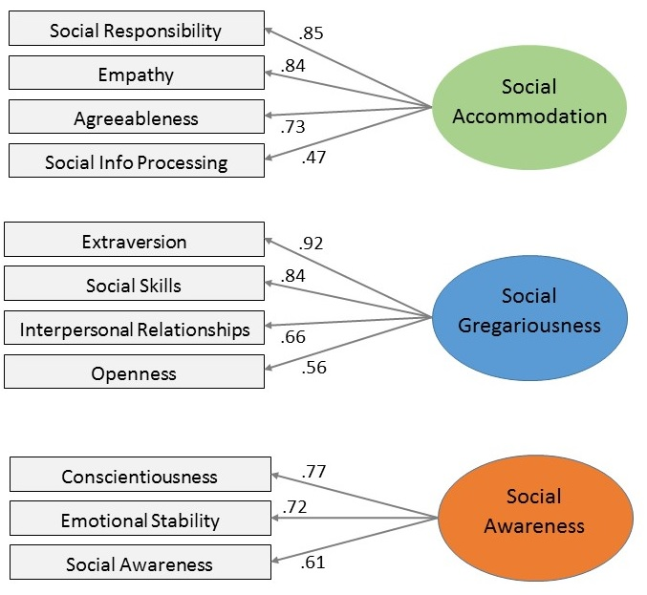

Figure 1. Factor loadings of 11 measures onto 3 social intelligence factors.

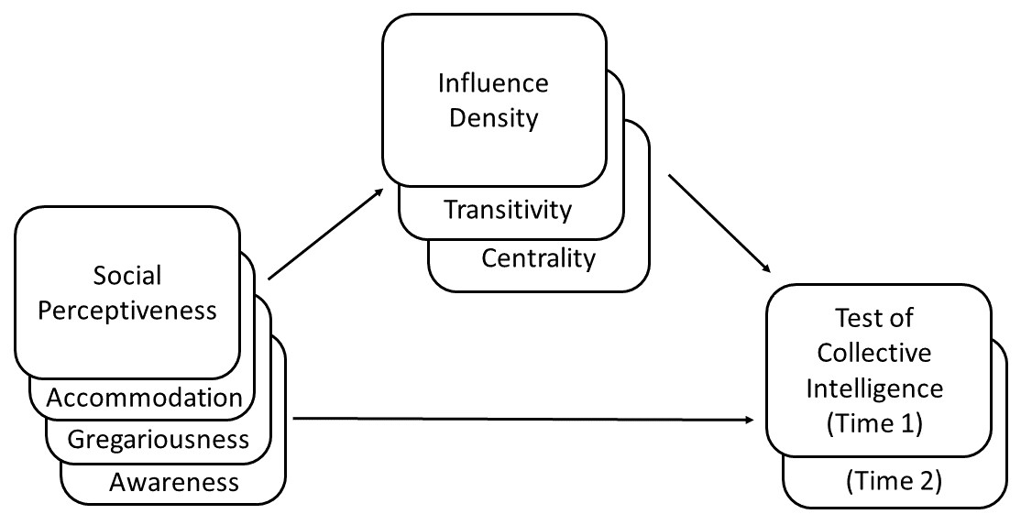

Figure 2. Mediation models: Social intelligence construct predictors, influence network mediators, and outcome variables.

|  |  |
| --- | --- |
| **A. Influence networks** | |
| Low density (0.10) | High density (0.55) |
| Low transitivity (0.00) | High transitivity (1.00) |
| Low centralization (0.00) | High centralization (0.70) |

Figure 3. Influence network visualizations, Time 1

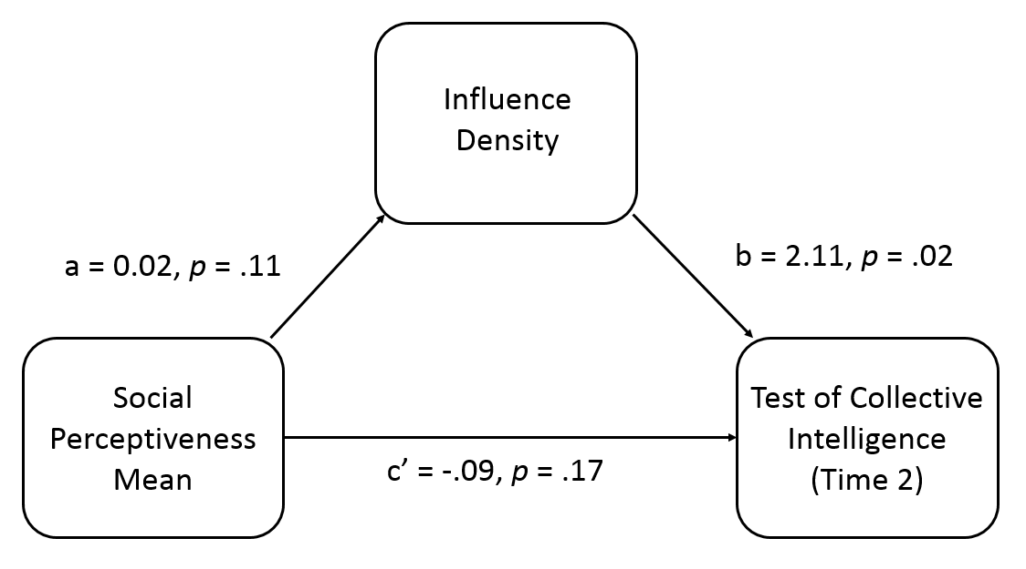

Figure 4. Mediation model, Time 2: Indirect effect of mean group social perceptiveness on group CI through influence density at Time 2.

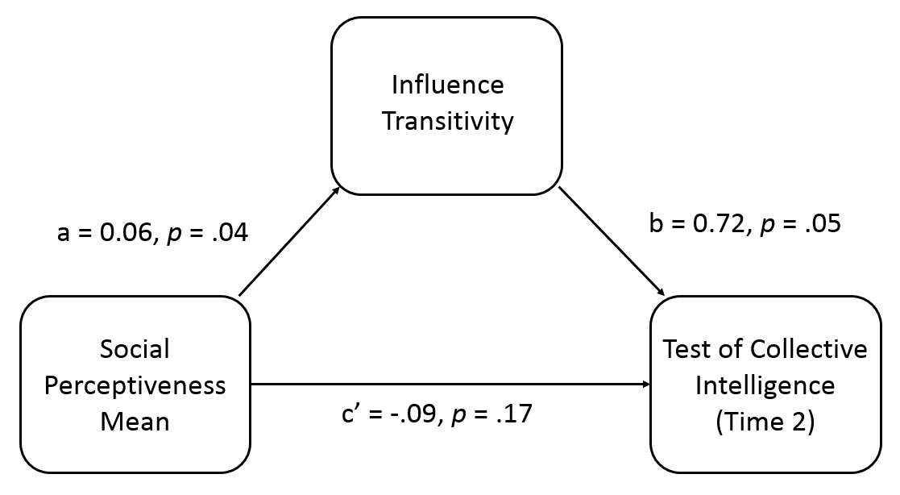

Figure 5. Mediation model, Time 2: Indirect effect of mean group social perceptiveness on group CI at Time 2, through influence transitivity at Time 2.

1. Jennifer. S. Labrecque is now at the Department of Psychology, Oklahoma State University.
2. Young Ji Kim is now at the Department of Communication, University of California, Santa Barbara.
3. The following abbreviations are used throughout the manuscript: collective intelligence (CI), Test of Collective Intelligence (TCI), and Reading the Mind in the Eyes task (RME).
4. Given this study was exploratory, approximately 40 groups were estimated to achieve a medium effect size based on previous literature (Woolley et al., 2010, Study 1). Post-hoc power analyses confirmed 78% power given this sample.
5. Range was alternatively calculated as standard deviation, and all results replicated. Range was selected because groups were small, and we wanted to capture differences across all group members.
6. There is no evidence that the racial diversity in our sample is related to biased RME scores at either the individual (*p* = .425) or group (*p* = .224) level as has been found in previous research (Adams et al., 2010). Race was unrelated to other factors and will not be further investigated.
7. Because the indirect effect is the product of two paths (a*b), effect sizes (r) should be squared (r2). Using this calculation with Cohen (1988) conventions, effect sizes are as follows: small = .01, medium = .09, and large = .25 (Kenny, 2016).