# Procrastinatron Xtreme

**Saad Usman Khan**  
**Ilja Kromonov**

**Meelis Müür**

## Objectives:

The main idea was to develop a game which was supposed to have a character able to move in a map consisting of walls and corridors. Something similar to:

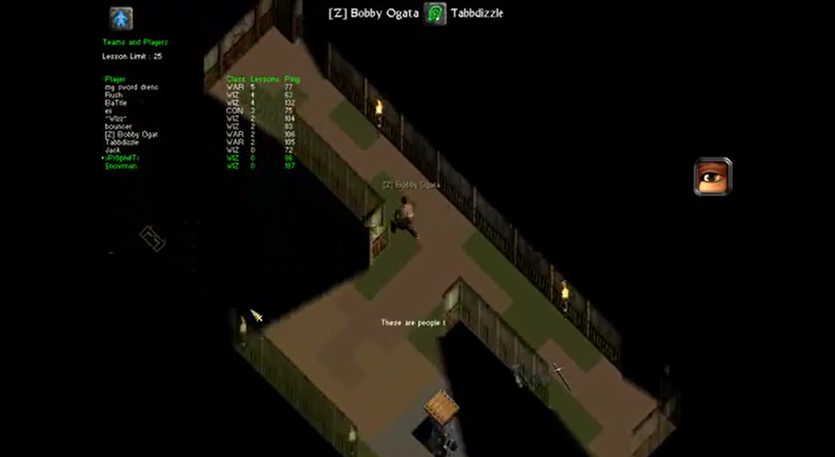

*Fig 1: Screen shot of NoX [1]*

The idea was to keep it very simple, the character could be very simple such as a sphere or a cylinder. The map was also supposed to much simpler and should contain only the walls and floor. Secondly we wanted to have the functionality that character doesn’t walk through walls and if he throws some projectiles they shouldn’t go through walls either.

Initially we considered unity game engine to make this game but then we decided against it as that would have been very simple for the functionality we were trying to create. Secondly we were learning mostly basic graphics things in class so we wanted to implement them and play around with them. So, finally we decided to write a custom engine which includes everything from scratch like lightning, modelling, support for multiplayer, an input engine to process the controls, a physics engine for detection of collisions and a nice object oriented structure to easily re-use things later and develop the game very quickly on top of the engine.

## Progress towards project:

Most of major skeleton of the project was completed. Multiplayer, ray casting and other standard graphics pipeline things were implemented.

## Failures:

Some of the very basic things take quite a lot of time and thinking to complete. Some of the features which are provided by game engines and are very easy to use such as detecting if two elements collide take a lot of effort to implement from scratch. Secondly if you are building a game engine with a strong structure then you also need to take into consideration how the functionalities provided will be used by other components apart from core functionality.

## Lessons Learnt:

Creating a game takes a lot more time than a person would normally think. Secondly, programming in C++ requires more time for debugging if you are not very used to it compared to languages like python or C#. So, we should either have chosen a smaller project or should have spent a lot more time on it.

## Conclusion:

The main reasoning behind choosing to implement everything from scratch was to learn and implement the low level graphics algorithms. Although the end result is not as dashing as it would have been had we used a game engine such as unity still we learnt a lot from this and hopefully we will use it in our future careers.

1. http://www.youtube.com/watch?v=XVf5U6R10Dk