1. Mongo DB :

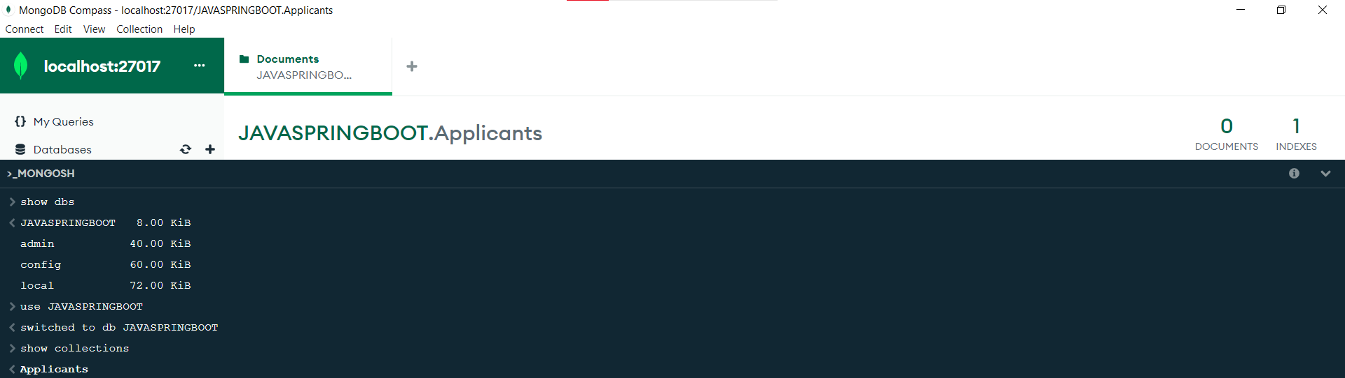

Create :

* 1. db.collectionName.insertOne({document}): Inserts a single document into a collection.
  2. db.collectionName.insertMany([{document1}, {document2}, ...]): Inserts multiple documents into a collection.

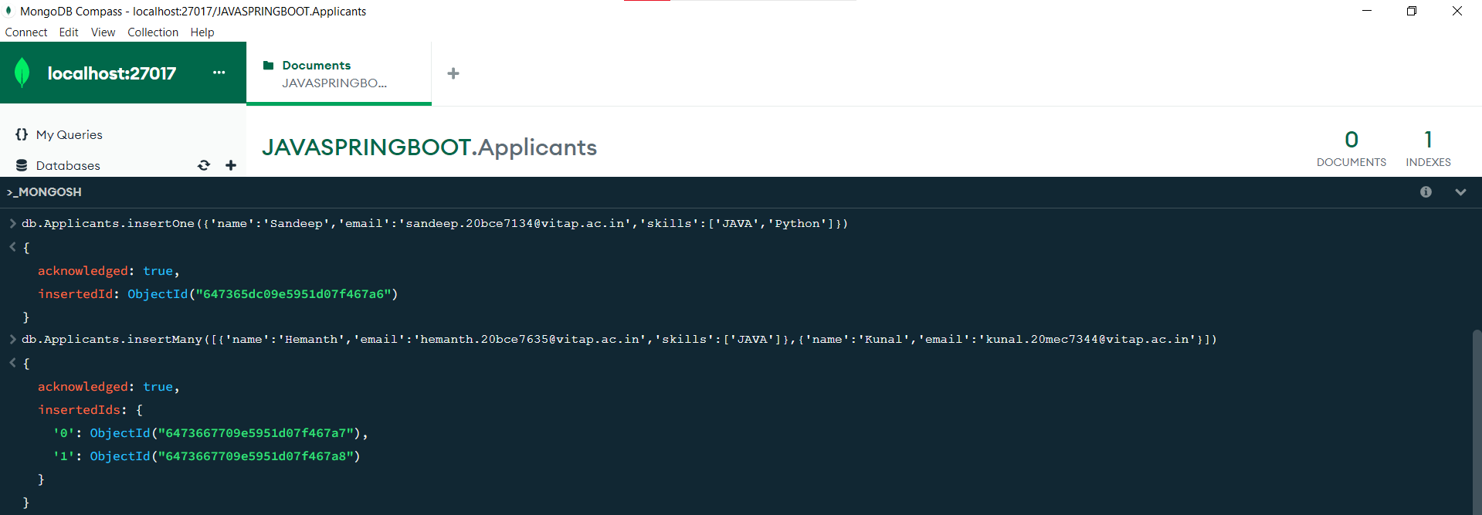

Read :

1. db.collectionName.find():

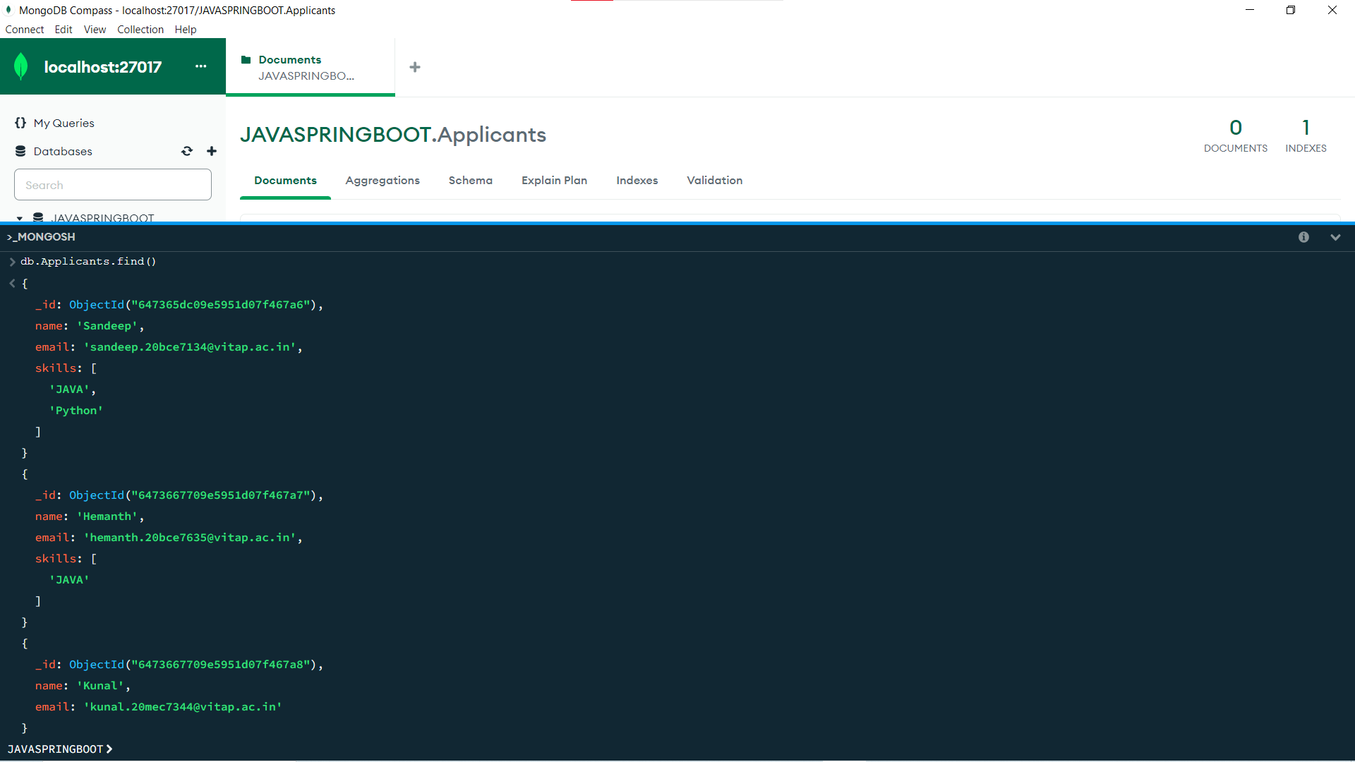

Update :

* 1. db.collectionName.updateOne({filter}, {update}): Updates a single document in a collection that matches the filter.

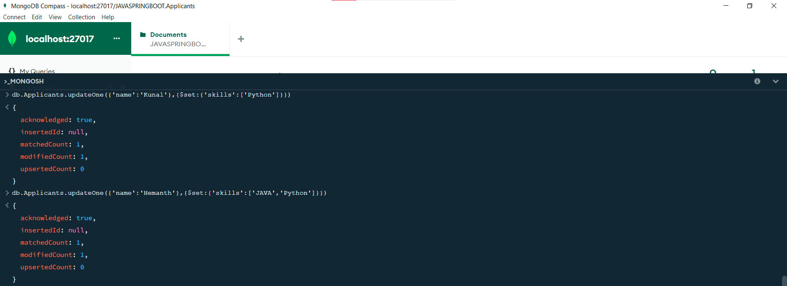

Delete :

* 1. db.collectionName.deleteOne({filter}): Deletes a single document from a collection that matches the filter.

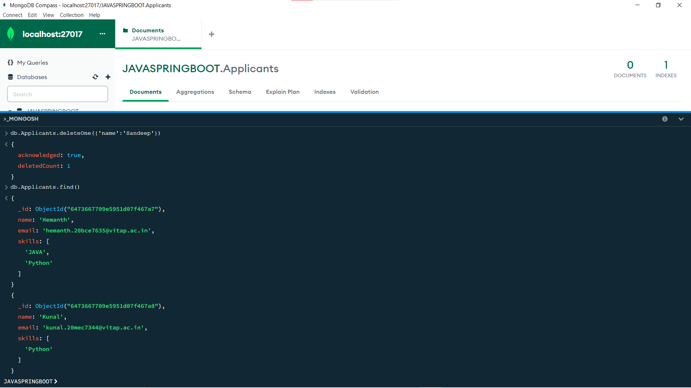

2. MY SQL :

[ CRUD --]

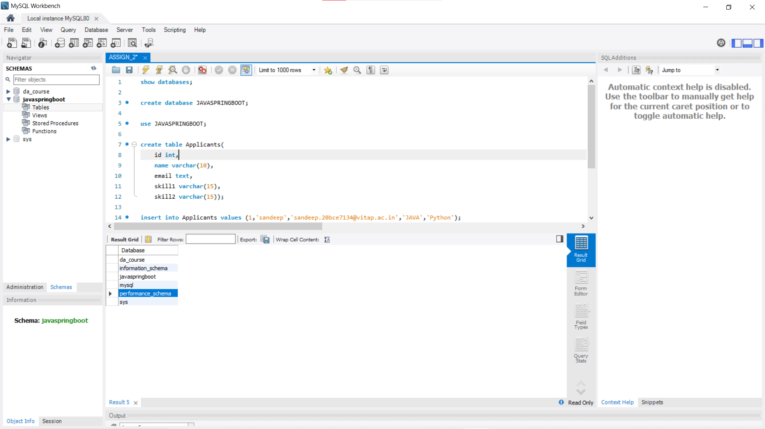

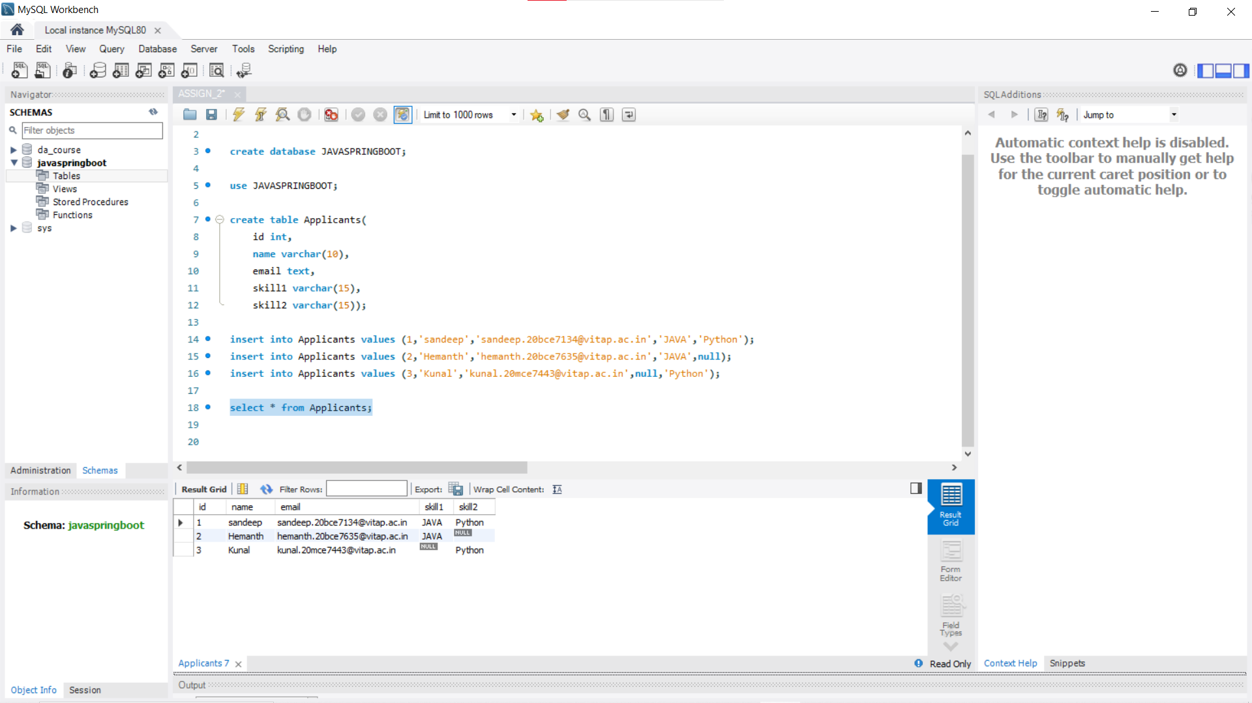

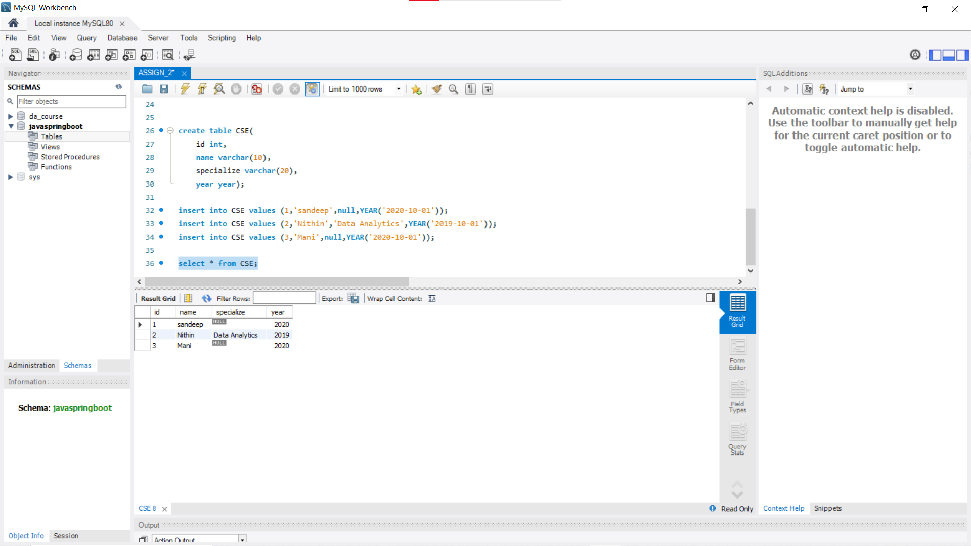

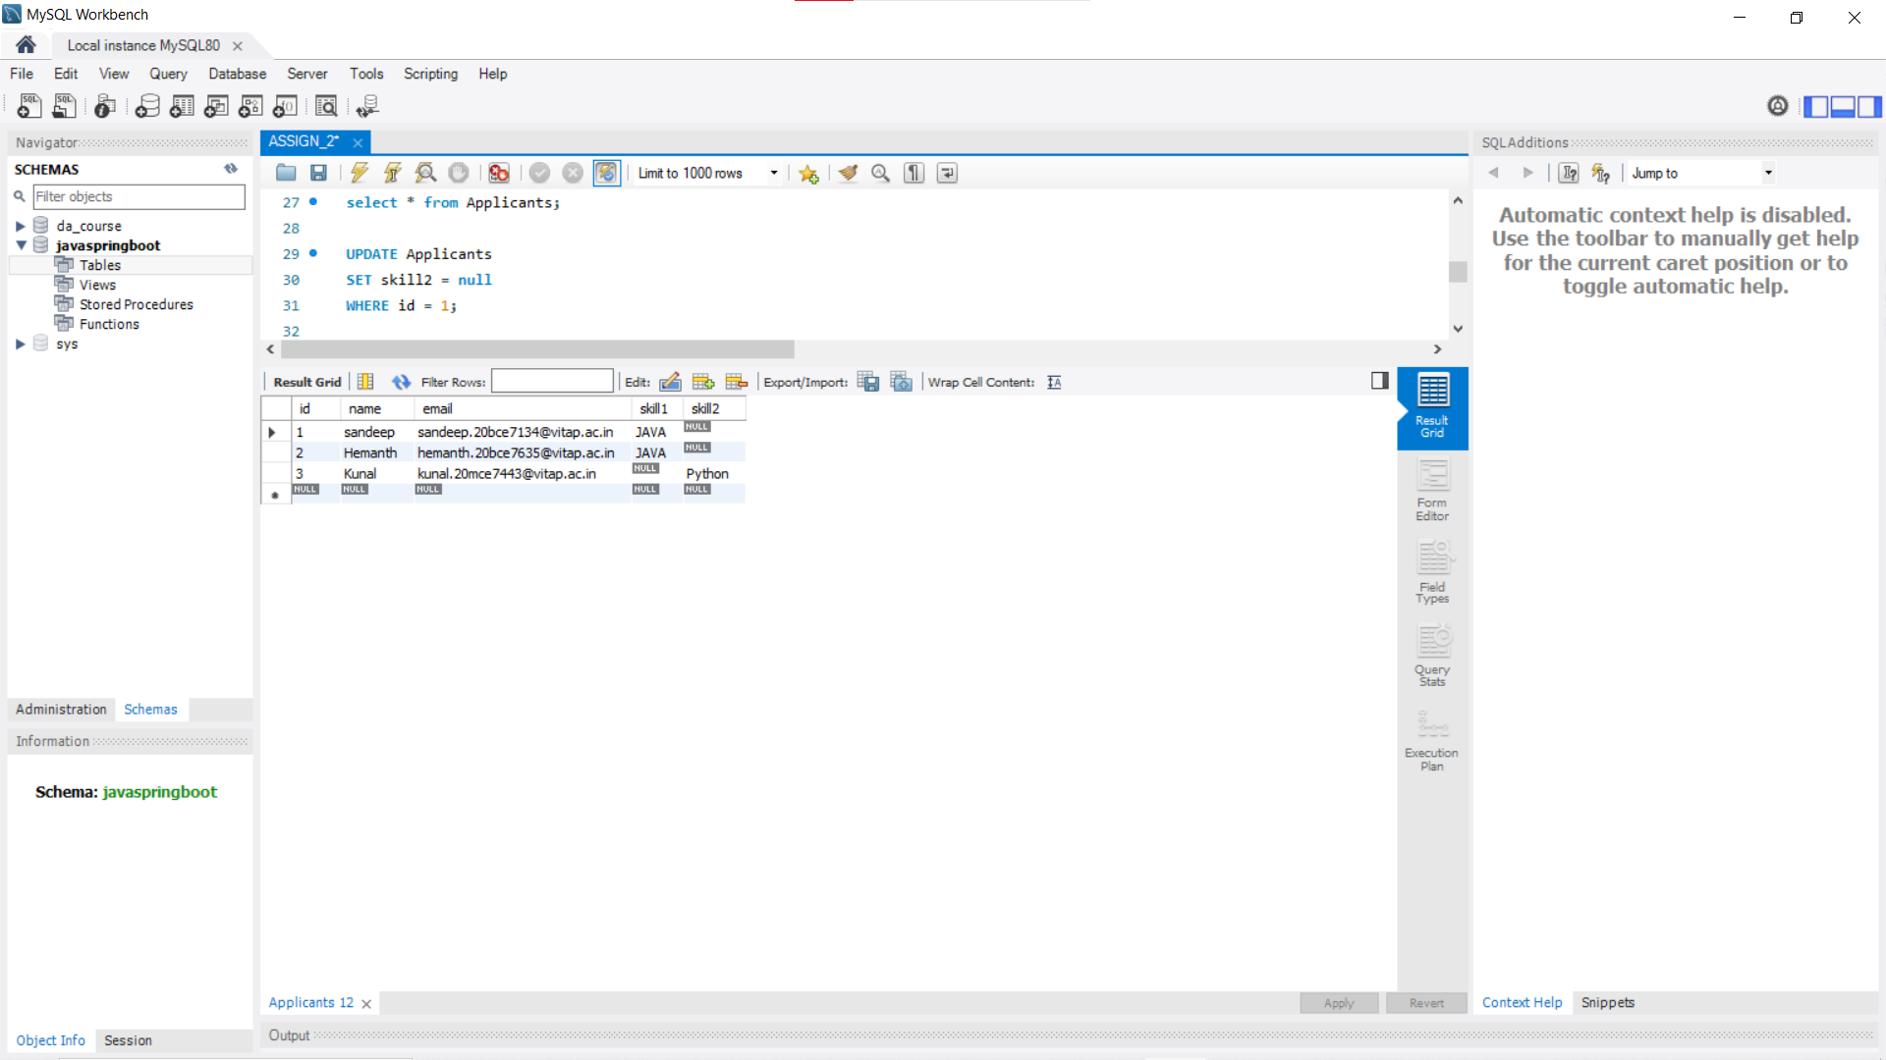

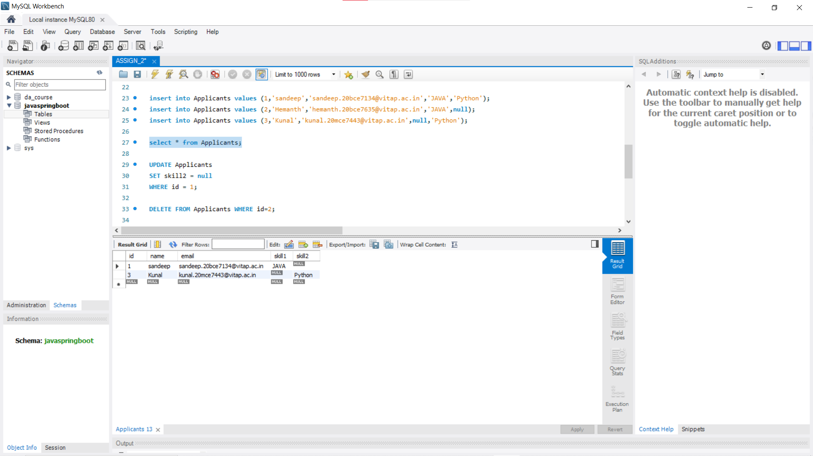

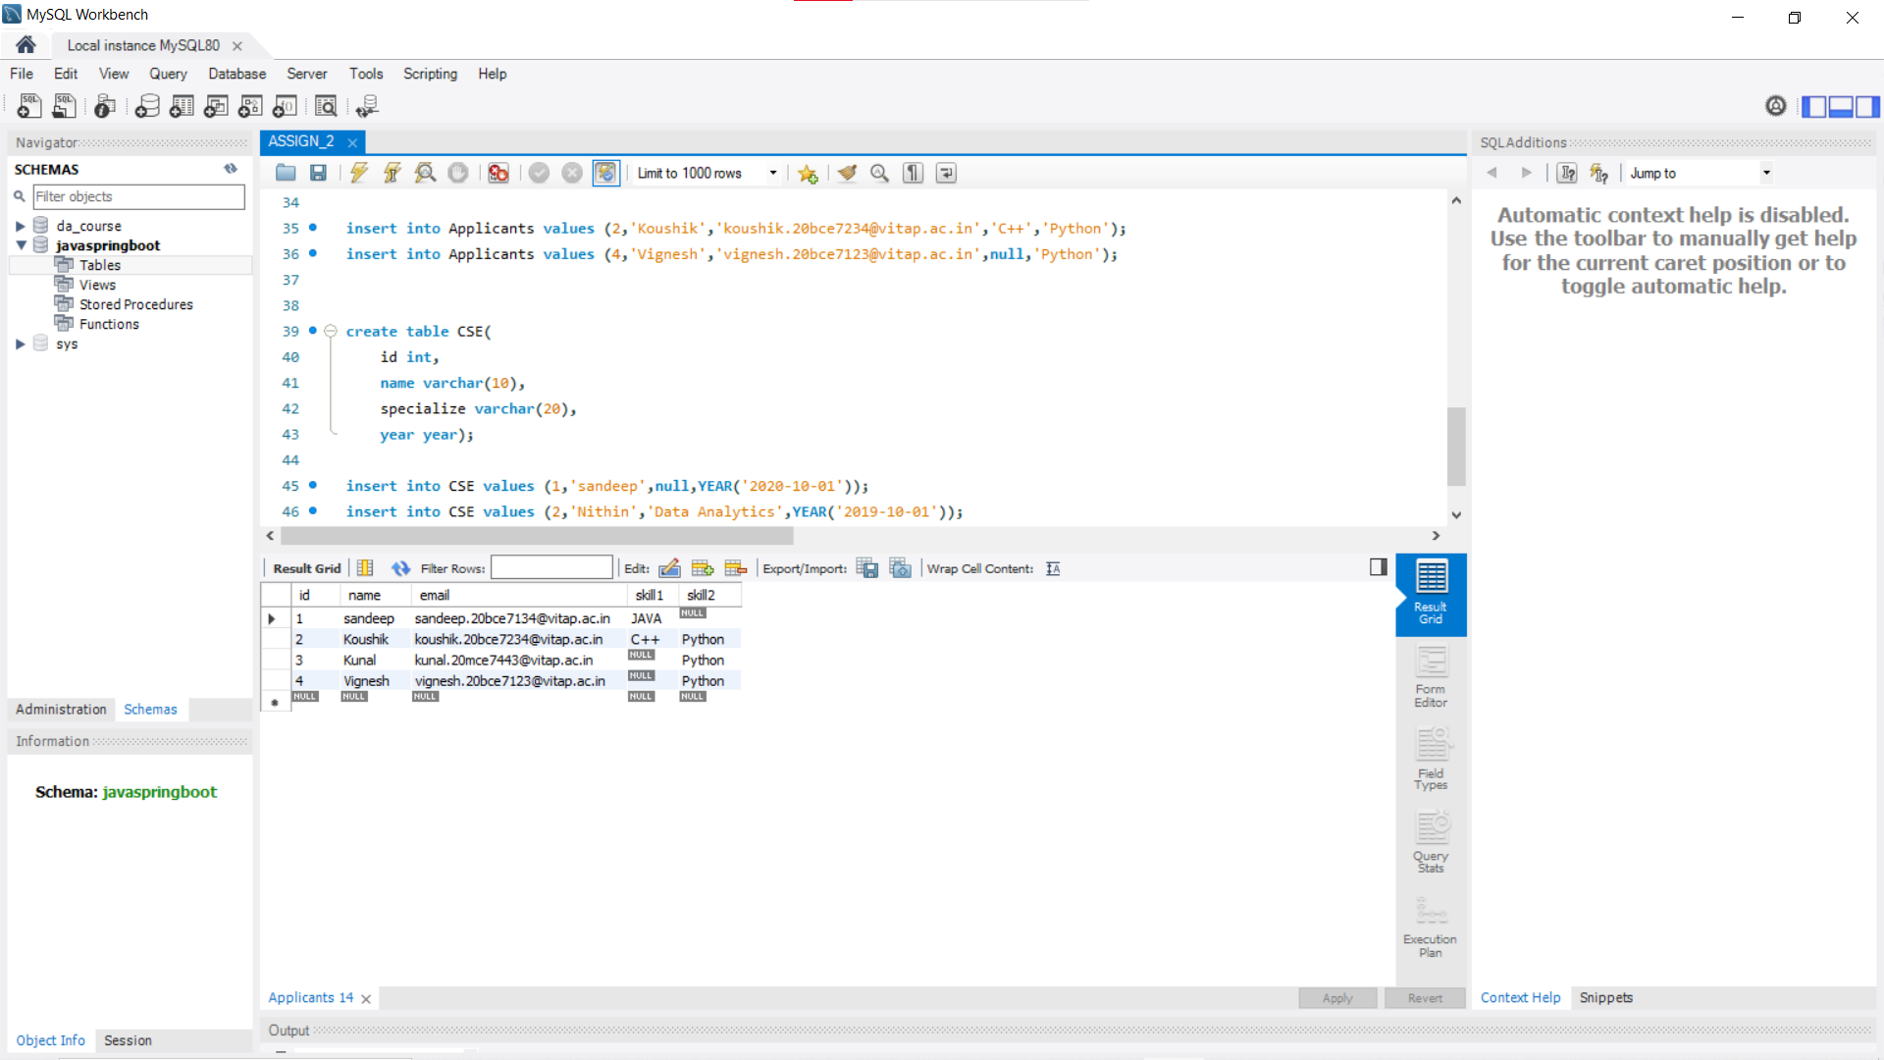

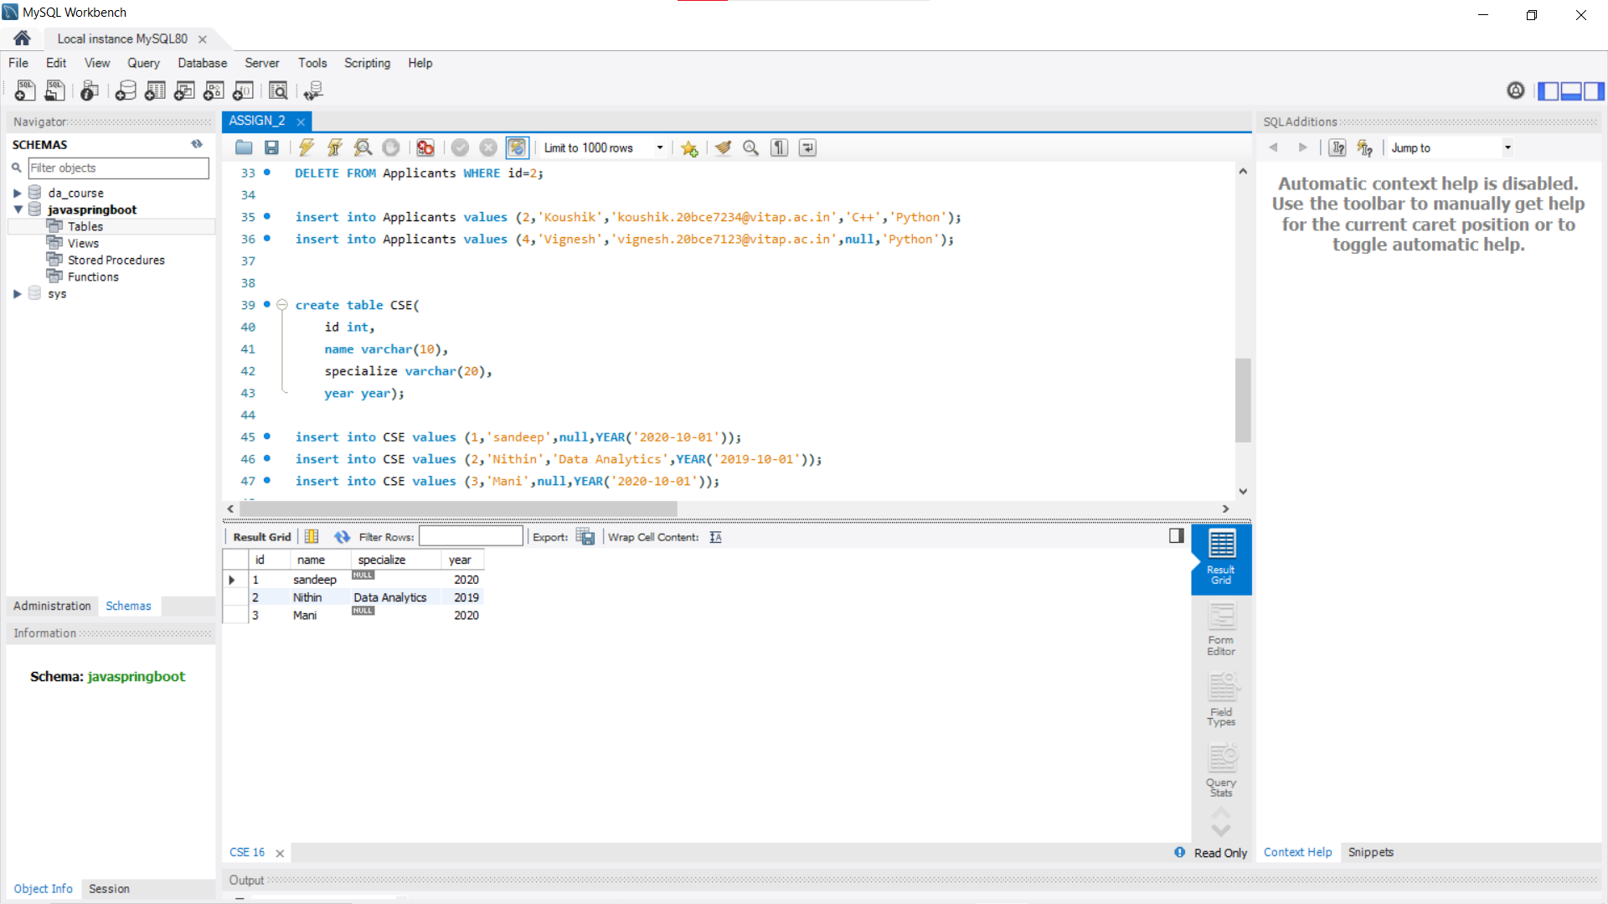

[ JOINS --]

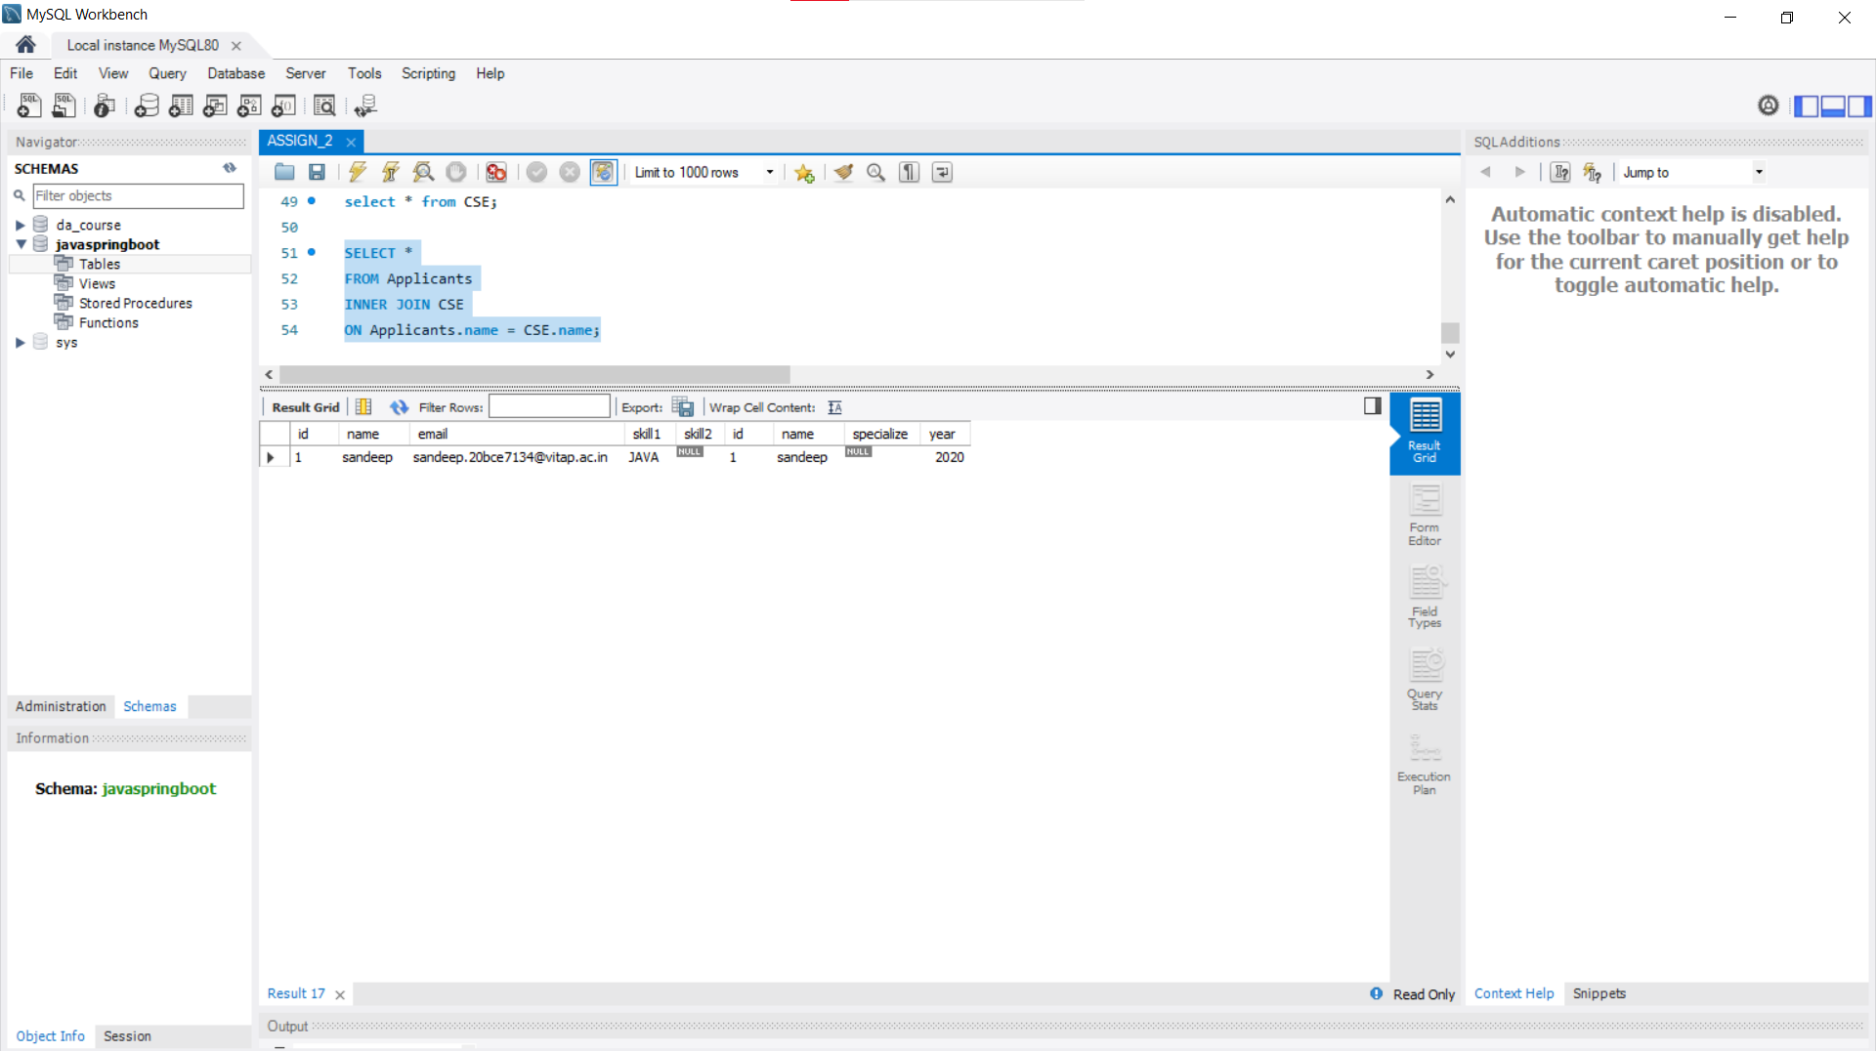

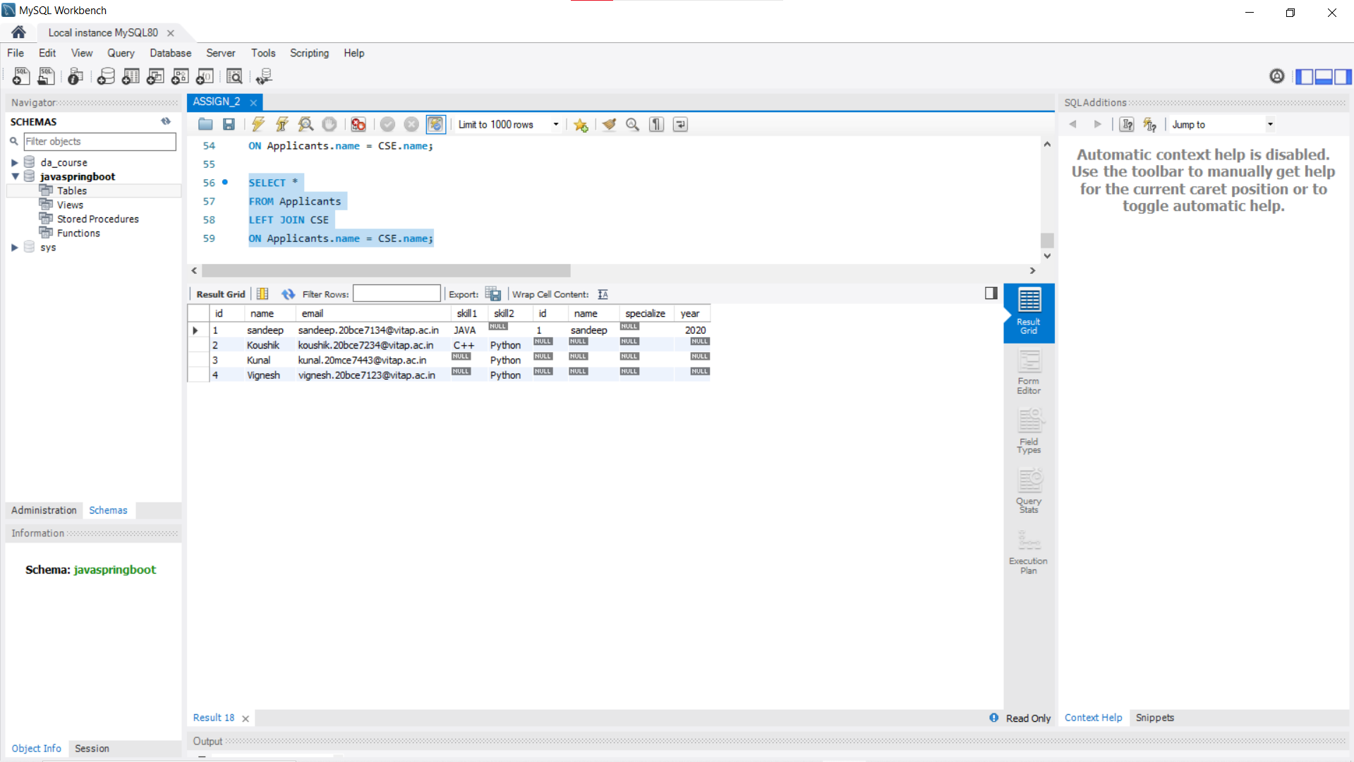

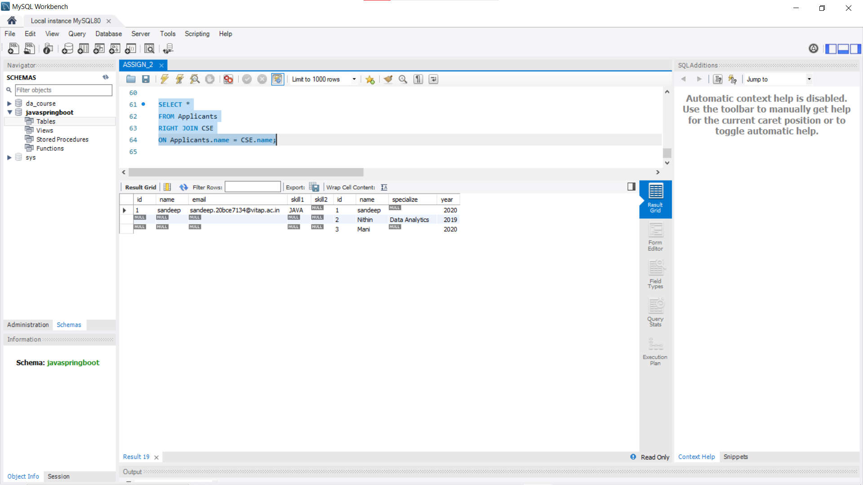

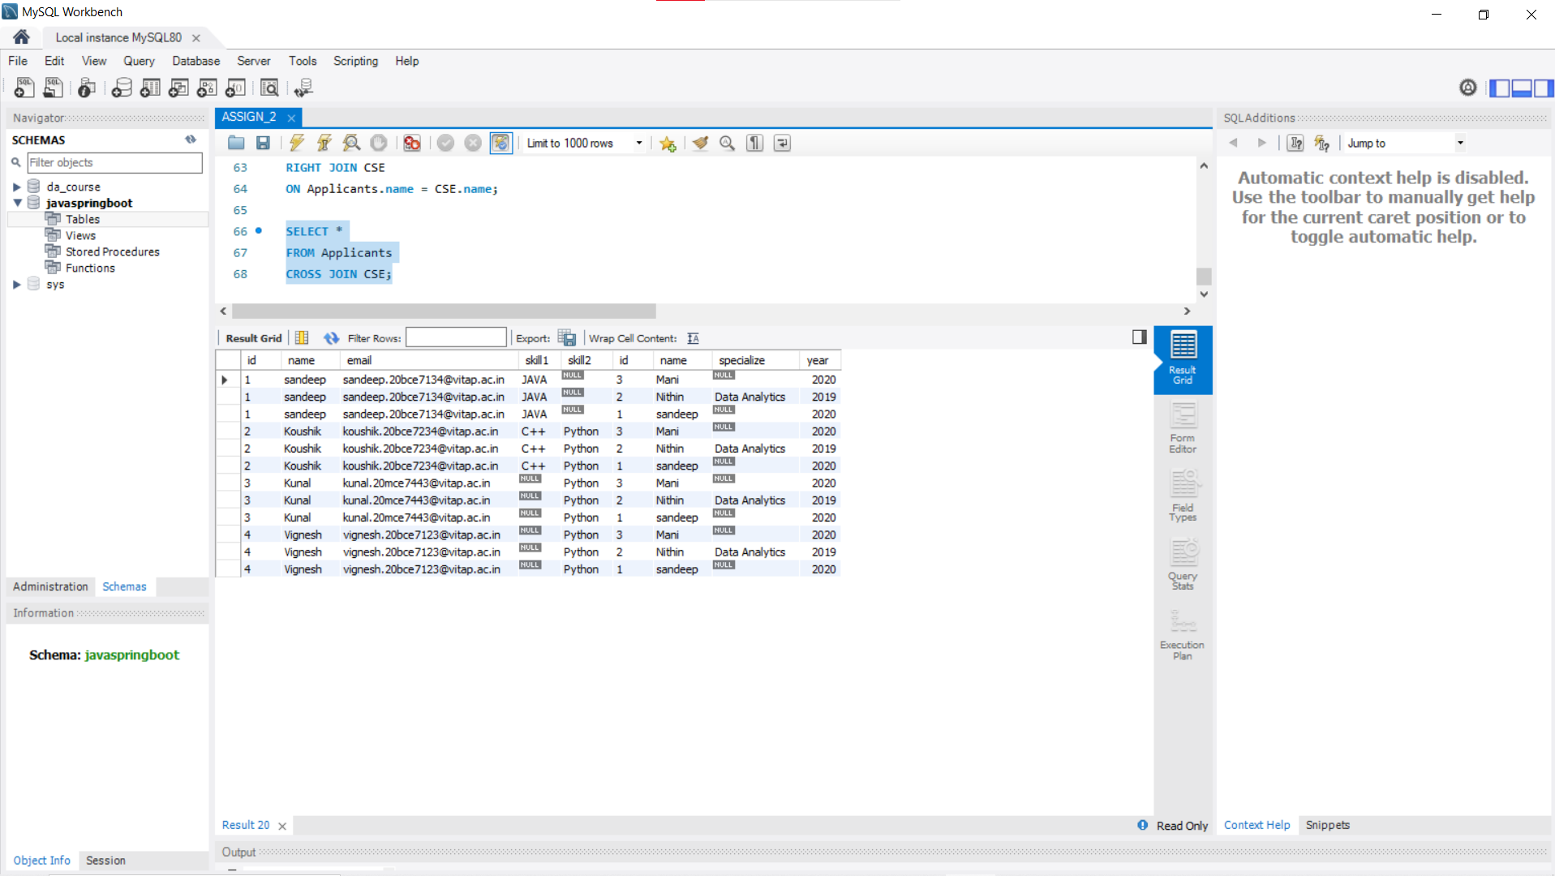

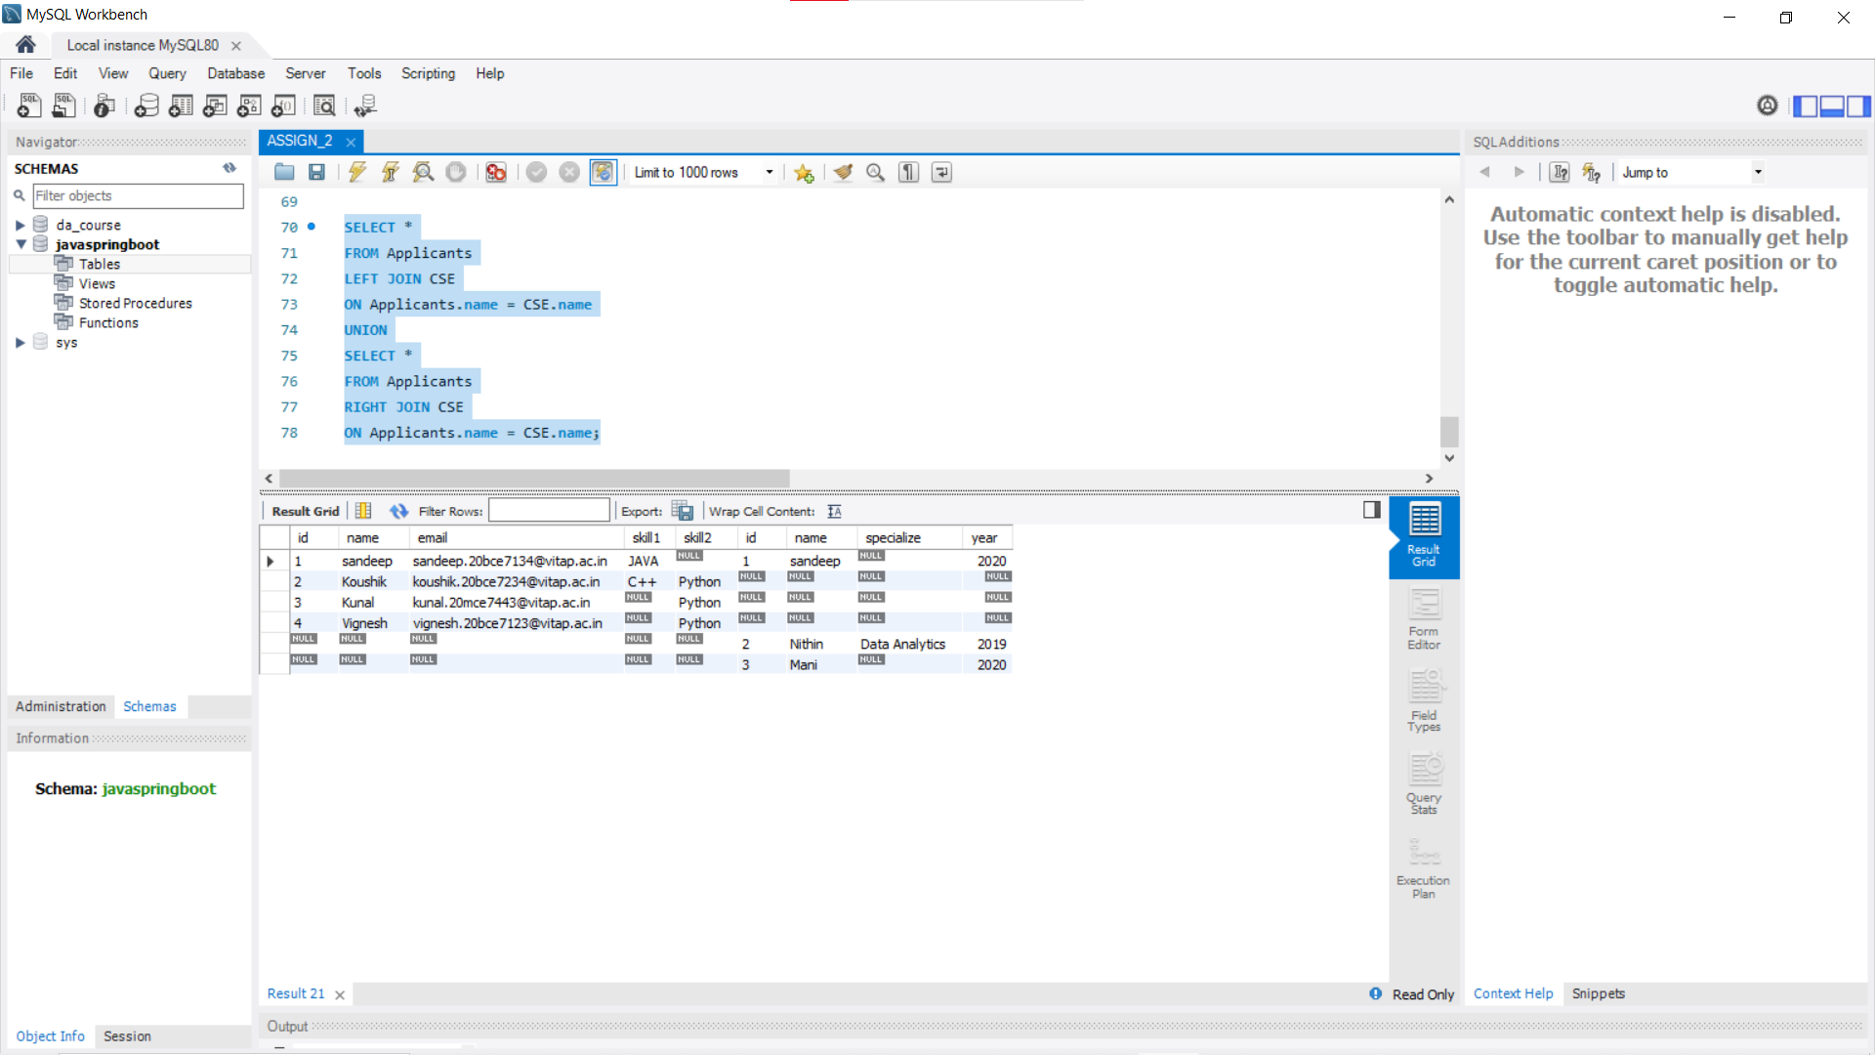

------------------------------------------------------------------------------------------THE END .