**What is Behavior-Driven Development (BDD)?**

BDD is a refinement of [Test-Driven Development (TDD)](https://www.geeksforgeeks.org/software-engineering/test-driven-development-tdd/) that encourages collaboration among all project stakeholders to define the desired behavior of a system before development begins. It involves writing specifications in a natural language format that is understandable by both technical and non-technical team members.

**Importance:**

BDD encourages teamwork, creating a clear, shared understanding of the problem.

* **Faster iterations**: Quick feedback and adjustments keep things moving.
* **Better code quality**: Clear requirements reduce bugs and maintenance costs.
* **Lower risks**: Everyone’s on the same page, avoiding costly wrong steps.

**Process of BDD**

In Behavior-Driven Development (BDD), teams work together. The business team writes the requirements for what users need. Developers, as actors, build the software to match the script. The QA team, like directors, ensures everything works as planned.

**1. Discovery Phase**

This is where the team figures out what the user needs. We sit together and ask simple questions:

* What problem are we trying to fix?
* Who will use this feature and why?
* How might users interact with it?
* What could go wrong?

**2. Formulation Phase**

Next, we write clear examples of how the feature should work using Gherkin, a simple language anyone can read. These examples are like short stories that:

* Use specific details.
* Cover the whole user experience from start to finish.
* Make sense and flow logically.

Here’s a Feature file of Behavior-Driven Development (BDD) scenarios for the Sauce Demo website Login functionality.

**Feature: Login Functionality**

Feature: Login to Sauce Demo website

Scenario: Successful login with valid credentials

Given the user is on the login page

When the user enters valid username "standard\_user" and password "secret\_sauce"

Then the user should be redirected to the products page

Scenario: Unsuccessful login with invalid credentials

Given the user is on the login page

When the user enters invalid username "invalid\_user" and password "wrong\_password"

Then the user should see an error message "Username and password do not match any user in this service"

Scenario: Login with locked-out user

Given the user is on the login page

When the user enters the username "locked\_out\_user" and password "secret\_sauce"

Then the user should see an error message "Sorry, this user has been locked out."

Scenario: Blank login attempt

Given the user is on the login page

When the user leaves both username and password fields blank

Then the user should see an error message "Epic sadface: Username is required"

These BDD scenarios are written in Gherkin syntax, which is easy to read and understand for both technical and non-technical team members. They help clearly define how the system should behave under different conditions.

**3. Automation Phase**

Now, developers take those Gherkin examples and turn them into code that tests the software.

* Checks if the feature works as planned.
* Helps catch issues if we change the software later.

**BDD Testing**

Behavior-Driven Development (BDD) testing is a software development approach that focuses on the behavior of the system from the end user's perspective. It emphasizes collaboration among stakeholders, including developers, QA engineers, and business analysts, to ensure that the software meets both business requirements and user expectations.

In BDD testing, scenarios are described using a domain-specific language (DSL) such as Gherkin, which is easily understandable by both technical and non-technical team members.

**BDD Life Cycle**

The Behavior-Driven Development (BDD) life cycle is a clear, step-by-step process to build software that meets user and business needs.

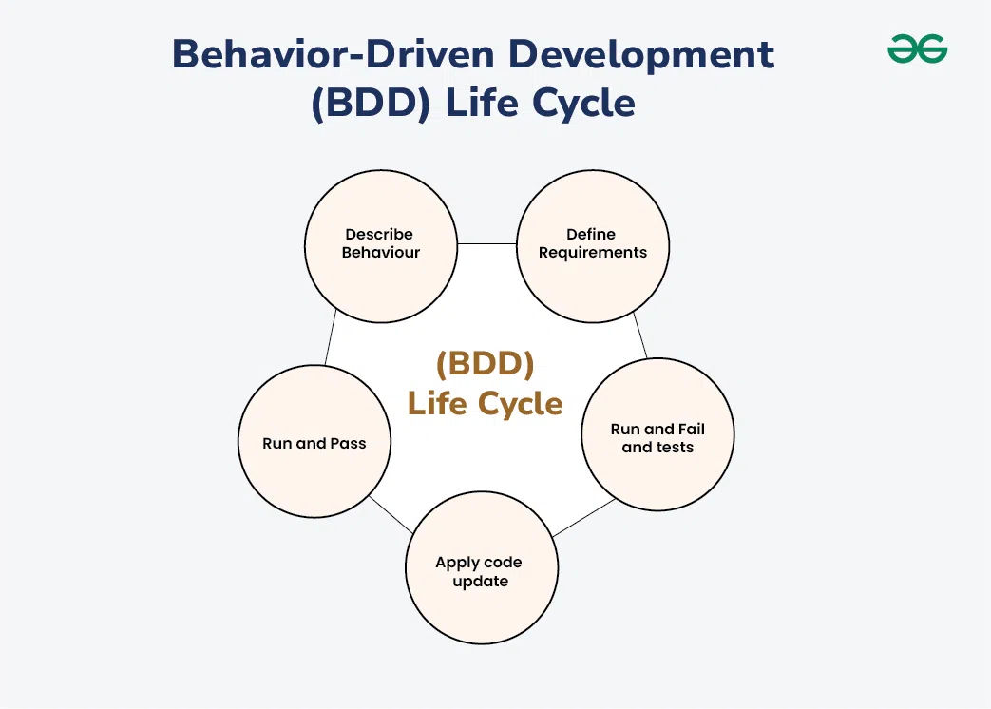

1. **Describe Behavior**: Define how the product should work, focusing on its features and user flow.
2. **Define Requirements**: Write clear rules and examples (often in Gherkin) to ensure everyone business, developers, and testers agrees on what’s needed.
3. **Run and Fail Tests**: Create and run automated tests based on the requirements. These tests will fail at first since the code isn’t built yet.
4. **Update Code**: Write or refactor code to meet the requirements, fixing what caused the tests to fail.
5. **Run and Pass Tests**: Run the tests again. If the code is correct, the tests pass, confirming the software works as expected.

**BDD Tools and Frameworks**

Behavior-Driven Development (BDD) tools and frameworks facilitate the implementation of BDD practices, enabling collaboration between developers, QA engineers, and business stakeholders. Here are some popular BDD tools and frameworks:

1. [**Cucumber**](https://www.geeksforgeeks.org/software-engineering/difference-between-cucumber-testing-and-selenium-testing/): Cucumber is a widely used BDD tool that supports various programming languages such as Ruby, Java, JavaScript, and others. It allows teams to write executable specifications in plain text using the Gherkin syntax and automate them using step definitions.
2. **SpecFlow**: SpecFlow is a BDD framework for .NET applications, primarily used with C#. It integrates seamlessly with Visual Studio and allows teams to define and execute behavior specifications using Gherkin syntax.
3. **Behave**: Behave is a Python BDD framework inspired by Cucumber. It enables teams to write behavior specifications in Gherkin syntax and execute them using Python's unittest framework.
4. **JBehave**: JBehave is a Java-based BDD framework that supports the execution of behavior specifications written in Gherkin syntax. It integrates with popular Java testing frameworks like JUnit and TestNG.
5. **RSpec**: RSpec is a BDD framework for Ruby applications. It allows developers to define behavior specifications using a descriptive syntax known as "describe" and "it" blocks, facilitating the writing of executable specifications.

Another page –

What is BDD?

BDD (Behavior-Driven Development) is a software development methodology that emphasizes collaboration between developers, testers, and business stakeholders.

BDD focuses on defining the behavior of an application in plain, human-readable language, using scenarios and examples. BDD uses tools like Cucumber or SpecFlow to write tests in **“Given-When-Then”** format, ensuring clear, shared understanding of requirements.

BDD brings together key stakeholders in the Software Development Process, often called the “Three Amigos” – the Business, Development, and QA teams. Using tests written in plain English allows all stakeholders to understand and agree on the software’s expected behavior, ensuring that the “right product” is being developed.

**The three principles of BDD are:**

* Focus on the desired behavior or outcomes
* Collaboration between developers, testers, and business stakeholders
* Use of a common language for communication and understanding.

BDD is an evolution of the [Test-Driven Development Methodology (TDD)](https://www.browserstack.com/guide/test-driven-development-for-testing-teams), but it shifts the focus from high test coverage to defining the application’s behavior.

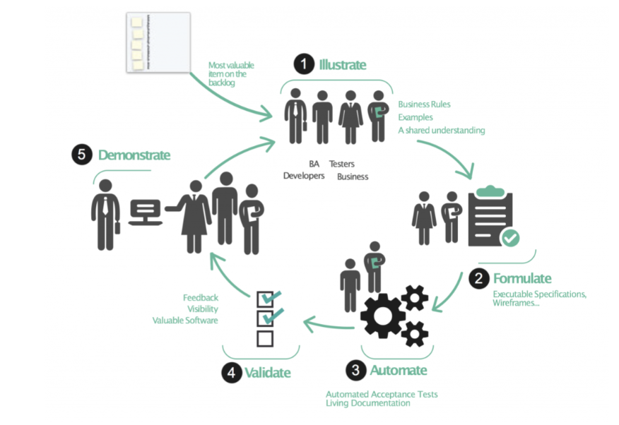

* In BDD, behaviors are well-articulated, human-understandable statements that define a specific process in a predetermined format.
* These are stored in “feature files” integrated into the software development process.
* Tools like [Cucumber](https://www.browserstack.com/guide/learn-about-cucumber-testing-tool) and [SpecFlow](https://www.browserstack.com/guide/specflow-automated-testing-tutorial" \o "SpecFlow Tutorial for Automation Testing" \t "_blank) parse through the behaviors in the feature file and execute the “glue code” that maps behaviors to executable steps, known as “step definitions”.

For example, consider an online shopping platform. A behavior could be “When a user adds an item to the cart and proceeds to checkout, the item should be available for purchase.” This behavior is written in a feature file and then validated during development.

What is the BDD Process?

Think of BDD as a play. In a play, you have characters (the business team, the development team, and the QA team) and a script (the behaviors or requirements).

* The business team is like the playwright, writing the script based on what they want the audience (the users) to experience.
* The development team is like the actors, bringing the script to life on the stage (the software).
* The QA team is like the director, ensuring the actors perform their parts correctly and the play goes as planned.

In BDD, the “script” is written in a language called Gherkin, which uses simple words like “Given”, “When”, and “Then” to describe the behavior of the software. For example, “Given a user is logged in, When they click on the ‘logout’ button, they should be logged out and redirected to the login page.” This script is then turned into automated tests that check if the software behaves as expected.

The beauty of BDD is that everyone involved in the play, from the playwright to the director, understands the script and agrees on the final performance. This way, everyone is on the same page, and the chances of the play being a hit are much higher!

Behavior-Driven Development (BDD) Life Cycle

Behavior-Driven Development (BDD) Life Cycle typically follows a series of steps that ensure clear communication between stakeholders and alignment with business goals. Here are the key stages of BDD Lifecycle:

1. **Discovery**: Gather requirements with stakeholders.
2. **Define Scenarios**: Write behavior scenarios in Given-When-Then format.
3. **Automate Scenarios**: Implement tests using BDD tools.
4. **Develop**: Write code to satisfy the scenarios.
5. **Test**: Run automated tests to verify functionality.
6. **Refactor**: Improve code while maintaining behavior.
7. **Feedback**: Get continuous feedback to improve code.
8. **Release**: Deploy when the system behaves as expected.
9. **Maintain**: Iterate and adapt as requirements evolve.

Advantages of BDD

BDD offers several advantages such as:

1. **Improved Collaboration**: Encourages communication between developers, testers, and business stakeholders, ensuring everyone shares the same understanding of requirements.
2. **Clearer Requirements**: The use of plain language for scenarios helps clarify the functionality and expected behavior of the system.
3. **Better Test Coverage**: Focuses on testing behavior from the user’s perspective, which leads to more relevant and comprehensive test cases.
4. **Early Detection of Issues**: Tests are written before implementation, allowing potential issues to be identified early in the development process.
5. **Documentation**: BDD scenarios double as living documentation that evolves with the system, making it easier for new team members to understand the application’s behavior.
6. **Increased Quality**: By aligning development with business goals and continuously validating behavior, BDD helps improve the overall quality of the software.

Limitations of BDD

BDD has some limitations, such as:

1. **Initial Learning Curve**: Teams may face a learning curve when adopting BDD, especially with new tools and the Given-When-Then syntax.
2. **Time-Consuming Setup**: Writing behavior-driven tests in detail can be time-consuming and may delay development, especially in complex projects.
3. **Overhead in Maintenance**: Keeping BDD scenarios up to date with changing requirements can become burdensome, particularly for large or rapidly evolving systems.
4. **Requires Collaboration**: Effective BDD requires continuous and active collaboration between developers, testers, and non-technical stakeholders, which may not always be feasible.
5. **Not Suitable for All Projects**: For projects with minimal user interaction or straightforward functionality, BDD might be overkill, leading to unnecessary complexity.
6. **Tool Dependency**: BDD relies heavily on specific tools (e.g., Cucumber, SpecFlow), which may introduce integration or compatibility issues, especially with legacy systems.

Popular BDD Frameworks

Here’s a list of Popular BDD Testing Frameworks:

1. Cucumber

Cucumber is one of the most widely used BDD frameworks. It allows users to write test scenarios in Gherkin language, which is a simple, human-readable syntax. Gherkin is a domain-specific language for behavior descriptions.

Cucumber integrates with various test runners and automation tools to execute these scenarios.

**Language**: Java, Ruby, JavaScript, Python, PHP, Perl, Swift, .NET, C++.

**Features**:

* Supports feature files written in Gherkin syntax.
* Extensive ecosystem with plugins and integrations.
* Good support for multiple languages and platforms.

2. Behave

Behave is a BDD framework for Python that uses Gherkin language for writing scenarios. Behave integrates well with Python’s testing ecosystem and is suitable for both web and non-web applications.

**Language**: Python

**Features**:

* Supports Gherkin syntax.
* Integration with popular Python testing libraries.
* Provides easy-to-use command-line tools for running tests.

3. JBehave

JBehave is a BDD framework for Java that allows writing scenarios in a natural language format. JBehave provides its own way of defining stories and steps, which are then mapped to Java code for execution.

**Language**: Java

**Features**:

* Supports scenarios written in a natural language.
* Integration with various testing frameworks like JUnit.
* Offers flexibility in defining and managing stories and steps.

4. SpecFlow

SpecFlow is a popular BDD framework for .NET applications. It allows you to write test scenarios in Gherkin language and bind them to C# code. It integrates well with various .NET test runners and CI/CD pipelines.

**Language**: .NET

**Features**:

* Supports Gherkin syntax for writing scenarios.
* Integrates with NUnit, xUnit, and MSTest.
* Provides rich integration with Visual Studio and Azure DevOps.

5. Concordion

Concordion is a BDD framework for Java that combines executable specifications with documentation. Concordion allows you to write test scenarios in HTML and integrates them with Java code for execution.

**Language**: Java

**Features**:

* Supports writing tests in HTML format.
* Provides detailed reports and documentation.
* Integrates with Java-based test runners.

6. FitNesse

FitNesse is a web-based testing framework that supports BDD principles. It allows writing test cases in a wiki-style format and supports integration with various testing tools and frameworks.

**Language**: Java

**Features**:

* Wiki-based interface for writing and managing tests.
* Integration with FitLibrary and other testing libraries.
* Provides a collaborative environment for writing and executing tests.

BDD Best Practices

When working with Behavior-Driven Development (BDD), following some best practices is important to ensure you’re getting the most out of this approach.

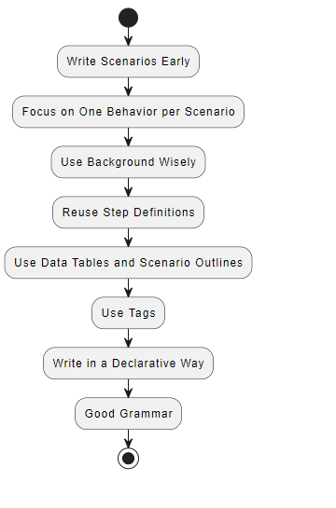

**Here are some key points to keep in mind:**

* **Write Scenarios Early:** You should start writing your [test scenarios](https://www.browserstack.com/guide/how-to-create-test-scenarios) as early as possible. This helps you define the software behavior and understand potential problems better. It’s like planning your trip before you start your journey. It saves time and reduces uncertainty later during development.
* **Focus on One Behavior per Scenario:** Each scenario should cover exactly one behavior. This makes it easier to understand, automate, and maintain. It’s like cooking a dish, you focus on one recipe at a time to ensure it turns perfect.
* **Use Background Wisely:** If there are steps that are repeated in every scenario, put them in the Background.
* **Reuse Step Definitions:** Try reusing the step definitions you frequently use in various scenarios.
* **Use Data Tables and Scenario Outlines:** When you have a large data set, use Data Tables and Scenario Outlines.
* **Use Tags:** Tags can help you organize and run specific groups of scenarios. It’s like labeling your food containers in the fridge so you can easily find what you’re looking for.
* **Write in a Declarative Way:** Scenarios should be written how the user would describe them. Avoid scenarios that only describe clicking links and entering data in form fields.
* **Good Grammar:** Write like your high school English teacher will be grading your Gherkin. Poor grammar, misspellings, and inconsistent phrasing can ruin the benefits of behavior specification.

Remember, BDD aims to improve collaboration and understanding among team members. So, keep your scenarios simple, clear, and focused on behavior.