**MongoDB**

**Assignment - 1**

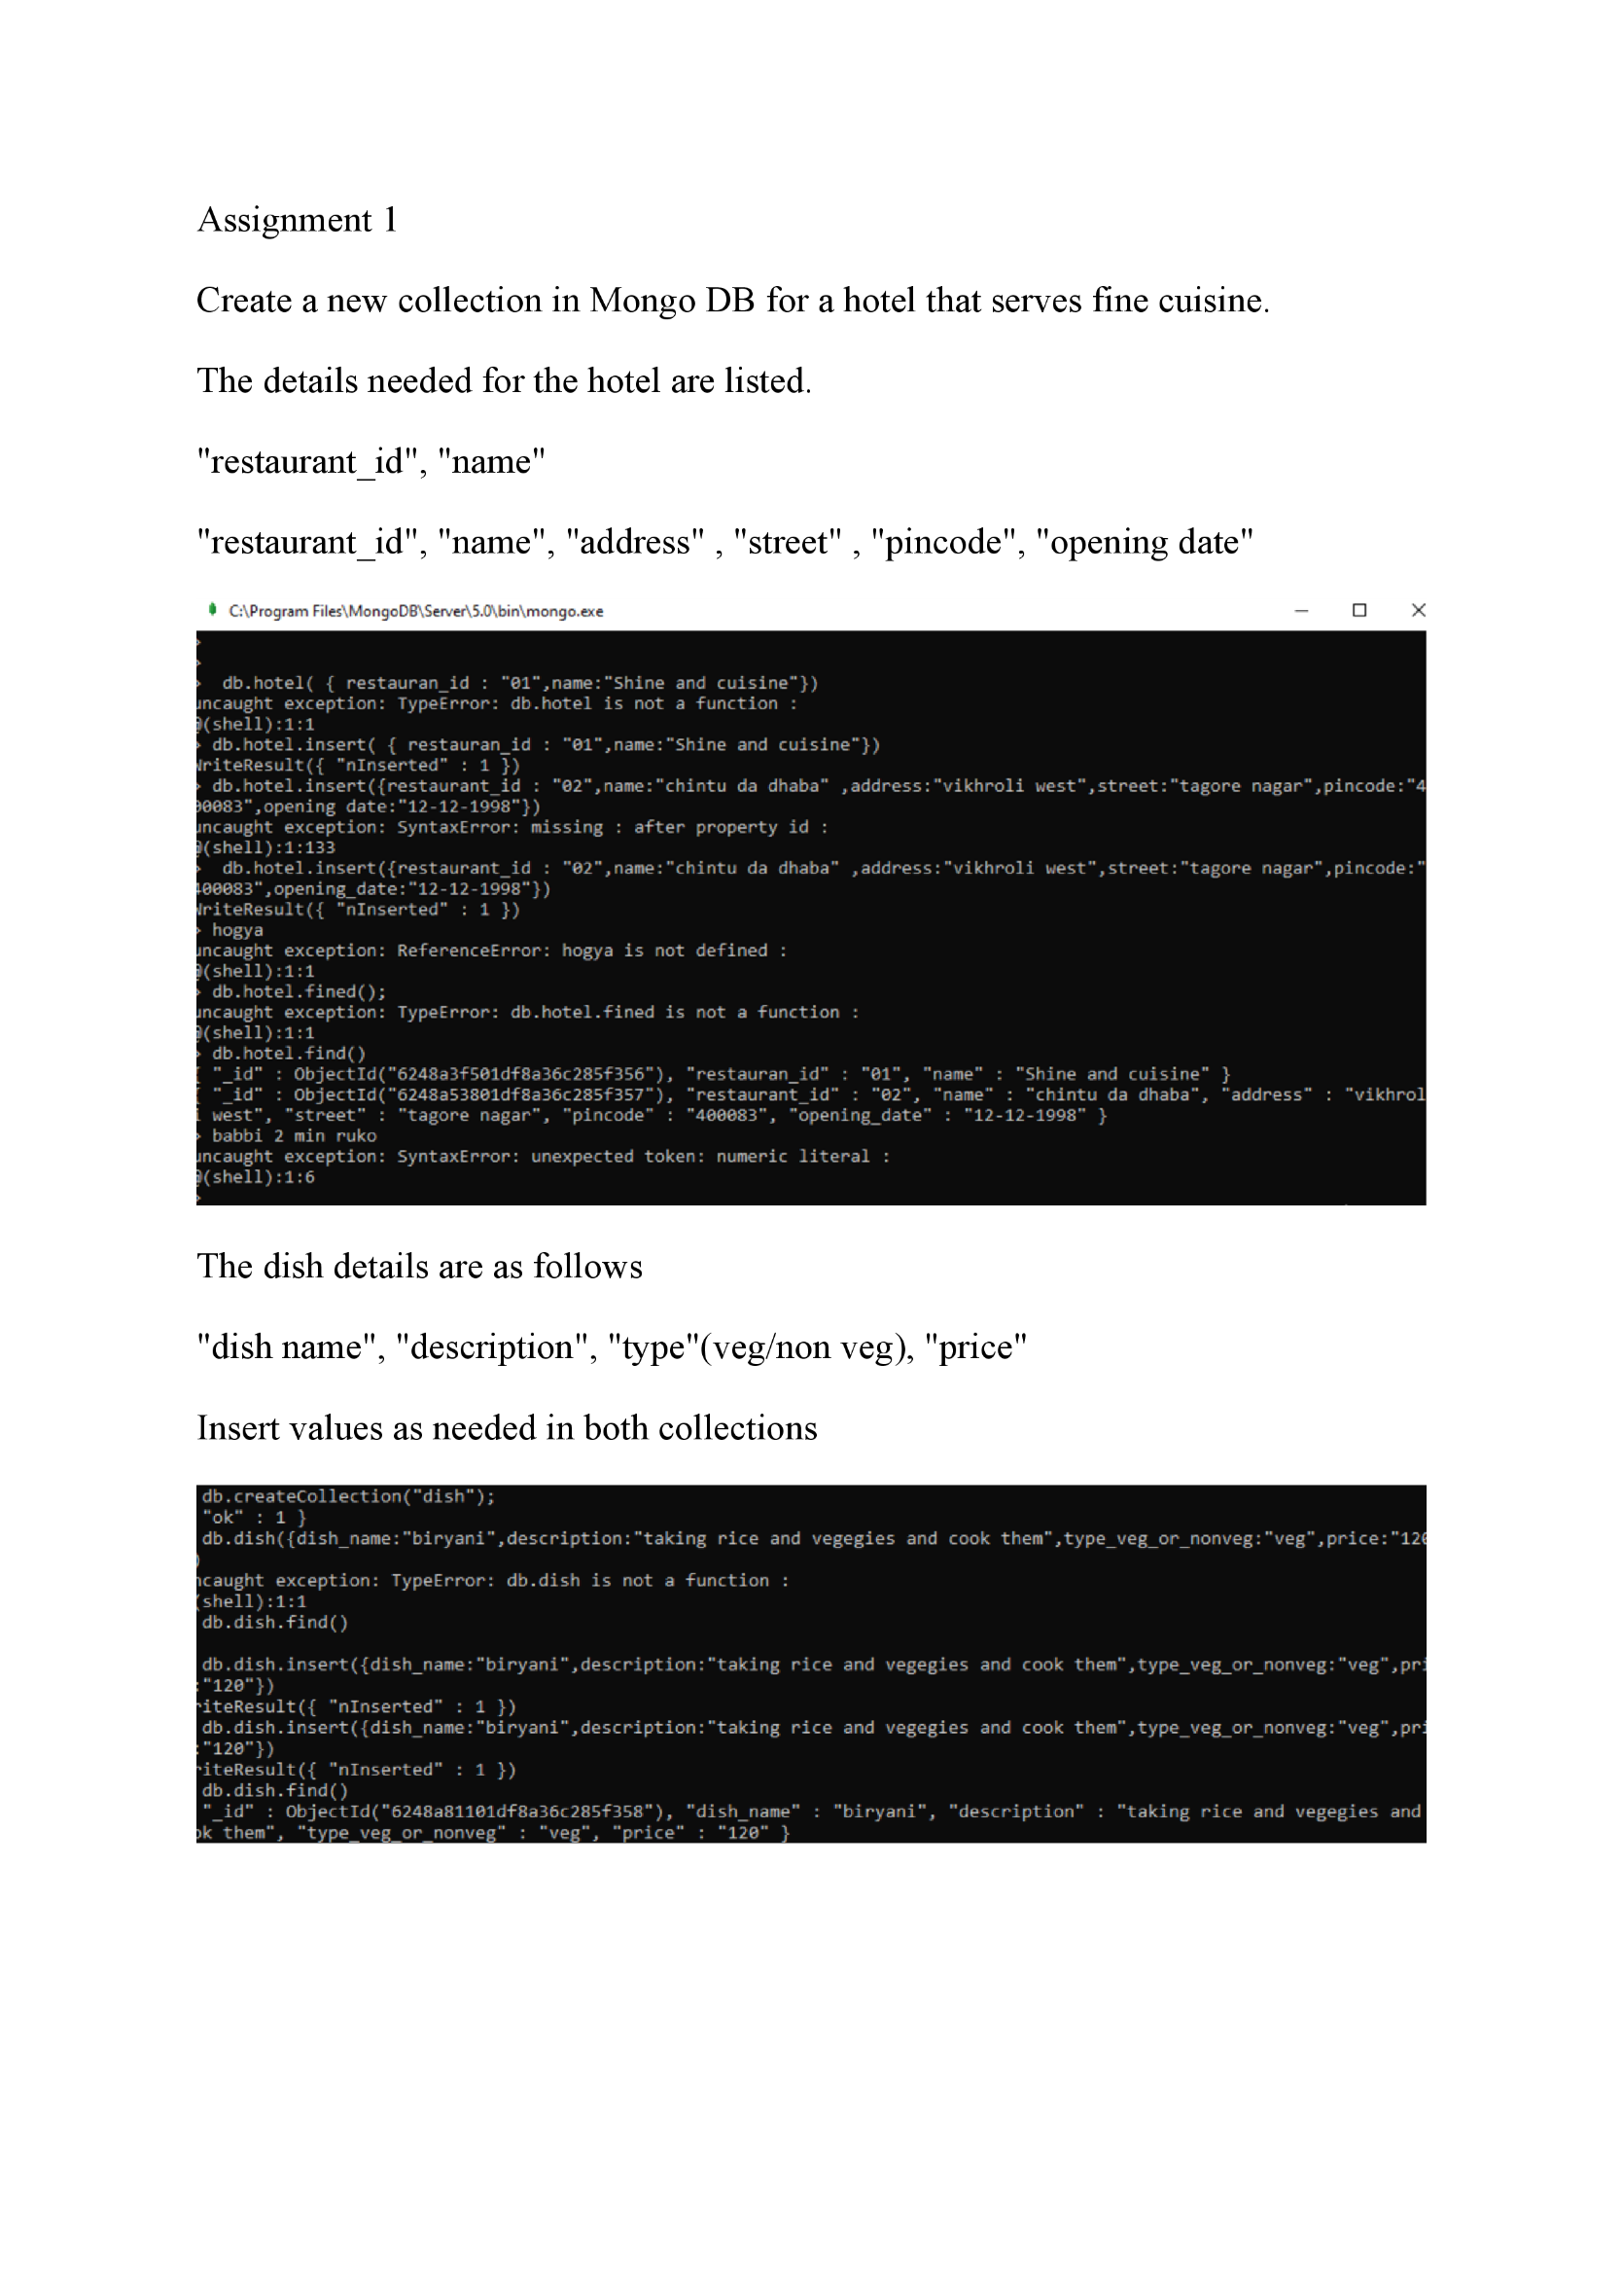Create Clusters of mongoDB to connect with MongoDB shell By installing MongoDB Server and all its required functionalities.