**MongoDB**

**Assignment - 2**

Create Database using Extended JSON with its different datatype in BSON

Answer :

Display the top 5 rated dishes by cost.

Using the collection from assignment 1 modify the collection to include GST percentage for every dish.

Include the cost of GST value in the cost of the dish.

Display the names of the dishes, the GST values and new rates of the dishes

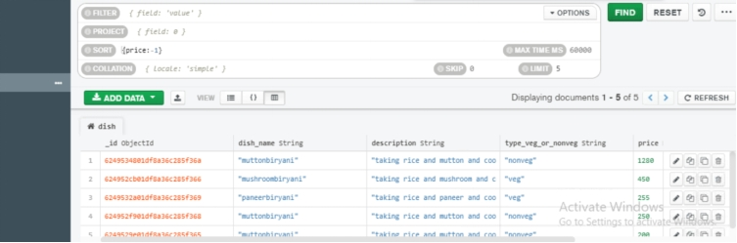Delete the 2 low rated (cost) dishes from the collection

