**MongoDB**

**Assignment - 4**

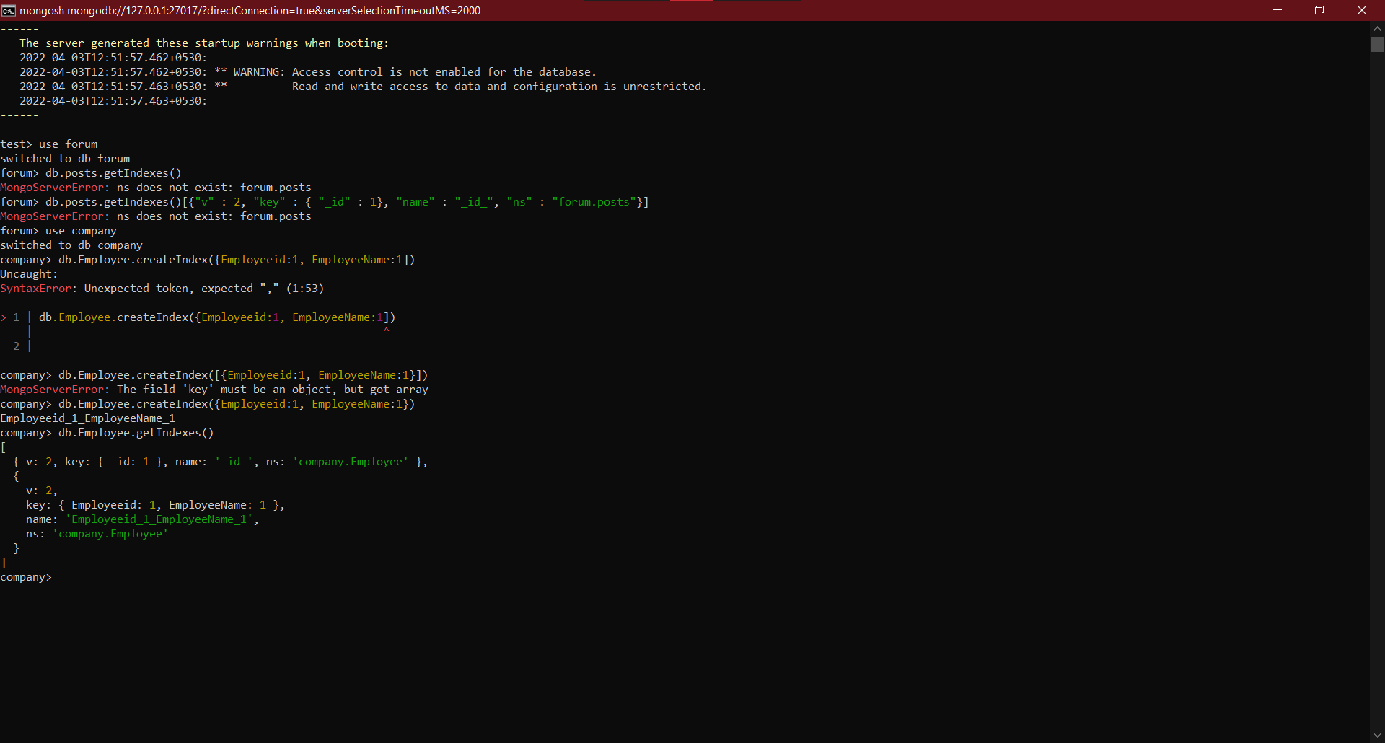Create a MongoDB framework which uses indexing & MongoDB Functionalities for created documents