O‘ZBEKISTON RESPUBLIKASI AXBOROT TEXNOLOGIYALARI VA KOMMUNIKATSIYALARINI RIVOJLANTIRISH VAZIRLIGI
MUHAMMAD AL-XORAZMIY NOMIDAGI TOSHKENT AXBOROT TEXNOLOGIYALARI UNIVERSITETI



Informatika asoslari kafedrasi
Dasturlash Fani

11 - AMALIY ISH

Bajardi: Umarov Murodjon

Tekshirdi: Ishniyazov O.O.

Toshkent 2023

1-topshiriq

12.04.2003

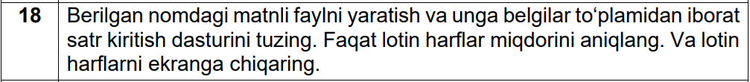

#include <bits/stdc++.h>

using namespace std;

bool isin(string s){
for(int i=0; i<s.size(); i++){
if(s[i] == 'k' or s[i] == 'K'){
return 1;
}
}

return 0;
}

int main (){
string name;
cin >> name;
string fs = "Berilgan nomdagi matnli faylni yaratish va unga satr kiritish dasturini tuzing. Tarkibida kamida bitta 'k' belgisi bolgan sozlarni ekranga chiqaring.";
ofstream myfile;
myfile.open (name + ".txt");

istringstream ss(fs);
string word;
while(ss >> word) {
if(isin(word)){
myfile << word << "\n";
cout << word << "\n";
}
}
cout << "\n\nk harfi qatnashgan so'zlar " << name << ".txt fayliga yozildi";
myfile.close();
return 0;
}

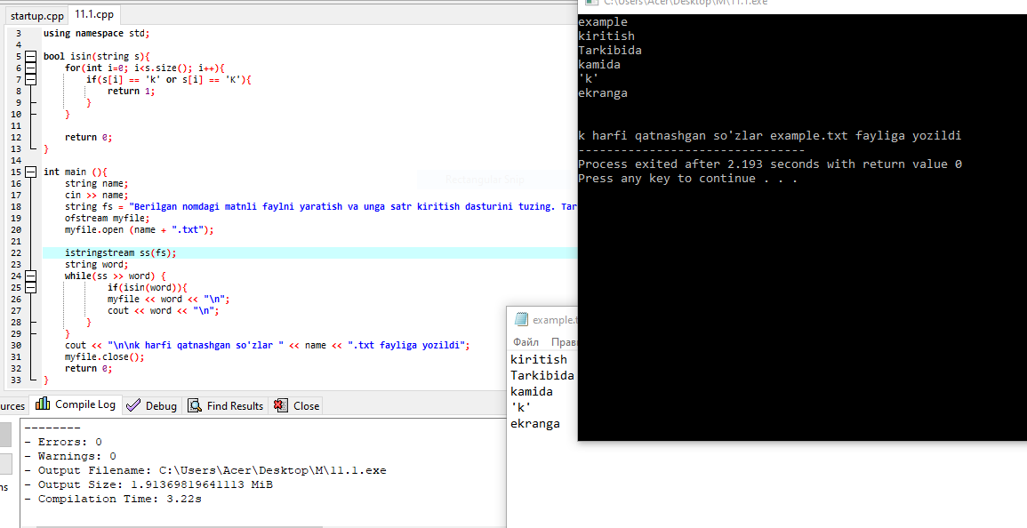
Rasm uchun link

2-topshiriq

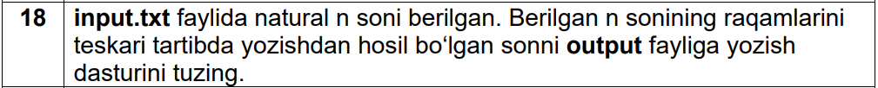

#include <bits/stdc++.h>
using namespace std;
int main(){
string num; int x=0; vector<int> v;
ifstream myf("input11.2.txt");
if(myf.is_open()){
while(getline(myf, num)){
stringstream gg(num);
gg >> x;
v.push_back(x);
}
myf.close();
}
cout << "Massiv(fayl)dagi sonlar: \n";
for(auto x : v) cout << x << " ";
cout << "\n\n";
ofstream file;
file.open("output11.2.txt");
sort(v.begin(), v.end());
file << v[0]+v[1];
cout << "output fayliga yozilgan son: " << v[0] + v[1];
file.close();

return 0;
}

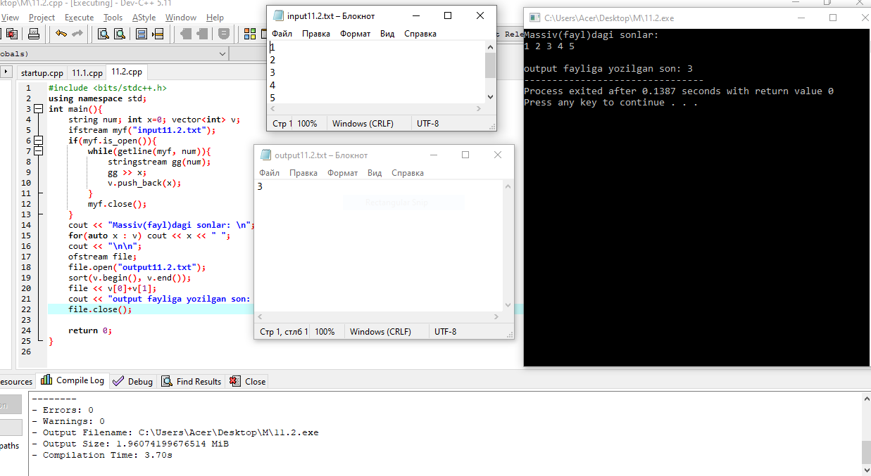

Rasm uchun link

Github: https://github.com/murodjon-umar0v/TUIT-DASTURLASH-MT

