O‘ZBEKISTON RESPUBLIKASI AXBOROT TEXNOLOGIYALARI VA KOMMUNIKATSIYALARINI RIVOJLANTIRISH VAZIRLIGI
MUHAMMAD AL-XORAZMIY NOMIDAGI TOSHKENT AXBOROT TEXNOLOGIYALARI UNIVERSITETI



Informatika asoslari kafedrasi
Dasturlash Fani

8 - AMALIY ISH

Bajardi: Umarov Murodjon

Tekshirdi: Ishniyazov O.O.

Toshkent 2023

1-topshiriq

12.04.2003

#include <bits/stdc++.h>

using namespace std;

class Mashina{
public:
string name;
string comp;
int year;
};

class Motosikl{
public:
string name;
string type;
int cost;
};

int main(){
Mashina obj1;
obj1.name = "Nexia3\t"; obj1.comp = "Chevrolet\t"; obj1.year = 2017;
cout << obj1.name << obj1.comp << obj1.year;
cout << "\n\n";
Motosikl mot;
mot.name = "Squirrel (Scott)"; mot.type = "touring"; mot.cost = 7500;
cout << mot.name << "\t" << mot.type << "\t" << mot.cost << "$";
}

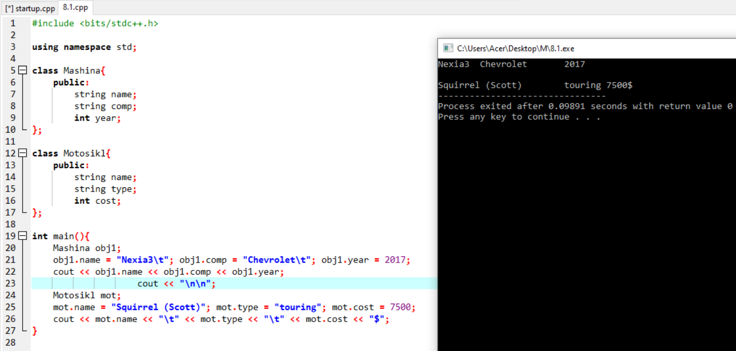

2-topshiriq

#include <bits/stdc++.h>

using namespace std;

class burchak4{
public:
int a, b;
void printsp(){
cout << "s="<<a*b << " p=" << 2*(a+b) << "\n";
}
};

int main(){
srand(time(0));
int t=5;

burchak4 info;

while(t--){
info.a = rand() % 100;
info.b = rand() % 100;

cout << "a=" << info.a << " " << "b=" << info.b << "\n";
info.printsp();

cout << "\n\n";
}

return 0;
}

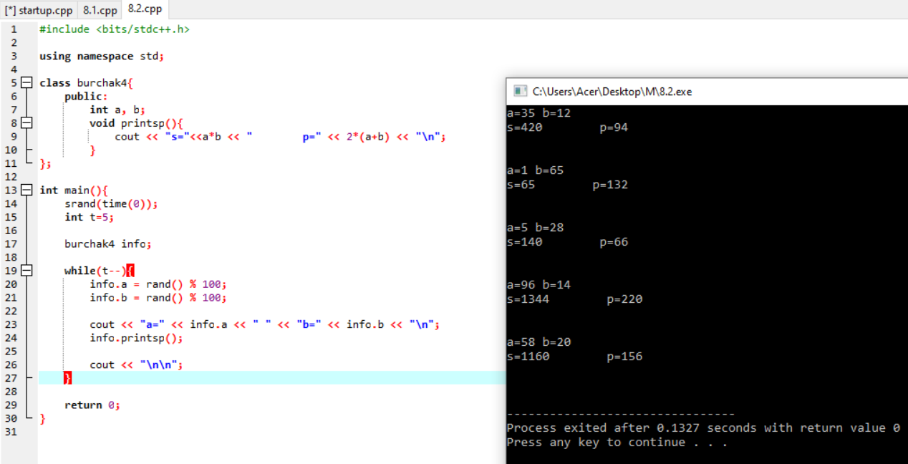

Github: https://github.com/murodjon-umar0v/TUIT-DASTURLASH-MT

