O‘ZBEKISTON RESPUBLIKASI AXBOROT TEXNOLOGIYALARI VA KOMMUNIKATSIYALARINI RIVOJLANTIRISH VAZIRLIGI
MUHAMMAD AL-XORAZMIY NOMIDAGI TOSHKENT AXBOROT TEXNOLOGIYALARI UNIVERSITETI



Informatika asoslari kafedrasi
Dasturlash Fani

9 - AMALIY ISH

Bajardi: Umarov Murodjon

Tekshirdi: Ishniyazov O.O.

Toshkent 2023

1-topshiriq
12.04.2003

#include <bits/stdc++.h>

using namespace std;
const int n=5;
class grade{
friend void debtor(grade grades[]);
private:
string name, surname; int grade;
public:
void setFullname(string s1, string s2){
name = s1; surname = s2;
}
void setGrade(int k){
grade = k;
}
};

void debtor(grade grades[]){
cout << "Imtihondan yiqilganlar: \n";
for(int i=0; i<n; i++){
if(grades[i].grade <= 2){
cout << grades[i].name << " " << grades[i].surname << "\n";
}
}
}

int main(){
grade grades[n];
string name, surname; int grade, t=n, i=0;
while(t--){
cout << "Ism, familiya va bahoni kiriting "; cin >> name >> surname >> grade;
grades[i].setFullname(name, surname); grades[i].setGrade(grade);
i++;
}
debtor(grades);

return 0;
}

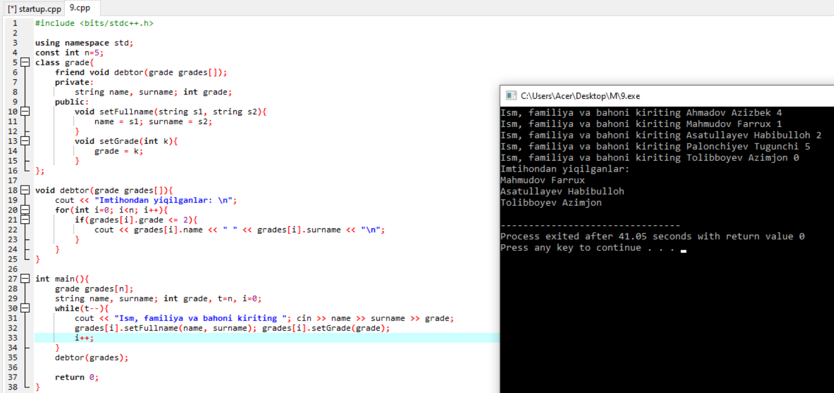

Github: https://github.com/murodjon-umar0v/TUIT-DASTURLASH-MT

