O‘ZBEKISTON RESPUBLIKASI AXBOROT TEXNOLOGIYALARI VA KOMMUNIKATSIYALARINI RIVOJLANTIRISH VAZIRLIGI
MUHAMMAD AL-XORAZMIY NOMIDAGI TOSHKENT AXBOROT TEXNOLOGIYALARI UNIVERSITETI



Informatika asoslari kafedrasi
Dasturlash Fani

3 - AMALIY ISH

Bajardi: Umarov Murodjon

Tekshirdi: Ishniyazov O.O.

Toshkent 2023
18-variant
1-topshiriq
12.04.2003

#include <iostream>
#include <vector>

int main() {
std::vector<int> myVector = {1, 2, 3, 4, 5};

auto it = myVector.begin() + 2;

myVector.insert(it, 10);

for (auto i : myVector) {
std::cout << i << "+";
}

return 0;
}
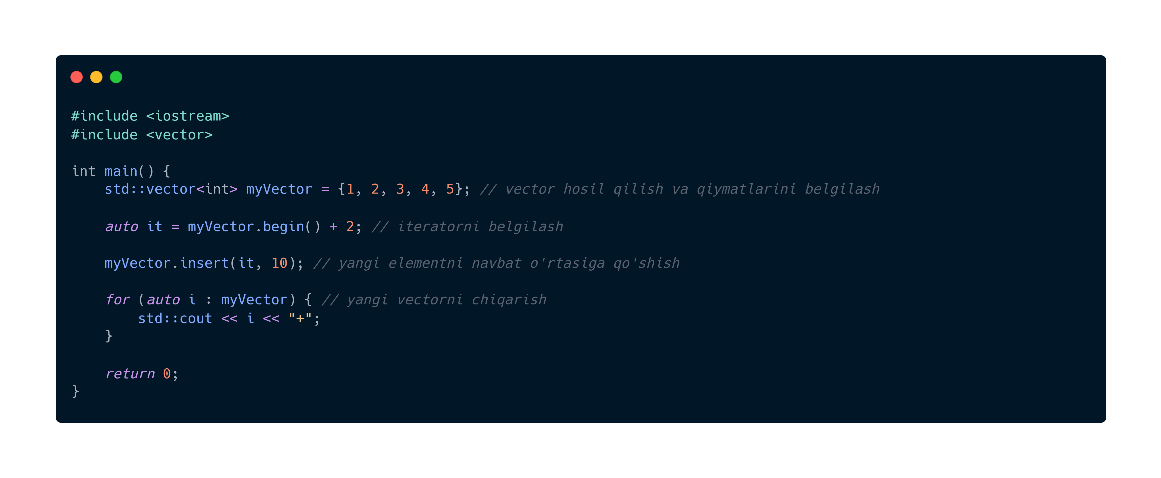


GitHub repository: https://github.com/murodjon-umar0v/TUIT-DASTURLASH-MT

