O‘ZBEKISTON RESPUBLIKASI AXBOROT TEXNOLOGIYALARI VA KOMMUNIKATSIYALARINI RIVOJLANTIRISH VAZIRLIGI
MUHAMMAD AL-XORAZMIY NOMIDAGI TOSHKENT AXBOROT TEXNOLOGIYALARI UNIVERSITETI



Informatika asoslari kafedrasi
Dasturlash Fani

5 - AMALIY ISH

Bajardi: Umarov Murodjon

Tekshirdi: Ishniyazov O.O.

Toshkent 2023
18-variant
1-topshiriq
12.04.2003

#include <iostream>
#include <string>
#include <set>

int main() {
std::string myString = "AbcDefGHiJKlmnopQRStuvwxyZ";
std::set<char> mySet;
std::multiset<char> myMultiset;

for (char c : myString) {
if (c >= 'A' && c <= 'Z') {
mySet.insert(c);
} else if (c >= 'a' && c <= 'z') {
myMultiset.insert(c);
}
}

std::cout << "Kata harflar to'plami: ";
for (char c : mySet) {
std::cout << c << " ";
}
std::cout << std::endl;

std::set<char> secondSet;
for (char c : myMultiset) {
if (secondSet.count(c) == 0) {
secondSet.insert(c);
}
}

std::cout << "Kichik harflar to'plamidan ikkinchi to'plam: ";
for (char c : secondSet) {
std::cout << c << " ";
}
std::cout << std::endl;

return 0;
}
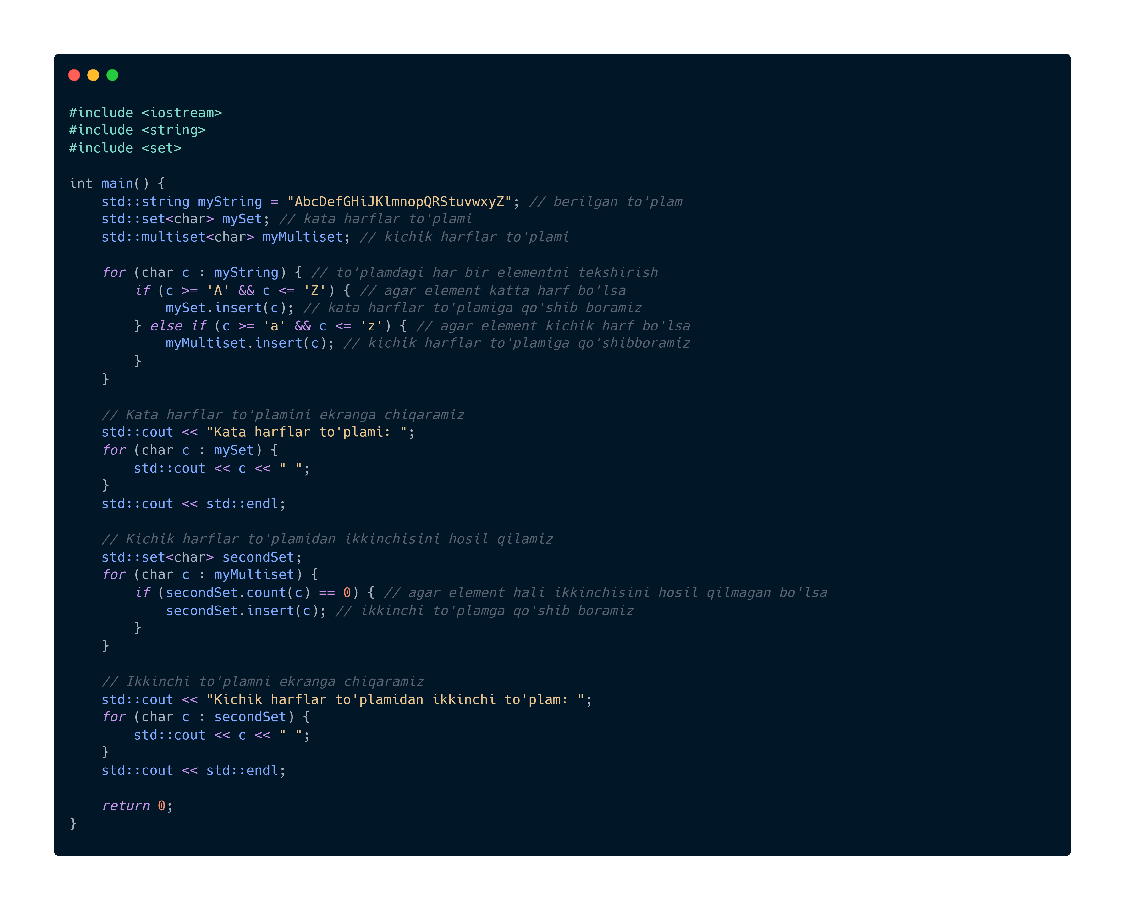
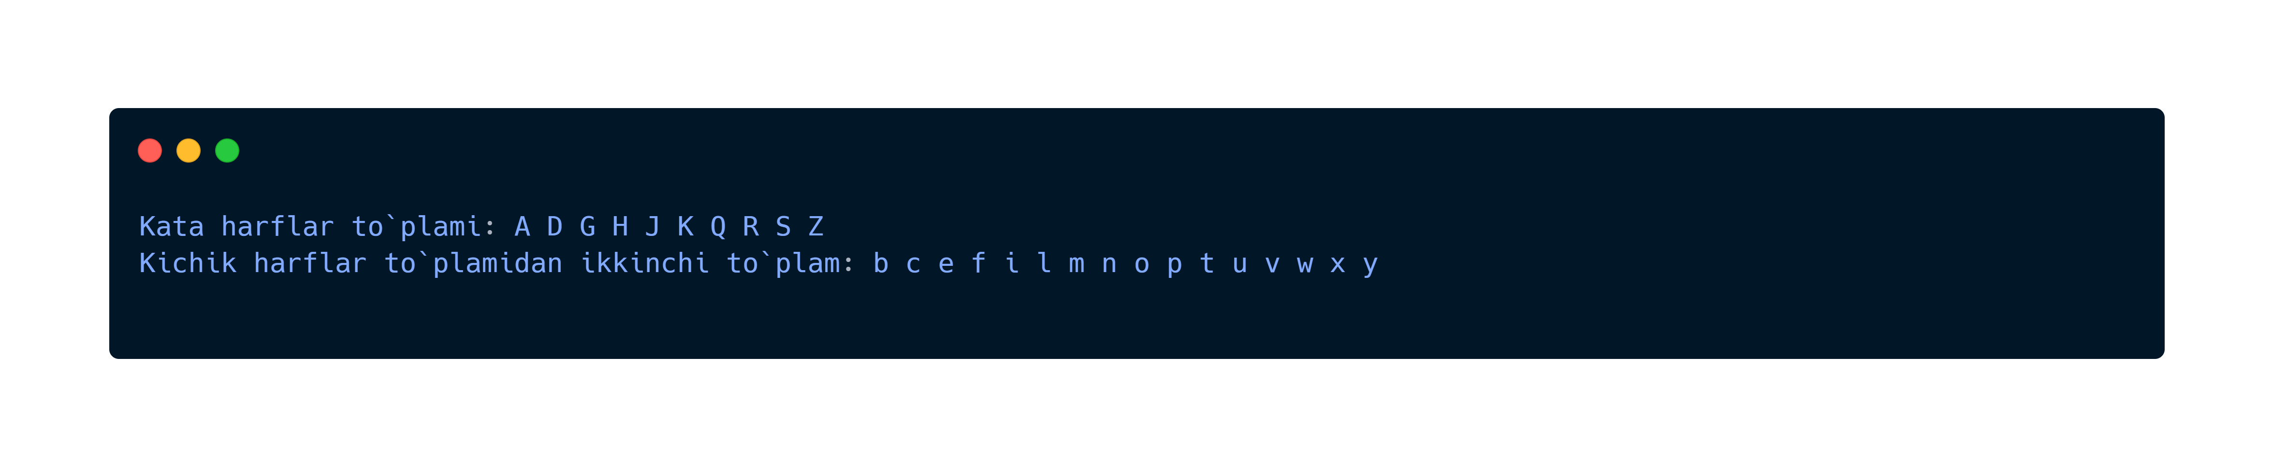

GitHub repository: https://github.com/murodjon-umar0v/TUIT-DASTURLASH-MT

