O‘ZBEKISTON RESPUBLIKASI AXBOROT TEXNOLOGIYALARI VA KOMMUNIKATSIYALARINI RIVOJLANTIRISH VAZIRLIGI
MUHAMMAD AL-XORAZMIY NOMIDAGI TOSHKENT AXBOROT TEXNOLOGIYALARI UNIVERSITETI



Informatika asoslari kafedrasi
Dasturlash Fani

6 - AMALIY ISH

Bajardi: Umarov Murodjon

Tekshirdi: Ishniyazov O.O.

Toshkent 2023
18-variant
1-topshiriq
12.04.2003

#include <iostream>
#include <stack>

int main() {
std::stack<int> myStack;

myStack.push(5);
myStack.push(10);
myStack.push(15);
myStack.push(20);

int topElement = myStack.top();

myStack.pop();
myStack.push(0);
myStack.push(topElement);

std::cout << "Stack: ";
while (!myStack.empty()) {
std::cout << myStack.top() << " ";
myStack.pop();
}
std::cout << std::endl;

return 0;
}
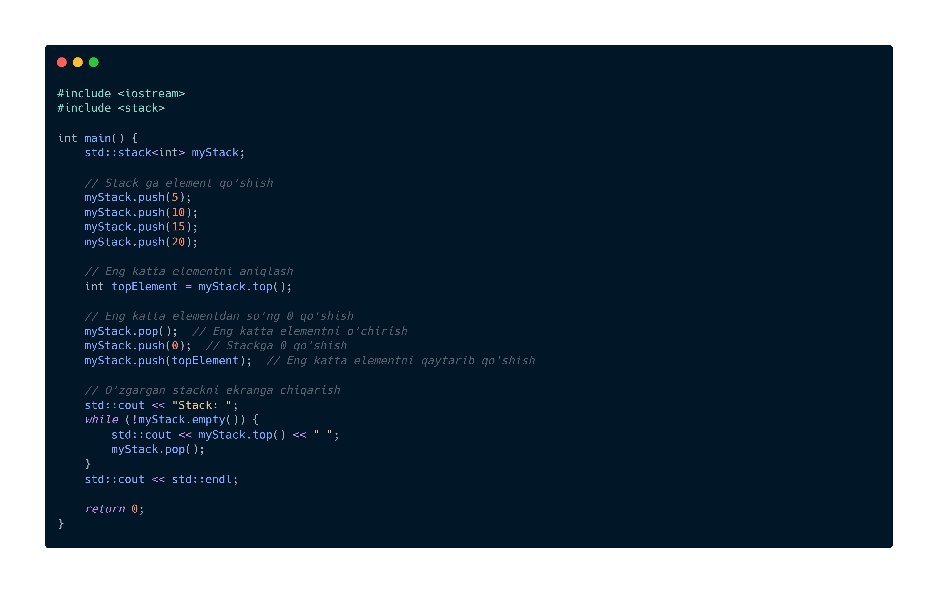


GitHub repository: https://github.com/murodjon-umar0v/TUIT-DASTURLASH-MT

