O‘ZBEKISTON RESPUBLIKASI AXBOROT TEXNOLOGIYALARI VA KOMMUNIKATSIYALARINI RIVOJLANTIRISH VAZIRLIGI
MUHAMMAD AL-XORAZMIY NOMIDAGI TOSHKENT AXBOROT TEXNOLOGIYALARI UNIVERSITETI



Informatika asoslari kafedrasi
Dasturlash Fani

10 - AMALIY ISH

Bajardi: Umarov Murodjon

Tekshirdi: Ishniyazov O.O.

Toshkent 2023

1-topshiriq
12.04.2003

#include <bits/stdc++.h>

using namespace std;

int main(){
char a;
cin >> a;
cout << int(a);

return 0;
}

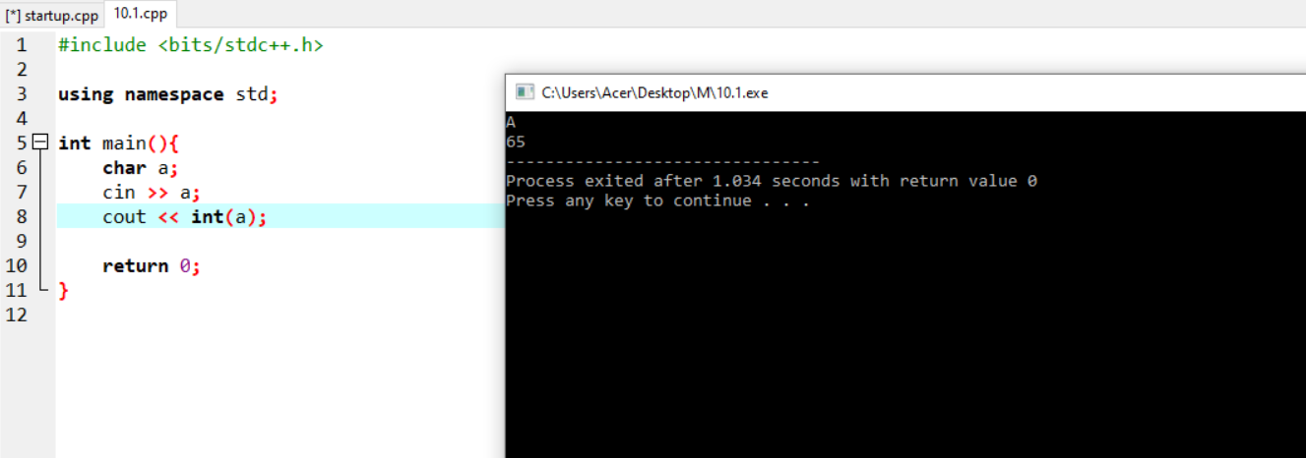

2-topshiriq

#include <bits/stdc++.h>

using namespace std;

int main(){
char a[1000]; string s="", s2="";

cin.get(a, 1000);
string a1=a;
for(int i=0; i<a1.size(); i++){
if(a1[i] == 'a' || a1[i] == 'e' || a1[i] == 'i' || a1[i] == 'o' || a1[i] == 'u'){
s += a[i];
}else{
s2 += a[i];
}
}

cout << s2 << "\n" << s;

return 0;
}

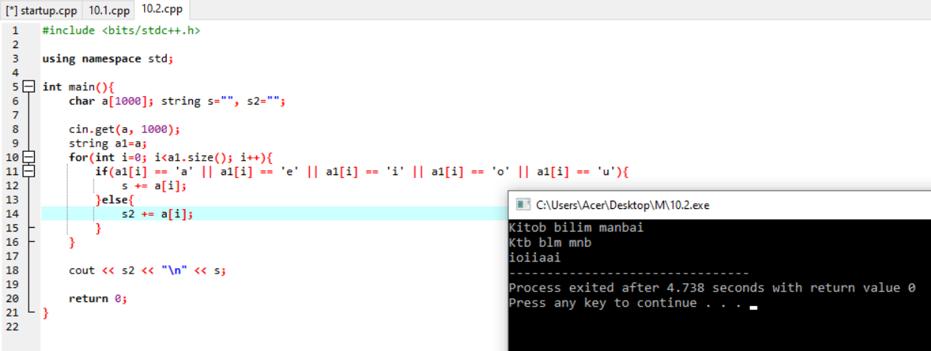

3-topshiriq

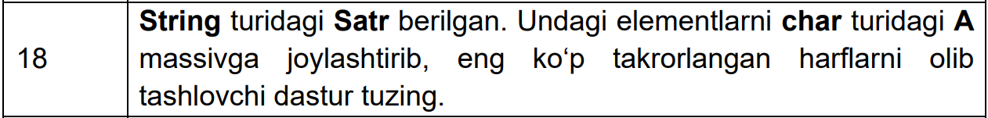

#include <bits/stdc++.h>

using namespace std;

int main(){
string s; int l[27]={0};
getline(cin, s);
char a[1000]={"\0"};
for(int i=0; i<s.size(); i++){
a[i] = s[i];
l[int(a[i])-96]++;
}
int mn = 1, ind = 1;
for(int i=0; i<s.size(); i++){
if(mn < l[i]){
ind = i; mn = l[i];
}
}

for(int i=0; i<s.size(); i++){
if(ind == int(s[i])-96){
s[i] = ' ';
}
}
cout << a << "\n" << s;
return 0;
}

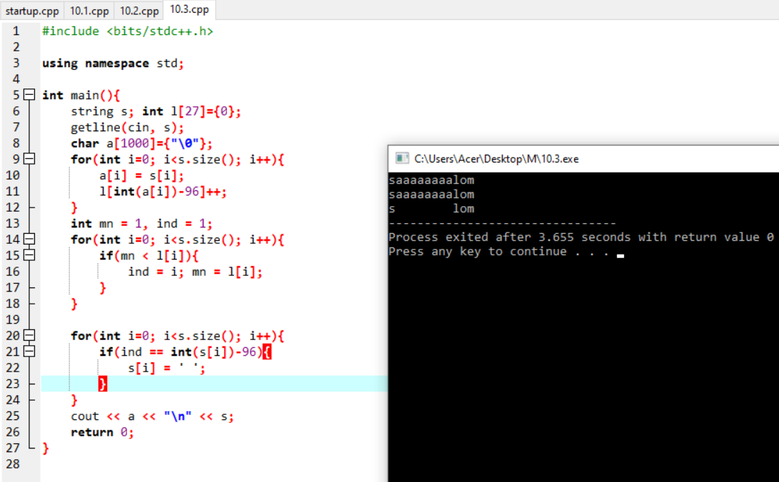

4-topshiriq

#include <bits/stdc++.h>

using namespace std;

int main(){
string s;
getline(cin, s);
int p = 1;
for(int i=0; i<s.length(); i++)
if(s[i] == ' ')
p ++;

cout << p;
return 0;
}

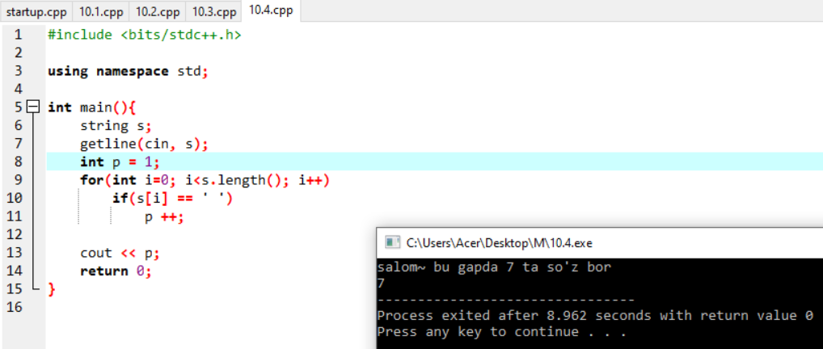

Github: https://github.com/murodjon-umar0v/TUIT-DASTURLASH-MT

