O‘ZBEKISTON RESPUBLIKASI AXBOROT TEXNOLOGIYALARI VA KOMMUNIKATSIYALARINI RIVOJLANTIRISH VAZIRLIGI
MUHAMMAD AL-XORAZMIY NOMIDAGI TOSHKENT AXBOROT TEXNOLOGIYALARI UNIVERSITETI



Informatika asoslari kafedrasi
Dasturlash Fani

1 - AMALIY ISH

Bajardi: Umarov Murodjon

Tekshirdi: Ishniyazov O.O.

Toshkent 2023

1-topshiriq

12.04.2003

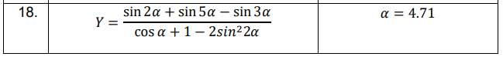

#include <iostream>
#include <cmath>
#include <algorithm>

using namespace std;

#define ld long double
#define ll long long

int main(){
ld a = 4.71;
ld y = (sin(2*a) + sin(5*a) - sin(3*a)) / (cos(a) + 1 - 2 * (sin(2*a)*sin(2*a)));
cout << y;
return 0;
}

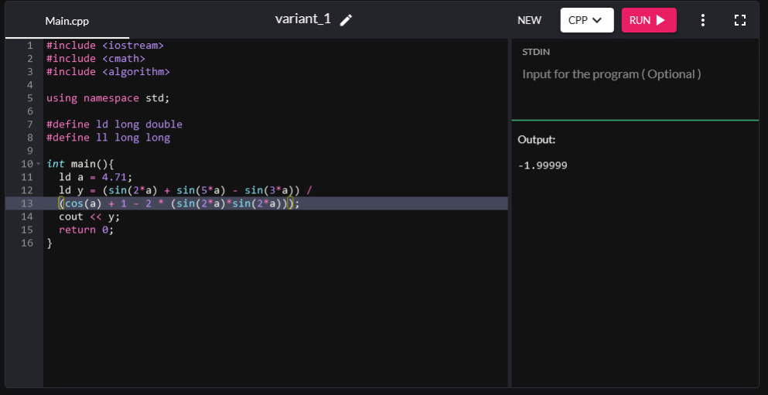

2-topshiriq

12.04.2003

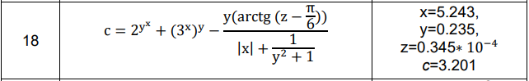

_
#include <iostream>
#include <cmath>
#include <algorithm>

using namespace std;

#define ld long double
#define ll long long
#define ex 2.71828
#define pi 3.14159265359

int main(){
ld x = 5.243, y = 0.235, z = 0.0000345, c;
c = pow(2, pow(y, x)) + pow(pow(3, x), y) - (y * atan(double(z - (pi / 6))))
/(fabs(x) + (1 / (y*y+1)));

cout << c;
return 0;
}
