O‘ZBEKISTON RESPUBLIKASI AXBOROT TEXNOLOGIYALARI VA KOMMUNIKATSIYALARINI RIVOJLANTIRISH VAZIRLIGI
MUHAMMAD AL-XORAZMIY NOMIDAGI TOSHKENT AXBOROT TEXNOLOGIYALARI UNIVERSITETI



Informatika asoslari kafedrasi
Dasturlash Fani

5 - AMALIY ISH

Bajardi: Umarov Murodjon

Tekshirdi: Ishniyazov O.O.

Toshkent 2023

1-topshiriq

12.04.2003

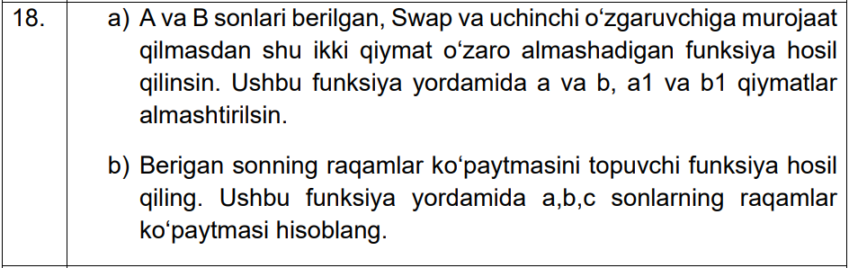

- masala

#include <iostream>
using namespace std;

void my_swap(int a, int b){
a=a+b; b=a-b; a=a-b;
cout << a << " " << b << "\n";
}

int main(){
int a=1, b=4, a1=78, b1=23;
my_swap(a, b); my_swap(a1, b1);
return 0;
}

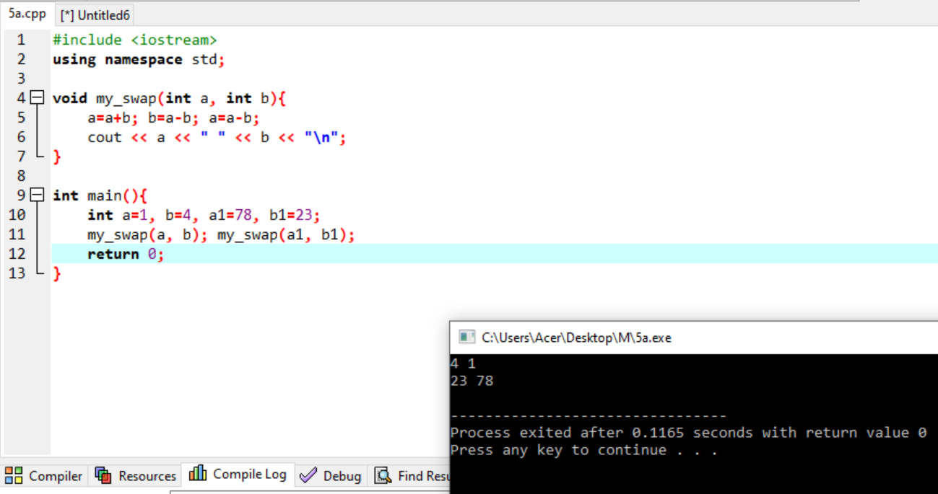

- masala

#include <iostream>
using namespace std;

void my_f(int a){
int s=1;
while(a>0){
s*=a%10;
a/=10;
}
cout << s << "\n";
}

int main(){
int a=87123, b=426851, c=82168531;
my_f(a); my_f(b); my_f(c);
}

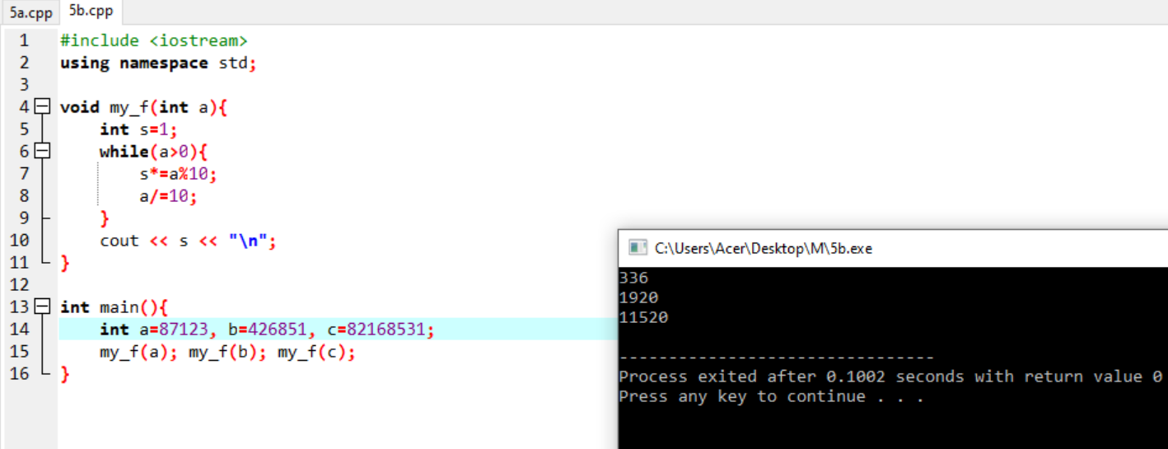

Github: https://github.com/murodjon-umar0v/TUIT-DASTURLASH-MT

