O‘ZBEKISTON RESPUBLIKASI AXBOROT TEXNOLOGIYALARI VA KOMMUNIKATSIYALARINI RIVOJLANTIRISH VAZIRLIGI
MUHAMMAD AL-XORAZMIY NOMIDAGI TOSHKENT AXBOROT TEXNOLOGIYALARI UNIVERSITETI



Informatika asoslari kafedrasi
Dasturlash Fani

1 - AMALIY ISH

Bajardi: Umarov Murodjon

Tekshirdi: Ishniyazov O.O.

Toshkent 2023
18-variant
1-topshiriq
12.04.2003

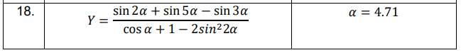

#include <iostream>
#include <cmath>

int main() {
double alpha = 4.71;
double numerator = sin(2 * alpha) + sin(5 * alpha) - sin(3 * alpha);
double denominator = cos(alpha) + 1 - pow(2 * sin(2 * alpha), 2 * alpha);
double result = numerator / denominator;

std::cout << "Y = " << result << std::endl;

return 0;
}

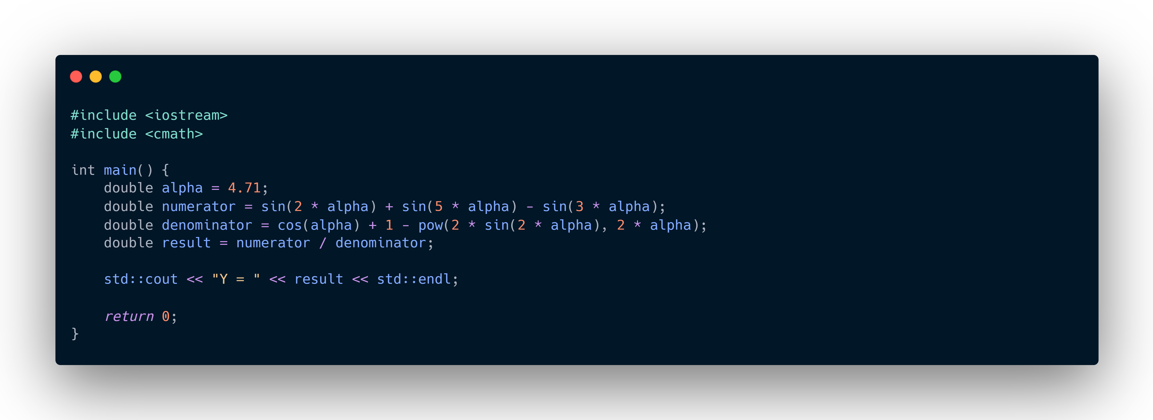
Y = -0.385

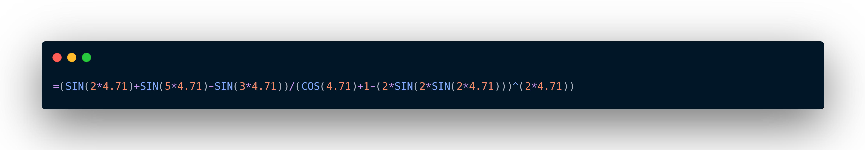
Natija Excel-da ham `-0.385` ga teng.

2-topshiriq

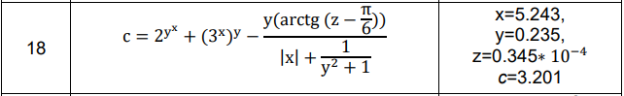

_

#include <iostream>
#include <cmath>
#include <algorithm>

using namespace std;

#define ld long double
#define ll long long
#define ex 2.71828
#define pi 3.14159265359

int main(){
ld x = 5.243, y = 0.235, z = 0.0000345, c;
c = pow(2, pow(y, x)) + pow(pow(3, x), y) - (y * atan(double(z - (pi / 6))))
/(fabs(x) + (1 / (y*y+1)));

cout << c;
return 0;
}

